Lesson 11: Building a Trundle Wheel
Let’s build a trundle wheel.

11.1: What Is a Trundle Wheel?
A tool that surveyors use to measure distances is called a trundle wheel.
- How does a trundle wheel measure distance?
- Why is this method of measuring distances better than the methods we used in the previous lesson?
- How could we construct a simple trundle wheel? What materials would we need?
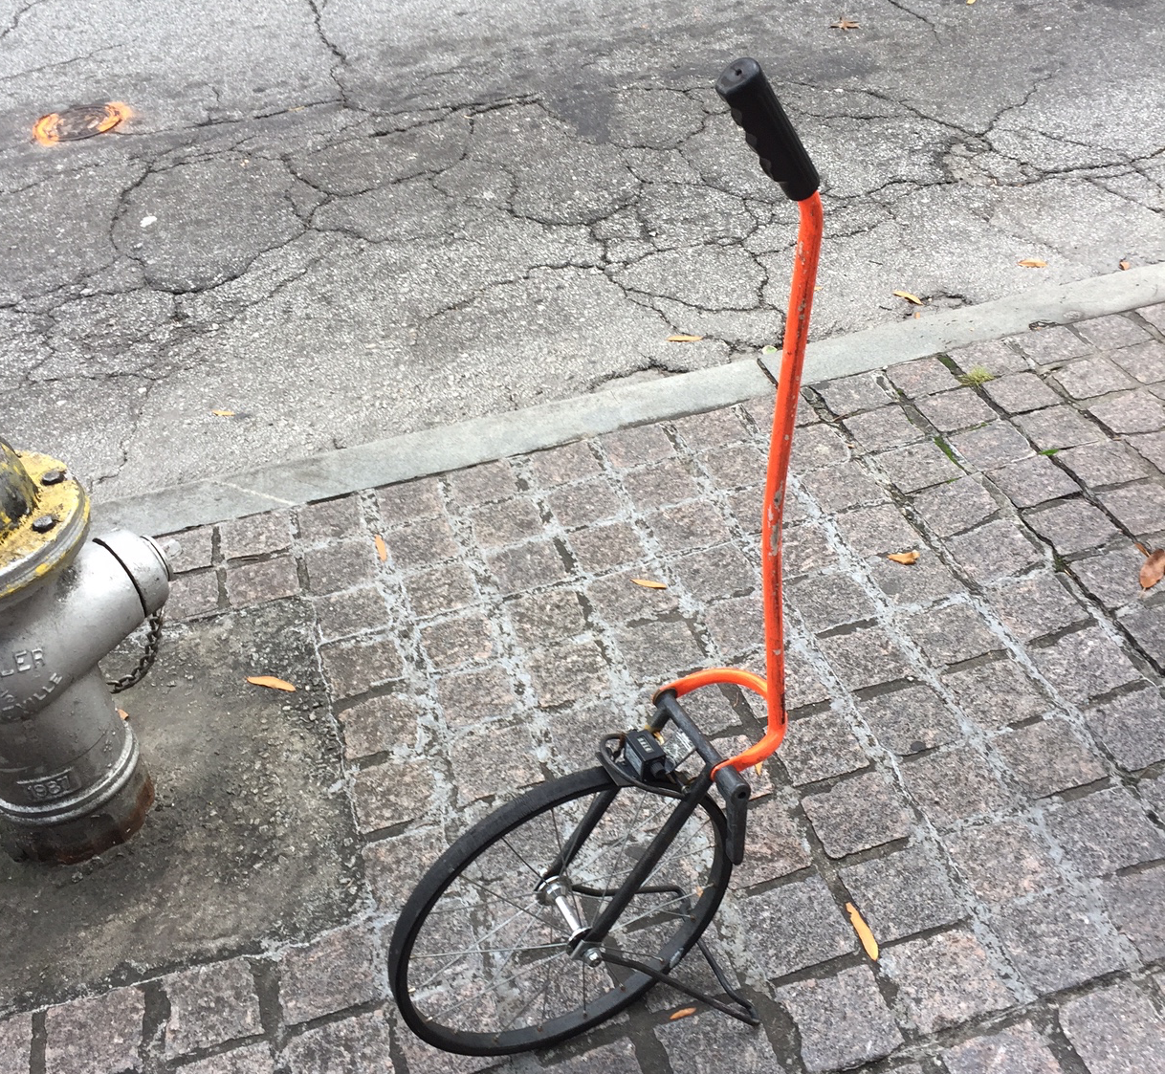

11.2: Building a Trundle Wheel
Your teacher will give you some supplies. Construct a trundle wheel and use it to measure the length of the classroom. Record:
- the diameter of your trundle wheel
- the number of clicks across classroom
- the length of the classroom (Be prepared to explain your reasoning.)
© CC BY Open Up Resources. Adaptations CC BY IM.

