Lesson 11: Making a Model for Data
Let’s model with functions.

11.1: What Function Could It Be?
What do you notice? What do you wonder?
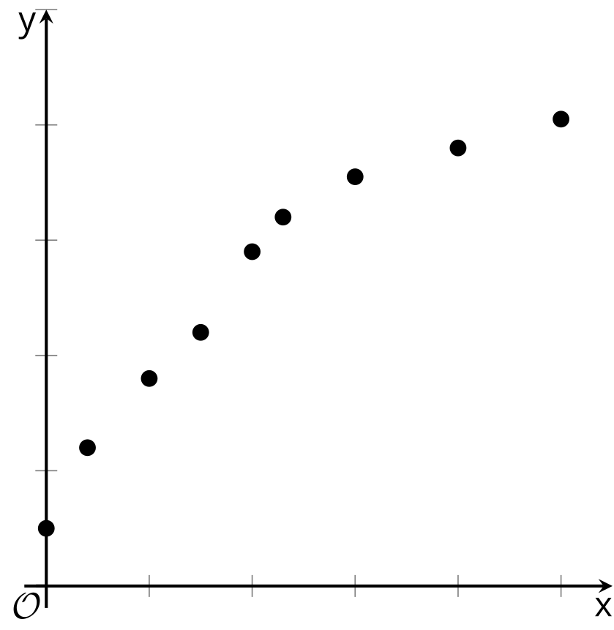

11.2: Heating Up
Here is a graph of data showing the temperature of a bottle of water after it has been removed from the refrigerator.
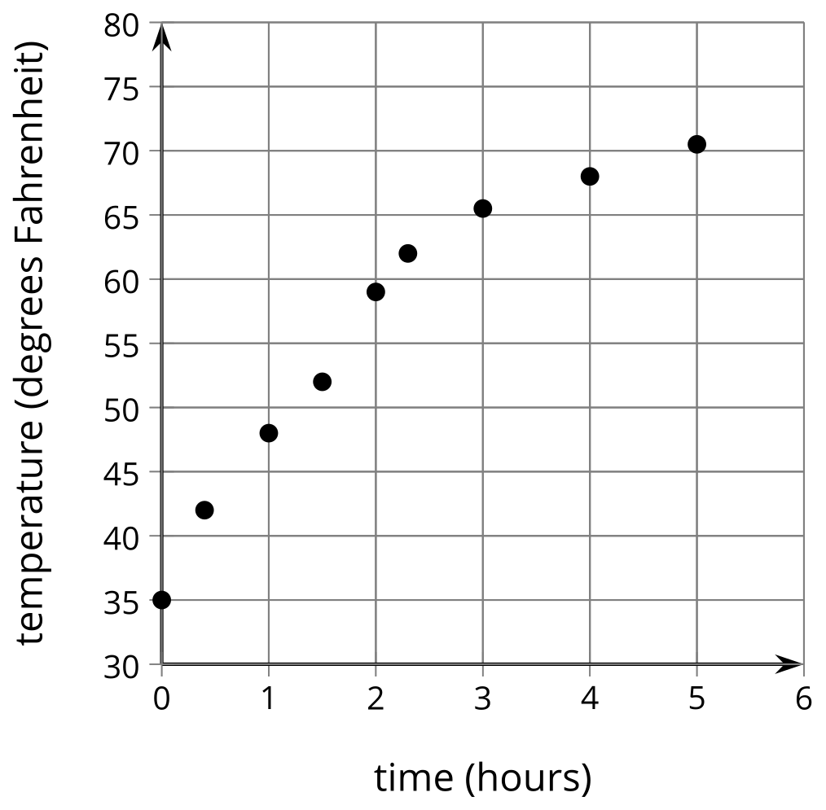
For the function types assigned by your teacher:
- Apply a sequence of transformations to your function so that it matches the data as well as possible.
- How well does your model fit the data? Make adjustments as needed.
© CC BY 2019 by Illustrative Mathematics®

