Unit 6 Lesson 11: Extending the Domain of Trigonometric Functions

1 Rewind to the Windmill (Warm up)

Images for Launch
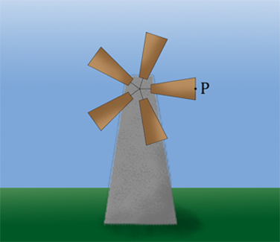

Student Task Statement
Priya is thinking about the windmill in an earlier lesson. That windmill had a point $P$ at $\left(1,0\right)$ at the end of the blade that starts at 0 radians pointing directly to the right. Priya says that if the blade rotates $\text{-}\frac{π}{2}$ radians, then $P$ will be at the lowest point in its circle of rotation.
What do you think Priya means by rotating $\text{-}\frac{π}{2}$ radians? Do you agree with Priya? Be prepared to explain your reasoning.

2 Math Talk: The Hour Hand

Student Task Statement
Here is a clock showing an hour hand at 3 p.m.
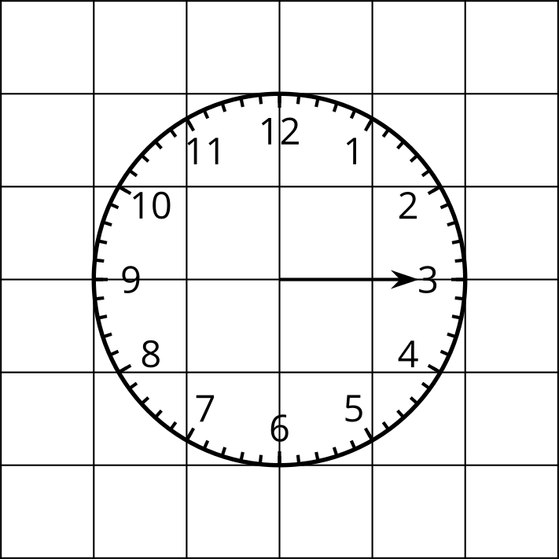
Your teacher will give you a time. Identify the radian angle measure that the hour hand rotates through if it starts at 3 p.m.

3 The Big Picture for Cosine and Sine

Student Task Statement
- Create a visual display for the following functions. Include a graph of the function from at least $\text{-}4π$ to $4π$ radians, the maximum and minimum value of the function, and the period of the function. Label any intersections the graph of the function has with the axes.
  - $y=cos\left(θ\right)$
  - $y=sin\left(θ\right)$
- The $y$-axis is a line of symmetry for one of the two graphs. Which one? Explain how you know.

4 Cosine and Sine Together (Optional)

Student Task Statement
Use graphing technology to graph the functions $y=cos\left(θ\right)$ and $y=sin\left(θ\right)$ on the same axes.
- Identify two points where the graphs intersect—one with a negative $θ$-coordinate, and one with a positive $θ$-coordinate. What is the exact $θ$-coordinate for each point? Explain or show how you know.
- What are the $y$-coordinates of the points of intersection? Explain or show how you know.
- What could be the value of $cos\left(θ\right)$ if $sin\left(θ\right)=0$? Explain your reasoning.

Activity Synthesis
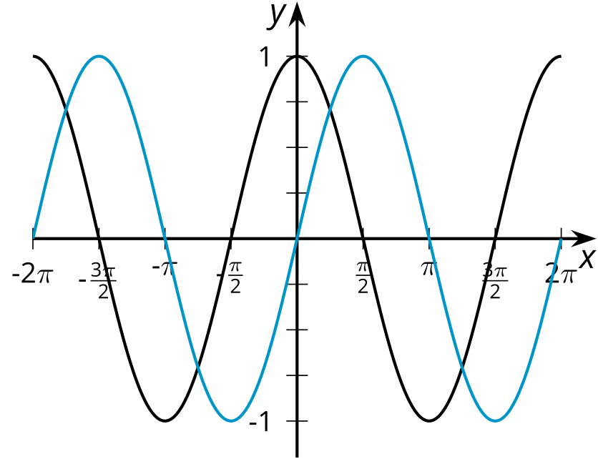
© CC BY 2019 by Illustrative Mathematics®

