Unit 2 Lesson 24: Solutions to Systems of Linear Inequalities in Two Variables

1 A Silly Riddle (Warm up)

Student Task Statement
Here is a riddle: “I am thinking of two numbers that add up to 5.678. The difference between them is 9.876. What are the two numbers?”
- Name any pair of numbers whose sum is 5.678.
- Name any pair of numbers whose difference is 9.876.
- The riddle can be represented with two equations. Write the equations.
- Solve the riddle. Explain or show your reasoning.

2 A Quilting Project

Student Task Statement
To make a quilt, a quilter is buying fabric in two colors, light and dark. He needs at least 9.5 yards of fabric in total.
The light color costs $9 a yard. The dark color costs $13 a yard. The quilter can spend up to $110 on fabric.
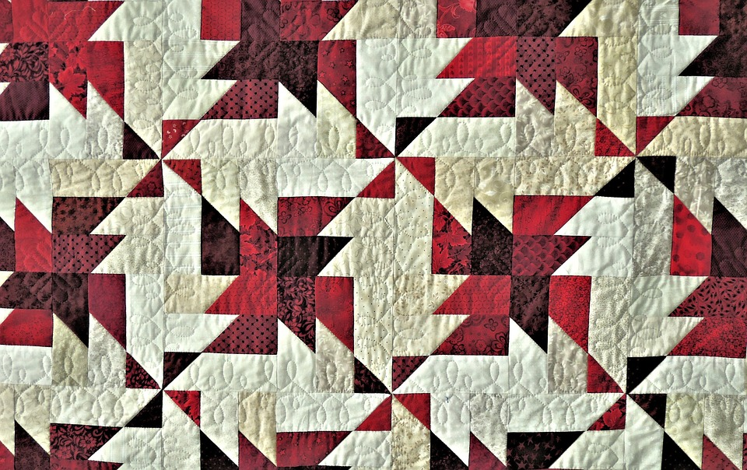
Here are two graphs that represent the two constraints.

A
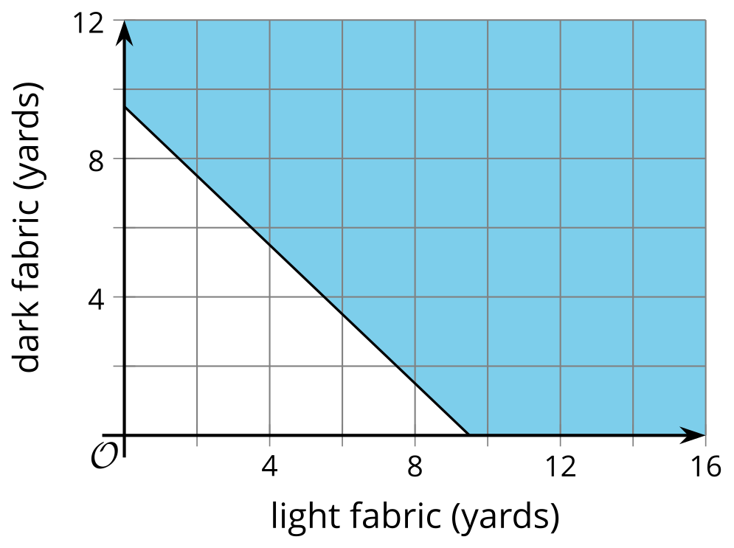

B
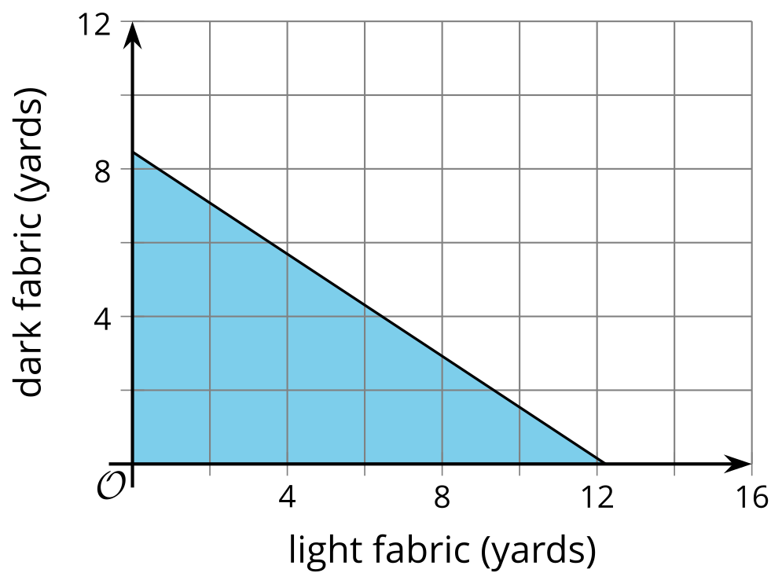
- Write an inequality to represent the length constraint. Let $x$ represent the yards of light fabric and $y$ represent the yards of dark fabric.
- Select all the pairs that satisfy the length constraint.
- $\left(5,5\right)$
- $\left(2.5,4.5\right)$
- $\left(7.5,3.5\right)$
- $\left(12,10\right)$
- Write an inequality to represent the cost constraint.
- Select all the pairs that satisfy the cost constraint.
- $\left(1,1\right)$
- $\left(4,5\right)$
- $\left(8,3\right)$
- $\left(10,1\right)$
- Explain why $\left(2,2\right)$ satisfies the cost constraint, but not the length constraint.
- Find at least one pair of numbers that satisfies both constraints. Be prepared to explain how you know.
- What does the pair of numbers represent in this situation?

3 Remember These Situations?

Student Task Statement
Here are some situations you have seen before. Answer the questions for one situation.
Bank Accounts
- A customer opens a checking account and a savings account at a bank. They will deposit a maximum of $600, some in the checking account and some in the savings account. (They might not deposit all of it and keep some of the money as cash.)
- The bank requires a minimum balance of $50 in the savings account. It does not matter how much money is kept in the checking account.
Concert Tickets
- Two kinds of tickets to an outdoor concert were sold: lawn tickets and seat tickets. Fewer than 400 tickets in total were sold.
- Lawn tickets cost $30 each and seat tickets cost $50 each. The organizers want to make at least $14,000 from ticket sales.
Advertising Packages
- An advertising agency offers two packages for small businesses who need advertising services. A basic package includes only design services. A premium package includes design and promotion. The agency's goal is to sell at least 60 packages in total.
- The basic advertising package has a value of $1,000 and the premium package has a value of $2,500. The goal of the agency is to sell more than $60,000 worth of small-business advertising packages.
1. Write a system of inequalities to represent the constraints. Specify what each variable represents.

2. Use technology to graph the inequalities and sketch the solution regions. Include labels and scales for the axes.
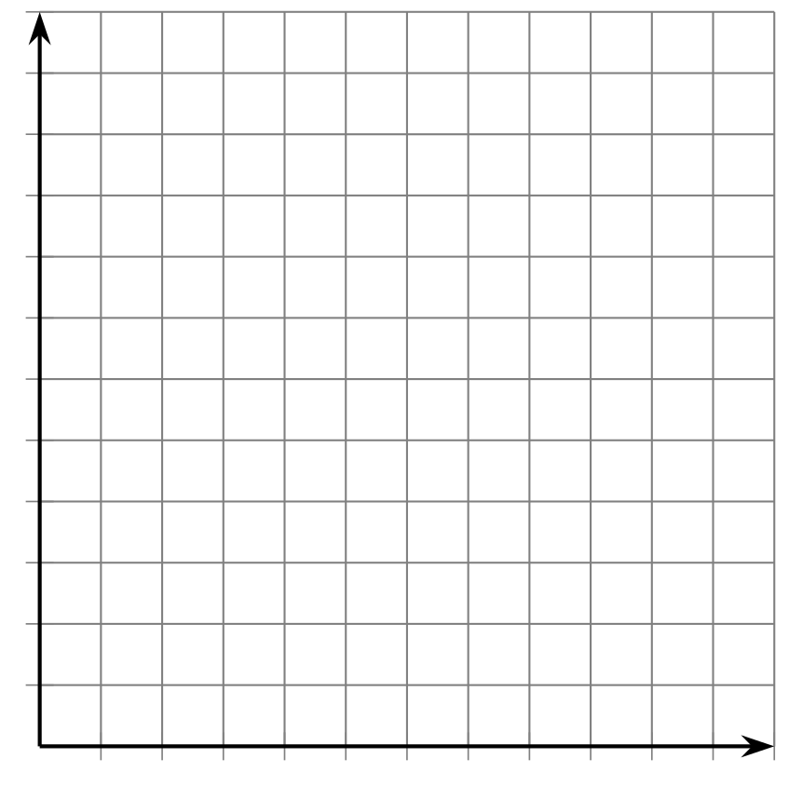
3. Identify a solution to the system. Explain what the numbers mean in the situation.

4 Scavenger Hunt (Optional)

Student Task Statement
Members of a high school math club are doing a scavenger hunt. Three items are hidden in the park, which is a rectangle that measures 50 meters by 20 meters.
- The clues are written as systems of inequalities. One system has no solutions.
- The locations of the items can be narrowed down by solving the systems. A coordinate plane can be used to describe the solutions.
Can you find the hidden items? Sketch a graph to show where each item could be hidden.
Clue 1: $y>14 x<10$
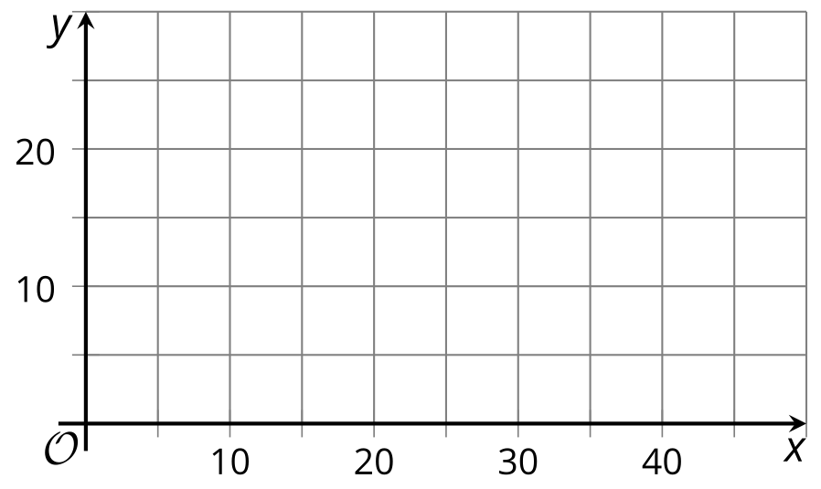
Clue 2: $x+y<20 x>6$
Clue 3: $y<\text{-}2x+20 y<\text{-}2x+10$
Clue 4: $y≥x+10 x>y$

Images for Activity Synthesis
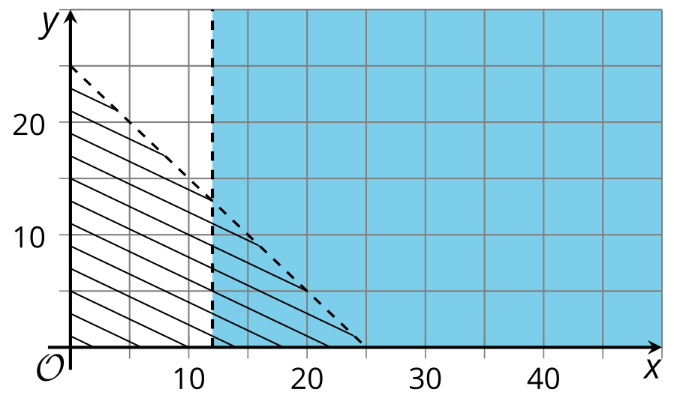
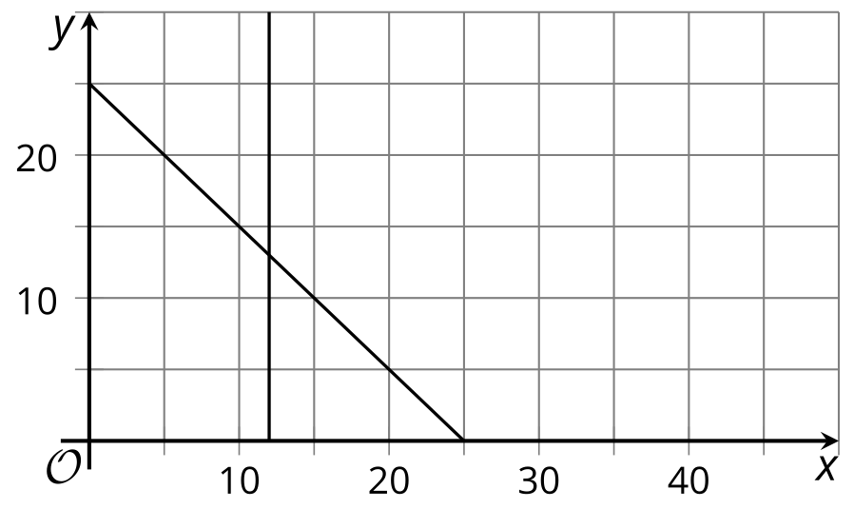
© CC BY 2019 by Illustrative Mathematics®

