Student Task Statements

Lesson 3: More Movement

3.1: Moving a Graph
How can we translate the graph of $A$ to match one of the other graphs?
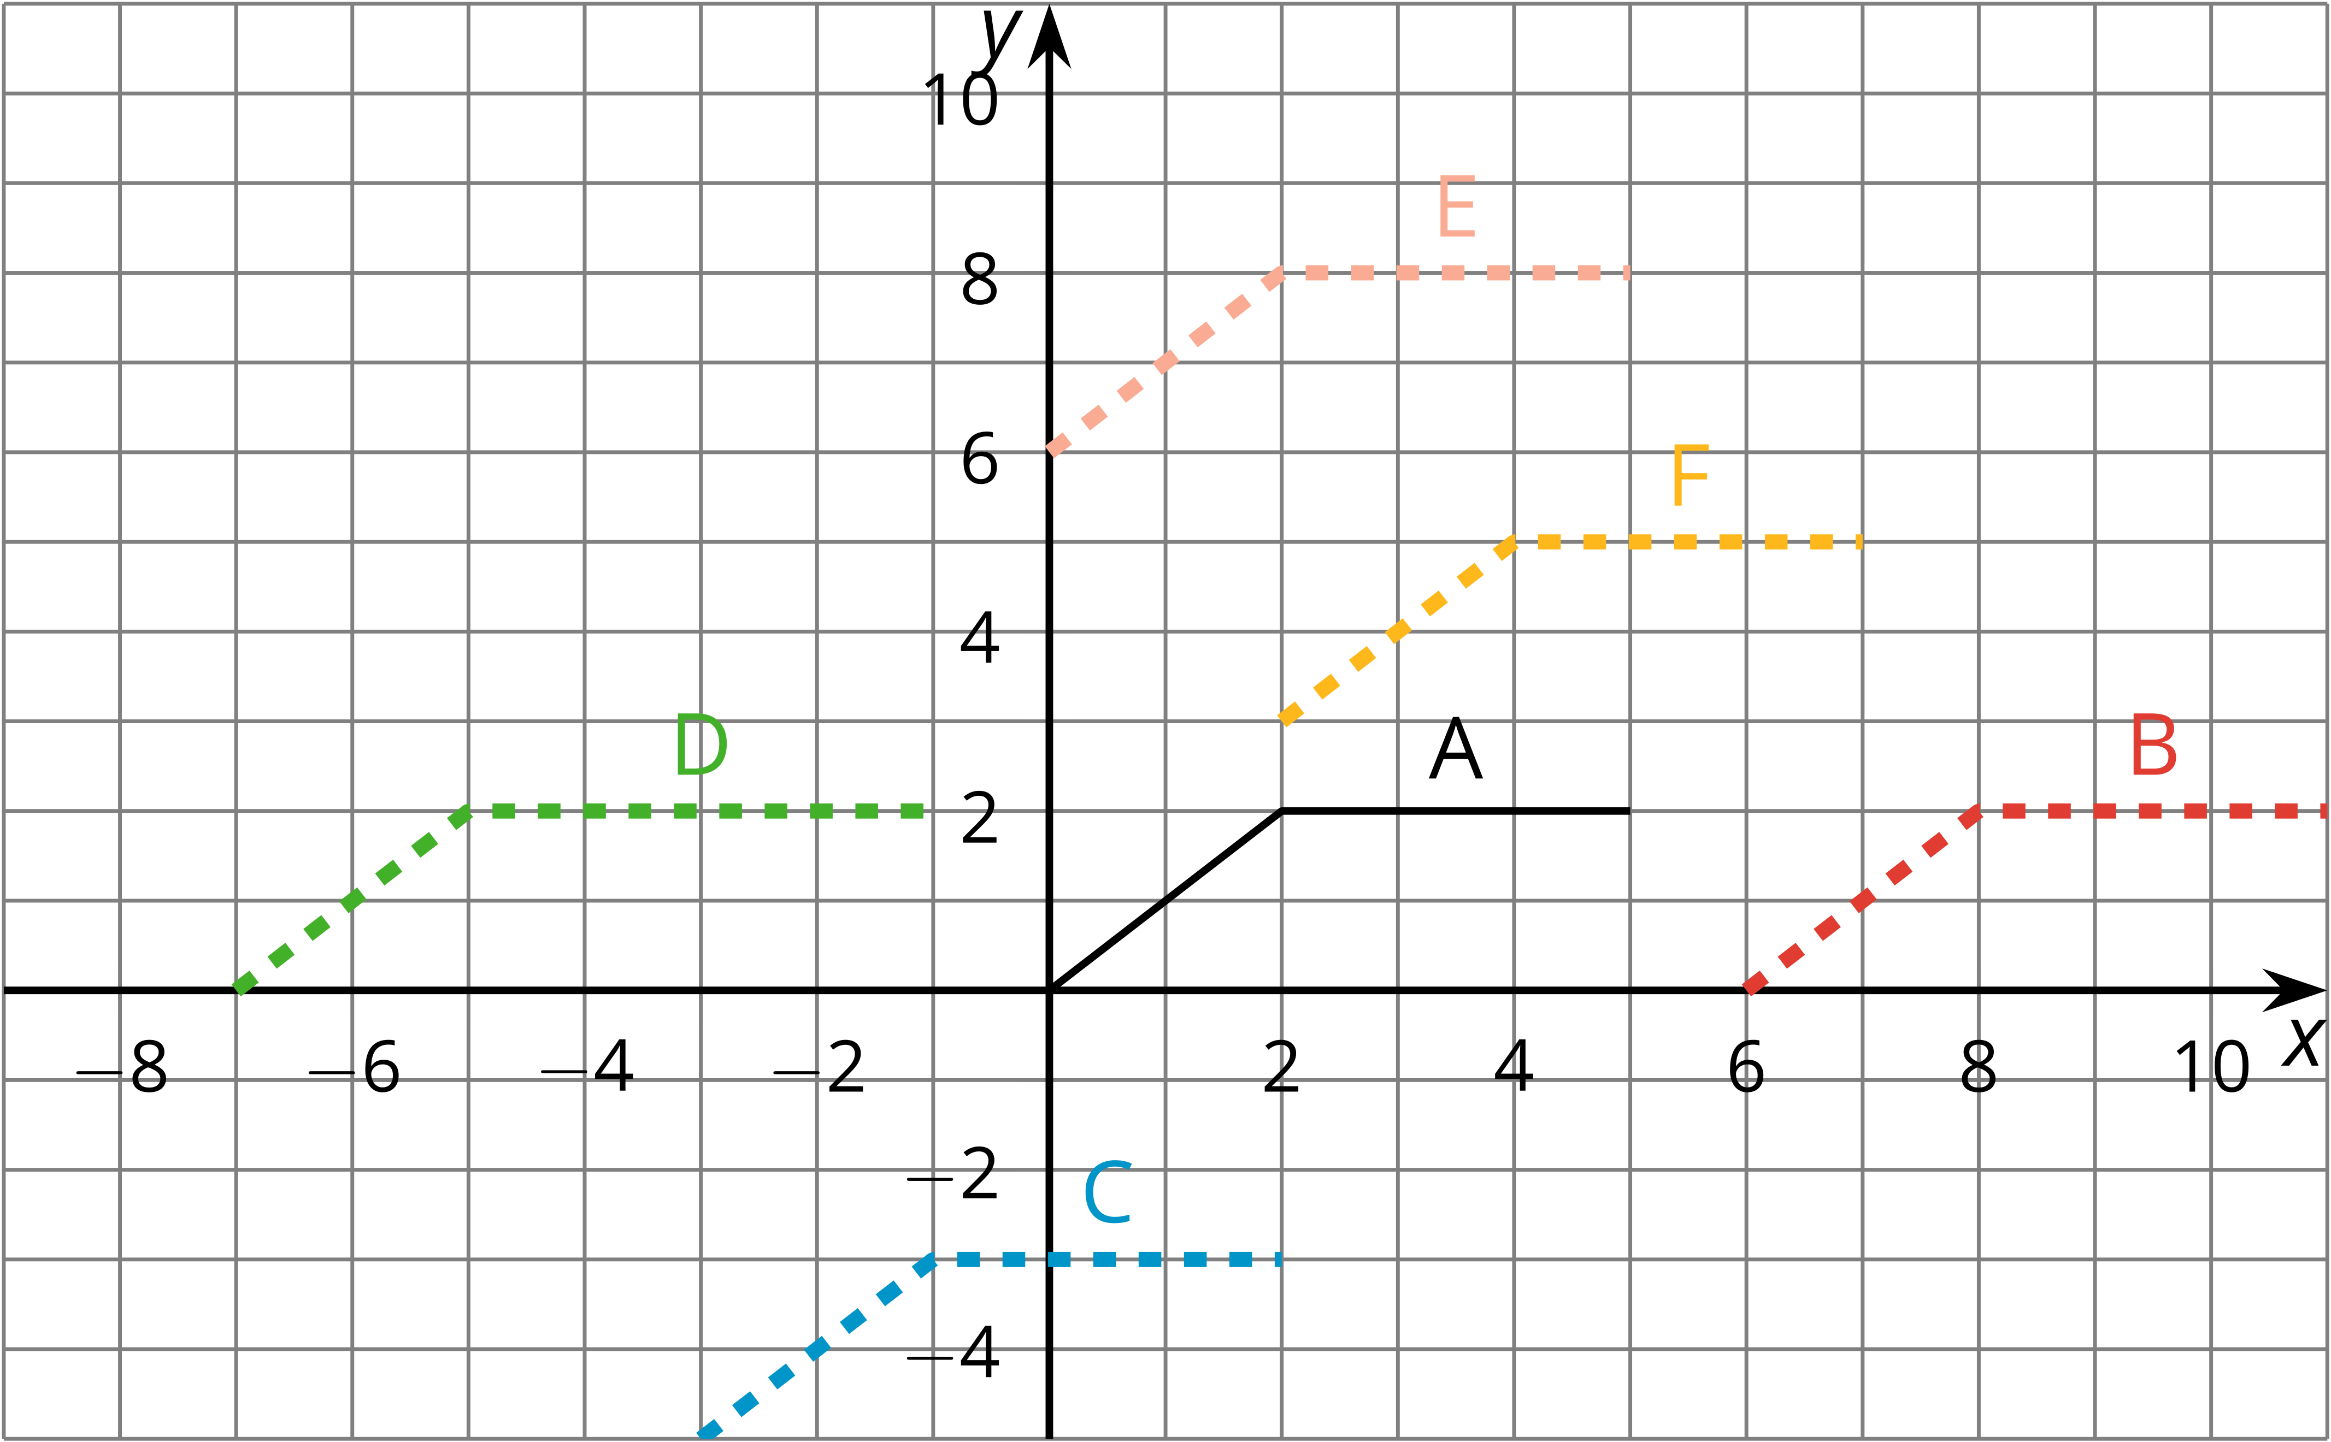

3.2: New Hours for the Kitchen
Remember the bakery with the thermostat set to ${65}^{∘}\text{F}$? At 5:00 a.m., the temperature in the kitchen rises to ${85}^{∘}\text{F}$ due to the ovens and other kitchen equipment being used until they are turned off at 10:00 a.m. When the owner decided to open 2 hours earlier, the baking schedule changed to match.
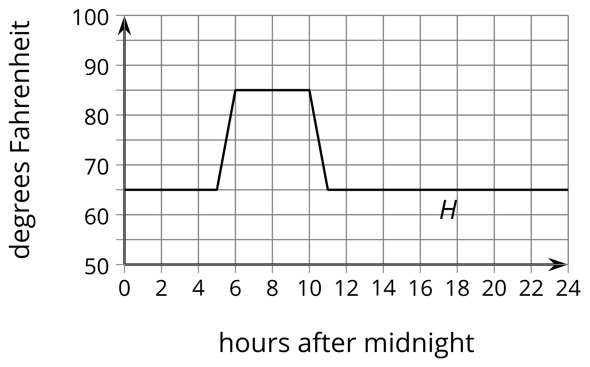
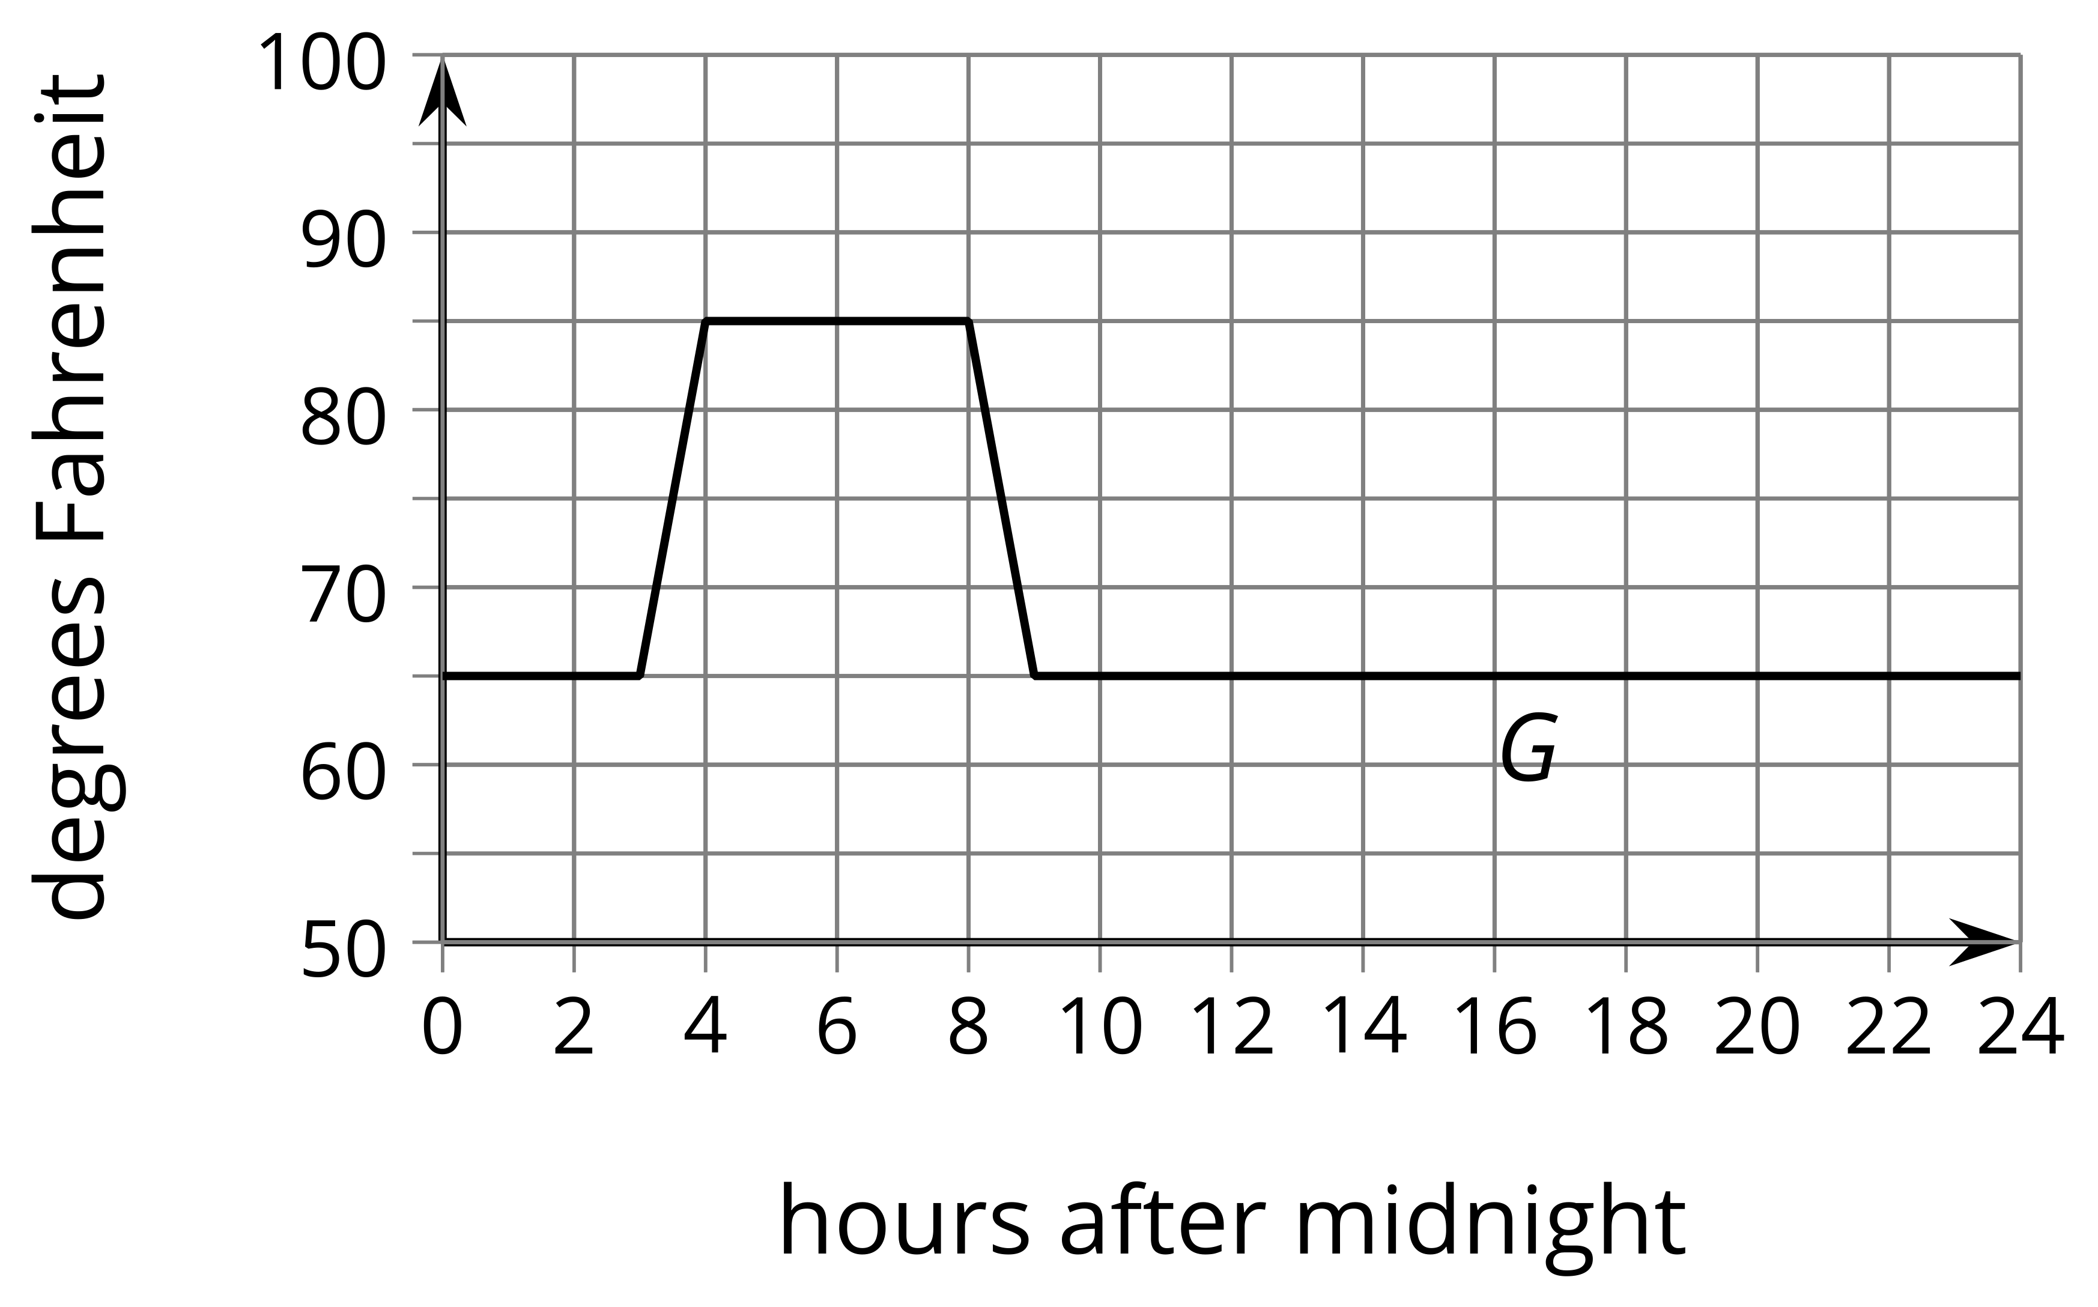
- Andre thinks, “When the bakery starts baking 2 hours earlier, that means I need to subtract 2 from $x$ and that $G(x)=H(x−2)$.” How could you help Andre understand the error in his thinking?
- The graph of $F$ shows the temperatures after a change to the thermostat settings. What did the owner do?
- 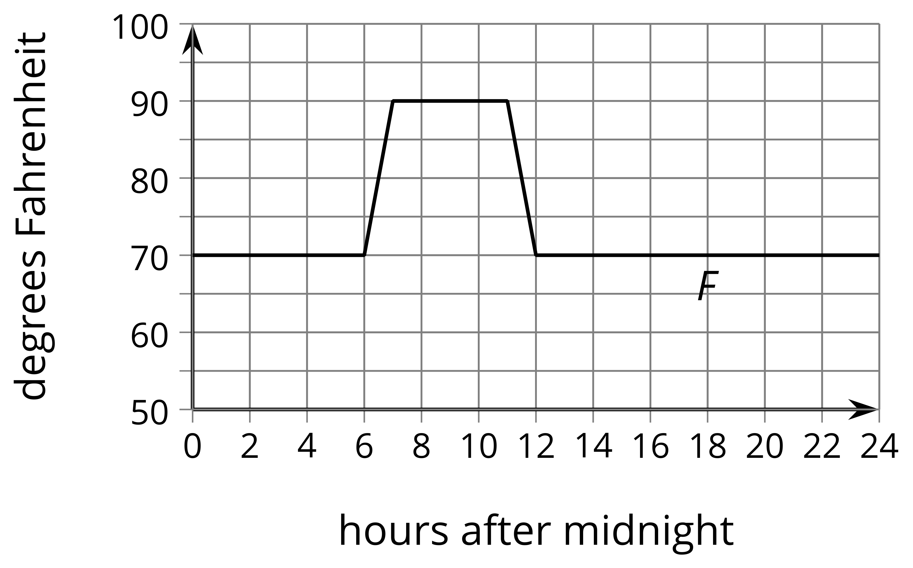
- Write an expression for $F$ in terms of the original baking schedule, $H$.

3.3: Thawing Meat
A piece of meat is taken out of the freezer to thaw. The data points show its temperature $M$, in degrees Fahrenheit, $t$ hours after it was taken out. The graph $M=G(t)$, where $G(t)=\text{-}62(0.85)^{t}$, models the shape of the data but is in the wrong position.
$t$ | $M$
0 | 13.1
0.41 | 22.9
1.84 | 29
2.37 | 36.1
2.95 | 36.8
3.53 | 38.8
3.74 | 40
4.17 | 42.2
4.92 | 45.8
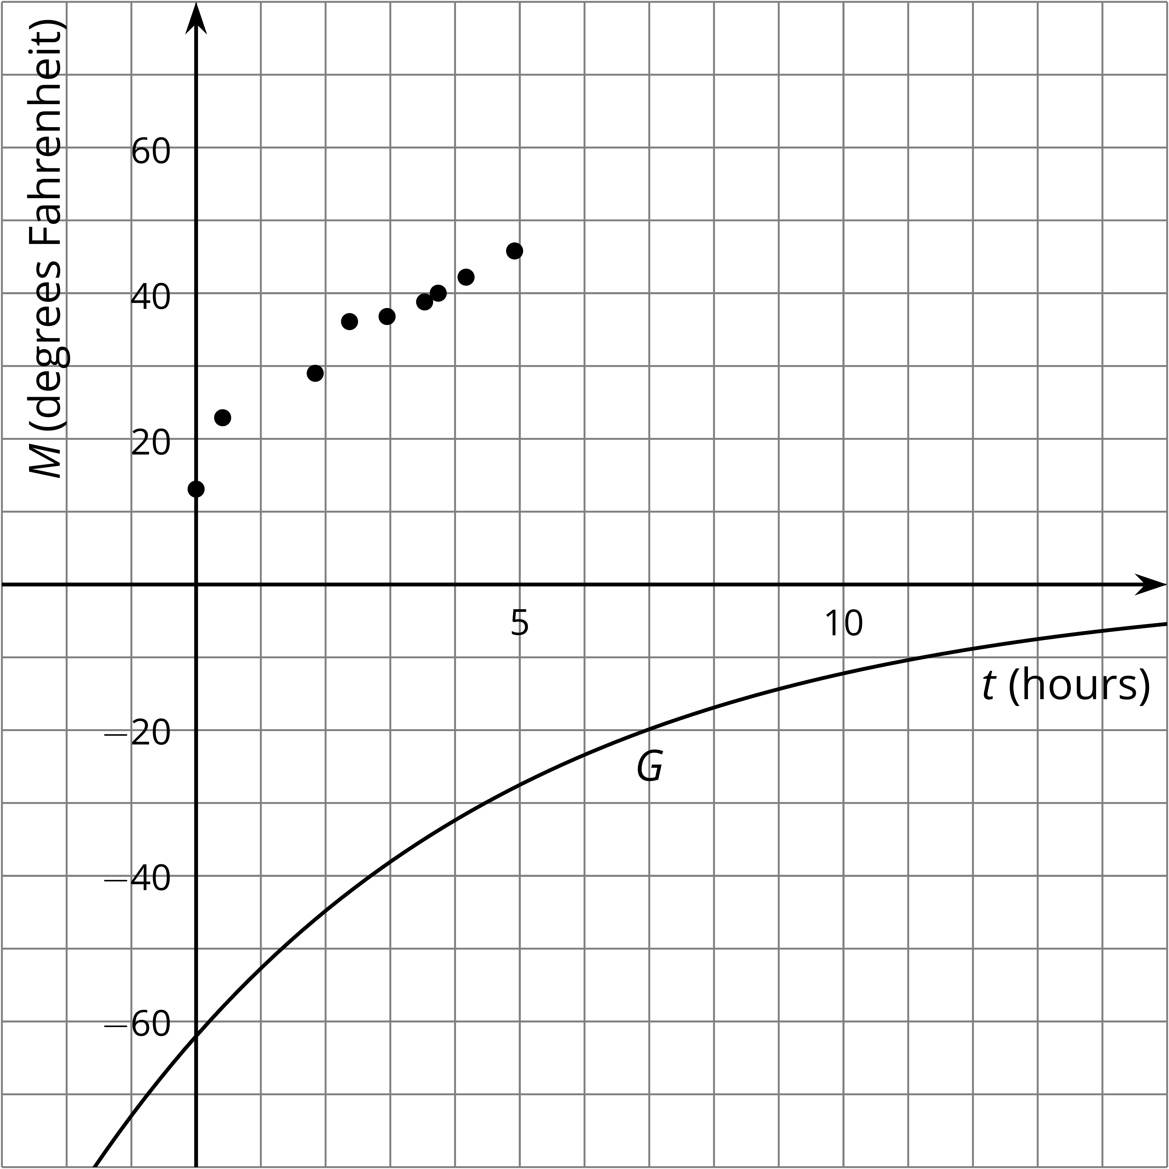
Jada thinks changing the equation to $J(t)=\text{-}62(0.85)^{t}+75.1$ makes a good model for the data. Noah thinks $N(t)=\text{-}62(0.85)^{(t+1)}+68$ is better.
- Without graphing, describe how Jada and Noah each transformed the graph of $G$ to make their new functions to fit the data.
- Use technology to graph the data, $J$ and $N$, on the same axes.
- Whose function do you think best fits the data? Be prepared to explain your reasoning.

Are you ready for more?
Elena excludes the first data point and chooses a linear model, $E(t)=21.32+5.06t$, to fit the remaining data.
- How well does Elena’s model fit the data?
- Is Elena’s idea to exclude the first data point a good one? Explain your reasoning.

Lesson 3 Summary
Remember the pumpkin catapult? The function $h$ gives the height $h(t)$, in feet, of the pumpkin above the ground $t$ seconds after launch. Now suppose $k$ represents the height $k(t)$, in feet, of the pumpkin if it were launched 5 seconds later. If we graph $k$ and $h$ on the same axes they looks identical, but the graph of $k$ is translated 5 units to the right of the graph of $g$.
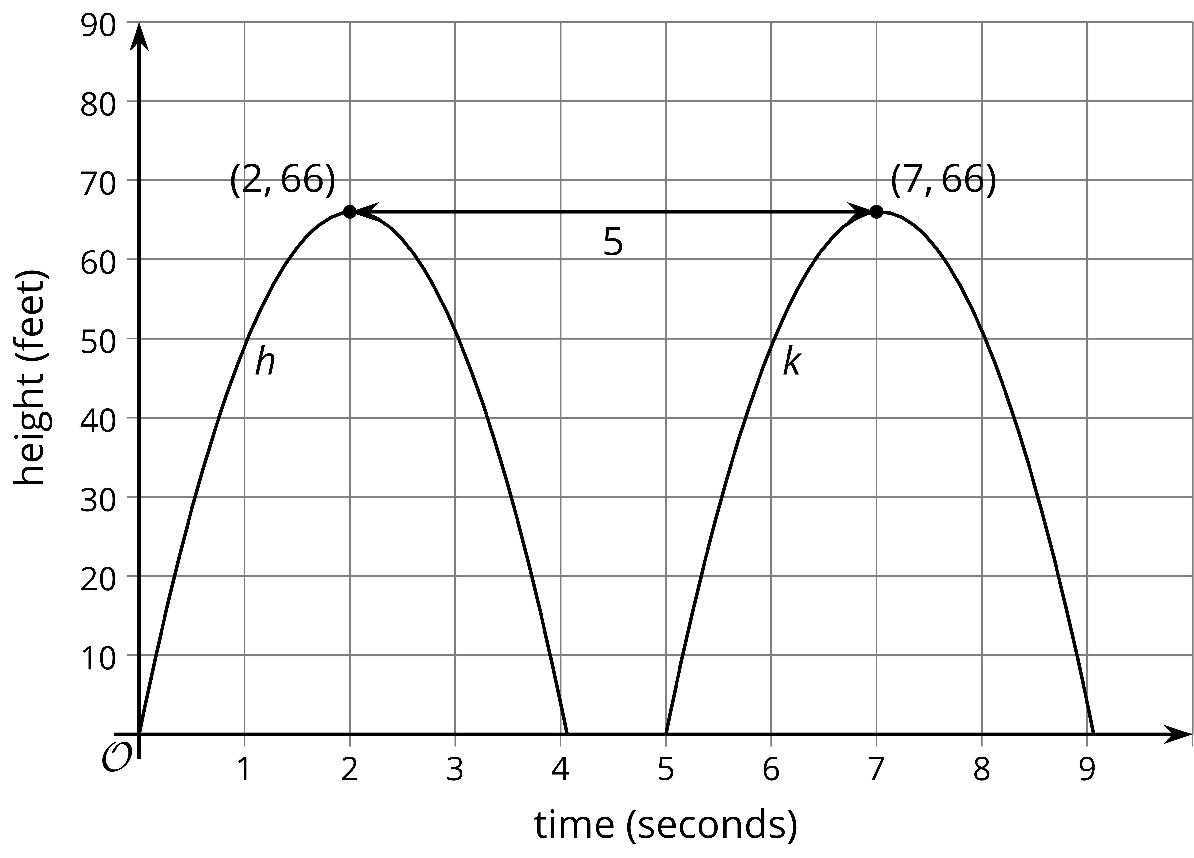
Since we know the pumpkin's height $k(t)$ at time $t$ is the same as the height $h(t)$ of the original pumpkin at time $t−5$, we can write $k$ in terms of $h$ as $k(t)=h(t−5)$.
Suppose there was a third function, $j$, where $j(t)=h(t+4)$. Even without graphing $j$, we know that the graph reaches a maximum height of 66 feet. To evaluate $j(t)$ we evaluate $h$ at the input $t+4$, which is zero when $t=\text{-}4$. So the graph of $j$ is translated 4 seconds to the left of the graph of $h$. This means that $j(t)$ is the height, in feet, of a pumpkin launched from the catapult 4 seconds earlier.
© CC BY 2019 by Illustrative Mathematics

