Unit 4 Lesson 3 Cumulative Practice Problems
- In this hanger, the weight of the triangle is $x$ and the weight of the square is $y$.
- 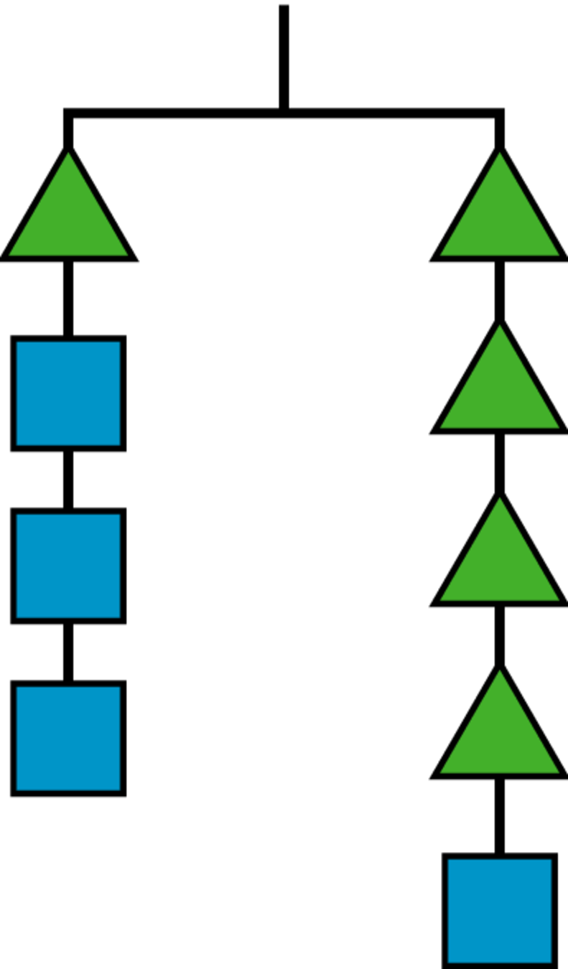
  - Write an equation using $x$ and $y$ to represent the hanger.
  - If $x$ is 6, what is $y$?
- Andre and Diego were each trying to solve $2x+6=3x−8$. Describe the first step they each make to the equation.
  - The result of Andre’s first step was $\text{-}x+6=\text{-}8$.

  - The result of Diego’s first step was $6=x−8$.
  - Complete the table with values for $x$ or $y$ that make this equation true: $3x+y=15$.
- $x$ | - 2 |  | - 6 | - 0 | - 3
- $y$ |  | - 3 |  |  |  | - 0 | - 8
  - Create a graph, plot these points, and find the slope of the line that goes through them.​​​​
- (From Unit 3, Lesson 11.)
- Match each set of equations with the move that turned the first equation into the second.
  - $6x+9=4x−3$
$2x+9=\text{-}3$
  - $\text{-}4(5x−7)=\text{-}18$
$5x−7=4.5$
  - $8−10x=7+5x$
$4−10x=3+5x$
  - $\frac{\text{-}5x}{4}=4$
$5x=\text{-}16$
  - $12x+4=20x+24$
$3x+1=5x+6$
  - Multiply both sides by $\frac{\text{-}1}{4}$
  - Multiply both sides by $\text{-}4$
  - Multiply both sides by $\frac{1}{4}$
  - Add $\text{-}4x$ to both sides
  - Add $\text{-}4$ to both sides
- Select all the situations for which only zero or positive solutions make sense.
  - Measuring temperature in degrees Celsius at an Arctic outpost each day in January.
  - The height of a candle as it burns over an hour.
  - The elevation above sea level of a hiker descending into a canyon.
  - The number of students remaining in school after 6:00 p.m.
  - A bank account balance over a year.
  - The temperature in degrees Fahrenheit of an oven used on a hot summer day.
- (From Unit 3, Lesson 14.)
© CC BY Open Up Resources. Adaptations CC BY IM.

