Lesson 25: Divide Decimals by Decimals
- Let’s divide decimals by decimals.

Warm-up: Number Talk: Same/Different
Find the value of each expression mentally.
- $20÷2$
- $2÷0.2$
- $50÷2$
- $5÷0.2$

25.1: Dividing by a Tenth and a Hundredth
- To find the value of $1.6÷0.1$, Jada drew this diagram.
  - Describe how the diagram shows 1.6.
  - 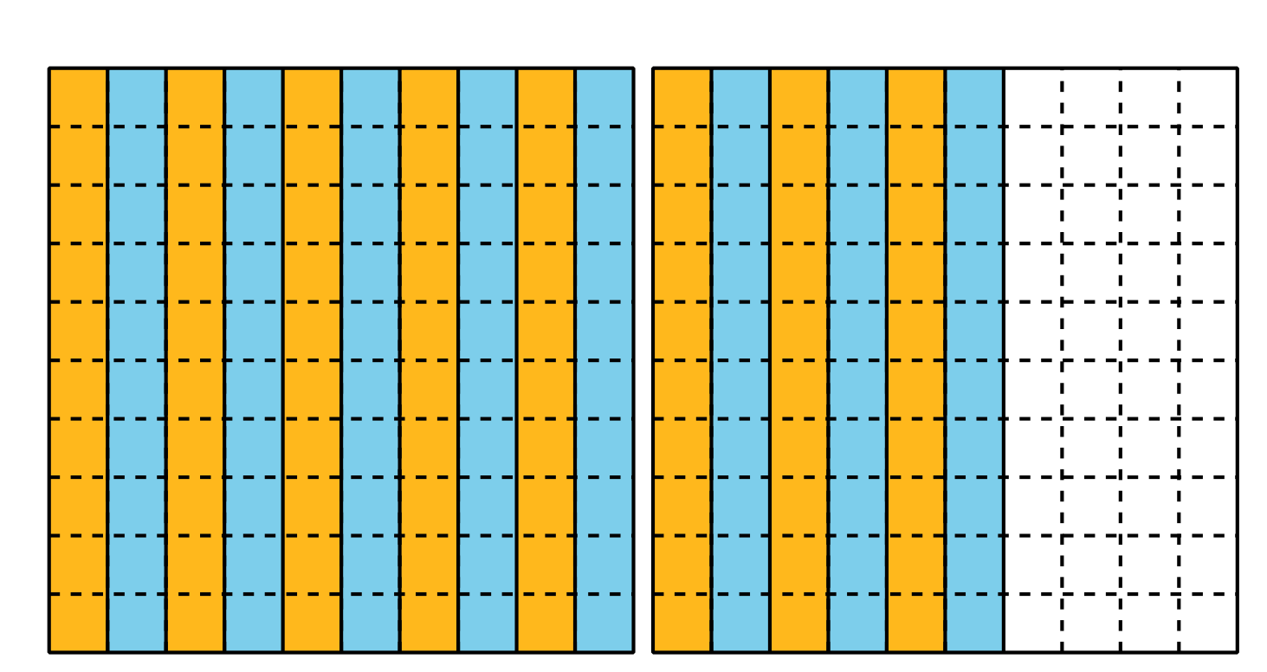
  - Describe how the diagram shows 16 groups of 1 tenth.
  - Describe how the diagram shows the value of $1.6÷0.1$.
  - Describe how the diagram also represents the expression $160÷10$.
- Explain how this diagram represents $1.3÷0.01$.
- 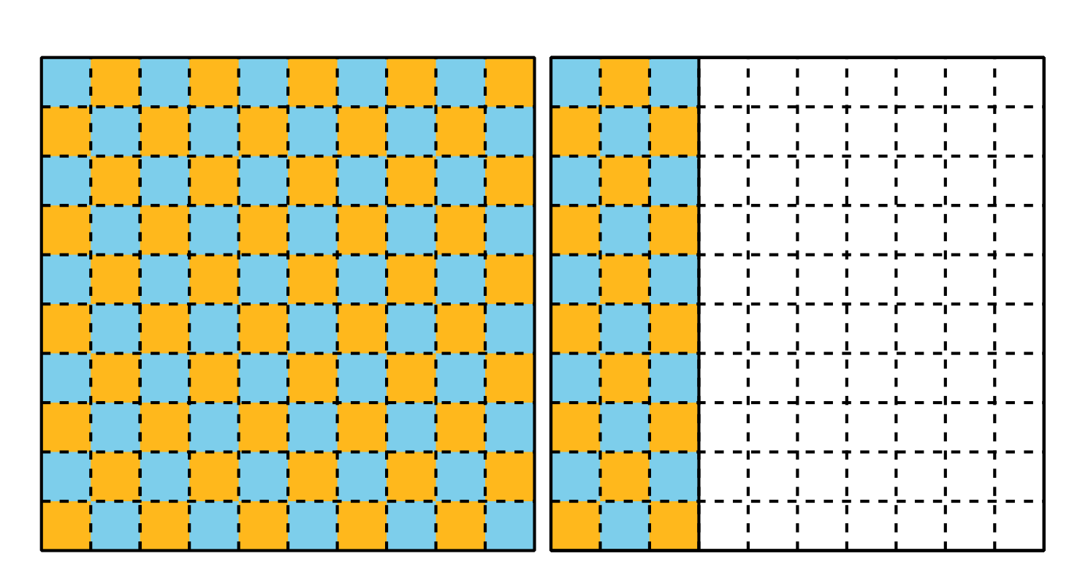
  - What is the value of $1.3÷0.01$? Explain or show your reasoning.

25.2: Divide Decimals by Decimals
Find the value of each expression. Explain or show your reasoning.
- $5÷0.1$
- $5÷0.01$
- $0.5÷0.1$
- $0.5÷0.01$
- $0.02÷0.01$
- $1.53÷0.01$

Section Summary
Section Summary
In this section we learned to divide with decimals. We studied different ways to find a quotient like $3÷0.1$. We can draw a diagram which shows that there are 10 groups of 0.1 in each whole so there are $3×10$ or 30 groups of 0.1 in 3 wholes: $3÷0.1=30$.
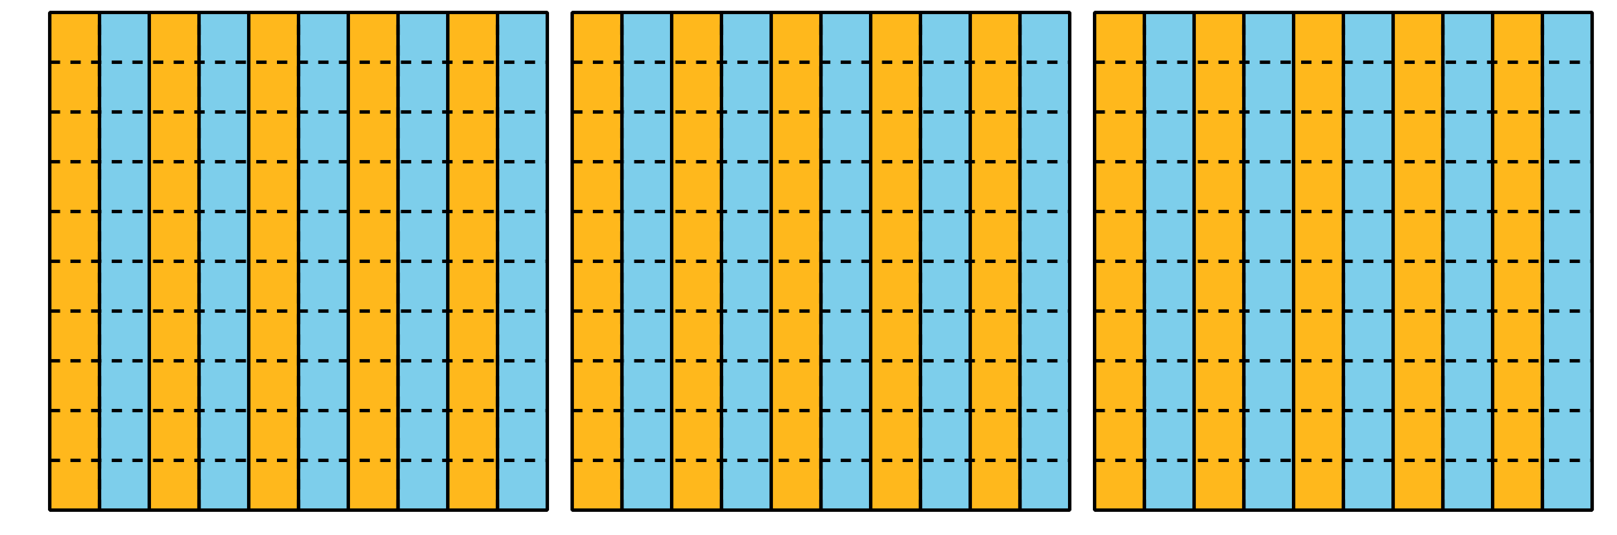
We can also think about place value. We know 3 is 30 tenths and 0.1 is 1 tenth, so $3÷0.1$ is equivalent to $30÷1$ which has the value 30. We also can use multiplication to find the value of $3÷0.1$. We know that $10×0.1=1$ and $30×0.1=3$ so this also shows that $3÷0.1=30$.
© CC BY 2021 Illustrative Mathematics®

