Unit 7 Lesson 13: Perimeter and Area of Rectangles

WU Estimation Exploration: Window Washing (Warm up)

Student Task Statement
What is the area of one window?
Record an estimate that is:
too low | about right | too high

1 Rectangle Perimeters

Student Task Statement
length (cm) | width (cm)
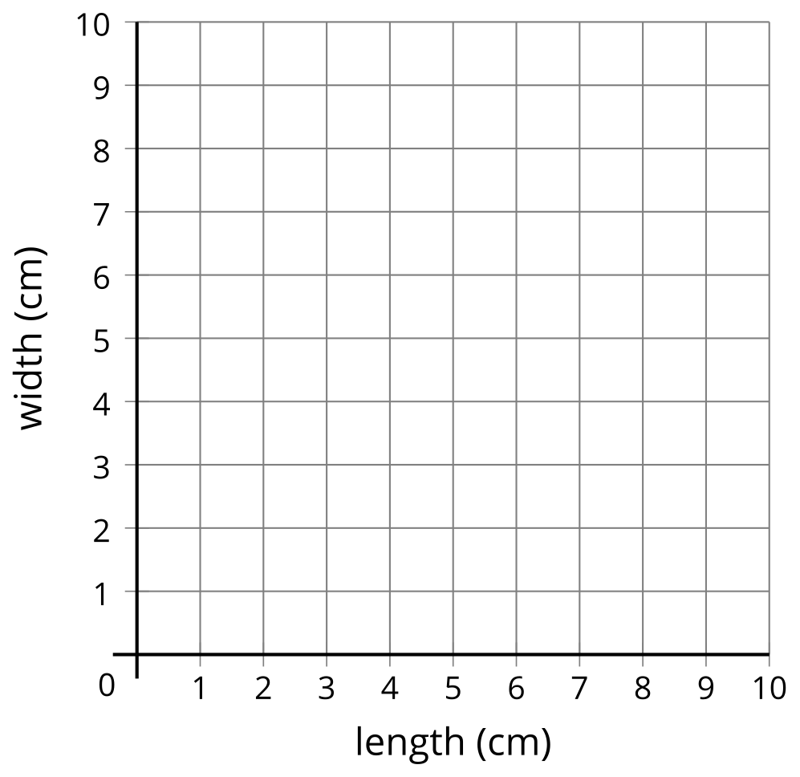
- Jada drew a rectangle with a perimeter of 12 centimeters. What could the length and width of Jada’s rectangle be? Use the table to record your answer.
- Plot the length and width of each rectangle on the coordinate grid.
- If Jada drew a square, how long and wide was it?
- If Jada’s rectangle was 2.5 cm long, how wide was it? Plot this point on the coordinate grid.
- If Jada’s rectangle was 3.25 cm long, how wide was it? Plot this point on the coordinate grid.

2 Rectangle Areas

Student Task Statement
length (cm) | width (cm)
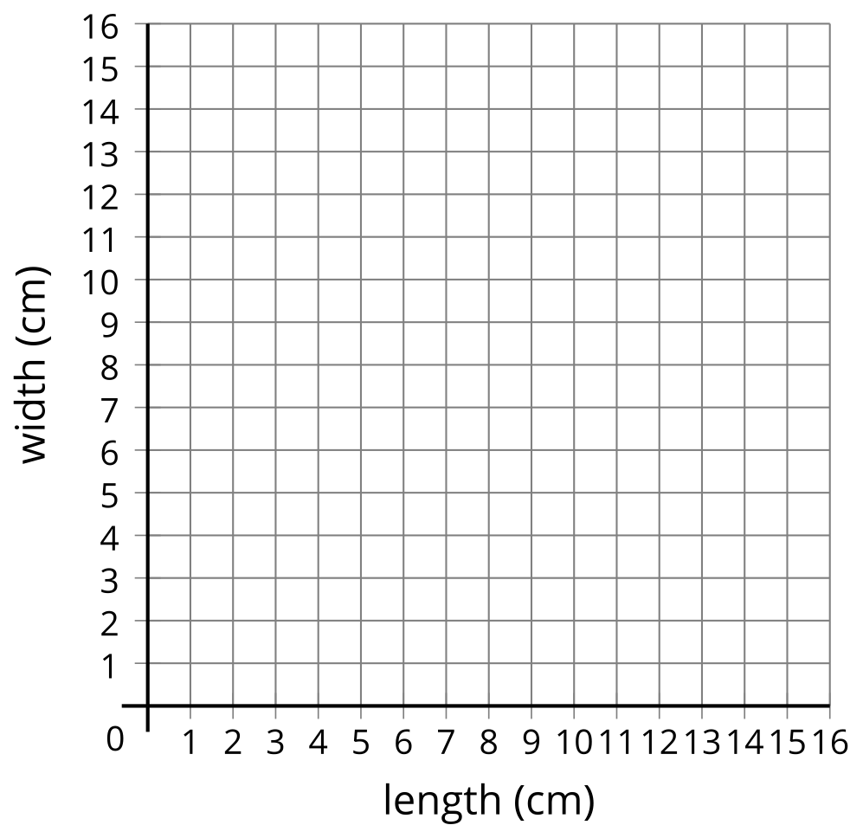
- Jada drew a rectangle with area 16 square centimeters. What could the length and width of Jada’s rectangle be? Use the table to record your answer.
- Plot the length and width of each rectangle on the coordinate grid.
- If Jada’s rectangle was 5 cm long, how wide was it? Plot this point on the coordinate grid.
- If Jada’s rectangle was 3 cm long, how wide was it? Plot this point on the coordinate grid.
- If Jada drew a square, how long and wide was it? Explain how you know.
© CC BY 2021 Illustrative Mathematics®

