Lesson 1: One Piece of One Part

Standards Alignments
Addressing | 5.NF.B.4.a
Building Towards | 5.NF.B.4, 5.NF.B.4.a

Teacher-facing Learning Goals
- Represent and interpret a unit fraction of a unit fraction in ways that make sense to them.

Student-facing Learning Goals
- Let’s solve problems about unit fractions.

Lesson Purpose
The purpose of this lesson is for students to interpret and represent a unit fraction of a unit fraction with diagrams.
In the previous unit, students found the product of a whole number and a fraction or mixed number, using tape diagrams and area diagrams. This unit continues that work to include products of two fractions. The goal of this lesson is for students to investigate fractions of fractional quantities in context. The focus is on interpreting representations in terms of the context (MP2). In later lessons, students will see that the diagrams can be represented by multiplication or division expressions.
In the first activity, students draw and explain their own representation of a situation involving macaroni and cheese. Students’ representations may differ so the discussion focuses on how their diagrams represent the situation. The second activity focuses on area diagrams like students worked with at the end of the previous unit. This lesson prepares students to relate diagrams to expressions in the next lesson.

Access for:

Students with Disabilities
- Action and Expression (Activity 1)

English Learners
- MLR2 (Activity 1)

Instructional Routines
5 Practices (Activity 1), Notice and Wonder (Warm-up)

Lesson Timeline
Warm-up | 10 min
Activity 1 | 20 min
Activity 2 | 15 min
Lesson Synthesis | 10 min
Cool-down | 5 min

Teacher Reflection Question
Which students had opportunities to share their diagrams and thinking during whole-class discussion? How did you select these students?

Cool-down
(to be completed at the end of the lesson) 5min
Macaroni and Cheese

Standards Alignments
Addressing | 5.NF.B.4.a

Student-facing Task Statement
- A pan of macaroni and cheese is $\frac{1}{2}$ full. Mai eats $\frac{1}{5}$ of the remaining macaroni and cheese in the pan.
  - Draw a diagram to represent the situation.
  - How much of the whole pan did Mai eat? Explain or show your reasoning.

Student Responses

  - Sample response:
  - 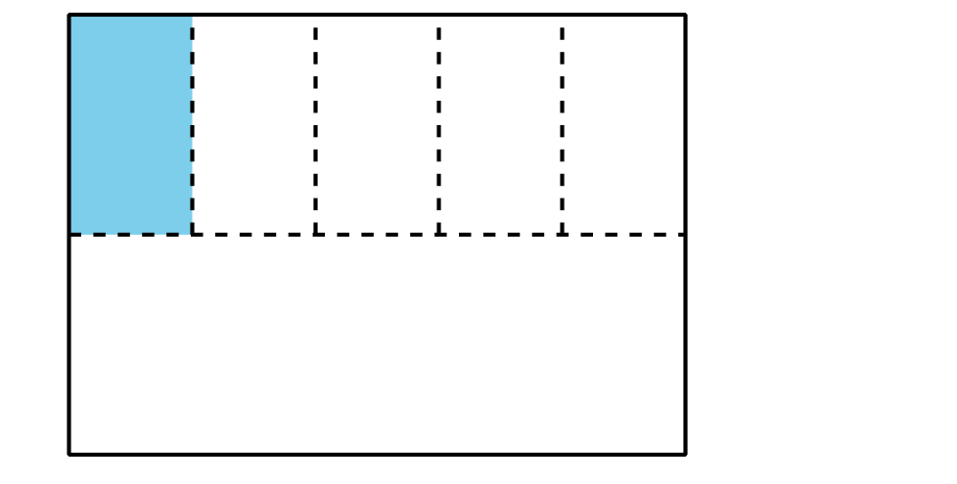
  - Mai ate $\frac{1}{10}$ of the whole pan. Students may refer to the diagram they drew.

