Lesson 10: Represent Data Using Picture Graphs and Bar Graphs

Standards Alignments
Addressing | 2.MD.D.10

Teacher-facing Learning Goals
- Explain how picture graphs, bar graphs, and tables represent the same data.
- Represent data using a picture graph and a bar graph.

Student-facing Learning Goals
- Let’s make our own picture graphs and bar graphs.

Lesson Purpose
The purpose of this lesson is for students to attend to the features of picture graphs and bar graphs as they represent a given set of categorical data in picture graphs and bar graphs.
In the first activity, students are introduced to the idea of using one symbol in a picture graph rather than a picture based on the category. They may find it easier and more efficient to use a symbol when drawing their graphs. In the second activity, students attend to the features of bar graphs as they draw a bar graph to represent a given set of categorical data. The work of this lesson connects to upcoming lessons as students move from a discrete representation of numbers with the picture graph to a continuous representation of numbers with the bar graph. From there, students use bar graphs to help them understand tape diagrams in later lessons.
Students use the graphs they create in this lesson in the following lesson.

Access for:

Students with Disabilities
- Engagement (Activity 2)

Instructional Routines
MLR8 Discussion Supports (Activity 1), Which One Doesn’t Belong? (Warm-up)

Materials to Gather
- Materials from a previous activity: Activity 2

Materials to Copy
- Data Tables (groups of 6): Activity 1
- Picture and Bar Graph Template (groups of 1): Activity 1
- Picture and Bar Graph Template (groups of 1): Activity 2

Lesson Timeline
Warm-up | 10 min
Activity 1 | 20 min
Activity 2 | 15 min
Lesson Synthesis | 10 min
Cool-down | 5 min

Teacher Reflection Question
What was the best question you asked students today? Why would you consider it the best one based on what students said or did?

Cool-down
(to be completed at the end of the lesson) 5min
Fruits We Love Graphs

Standards Alignments
Addressing | 2.MD.D.10

Student-facing Task Statement
Mr. Green asked the soccer team, “What fruits do you love to eat?”
Mai and Lin used the data he collected to make graphs.
Mai started a picture graph. Lin started a bar graph.
Complete each graph.
Mai's Graph
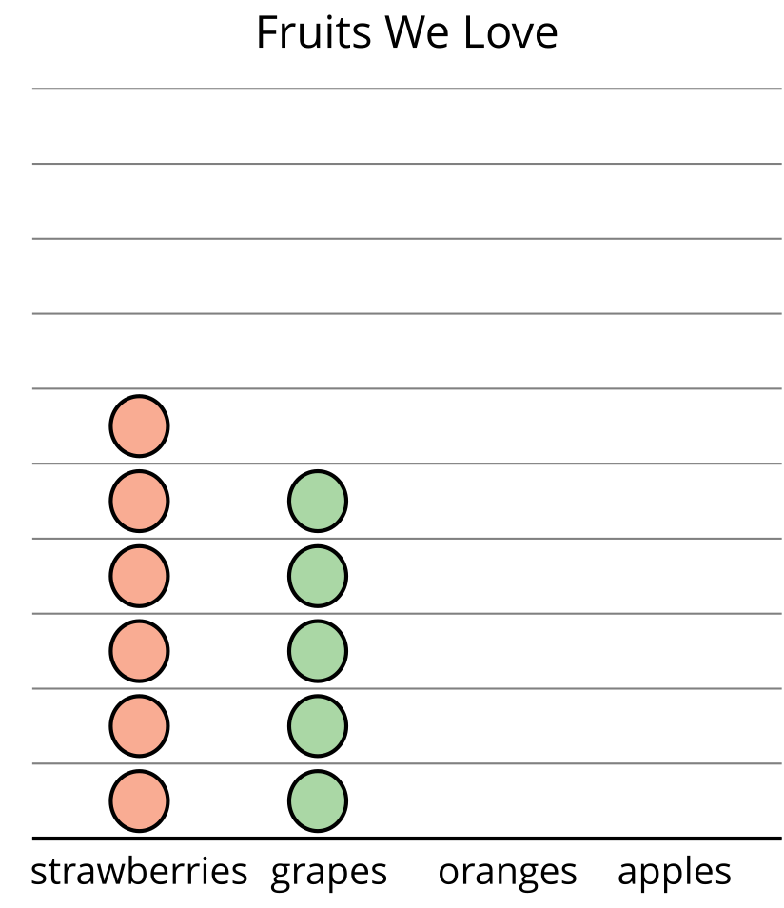
Lin's Graph
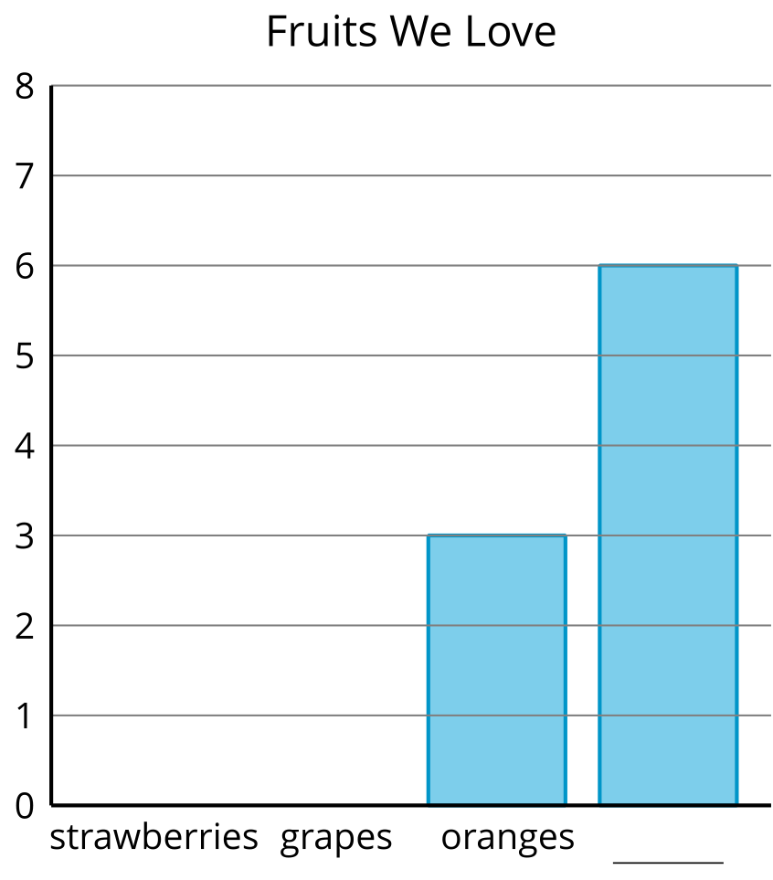

Student Responses
Students show 6 strawberries, 5 grapes, 3 oranges, and 6 apples in each graph.

