Unit 4 Lesson 20: Make Two-Digit Numbers in Different Ways

WU Estimation Exploration: Tens and Ones (Warm up)

Student Task Statement
- How many do you see?
- 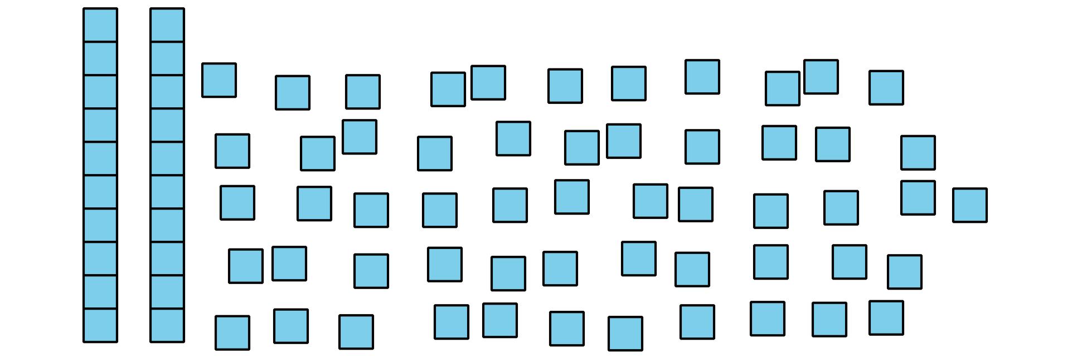
- Record an estimate that is:
- too low | - about right | - too high
- How many do you see?
- 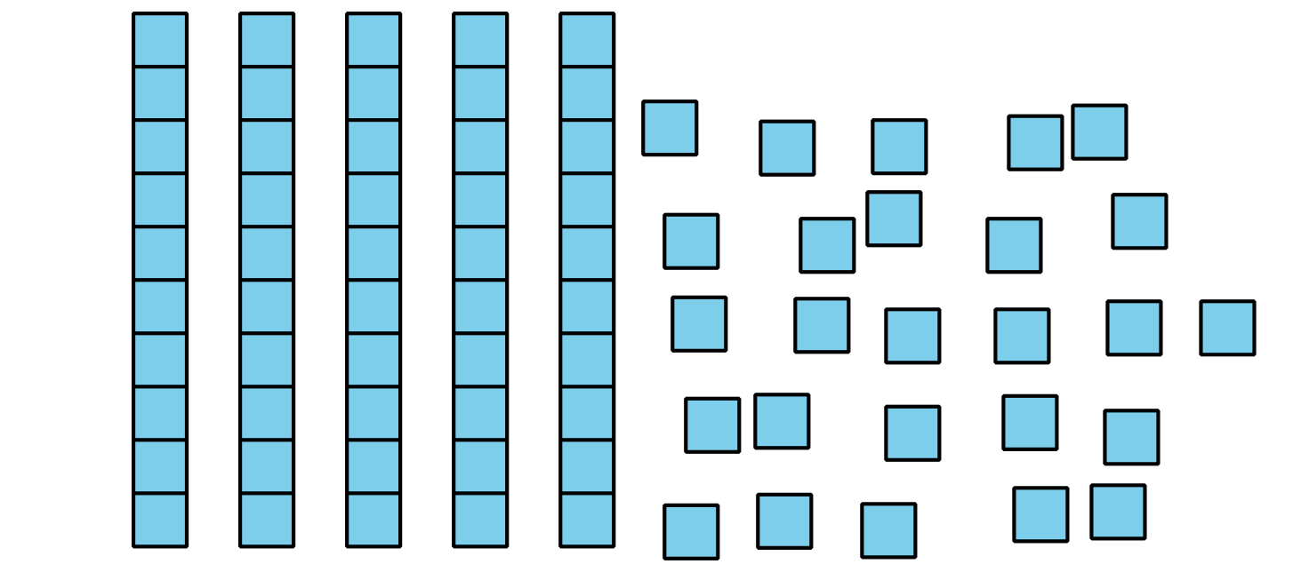
- Record an estimate that is:
- too low | - about right | - too high

1 All The Ways to Make 94

Student Task Statement
How many ways can you make 94 using tens and ones?
Show your thinking using drawings, numbers, or words.

2 Mystery Bags

Student Task Statement
- Bag A has 2 ones and 5 tens.
How many cubes are in Bag A?
Show your thinking using drawings, numbers, or words.
- Bag B has 4 tens and 25 ones.
How many cubes are in Bag B?
Show your thinking using drawings, numbers, or words.
- Bag C has 49 cubes.
If there are 29 ones, how many tens are in the bag?
Show your thinking using drawings, numbers, or words.
- Bag D has 36 cubes.
If there are only 2 tens, how many ones are in the bag?
Show your thinking using drawings, numbers, or words.
If you have time: Write a mystery bag problem about tens and ones.
Switch with your partner.
Solve.
© CC BY 2021 Illustrative Mathematics®

