Unit 6 Lesson 13: Situations Involving Equal-size Groups

WU Estimation Exploration: Lots of Paletas (Warm up)

Student Task Statement
How many paletas are in the case?
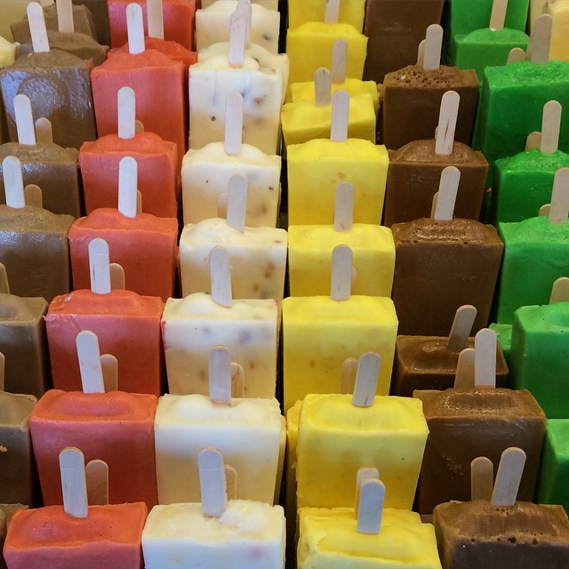
Record an estimate that is:
too low | about right | too high

1 Paletas for a Class Party

Student Task Statement
Diego’s aunt is buying paletas, which are ice pops, for a class party. At the local market, paletas come in different flavors. She buys the same number of paletas of each flavor.
- What mathematical questions can we ask about this situation?
- Here is an equation:
- $84÷7=?$
- In the situation about the class party, what questions could the equation represent?
- Find the answer to one of the questions you wrote. Show your reasoning.

2 More Snacks for a Class Party

Student Task Statement
- Priya’s mom made 85 gulab jamuns for the class to share. Priya gave 5 to each student in the class.
- How many students are in Priya’s class? Explain or show your reasoning.
- 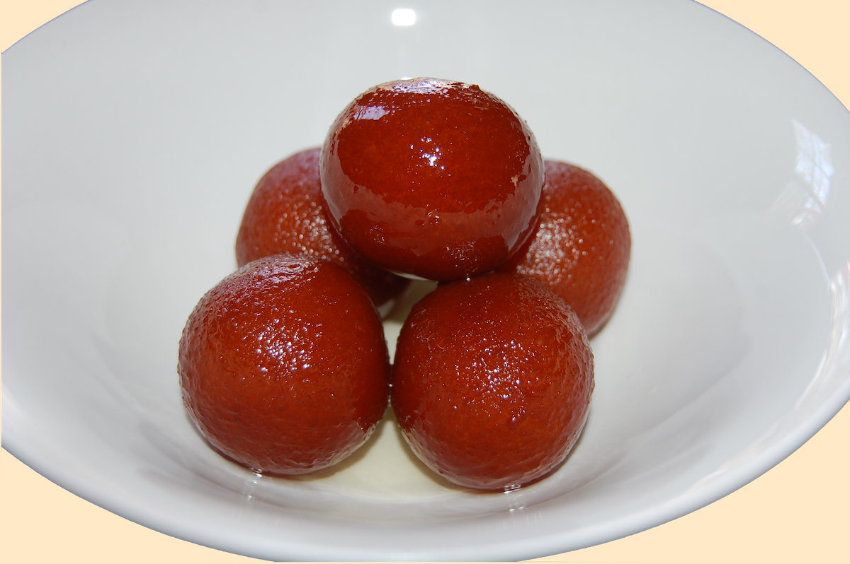
- Han’s uncle sent in 110 chocolate-covered breadsticks for a snack. The students in Han's class are seated at 6 tables. Han plans to give the same number of breadsticks to each table.
- How many breadsticks does each table get? Explain or show your reasoning.
- 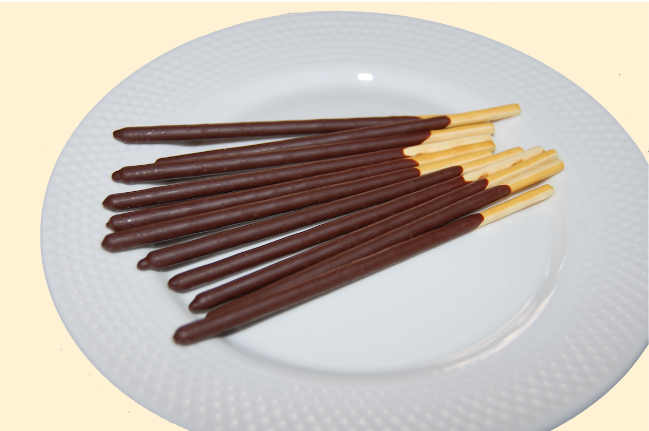
© CC BY 2021 Illustrative Mathematics®

