Unit 2 Lesson 6: Similarity

1 Equivalent Expressions (Warm up)

Student Task Statement
Use what you know about operations and their properties to write three expressions equivalent to the expression shown.
$10\left(2+3\right)−8⋅3$

2 Similarity Transformations (Part 1)

Images for Launch
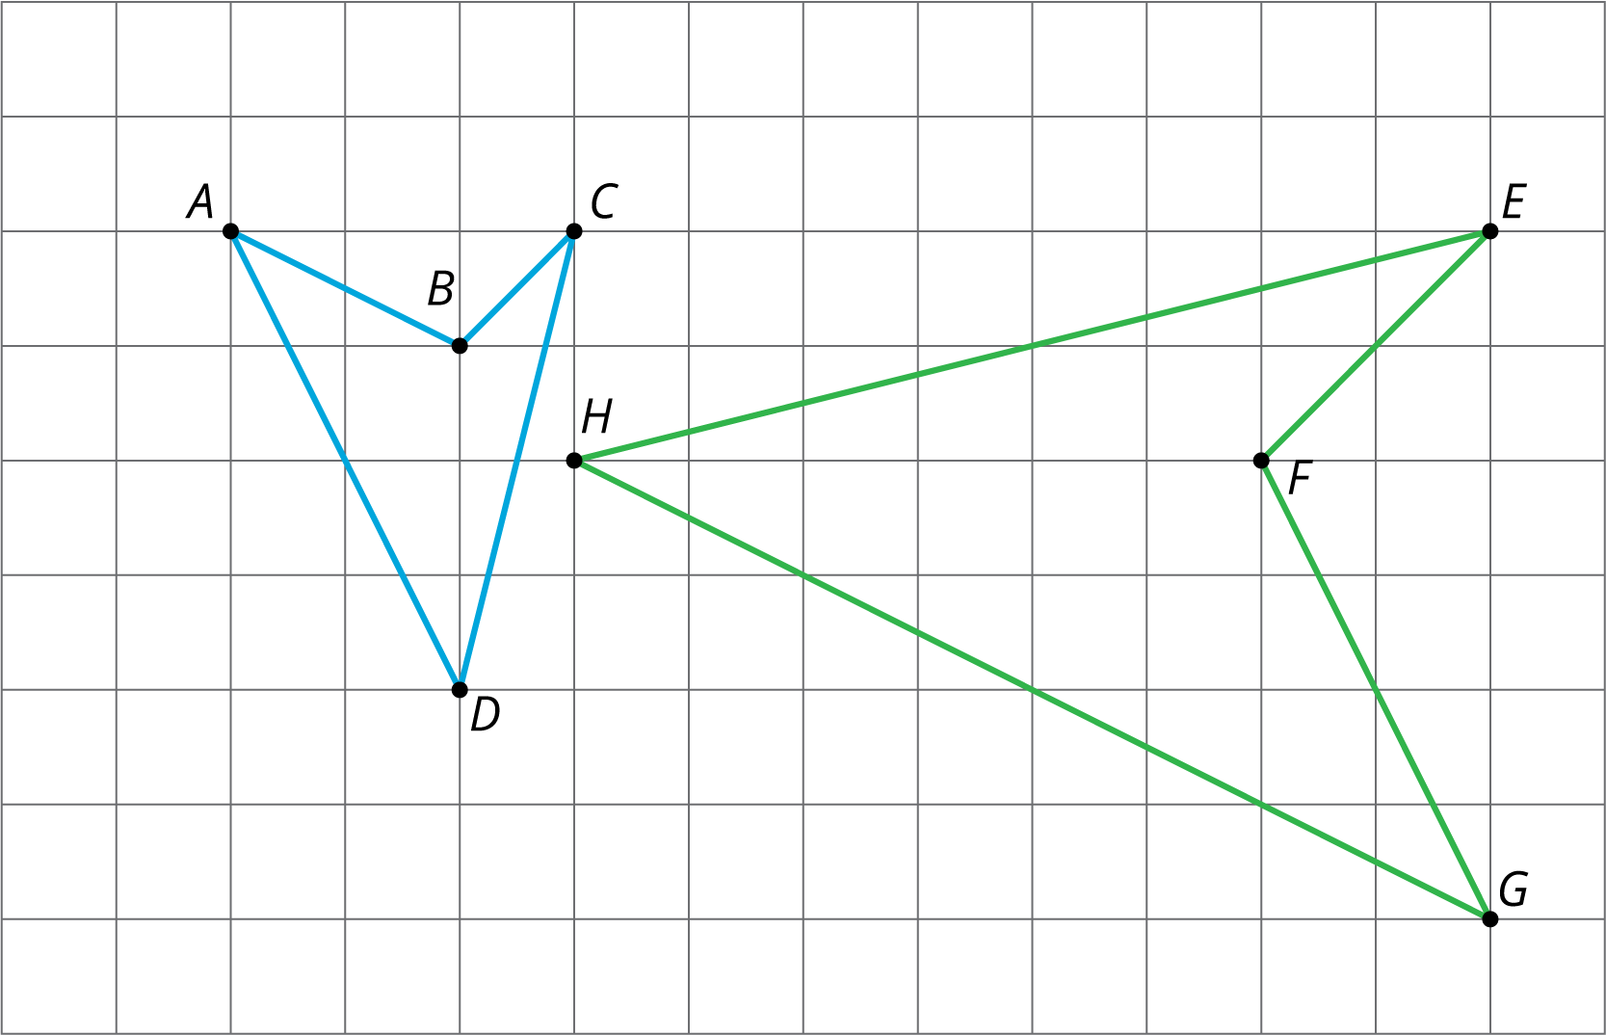

Student Task Statement
- Triangle $EGH$ and triangle $LME$ are similar. Find a sequence of translations, rotations, reflections, and dilations that shows this.
- 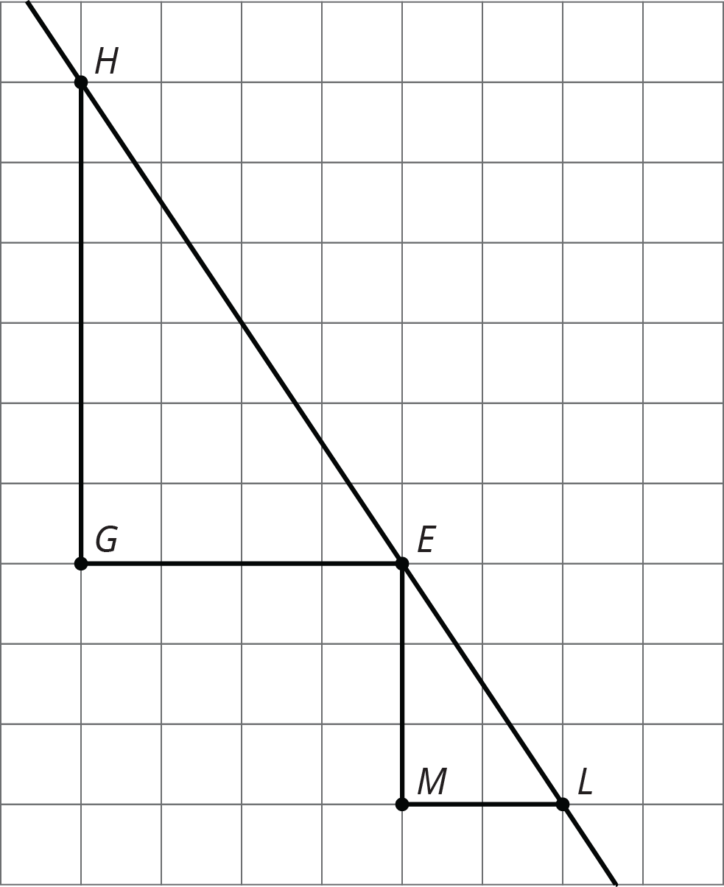
- Hexagon $ABCDEF$ and hexagon $HGLKJI$ are similar. Find a sequence of translations, rotations, reflections, and dilations that shows this.
- 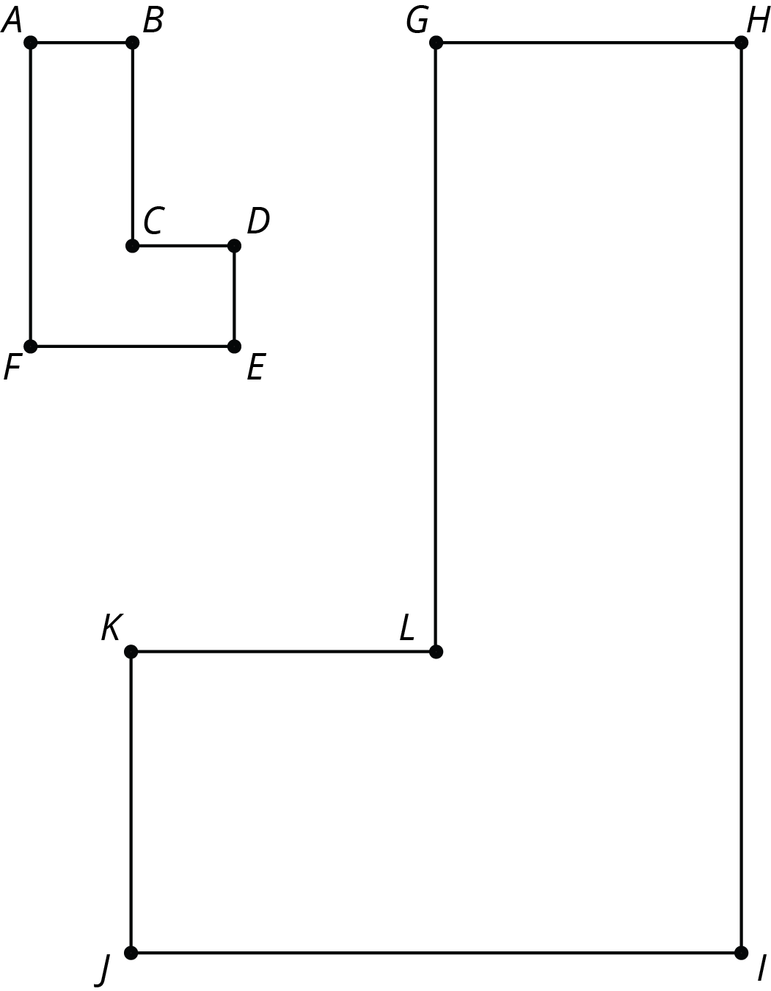

3 Similarity Transformations (Part 2)

Student Task Statement
Sketch figures similar to Figure A that use only the transformations listed to show similarity.
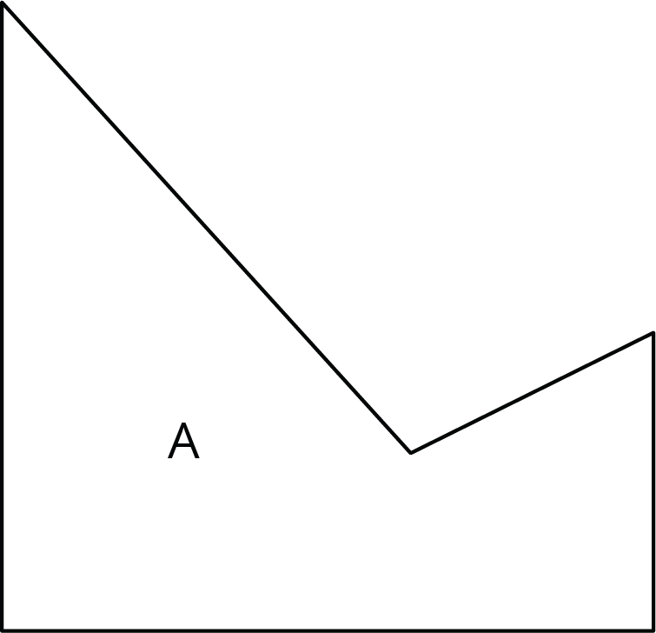

- A translation and a reflection. Label your sketch Figure B.
Pause here so your teacher can review your work.
- A reflection and a dilation with scale factor greater than 1. Label your sketch Figure C.
- A rotation and a reflection. Label your sketch Figure D.
- A dilation with scale factor less than 1 and a translation. Label your sketch Figure E.

4 Methods for Translations and Dilations (Optional)

Student Task Statement
Your teacher will give you a set of five cards and your partner a different set of five cards. Using only the cards you were given, find at least one way to show that triangle $ABC$ and triangle $DEF$ are similar. Compare your method with your partner’s method. What is the same about your methods? What is different?
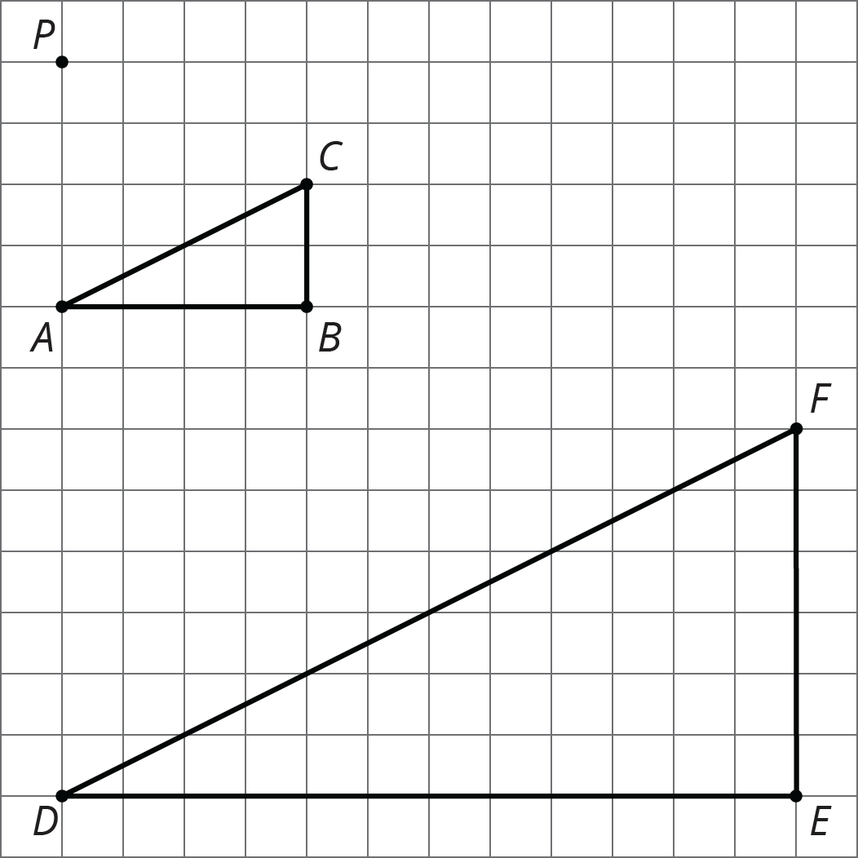

© CC BY Open Up Resources. Adaptations CC BY IM.

