Lesson 10 Practice Problems
- Estimate the side length of a square that has a 9 cm long diagonal.
- Select all quantities that are proportional to the diagonal length of a square.
  - Area of the square
  - Perimeter of the square
  - Side length of the square
- Diego made a graph of two quantities that he measured and said, “The points all lie on a line except one, which is a little bit above the line. This means that the quantities can’t be proportional.” Do you agree with Diego? Explain.
- The graph shows that while it was being filled, the amount of water in gallons in a swimming pool was approximately proportional to the time that has passed in minutes.
  - About how much water was in the pool after 25 minutes?
  - Approximately when were there 500 gallons of water in the pool?
  - Estimate the constant of proportionality for the gallons of water per minute going into the pool.
- 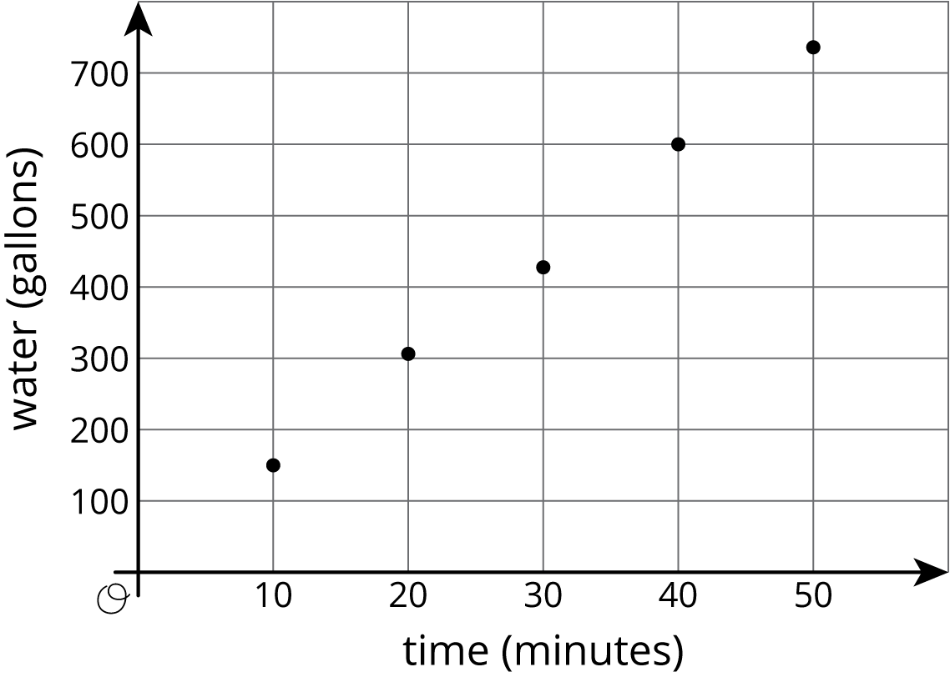
- ​​​​​​
© CC BY Open Up Resources. Adaptations CC BY IM.

