Unit 3 Lesson 13: Using Equations to Solve for Unknown Angles

1 Is This Enough? (Warm up)

Student Task Statement
Tyler thinks that this figure has enough information to figure out the values of $a$ and $b$.
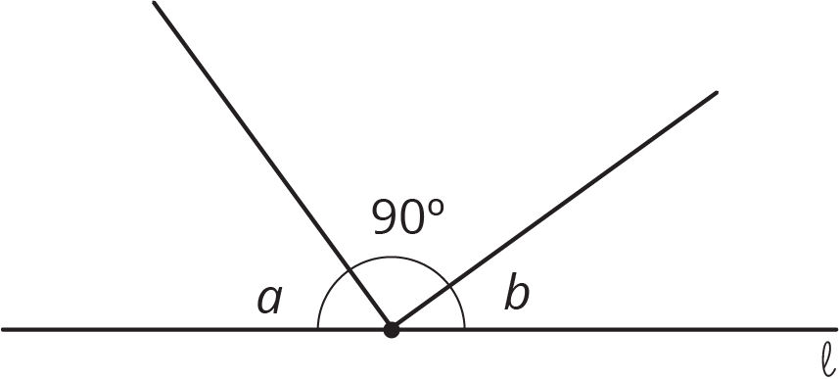
Do you agree? Explain your reasoning.

Activity Synthesis
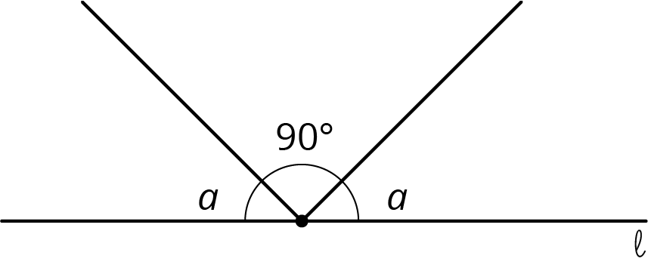

2 What Does It Look Like?

Student Task Statement
Elena and Diego each wrote equations to represent these diagrams. For each diagram, decide which equation you agree with, and solve it. You can assume that angles that look like right angles are indeed right angles.
- Elena: $x=35$
- Diego: $x+35=180$
- 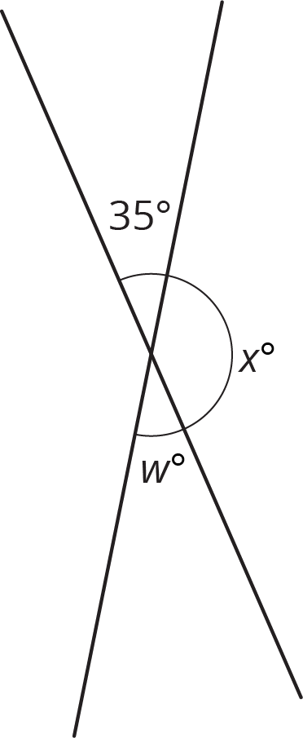
- Elena: $35+w+41=180$
- Diego: $w+35=180$
- 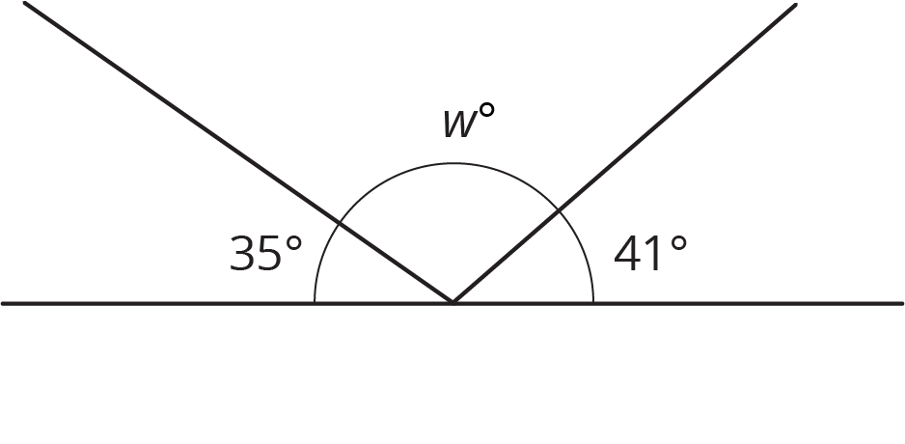
- Elena: $w+35=90$
- Diego: $2w+35=90$
- 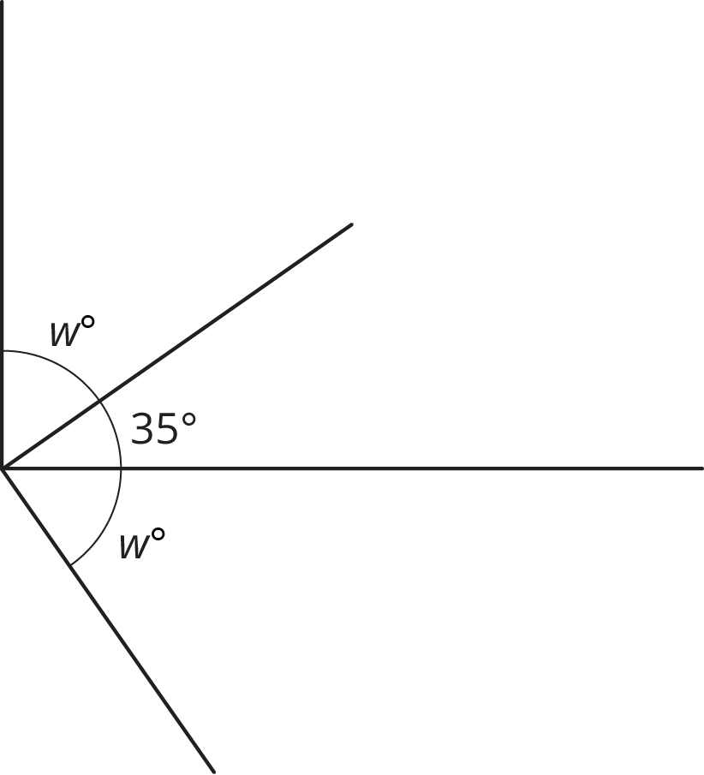
- Elena: $2w+35=90$
- Diego: $w+35=90$
- 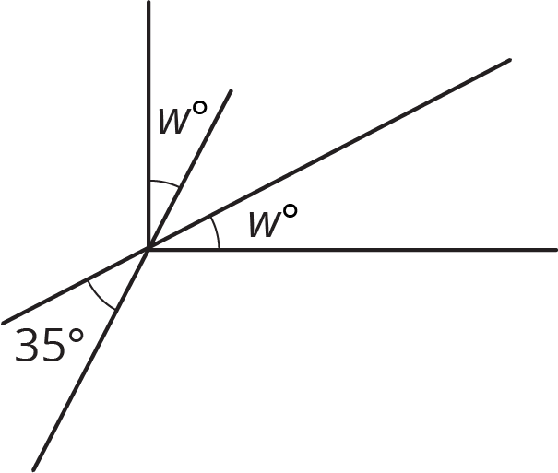
- Elena: $w+148=180$
- Diego: $x+90=148$
- 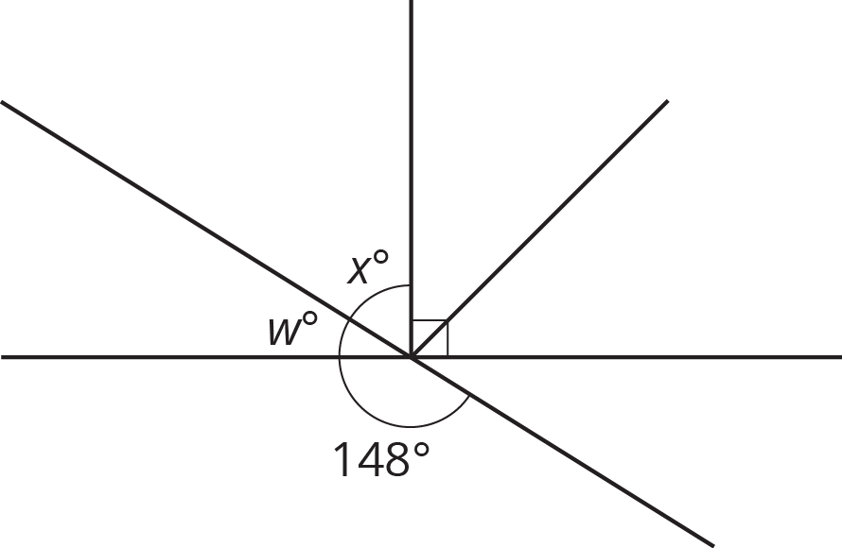

3 Calculate the Measure

Student Task Statement
Find the unknown angle measures. Show your thinking. Organize it so it can be followed by others.
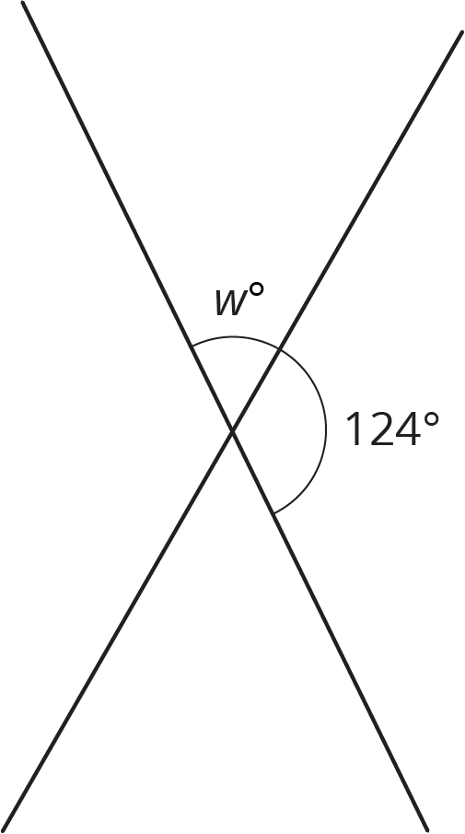
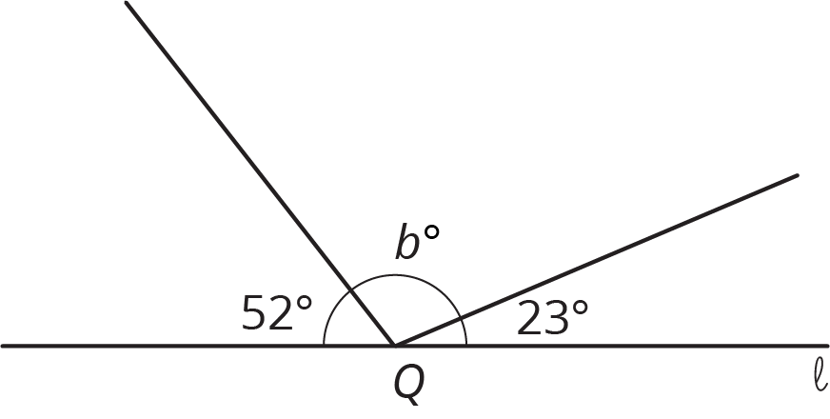

Lines $ℓ$ and $m$ are perpendicular.
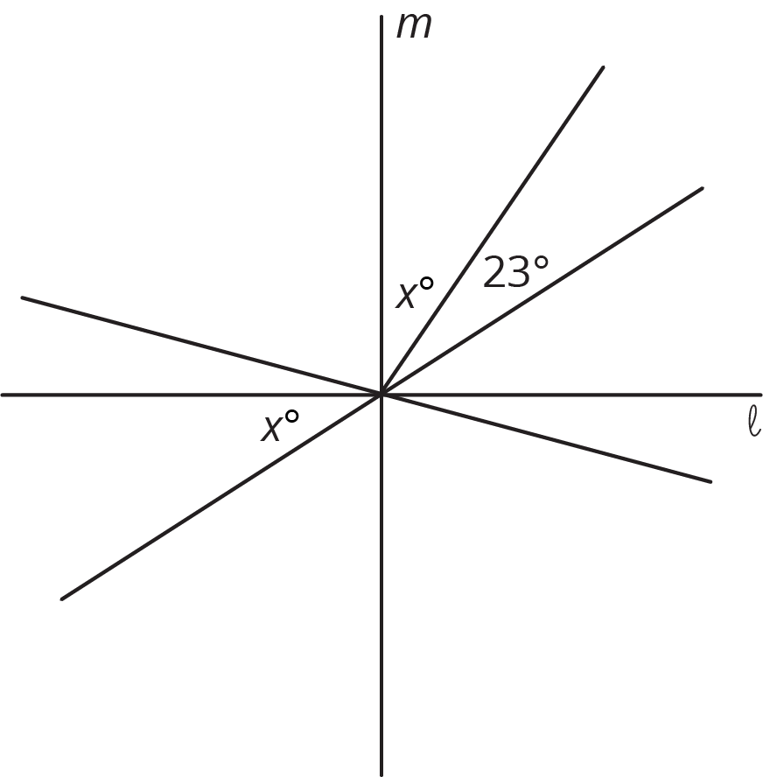
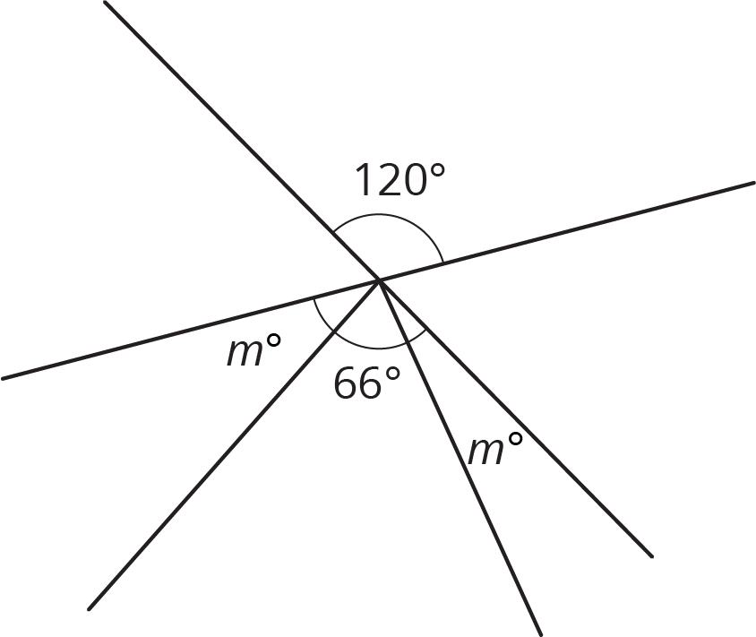

© CC BY Open Up Resources. Adaptations CC BY IM.

