Unit 5 Lesson 13: Building a Volume Formula for a Pyramid

1 Cover Your Bases (Warm up)

Student Task Statement
Two solids are shown.

A
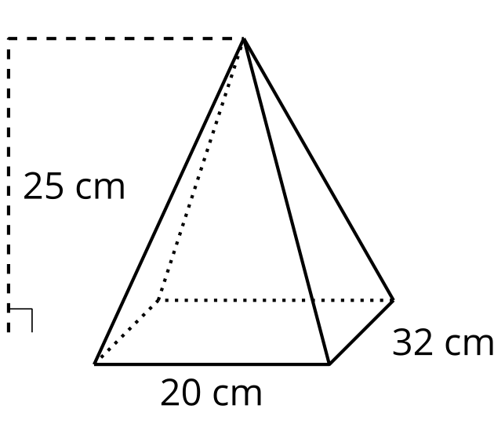

B
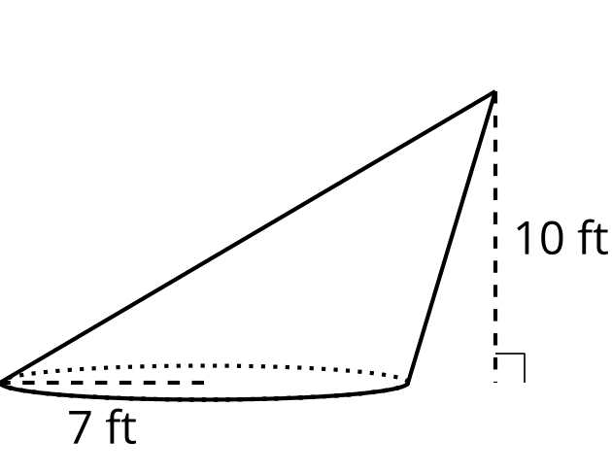
For each solid, draw and label a prism or cylinder that has a base congruent to the solid’s and a height equal to the solid’s.

2 Splitting a Prism into Pyramids

Student Task Statement
Here is a triangular prism.
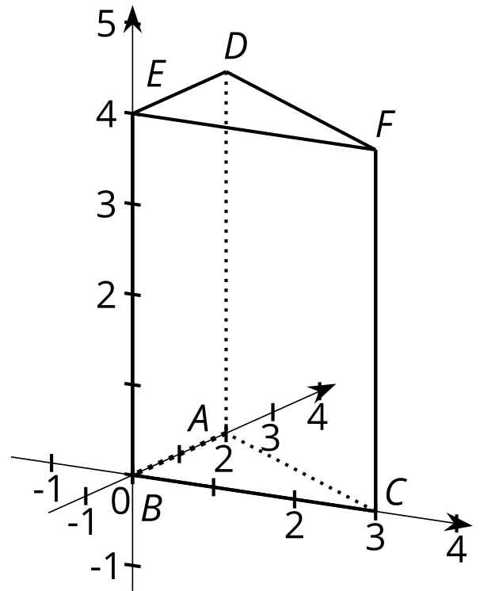
Suppose we split the prism into pyramids like the ones you built earlier. The first pyramid is split off by slicing through points $E$, $D$, and $C$. The remaining part of the prism is sliced through $B$, $C$, and $D$.

P1
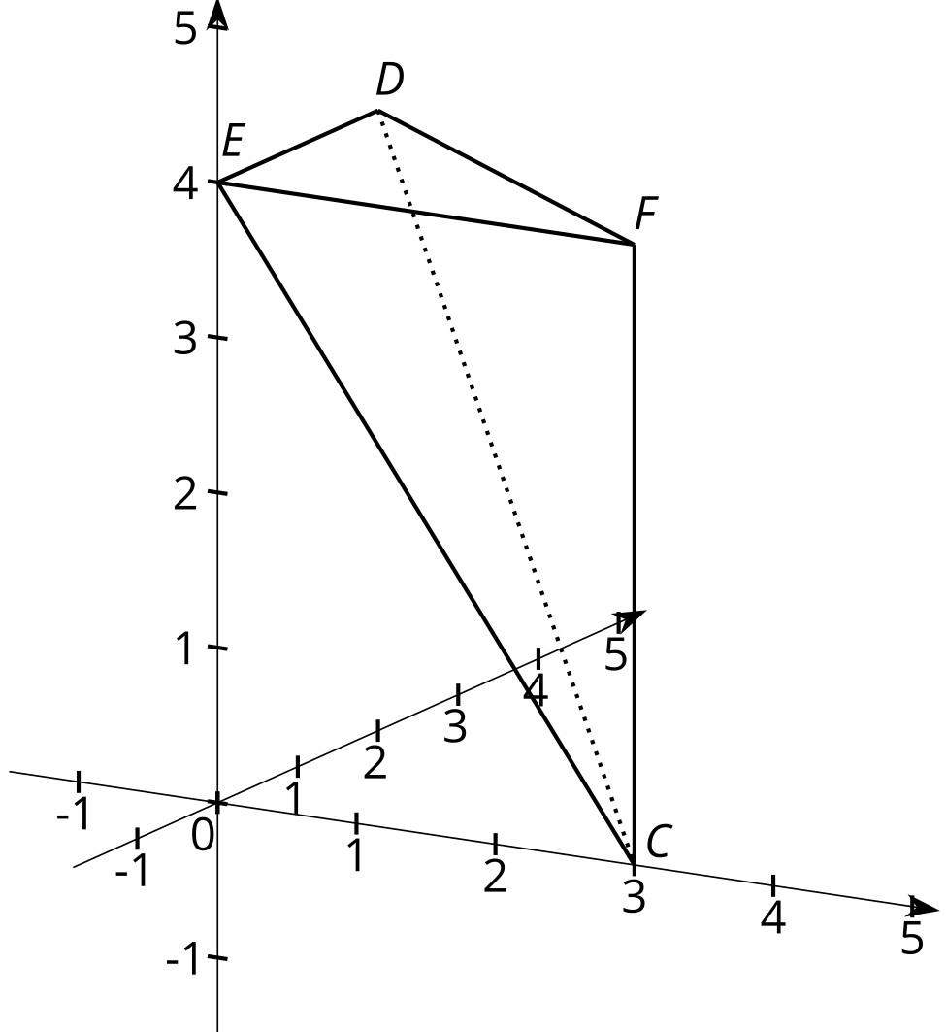

P2
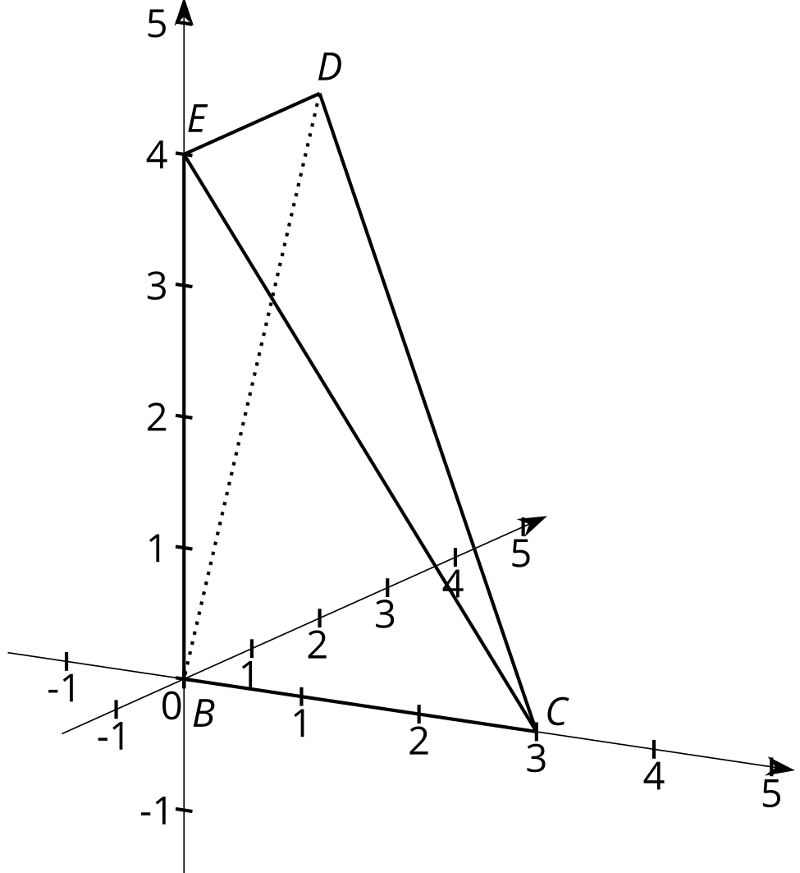

P3
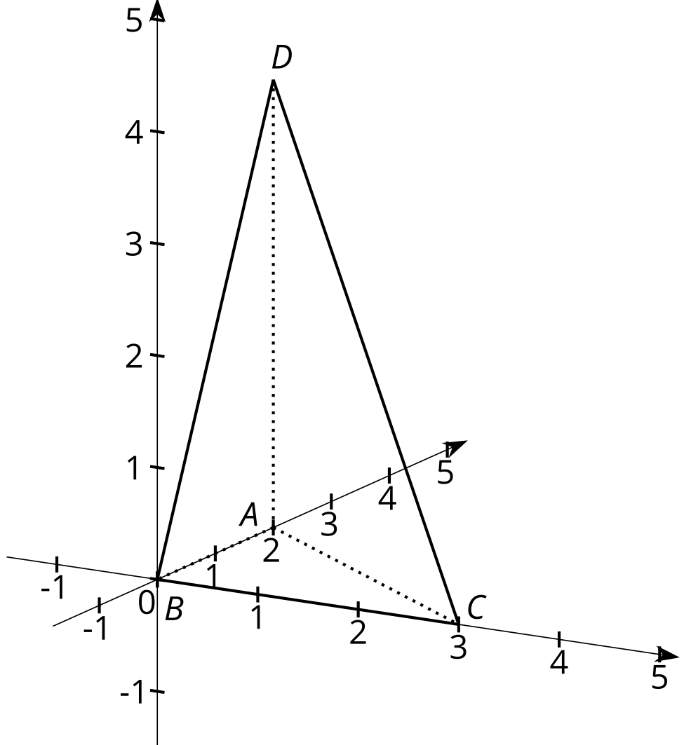
- Using the pyramids you built, compare pyramids P1 and P3.
  - Think of the faces marked P1 and P3 as the bases of the pyramids. These triangles are the two bases of the original prism. How do the areas of these two bases compare?
  - How do the heights of pyramids P1 and P3 compare? Explain your reasoning.
  - How do the volumes of pyramids P1 and P3 compare? Explain your reasoning.
- Using the pyramids you built, compare pyramids P2 and P3.
  - Think of the gray shaded triangles as the bases of the pyramids. These are formed by slicing one of the prism’s rectangular faces down its diagonal. How do the areas of these two bases compare?
  - The heights of pyramids P2 and P3 are equal because when assembled into the prism, the height lines coincide along the length of the prism. How, then, do the volumes of these pyramids compare? Explain your reasoning.
- Based on your answers, how does the volume of each pyramid compare to the volume of the prism?
- How could you use this information to find the volume of one of the pyramids?

Activity Synthesis
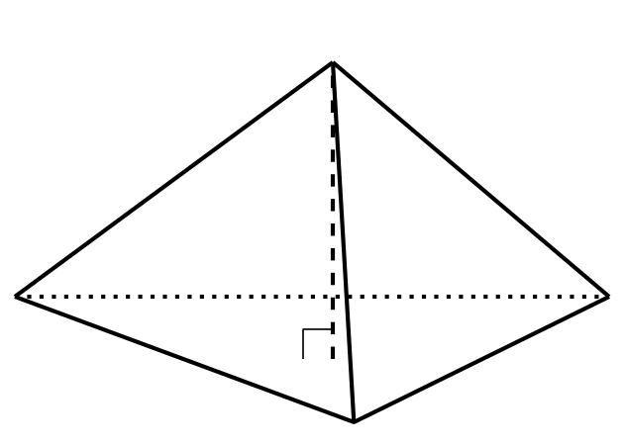

3 Comparing Cross Sections

Student Task Statement
Each solid in the image has height 6 units. The area of each solid’s base is 10 square units. A cross section has been created in each by dilating the base using the apex as a center with scale factor $k=0.5$.
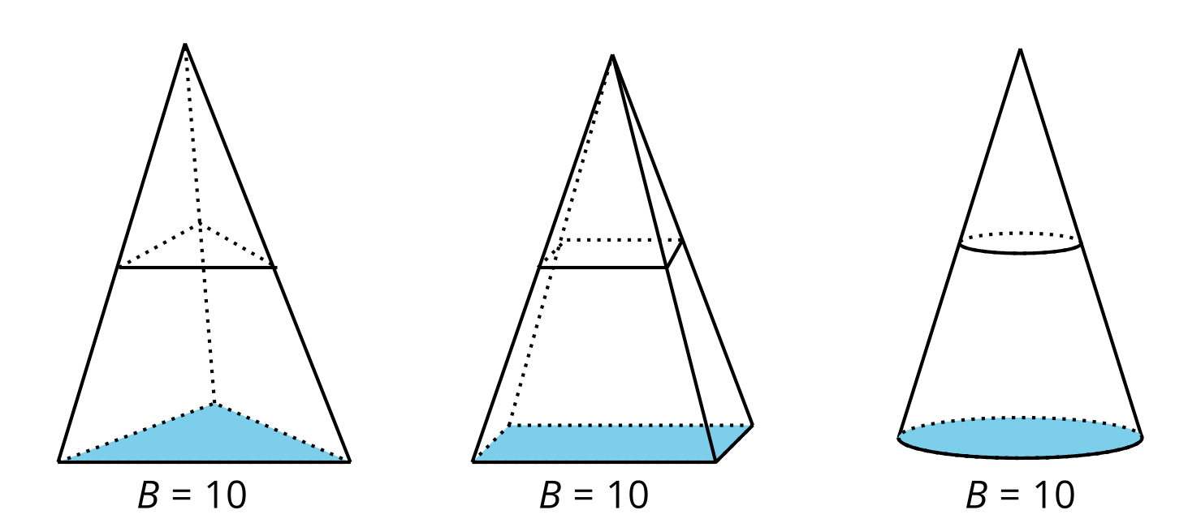
- Calculate the area of each of the 3 cross sections.
- Suppose a new cross section was created in each solid, all at the same height, using some scale factor $k$. How would the areas of these 3 cross sections compare? Explain your reasoning.
- What does this information about cross sections tell you about the volumes of the 3 solids?
- Calculate the volume of each of the solids.

Images for Activity Synthesis
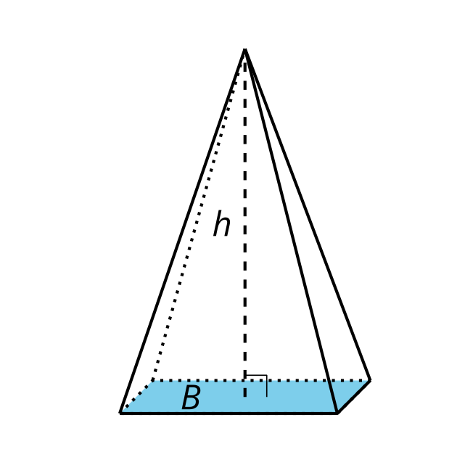
© CC BY 2019 by Illustrative Mathematics®

