Unit 1 Lesson 18 Cumulative Practice Problems
  - What is the volume of a cube with edge length 8 in?
  - What is the volume of a cube with edge length $\frac{1}{3}$ cm?
  - A cube has a volume of 8 ft³. What is its edge length?
  - What three-dimensional figure can be assembled from this net?
  - 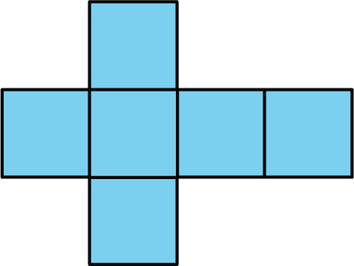
  - If each square has a side length of 61 cm, write an expression for the surface area and another for the volume of the figure.
  - Draw a net for a cube with edge length $x$ cm.
  - What is the surface area of this cube?
  - What is the volume of this cube?
- Here is a net for a rectangular prism that was not drawn accurately.
- 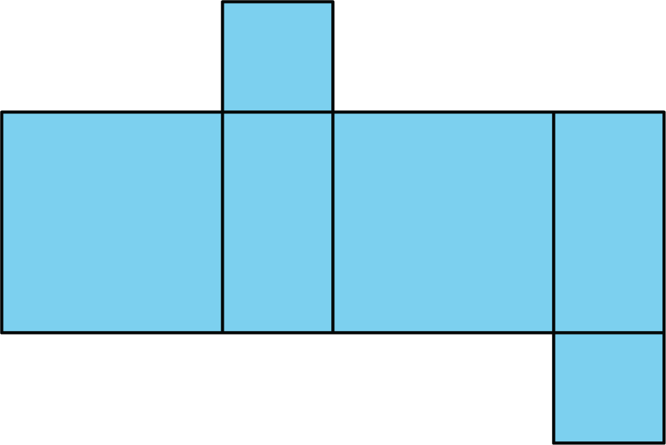
  - Explain what is wrong with the net.
  - Draw a net that can be assembled into a rectangular prism.
  - Create another net for the same prism.
- (From Unit 1, Lesson 14.)
- State whether each figure is a polyhedron. Explain how you know.
- 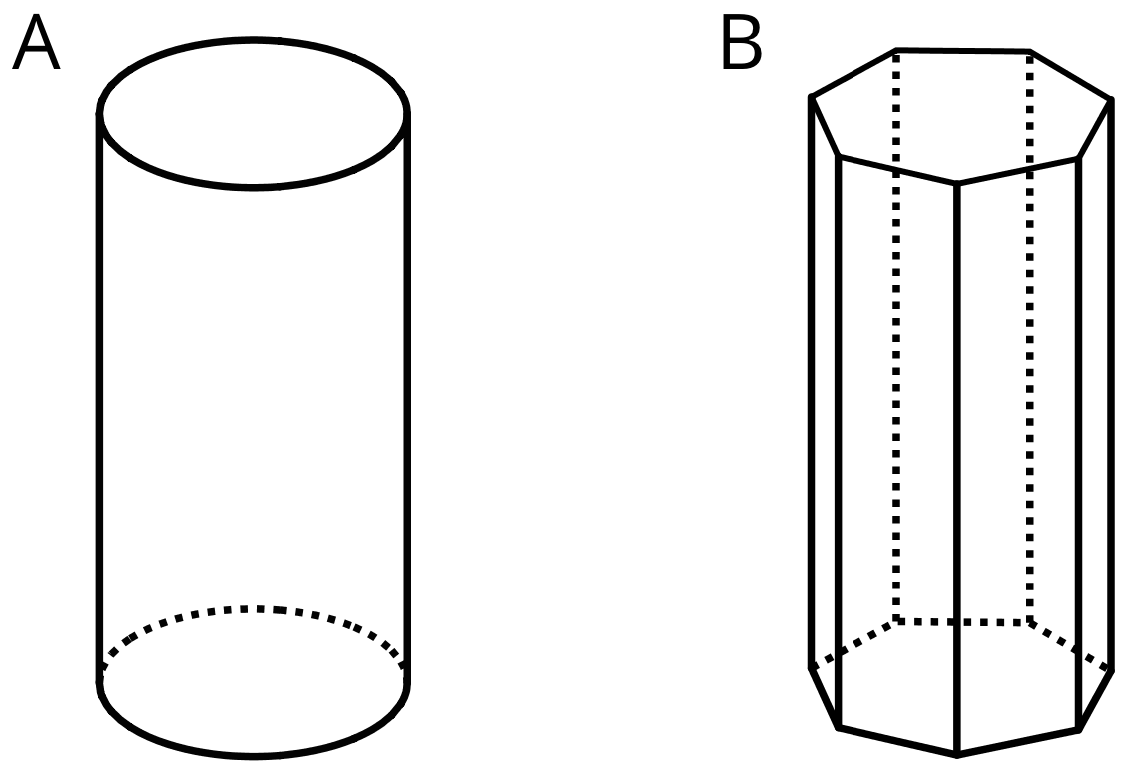
- (From Unit 1, Lesson 13.)
- Here is Elena’s work for finding the surface area of a rectangular prism that is 1 foot by 1 foot by 2 feet.
- 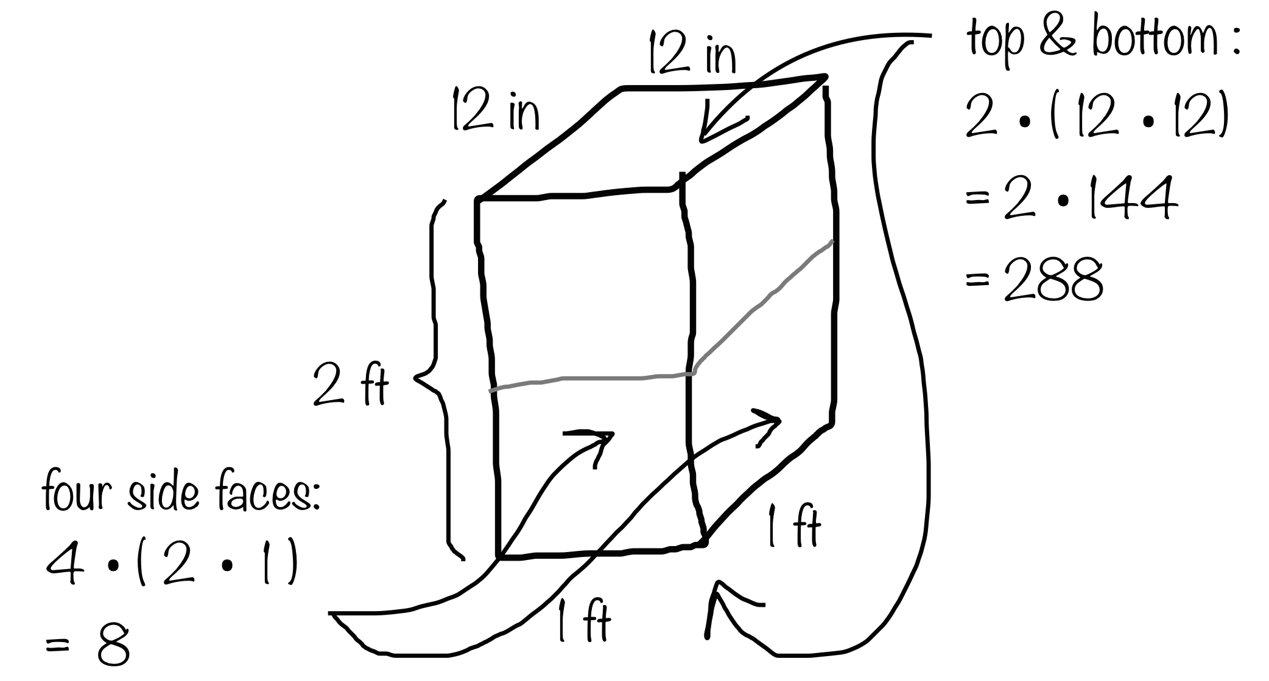
- She concluded that the surface area of the prism is 296 square feet. Do you agree with her? Explain your reasoning.
- (From Unit 1, Lesson 12.)
© CC BY Open Up Resources. Adaptations CC BY IM.

