### Lesson 7 Practice Problems

1. A lemonade recipe calls for cup of lemon juice for every cup of water.
   1. Use the table to answer these questions.
      1. What does represent?
      2. What does represent?
      3. Is there a proportional relationship between and ?
   2. Plot the pairs in the table in a coordinate plane.

|  |  |
| --- | --- |
| * 1 |  |
| * 2 |  |
| * 3 |  |
| * 4 | * 1 |

1. There is a proportional relationship between the number of months a person has had a streaming movie subscription and the total amount of money they have paid for the subscription. The cost for 6 months is $47.94. The point is shown on the graph below.

* 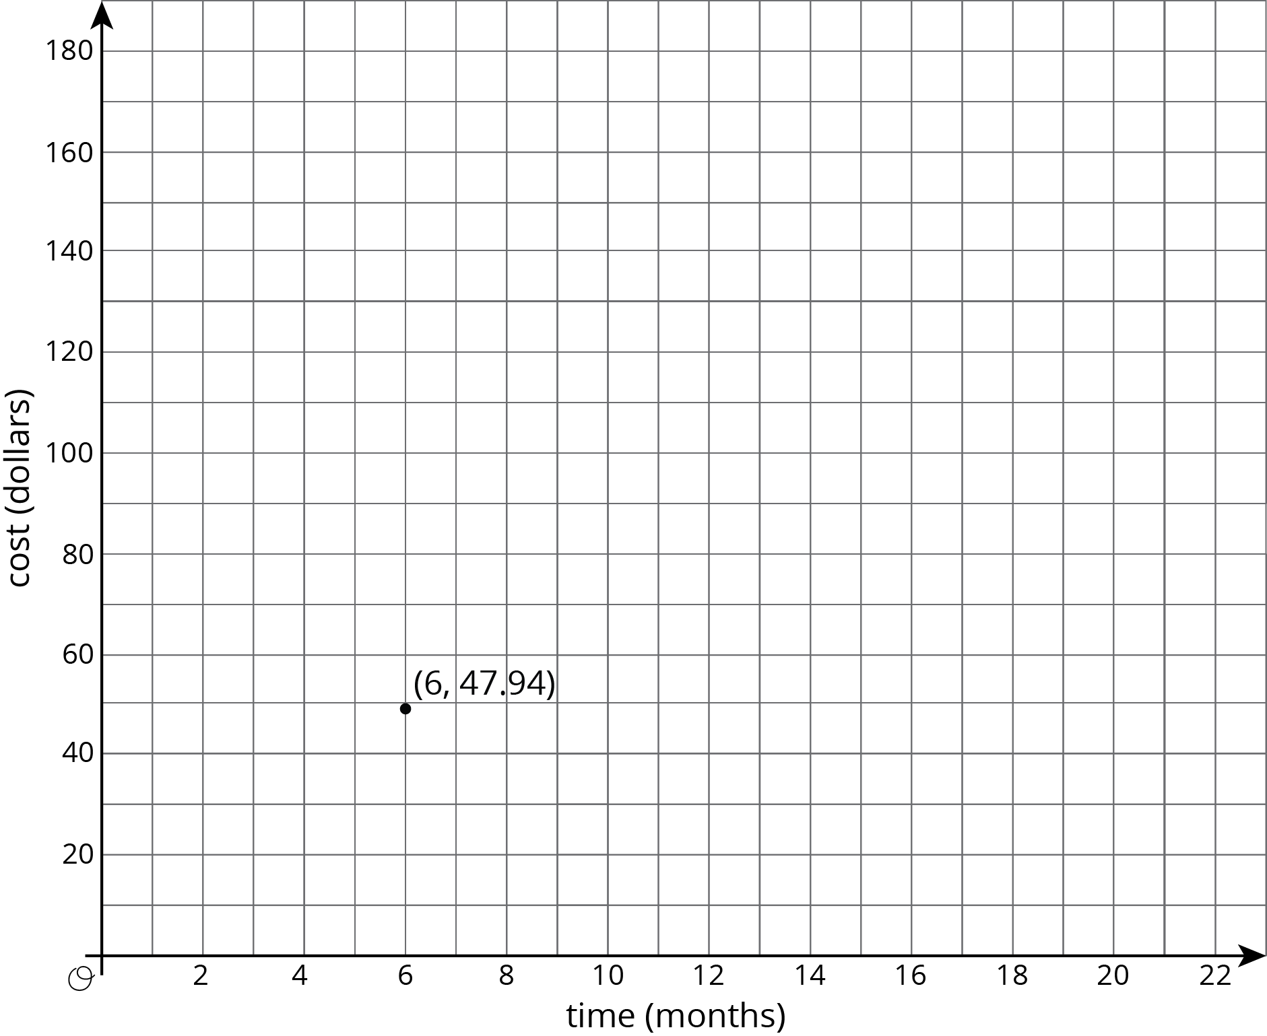
  1. What is the constant of proportionality in this relationship?
  2. What does the constant of proportionality tell us about the situation?
  3. Add at least three more points to the graph and label them with their coordinates.
  4. Write an equation that represents the relationship between , the total cost of the subscription, and , the number of months.

1. The graph shows the amounts of almonds, in grams, for different amounts of oats, in cups, in a granola mix. Label the point on the graph, find the value of , and explain its meaning.

* 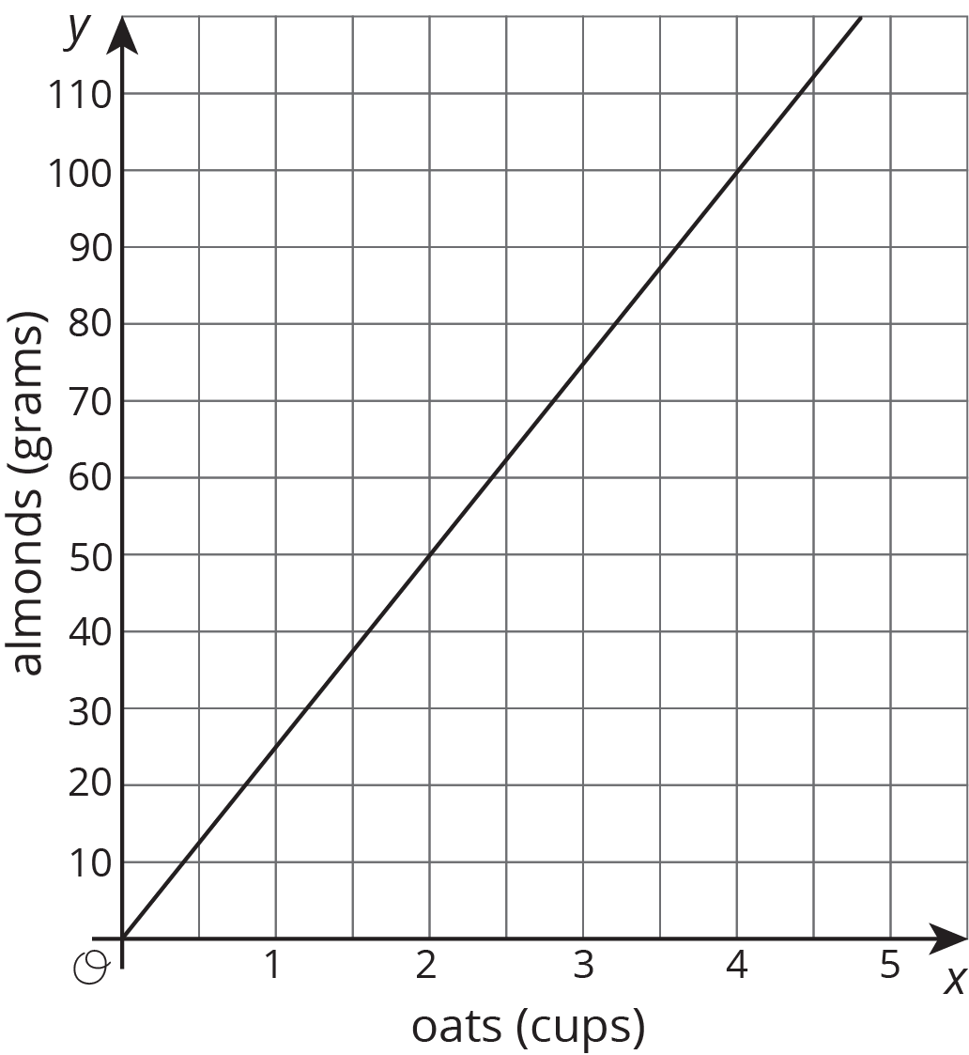

1. Select **all** the pieces of information that would tell you and have a proportional relationship. Let represent the distance in meters between a rock and a turtle's current position and represent the time in minutes the turtle has been moving.
   1. After 4 minutes, the turtle has walked 12 feet away from the rock.
   2. The turtle walks for a bit, then stops for a minute before walking again.
   3. The turtle walks away from the rock at a constant rate.

* (From Unit 5, Lesson 6.)

1. What information do you need to know to write an equation relating two quantities that have a proportional relationship?

* (From Unit 5, Lesson 6.)



© CC BY Open Up Resources. Adaptations CC BY IM.