Lesson 5 Practice Problems
- Rewrite each equation so that the expression on one side could be graphed and the $x$-intercepts of the graph would show the solutions to the equation.
  - $3x^{2}=81$
  - $(x−1)(x+1)−9=5x$
  - $x^{2}−9x+10=32$
  - $6x(x−8)=29$
  - Here are equations that define quadratic functions $f,g$, and $h$. Sketch a graph, by hand or using technology, that represents each equation.
  - $f(x)=x^{2}+4$
  - 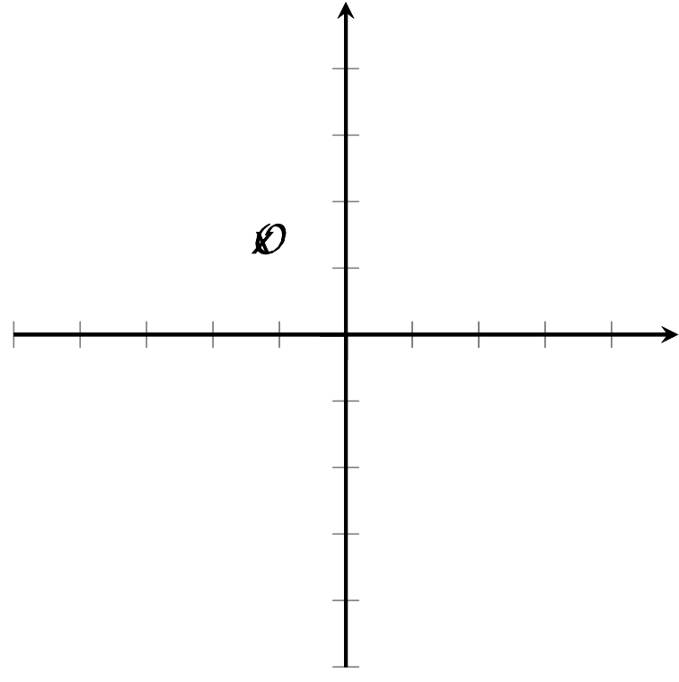
  - $g(x)=x(x+3)$
  - $h(x)=(x−1)^{2}$
  - Determine how many solutions each $f(x)=0,g(x)=0$, and $h(x)=0$ has. Explain how you know.
- Mai is solving the equation $(x−5)^{2}=0$. She writes that the solutions are $x=5$ and $x=\text{-}5$. Han looks at her work and disagrees. He says that only $x=5$ is a solution. Who do you agree with? Explain your reasoning.
- The graph shows the number of square meters, $A$, covered by algae in a lake $w$ weeks after it was first measured.
- In a second lake, the number of square meters, $B$, covered by algae is defined by the equation $B=975⋅{\left(\frac{2}{5}\right)}^{w}$, where $w$ is the number of weeks since it was first measured.
- 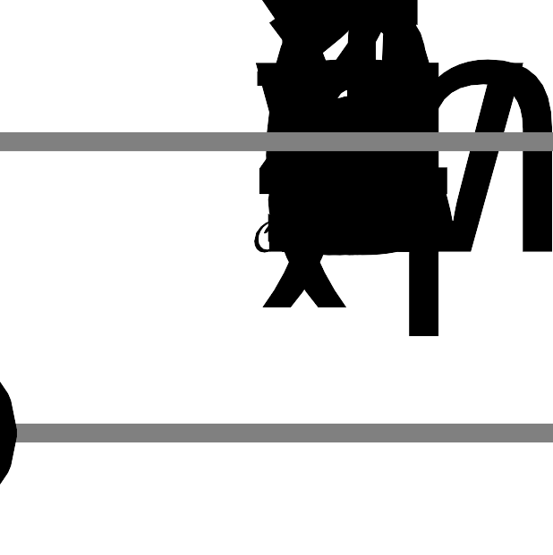
- For which algae population is the area decreasing more rapidly? Explain how you know.
- (From Unit 5, Lesson 6.)
- If the equation $(x−4)(x+6)=0$ is true, which is also true according to the zero product property?
  - only $x−4=0$
  - only $x+6=0$
  - $x−4=0$ or $x+6=0$
  - $x=\text{-}4$ or $x=6$
- (From Unit 7, Lesson 4.)
  - Solve the equation $25=4z^{2}$.
  - Show that your solution or solutions are correct.
- (From Unit 7, Lesson 3.)
- To solve the quadratic equation $3(x−4)^{2}=27$, Andre and Clare wrote the following:
- Andre
- $\begin{matrix}3(x−4)^{2} & =27 \\ (x−4)^{2} & =9 \\ x^{2}−4^{2} & =9 \\ x^{2}−16 & =9 \\ x^{2} & =25 \\ x=5 & \text{ or } x=\text{-}5\end{matrix}$
- Clare
- $\begin{matrix}3(x−4)^{2} & =27 \\ (x−4)^{2} & =9 \\ x−4 & =3 \\ x & =7\end{matrix}$
  - Identify the mistake each student made.
  - Solve the equation and show your reasoning.
- (From Unit 7, Lesson 3.)
- Decide if each equation has 0, 1, or 2 solutions and explain how you know.
  - $x^{2}−144=0$
  - $x^{2}+144=0$
  - $x(x−5)=0$
  - $(x−8)^{2}=0$
  - $(x+3)(x+7)=0$
© CC BY 2019 by Illustrative Mathematics®

