Lesson 14: Solving Systems by Elimination (Part 1)
- Let’s investigate how adding or subtracting equations can help us solve systems of linear equations.

14.1: Notice and Wonder: Hanger Diagrams
What do you notice? What do you wonder?
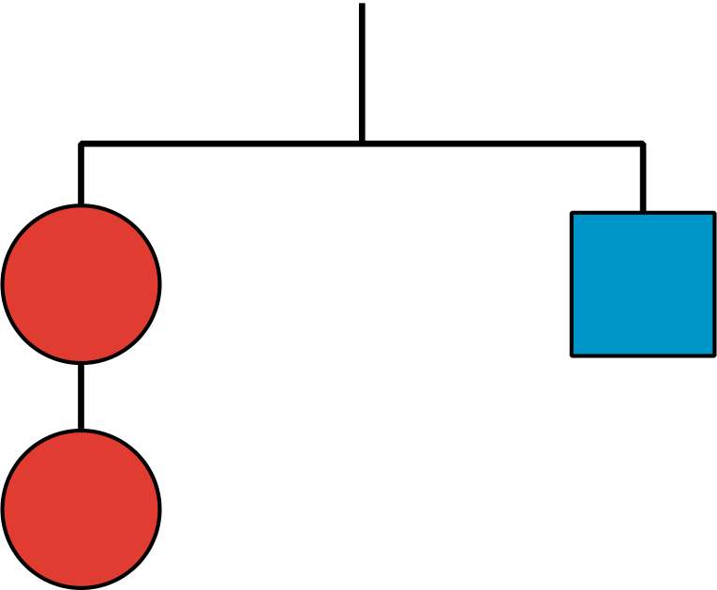
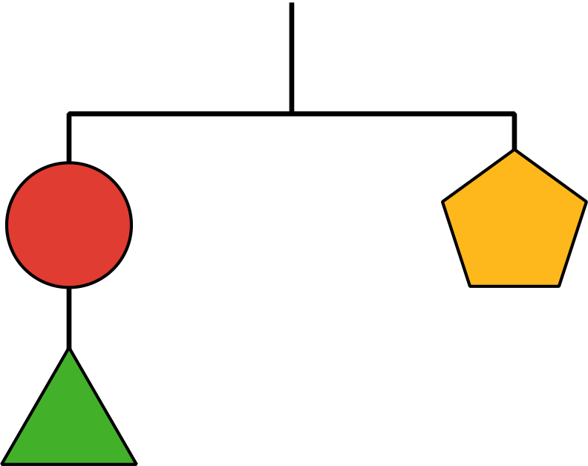
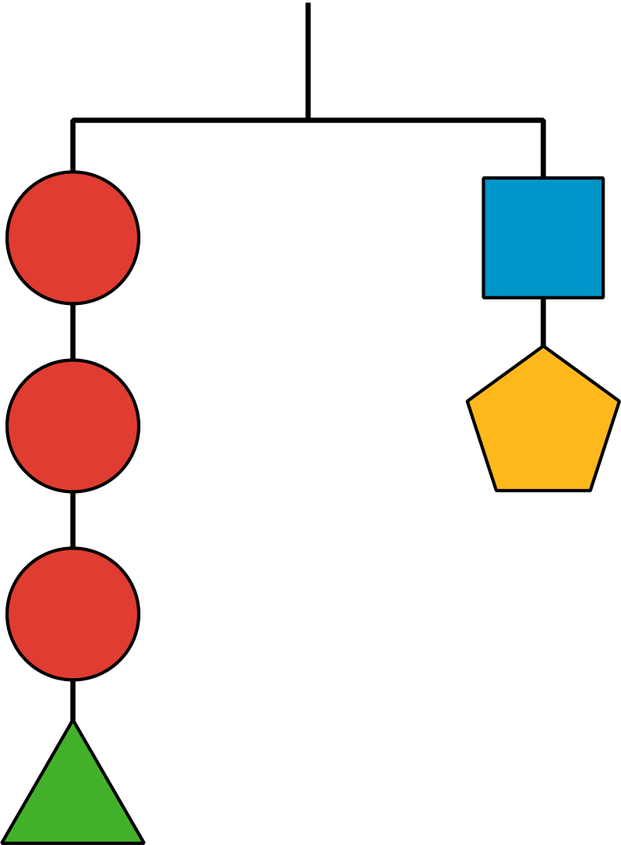

14.2: Adding Equations
Diego is solving this system of equations:
$\left\{\begin{matrix}\begin{matrix}4x+3y & =10 \\ \text{-}4x+5y & =6\end{matrix}\end{matrix}\right.$
Here is his work:
$\begin{matrix}4x+3y & =10 \\ \text{-}4x+5y & = 6 + \\ \overset{¯}{ 0+8y} & \overset{¯}{ =16 } \\ y & =2\end{matrix}$
$\begin{matrix}4x+3\left(2\right) & =10 \\ 4x+6 & =10 \\ 4x & =4 \\ x & =1\end{matrix}$
- Make sense of Diego’s work and discuss with a partner:
  - What did Diego do to solve the system?
  - Is the pair of $x$ and $y$ values that Diego found actually a solution to the system? How do you know?
- Does Diego’s method work for solving these systems? Be prepared to explain or show your reasoning.
- a. $\left\{\begin{matrix}\begin{matrix}2x+y & =4 \\ x−y & =11\end{matrix}\end{matrix}\right.$
- b. $\left\{\begin{matrix}\begin{matrix}8x+11y & =37 \\ 8x+ y & = 7\end{matrix}\end{matrix}\right.$

14.3: Adding and Subtracting Equations to Solve Systems
Here are three systems of equations you saw earlier.
System A
$\left\{\begin{matrix}\begin{matrix}4x+3y & =10 \\ \text{-}4x+5y & = 6\end{matrix}\end{matrix}\right.$
System B
$\left\{\begin{matrix}\begin{matrix}2x+y & =4 \\ x−y & =11\end{matrix}\end{matrix}\right.$
System C
$\left\{\begin{matrix}\begin{matrix}8x+11y & =37 \\ 8x+ y & = 7\end{matrix}\end{matrix}\right.$

For each system:
- Use graphing technology to graph the original two equations in the system. Then, identify the coordinates of the solution.
- Find the sum or difference of the two original equations that would enable the system to be solved.
- Graph the third equation on the same coordinate plane. Make an observation about the graph.

Are you ready for more?
Mai wonders what would happen if we multiply equations. That is, we multiply the expressions on the left side of the two equations and set them equal to the expressions on the right side of the two equations.
- In system B write out an equation that you would get if you multiply the two equations in this manner.
- Does your original solution still work in this new equation?
- Use graphing technology to graph this new equation on the same coordinate plane. Why is this approach not particularly helpful?

Lesson 14 Summary
Another way to solve systems of equations algebraically is by elimination. Just like in substitution, the idea is to eliminate one variable so that we can solve for the other. This is done by adding or subtracting equations in the system. Let’s look at an example.
$\left\{\begin{matrix}\begin{matrix}5x+7y=64 \\ 0.5x−7y=\text{-}9\end{matrix}\end{matrix}\right.$
Notice that one equation has $7y$ and the other has $\text{-}7y$.
If we add the second equation to the first, the $7y$ and $\text{-}7y$ add up to 0, which eliminates the $y$-variable, allowing us to solve for $x$.
$\begin{matrix}5x+7y & =64 \\ 0.5x−7y & =\text{-}9 + \\ \overset{¯}{5.5x+0} & \overset{¯}{ =55} \\ 5.5x & =55 \\ x & =10\end{matrix}$
Now that we know $x=10$, we can substitute 10 for $x$ in either of the equations and find $y$:
$\begin{matrix}5x+7y & =64 \\ 5\left(10\right)+7y & =64 \\ 50+7y & =64 \\ 7y & =14 \\ y & =2\end{matrix}$
$\begin{matrix}0.5x−7y & =\text{-}9 \\ 0.5\left(10\right)−7y & =\text{-}9 \\ 5−7y & =\text{-}9 \\ \text{-}7y & =\text{-}14 \\ y & =2\end{matrix}$
In this system, the coefficient of $y$ in the first equation happens to be the opposite of the coefficient of $y$ in the second equation. The sum of the terms with $y$-variables is 0.
What if the equations don't have opposite coefficients for the same variable, like in the following system? ​​​​​​
$\left\{\begin{matrix}\begin{matrix}8r+4s & =12 \\ 8r+ s & = \text{-}3\end{matrix}\end{matrix}\right.$
Notice that both equations have $8r$ and if we subtract the second equation from the first, the variable $r$ will be eliminated because $8r−8r$ is 0.
$\begin{matrix}8r+4s & =12 \\ 8r+ s & = \text{-}3 − \\ \overset{¯}{ 0+3s} & \overset{¯}{ =15} \\ 3s & =15 \\ s & =5\end{matrix}$
Substituting 5 for $s$ in one of the equations gives us $r$:
$\begin{matrix}8r+4s & =12 \\ 8r+4\left(5\right) & =12 \\ 8r+20 & =12 \\ 8r & =\text{-}8 \\ r & =\text{-}1\end{matrix}$
Adding or subtracting the equations in a system creates a new equation. How do we know the new equation shares a solution with the original system?
If we graph the original equations in the system and the new equation, we can see that all three lines intersect at the same point, but why do they?
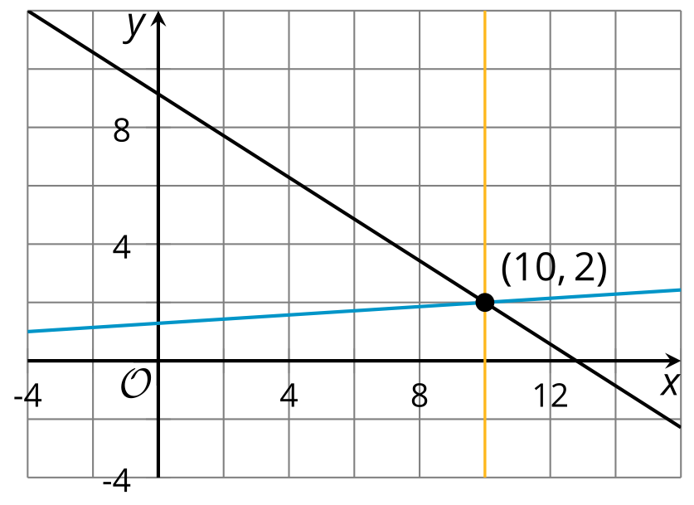
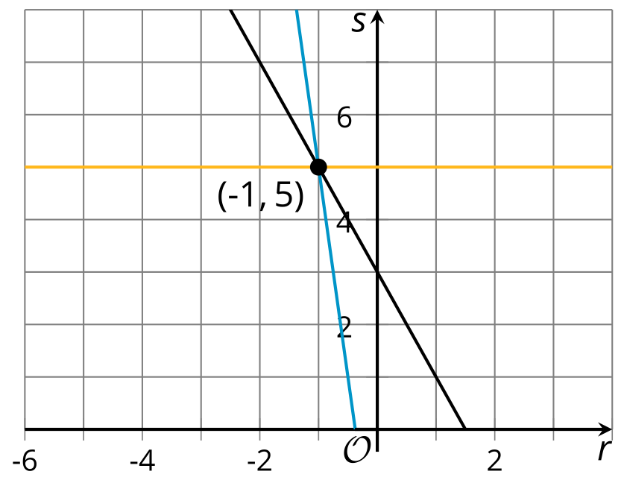
In future lessons, we will investigate why this strategy works.
© CC BY 2019 by Illustrative Mathematics®

