Lesson 5: Fitting Lines
- Let’s find the best linear model for some data.

5.1: Selecting the Best Line
Which of the lines is the best fit for the data in each scatter plot? Explain your reasoning.
1.
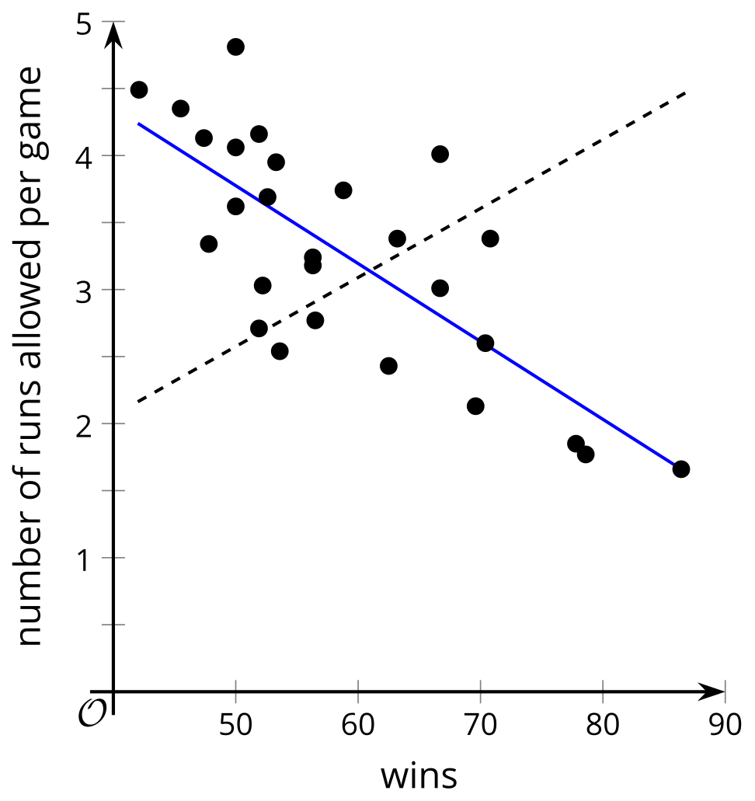
2.
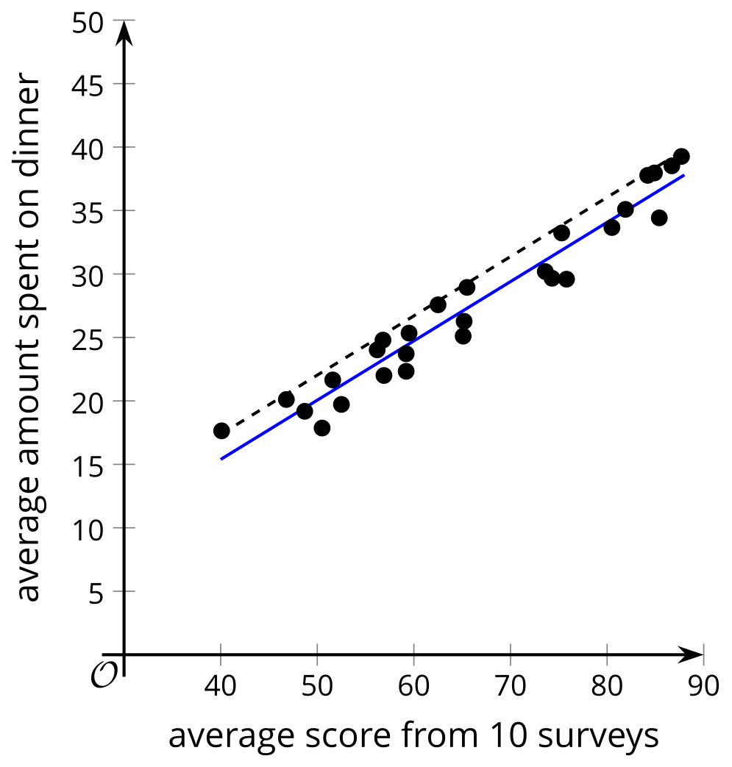
3.
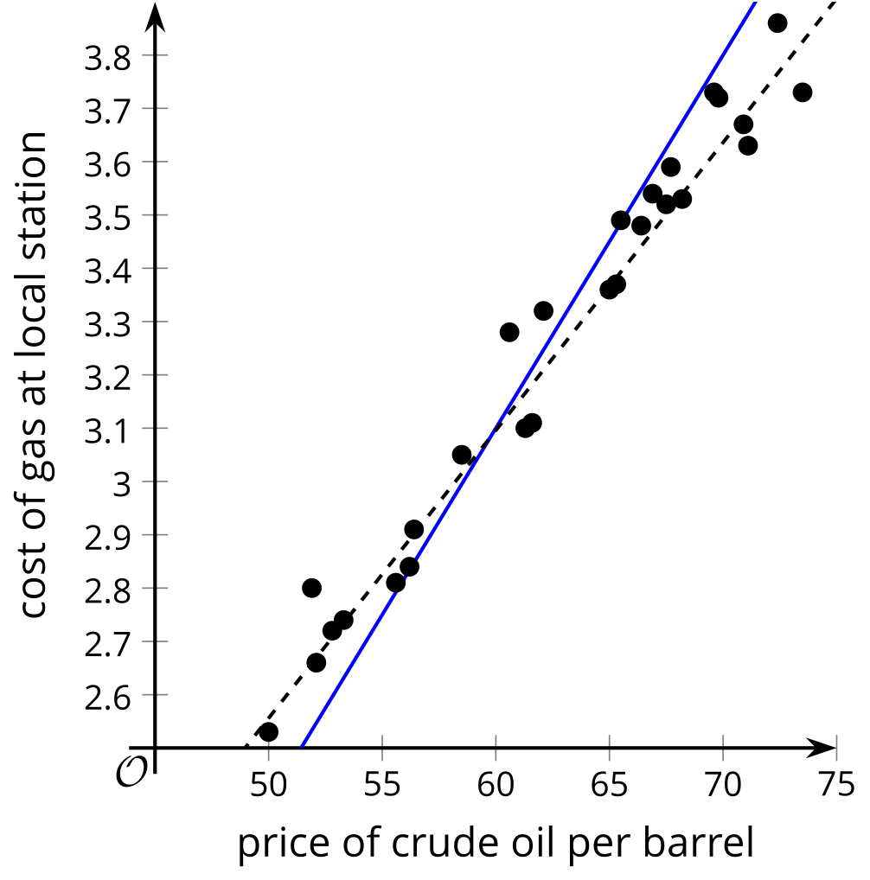
4.
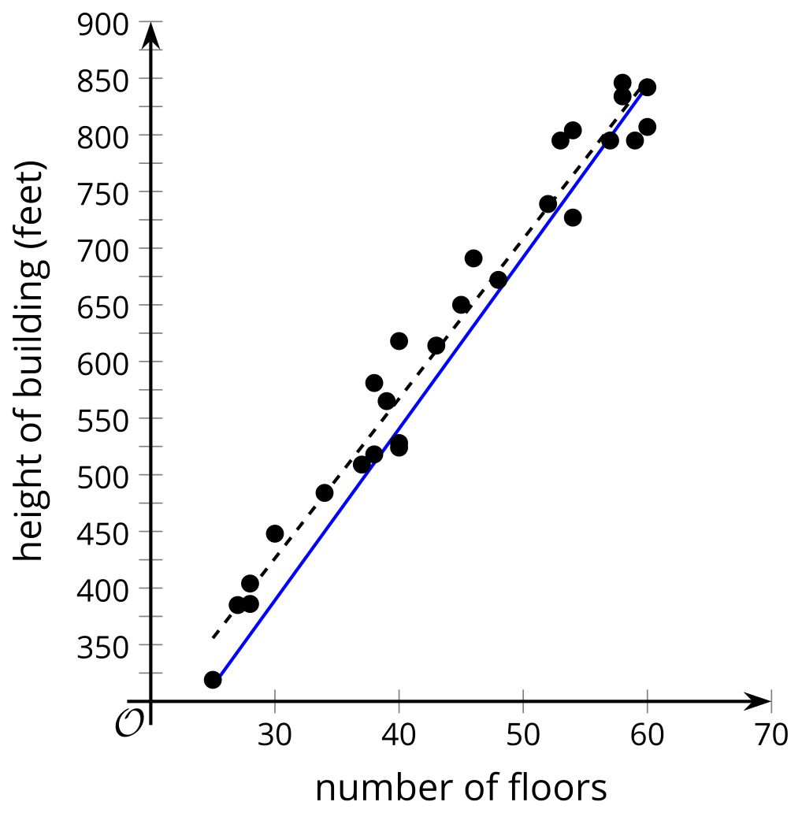

5.2: Card Sort: Data Patterns
Your teacher will give you a set of cards that show scatter plots.
- Arrange all the cards in three different ways. Ensure that you and your partner agree on the arrangement before moving on to the next one. Sort all the cards in order from:
  - best to worst for representing with a linear model
  - least to greatest slope of a linear model that fits the data well
  - least to greatest vertical intercept of a linear model that fits the data well
- For each card, write a sentence that describes how $y$ changes as $x$ increases and whether the linear model is a good fit for the data or not.

5.3: Fitting Lines with Technology
The weight of ice cream sold in a day at a small store in pounds ($x$) and the average temperature outside during the day in degrees Celsius ($y$) are recorded in the table.
$x$ | 20 | 18 | 21 | 17 | 21.5 | 19.5 | 21 | 18
$y$ | 6 | 4.5 | 6.5 | 3.5 | 7.5 | 6.5 | 7 | 5
- For this data, create a scatter plot and sketch a line that fits the data well.
- Use technology to compute the best fit line. Round any numbers to 2 decimal places.
- What are the values for the slope and $y$-intercept for the best fit line? What do these values mean in this situation?
- Use the best fit line to predict the $y$ value when $x$ is 10. Is this a good estimate for the data? Explain your reasoning.
- Your teacher will give you a data table for one of the other scatter plots from the previous activity. Use technology and this table of data to create a scatter plot that also shows the line of best fit, then interpret the slope and $y$-intercept.

Are you ready for more?
Priya uses several different ride services to get around her city. The table shows the distance, in miles, she traveled during her last 10 trips and the price of each trip, in dollars.
distance (miles) | price ($)
3.1 | 12.5
4.2 | 14.75
5 | 16
3.5 | 13.25
2.5 | 12
1 | 9
0.8 | 8.75
1.6 | 9.75
4.3 | 12
3.3 | 14
- Priya creates a scatter plot of the data using the distance, $x$, and the price, $y$. She determines that a linear model is appropriate to use with the data. Use technology to find the equation of a line of best fit.
- Interpret the slope and the $y$-intercept of the equation of the line of best fit in this situation.
- Use the line of best fit to estimate the cost of a 3.6-mile trip. Will this estimate be close to the actual value? Explain your reasoning.
- On her next trip, Priya tries a new ride service and travels 3.6 miles, but pays only $4.00 because she receives a discount. Include this trip in the table and calculate the equation of the line of best fit for the 11 trips. Did the slope of the equation of the line of best fit increase, decrease, or stay the same? Why? Explain your reasoning.
- Priya uses the new ride service for her 12th trip. She travels 4.1 miles and is charged $24.75. How do you think the slope of the equation of the line of best fit will change when this 12th trip is added to the table?

Lesson 5 Summary
Some data appear to have a linear relationship, so finding an equation for a line that fits the data can help you understand the relationship between the variables.
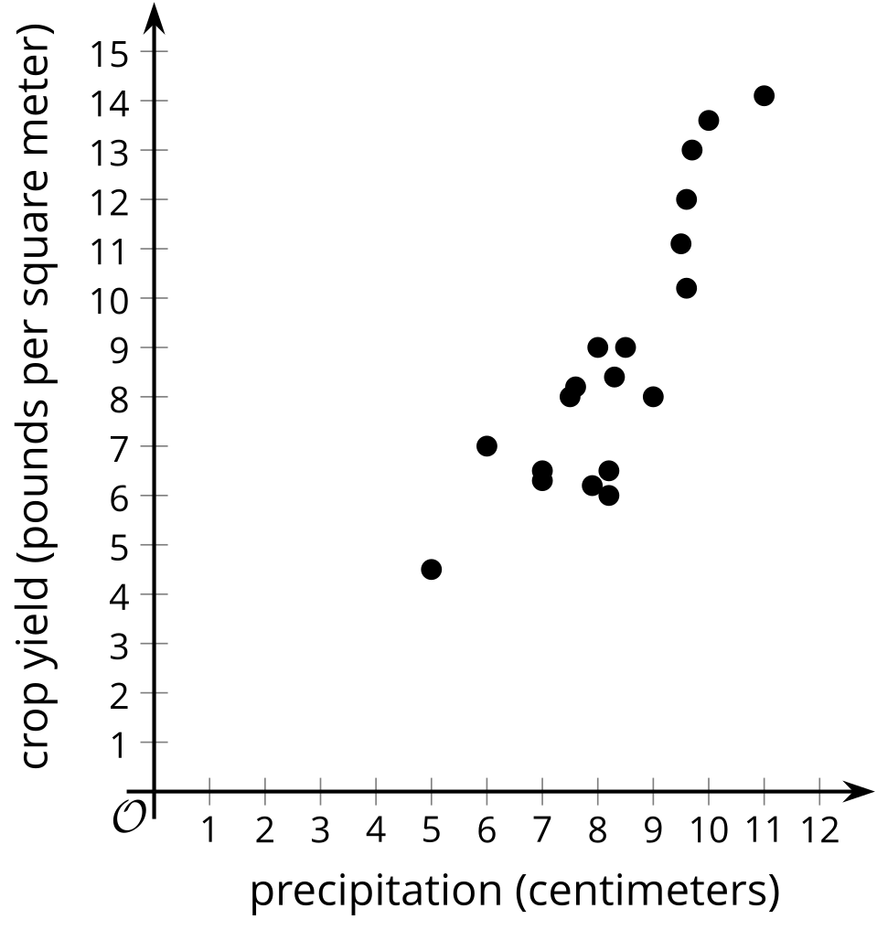
Other data may follow non-linear trends or not have an apparent trend at all.
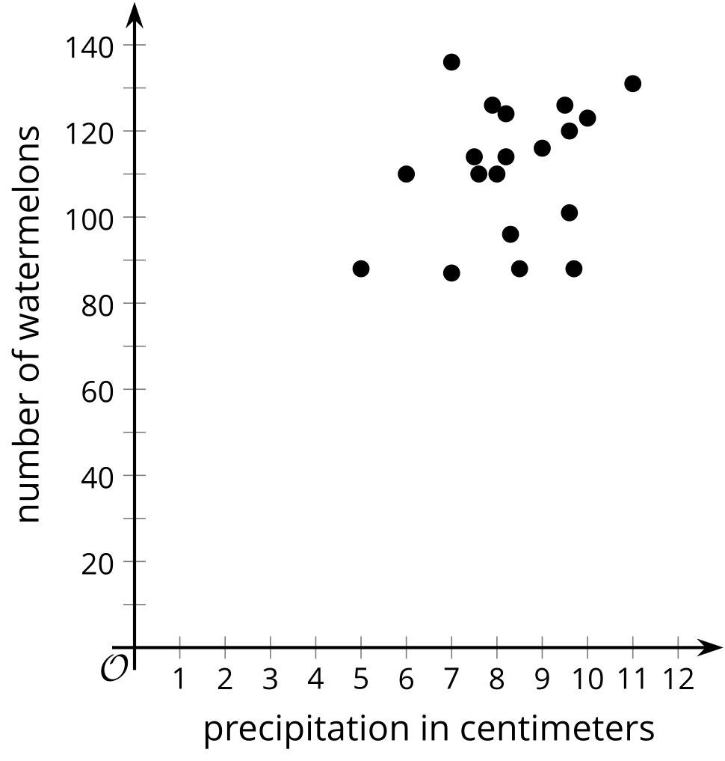
When modeling data with a linear function seems useful, it is important to find a linear function that is close to the data. The line should have a $y$-intercept and slope to follow the shape of the data in the scatter plot as much as possible.
Technology can be used to quickly find a line of best fit for the data and provide the equation of the line that we can use to analyze the situation.
© CC BY 2019 by Illustrative Mathematics®

