Lesson 2: Half a Square
- Let’s investigate the properties of diagonals of squares.

2.1: Diagonals of Rectangles
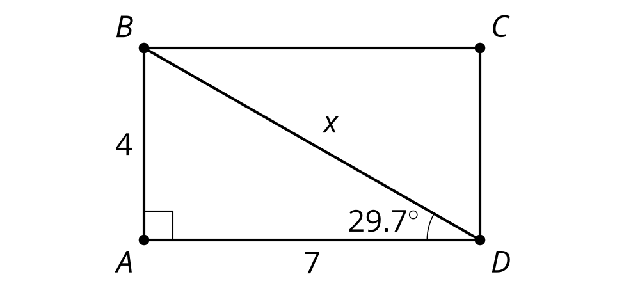
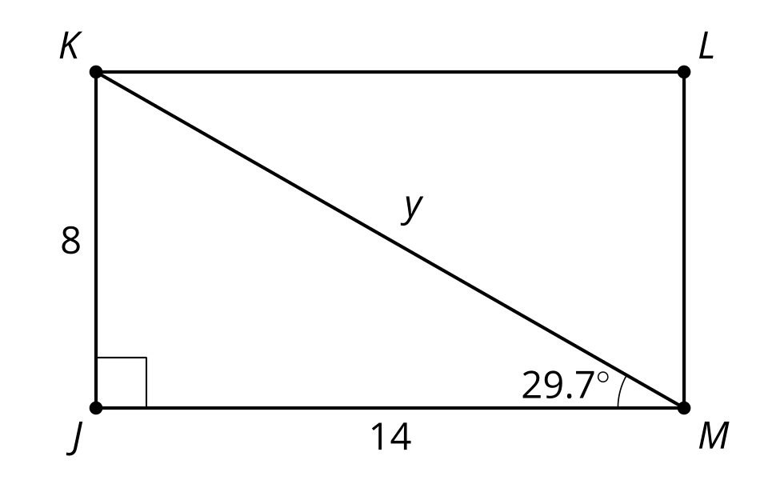
Calculate the values of $x$ and $y$.

2.2: Decomposing Squares
- Draw a square with side lengths of 1 cm. Estimate the length of the diagonal. Then calculate the length of the diagonal.
- Measure the side length and diagonal length of several squares, in centimeters. Compute the ratio of side to diagonal length for each.
- Make a conjecture.

2.3: Generalize Half Squares
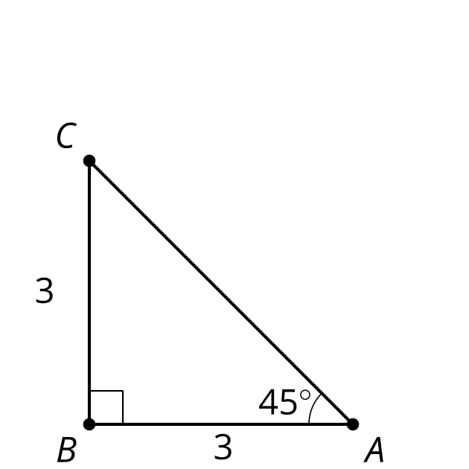
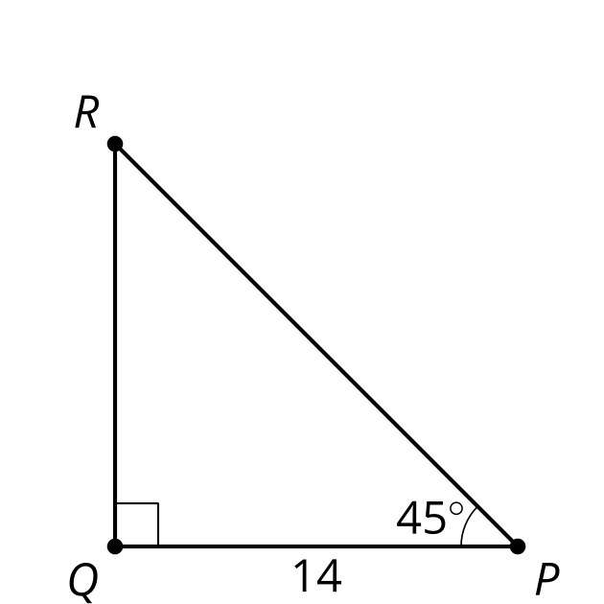
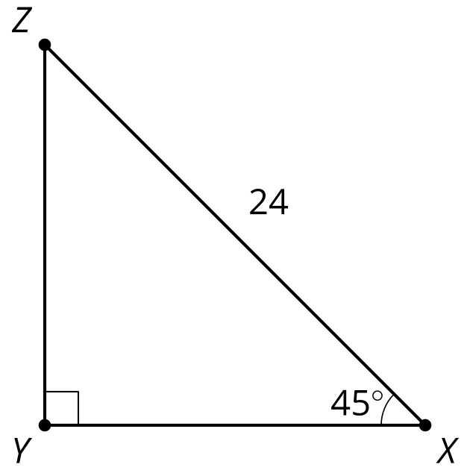
Calculate the lengths of the 5 unlabeled sides.

Are you ready for more?
Square $ABCD$ has a diagonal length of $x$ and side length of $s$. Rhombus $EFGH$ has side length $s$.
- How do the diagonals of $EFGH$ compare to the diagonals of $ABCD$?
- What is the maximum possible length of a diagonal of a rhombus of side length $s$?

Lesson 2 Summary
Drawing the diagonal of a square decomposes the square into 2 congruent triangles. They are right isosceles triangles with acute angles of 45 degrees. These congruent angles make all right isosceles triangles similar by the Angle-Angle Triangle Similarity Theorem.
Consider an isosceles right triangle with legs 1 unit long where $c$ is the length of the hypotenuse. By the Pythagorean Theorem, we can say $1^{2}+1^{2}=c^{2}$ so $c=\sqrt{2}$. The hypotenuse of an isosceles right triangle with legs 1 unit long is $\sqrt{2}$ units long.
Now, consider an isosceles right triangle with legs $x$ units long. By the Angle-Angle Triangle Similarity Theorem, the triangle is similar to the isosceles right triangle with side lengths of 1, 1, and $\sqrt{2}$ units. A scale factor of $x$ takes the triangle with leg length of 1 to the triangle with leg length of $x$. Therefore, the hypotenuse of the isosceles right triangle with legs $x$ units long is $x\sqrt{2}$ units long.
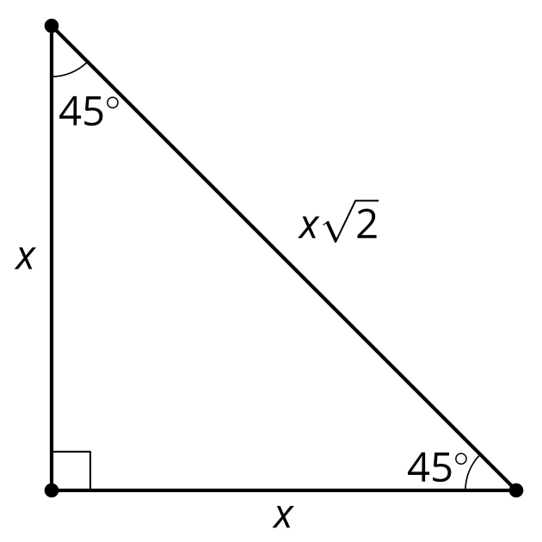
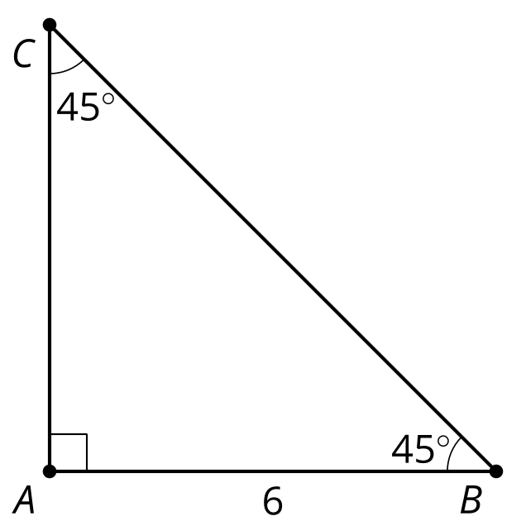
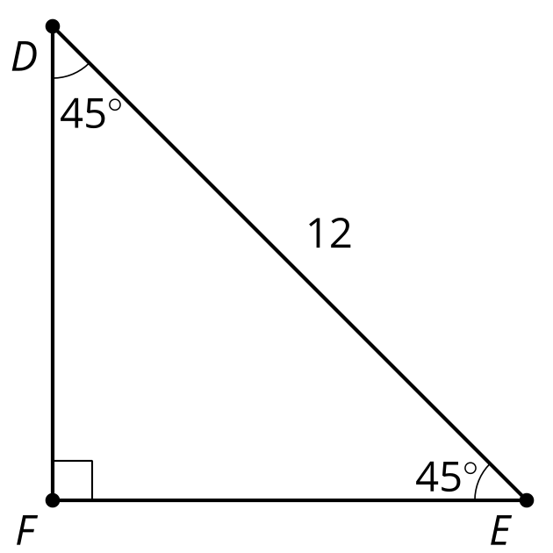
In triangle $ABC,x=6$ so $AC$ is 6 units long and $BC$ is $6\sqrt{2}$ units long.
In triangle $DEF,x\sqrt{2}=12$ so $x=\frac{12}{\sqrt{2}}$, which means both $EF$ and $DF$ are $\frac{12}{\sqrt{2}}$ units long.
© CC BY 2019 by Illustrative Mathematics®

