Unit 2 Lesson 9: Relate Area to Multiplication

WU Which One Doesn’t Belong: Area (Warm up)

Student Task Statement
Which one doesn’t belong?
A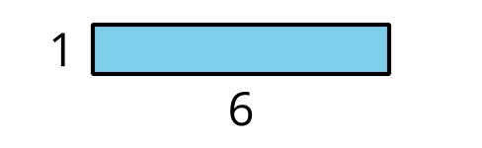
B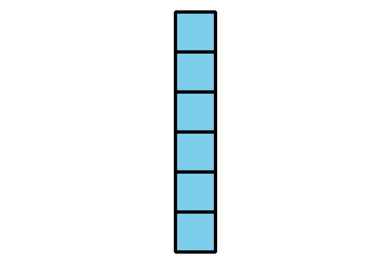
C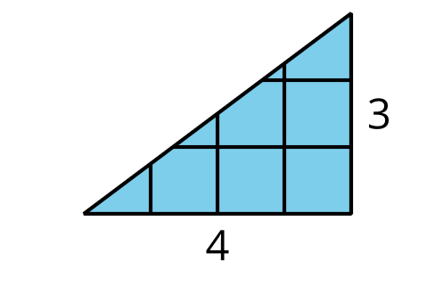
D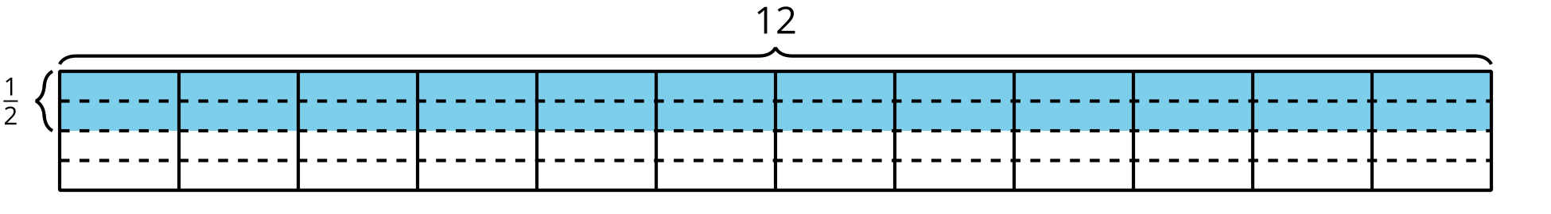

1 Find the Area

Student Task Statement
Find the area of the shaded region. Explain or show your reasoning.

- 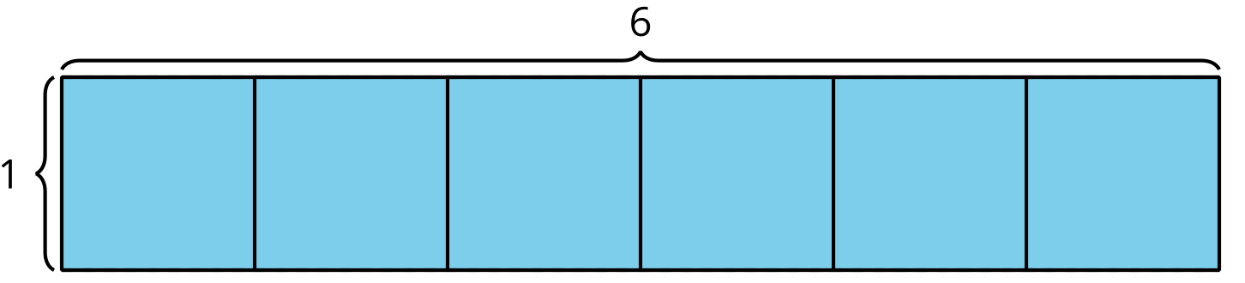

- 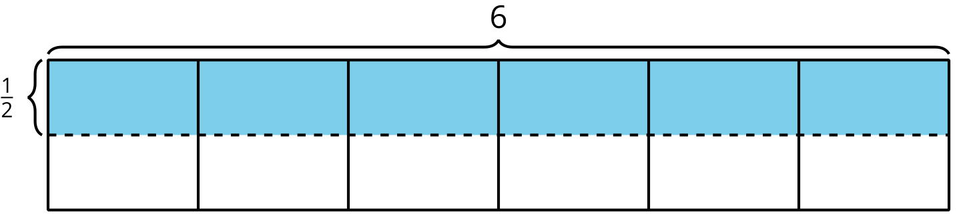

- 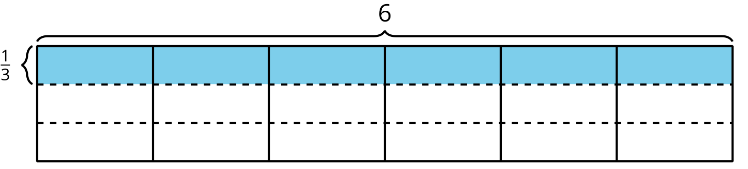

- 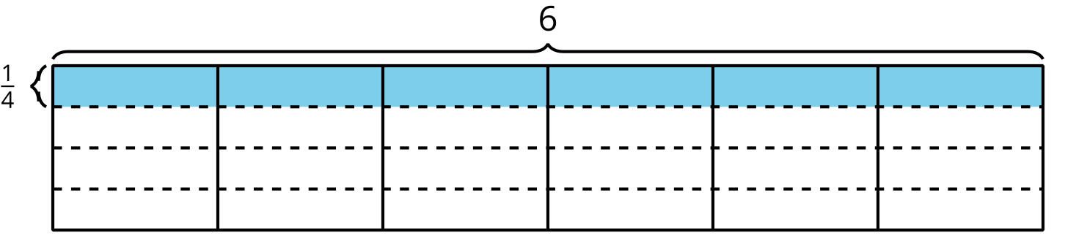

2 Draw Rectangles

Student Task Statement
- Represent each rectangle on grid paper:
  - $\frac{1}{2}$ unit by 1 unit
  - $\frac{1}{2}$ unit by 2 units
  - $\frac{1}{2}$ unit by 3 units
  - $\frac{1}{2}$ unit by 4 units
- Find the area of each rectangle that you drew.
- What information do you need to find the area of the shaded region?
- What might the area of the shaded region be? Explain or show your reasoning.
© CC BY 2021 Illustrative Mathematics®

