Lesson 21: Food Waste Journal
- Let's use multiplication and division to think about food waste.

Warm-up: Notice and Wonder: Food Waste
What do you notice? What do you wonder?
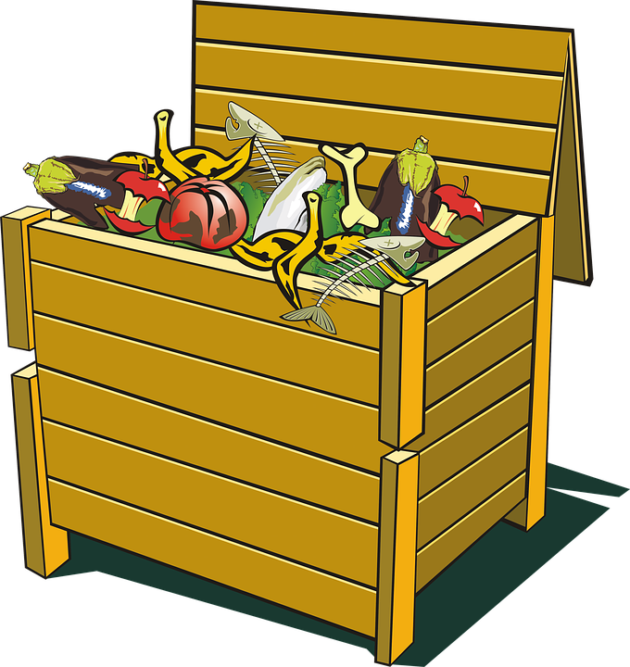

21.1: Food Waste in the United States
The average person produces 219 pounds of food waste per year.
- If each person produces the average amount, about how many pounds of food waste is produced by each group in each amount of time? Explain or show your reasoning.
  - a person in 1 month
  - a person in 1 week
  - your family in 1 year
  - your class in 1 year
  - everyone in your school in 1 year
- There are 16 ounces in a pound. How many ounces of food waste does the average person produce in 1 year?

21.2: Food Journal
Complete the table for the food waste you produced today. Be prepared to share your reasoning for the estimated weight.
name/type | reason thrown away | estimated weight (ounces)
- About how many pounds of food waste have you produced so far today?
- Look back at the weekly estimated pounds of food waste based on the national average in the last activity. Do you think the estimate is more or less than what you actually produce in a week? Explain your reasoning.

21.3: Analyze Food Journals
Use your food waste journal to answer the questions. Be prepared to share.
- How many pounds of food waste did you or your family produce in a week?
- If you produce about the same food waste each week as recorded in the food waste journal, how much would you produce in a month? In a year?
- The average person produces 219 pounds of food waste per year in the United States. With your partner, discuss reasons for the differences between your data and the national average.
© CC BY 2021 Illustrative Mathematics®

