Unit 3 Lesson 27: Center Day 4

WU Number Talk: Subtract 10 (Warm up)

Student Task Statement
Find the value of each expression mentally.
- $20−10$
- $20−10−1$
- $18−10−4$
- $18−14$

1 Introduce How Close? Subtract from 20

Student Task Statement

2 Introduce Compare, Add and Subtract Within 20

Student Task Statement
Choose a center.
Compare
Five in a Row
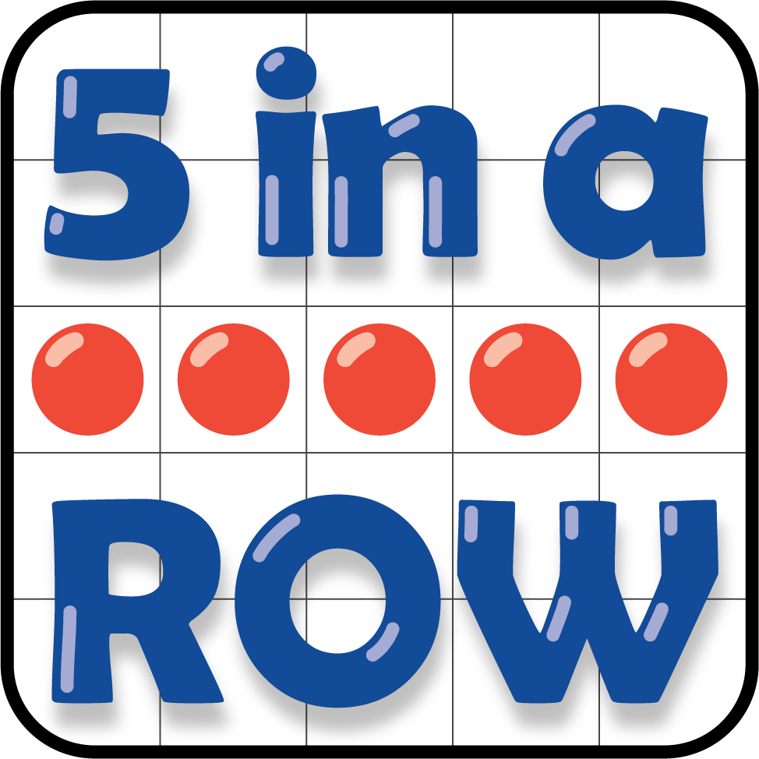
How Close?
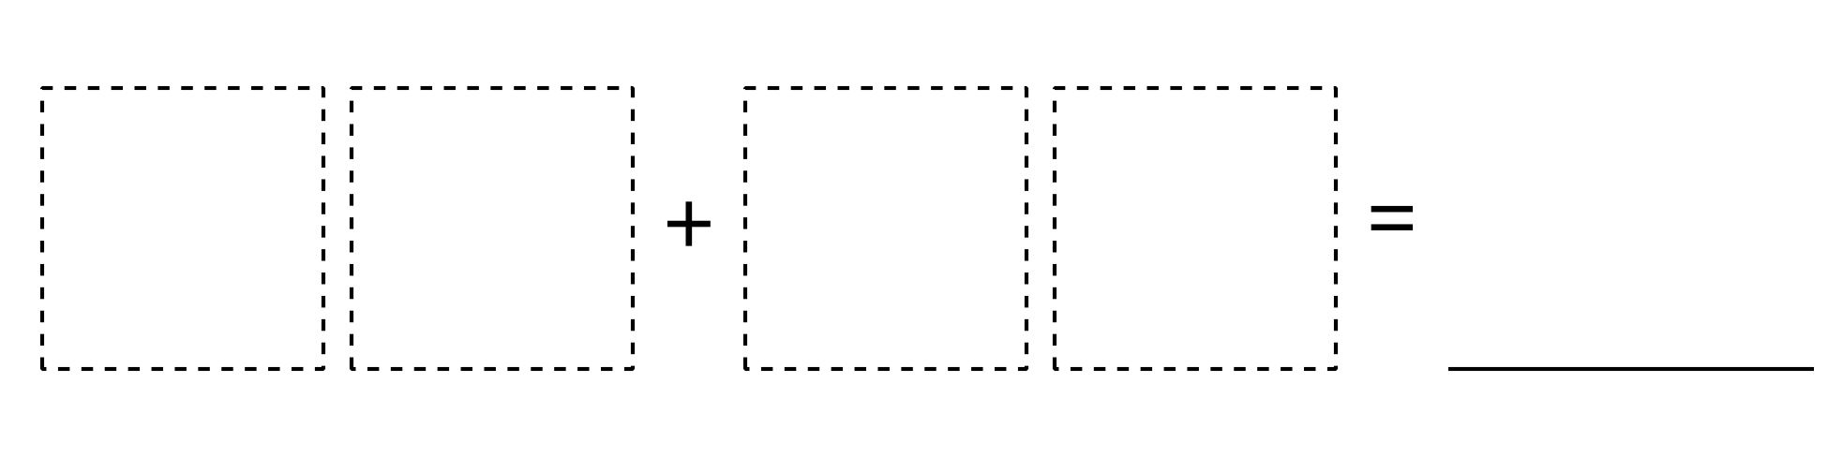
© CC BY 2021 Illustrative Mathematics®

