Unit 7 Lesson 3: Shapes That Are Flat

WU Which One Doesn’t Belong: All the Shapes (Warm up)

Student Task Statement
Which one doesn’t belong?
A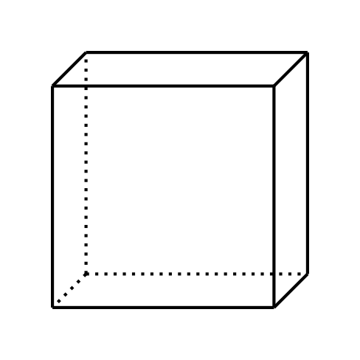
B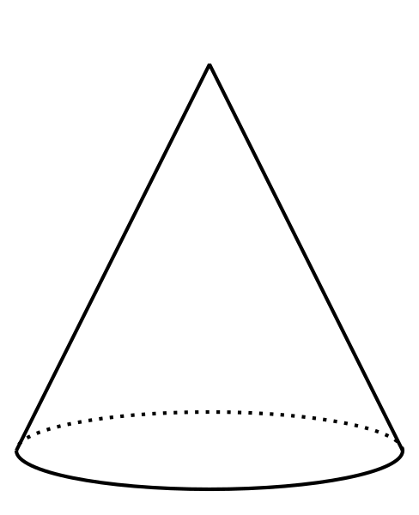
C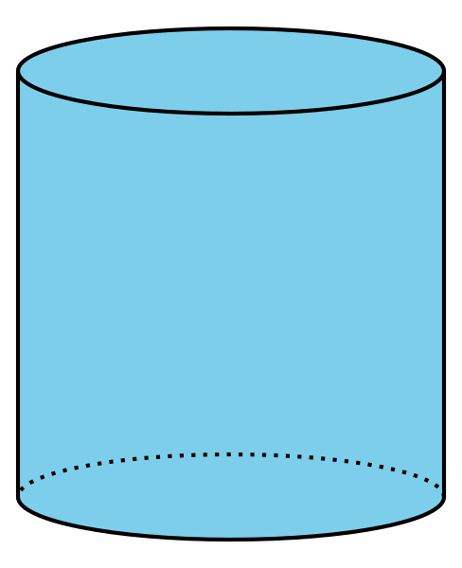
D

1 Card Sort: Flat Shapes

Student Task Statement

2 Shape Sort Gallery Walk

Student Task Statement
Group 1: They sorted
Group 2: They sorted
Group 3: They sorted
© CC BY 2021 Illustrative Mathematics®

