Unit 2 Lesson 4: Dilations on a Square Grid

1 Estimating a Scale Factor (Warm up)

Student Task Statement

Point $C$ is the dilation of point $B$ with center of dilation $A$ and scale factor $s$. Estimate $s$. Be prepared to explain your reasoning.

2 Dilations on a Grid

Student Task Statement
- Find the dilation of quadrilateral $ABCD$ with center $P$ and scale factor 2.
- 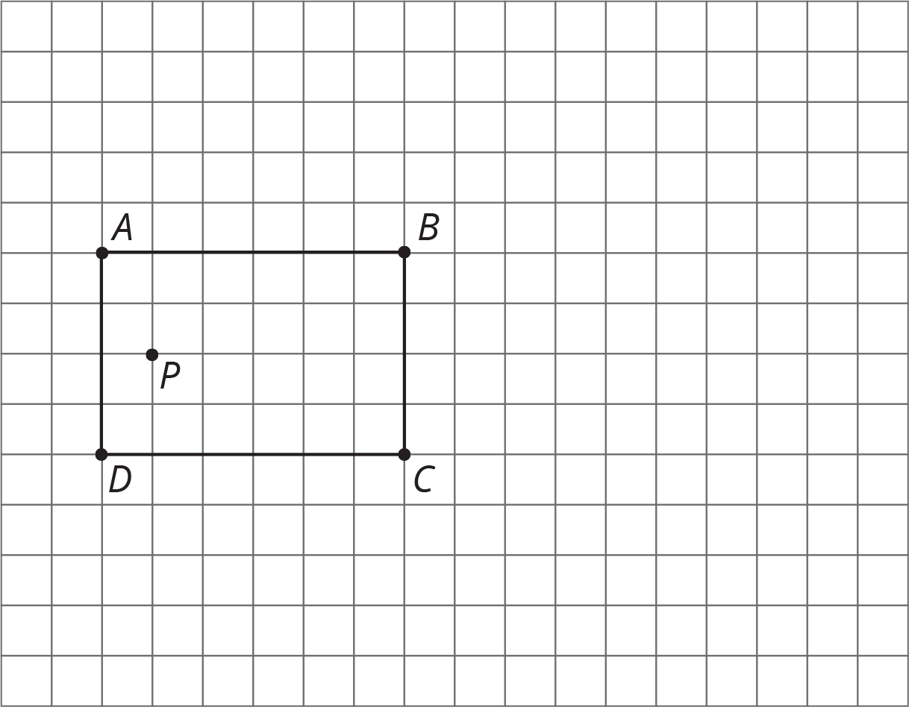
- Find the dilation of triangle $QRS$ with center $T$ and scale factor 2.
- Find the dilation of triangle $QRS$ with center $T$ and scale factor $\frac{1}{2}$.
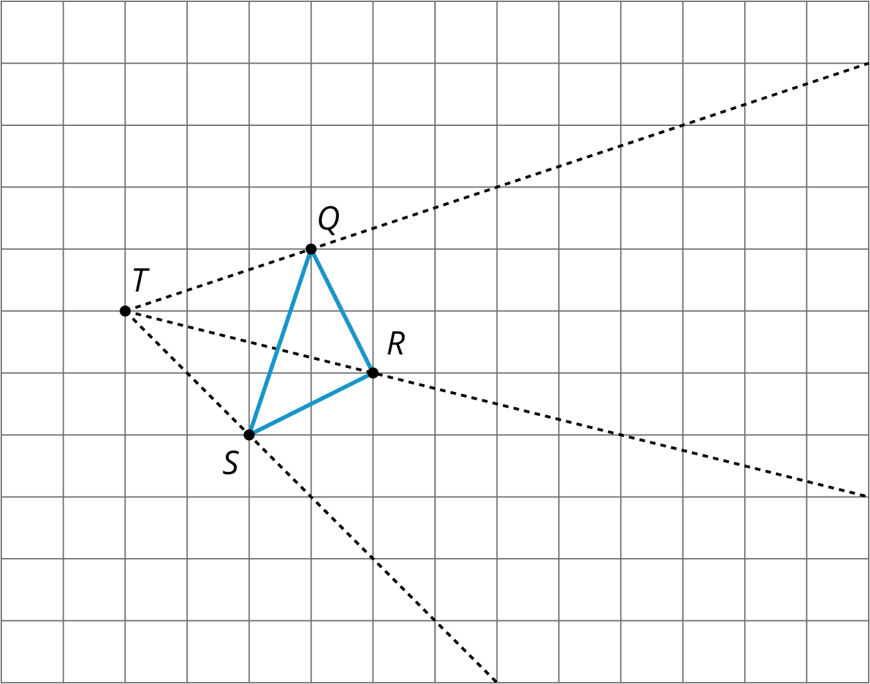

3 Card Sort: Matching Dilations on a Coordinate Grid

Student Task Statement
Your teacher will give you some cards. Each of Cards 1 through 6 shows a figure in the coordinate plane and describes a dilation.
Each of Cards A through E describes the image of the dilation for one of the numbered cards.
Match number cards with letter cards. One of the number cards will not have a match. For this card, you’ll need to draw an image.

Images for Activity Synthesis
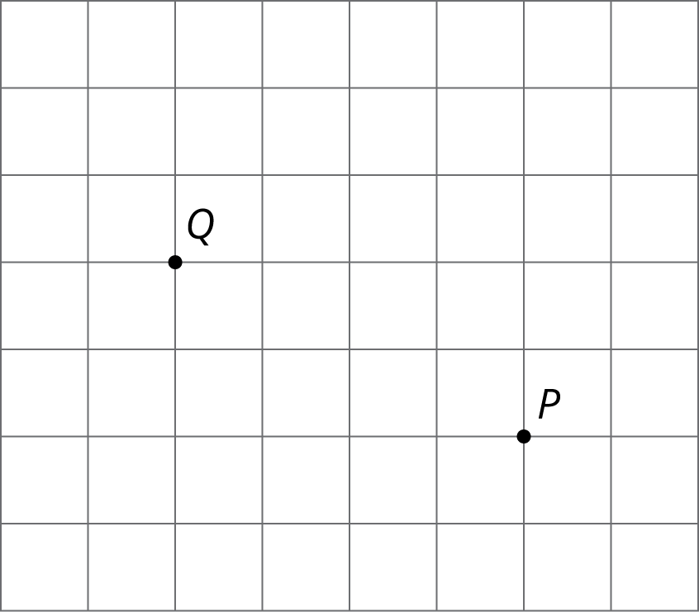
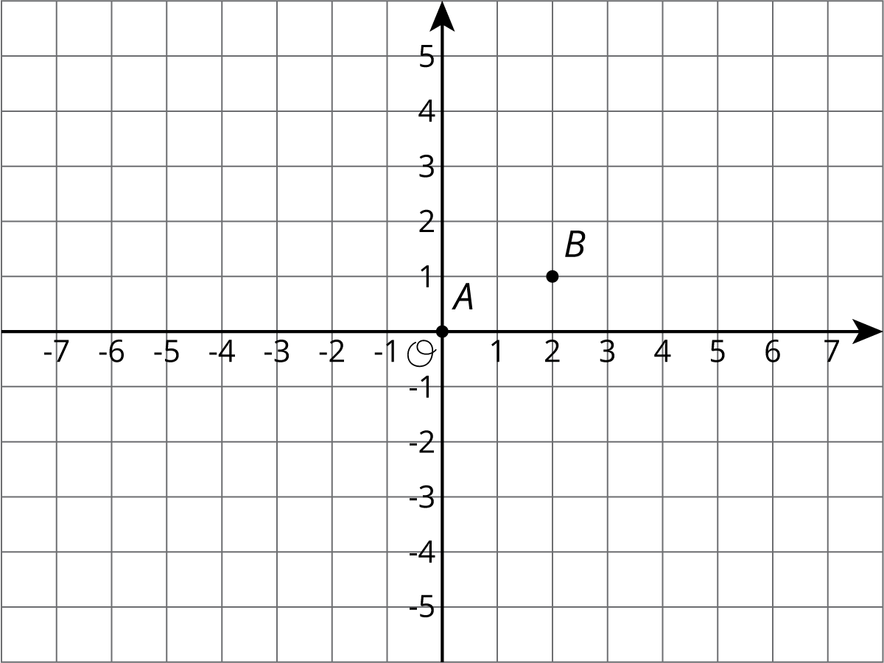
© CC BY Open Up Resources. Adaptations CC BY IM.

