Unit 6 Lesson 1: Half as Much Again

1 Notice and Wonder: Tape Diagrams (Warm up)

Student Task Statement
What do you notice? What do you wonder?
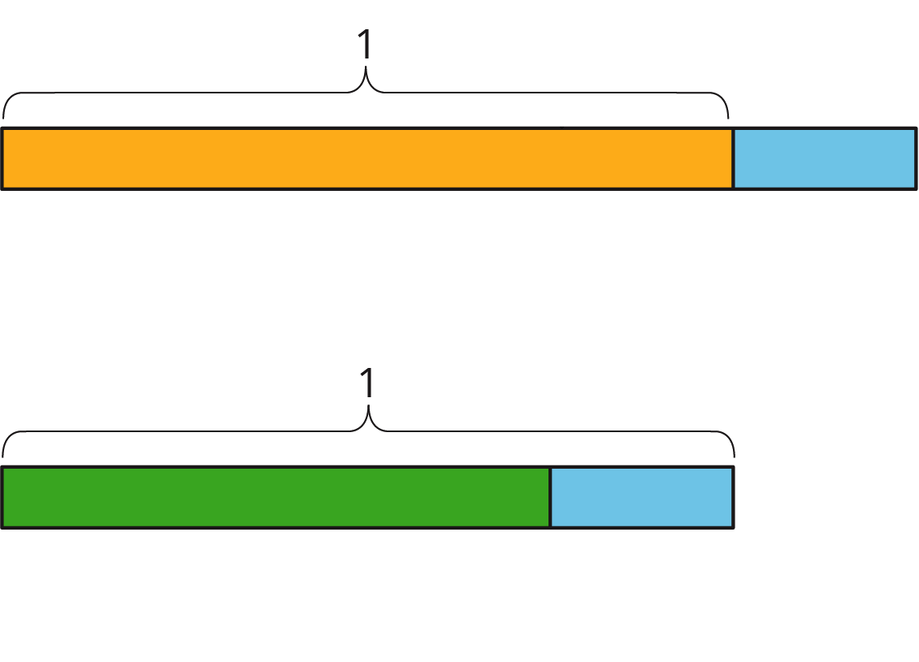

2 Walking Half as Much Again

Images for Launch
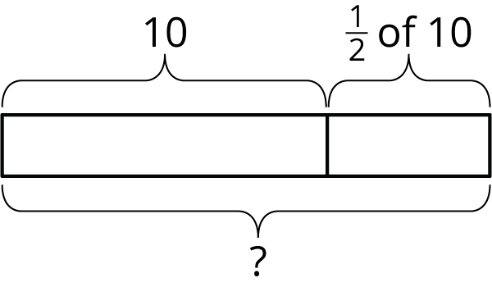

Student Task Statement
- Complete the table to show the total distance walked in each case.
  - Jada’s pet turtle walked 10 feet, and then half that length again.
  - Jada’s baby brother walked 3 feet, and then half that length again.
  - Jada’s hamster walked 4.5 feet, and then half that length again.
  - Jada’s robot walked 1 foot, and then half that length again.
  - A person walked $x$ feet and then half that length again.
- initial distance | - total distance
- 10
- 3
- 4.5
- 1
- $x$
- Explain how you computed the total distance in each case.
- Two students each wrote an equation to represent the relationship between the initial distance walked ($x$) and the total distance walked ($y$).
  - Mai wrote $y=x+\frac{1}{2}x$.
  - Kiran wrote $y=\frac{3}{2}x$.
- Do you agree with either of them? Explain your reasoning.

3 More and Less

Student Task Statement
- Match each situation with a diagram. A diagram may not have a match.
- 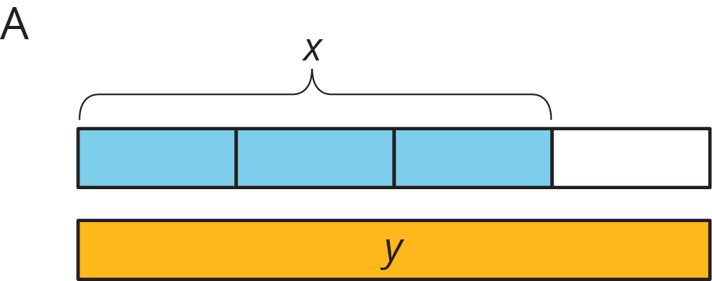
- 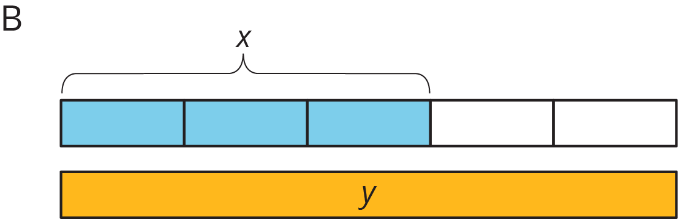
- 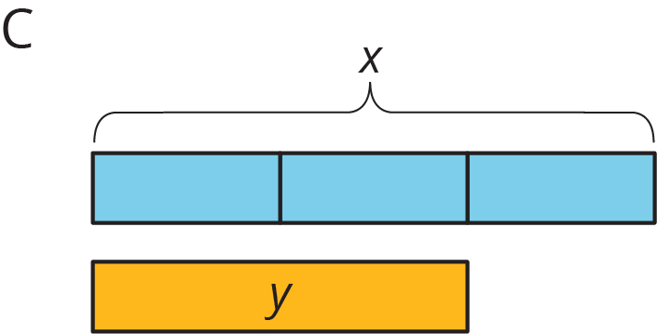
- 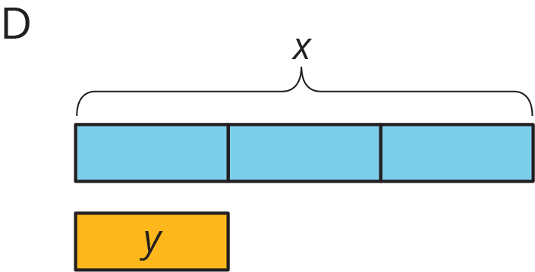
  - Han ate $x$ ounces of blueberries. Mai ate $\frac{1}{3}$ less than that.
  - Mai biked $x$ miles. Han biked $\frac{2}{3}$ more than that.
  - Han bought $x$ pounds of apples. Mai bought $\frac{2}{3}$ of that.
- For each diagram, write an equation that represents the relationship between $x$ and $y$.
  - Diagram A:
  - Diagram B:
  - Diagram C:
  - Diagram D:
- Write a story for one of the diagrams that doesn't have a match.

4 Card Sort: Representations of Proportional Relationships (Optional)

Student Task Statement
Your teacher will give you a set of cards that have proportional relationships represented three different ways: as descriptions, equations, and tables. Mix up the cards and place them all face-up.
- Take turns with a partner to match a description with an equation and a table.
  - For each match you find, explain to your partner how you know it’s a match.
  - For each match your partner finds, listen carefully to their explanation, and if you disagree, explain your thinking.
- When you agree on all of the matches, check your answers with the answer key. If there are any errors, discuss why and revise your matches.
© CC BY Open Up Resources. Adaptations CC BY IM.

