Lesson 1: Formas de ver figuras

Standards Alignments
Addressing | 4.G.A.1, 4.G.A.2
Building Towards | 4.G.A.2

Teacher-facing Learning Goals
- Analyze the attributes of two-dimensional shapes and categorize the shapes in a way that makes sense to them.

Student-facing Learning Goals
- Clasifiquemos figuras de dos dimensiones.

Lesson Purpose
The purpose of this lesson is for students to analyze two-dimensional figures and sort them into different categories based on their attributes.
In grades 2 and 3, students studied some attributes of two-dimensional figures. In a previous unit, they investigated lines, rays, and segments, and drew and measured angles. They learned what it means when two lines or segments are parallel and perpendicular.
In this lesson, students use these understandings to examine attributes of two-dimensional shapes and sort the shapes into categories. As long as students can explain their rationale, they may choose to categorize the shapes using any attribute or combination of attributes—for instance, by the number of sides or angles, measurement of sides or angles, presence of parallel or perpendicular lines, and so on. Although each activity is designed to be open-ended, monitor for students who look for ways to describe or sort their shapes based on the presence or absence of angles of a specified size (right, obtuse, acute), parallel sides, or perpendicular sides. These attributes will be explored more in upcoming lessons.
This unit will continue to introduce new vocabulary to students. They should be encouraged to add to their portable word walls throughout the unit to support successful acquisition of geometry terms.

Access for:

Students with Disabilities
- Engagement (Activity 1)

Instructional Routines
MLR2 Collect and Display (Activity 1), Which One Doesn’t Belong? (Warm-up)

Materials to Gather
- Protractors: Activity 1
- Rulers: Activity 1
- Sticky notes: Activity 1

Materials to Copy
- Shape Cards Grade 4 (groups of 2): Activity 1

Required Preparation

Lesson Timeline
Warm-up | 10 min
Activity 1 | 20 min
Activity 2 | 15 min
Lesson Synthesis | 10 min
Cool-down | 5 min

Teacher Reflection Question
Students learned about angle measurement and parallel lines in an earlier unit. In what ways did you see and hear students building on those ideas when they described and sorted the shapes in this lesson?

Cool-down
(to be completed at the end of the lesson) 5min
¿Qué tienen en común?

Standards Alignments
Building Towards | 4.G.A.2

Student-facing Task Statement
Estas cinco figuras tienen algunas características en común.
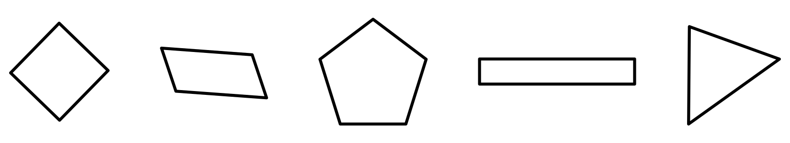
Selecciona todas las afirmaciones que sean verdaderas sobre las características que tienen en común.
- Todas las figuras tienen por lo menos dos lados que tienen la misma longitud.
- Todas las figuras tienen por lo menos un ángulo recto.
- Todas las figuras tienen por lo menos un par de lados paralelos.
- Todas las figuras tienen lados de longitudes diferentes.
- Todas las figuras tienen por lo menos dos ángulos del mismo tamaño.

Student Responses
A and E

