Lesson 10 Practice Problems
- Triangle $ABC$ is dilated using $D$ as the center of dilation with scale factor 2.
- The image is triangle $A^{′}B^{′}C^{′}$. Clare says the two triangles are congruent, because their angle measures are the same. Do you agree? Explain how you know.
- 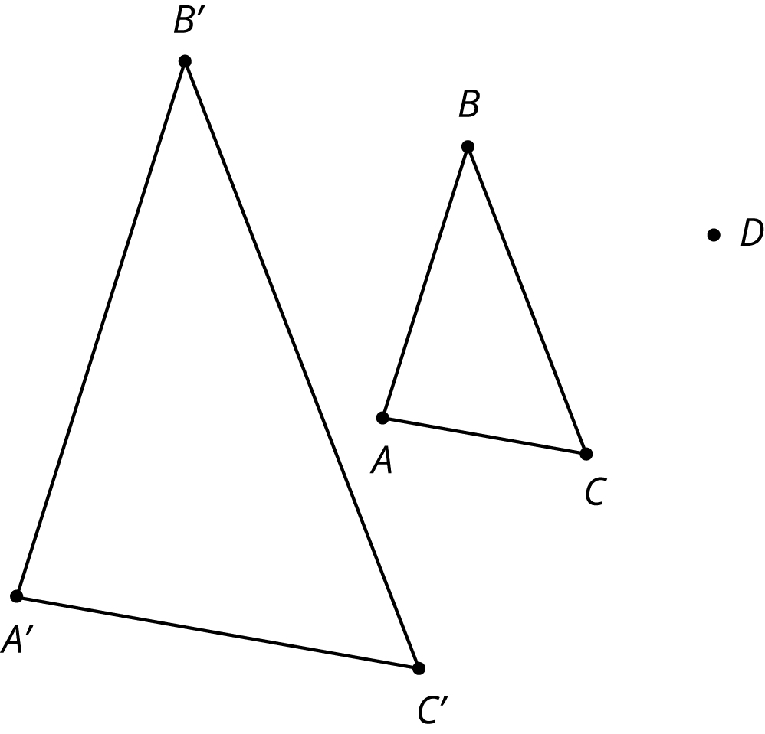
- On graph paper, sketch the image of quadrilateral PQRS under the following dilations:
  - The dilation centered at $R$ with scale factor 2.
  - The dilation centered at $O$ with scale factor $\frac{1}{2}$.
  - The dilation centered at $S$ with scale factor $\frac{1}{2}$.
- 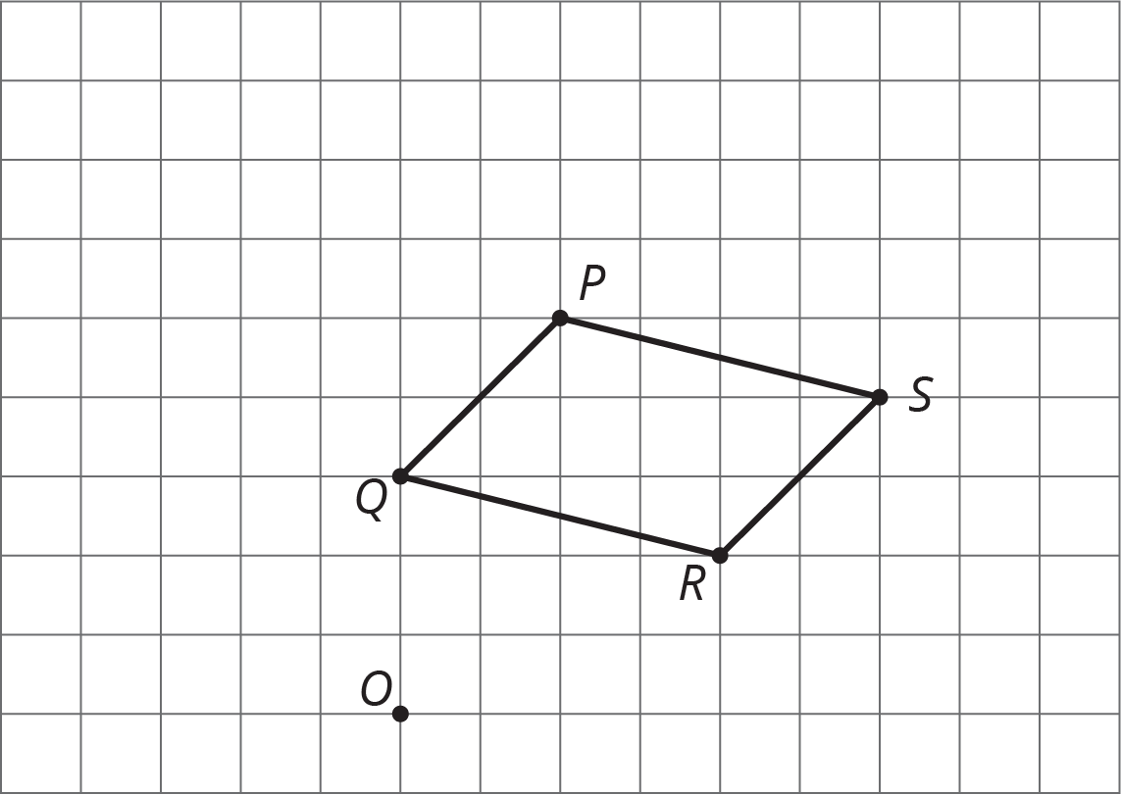
- Quadrilateral $ABCD$ is dilated with center $\left(0,0\right)$, taking $B$ to $B^{′}$. Draw $A^{′}B^{′}C^{′}D^{′}$.
- 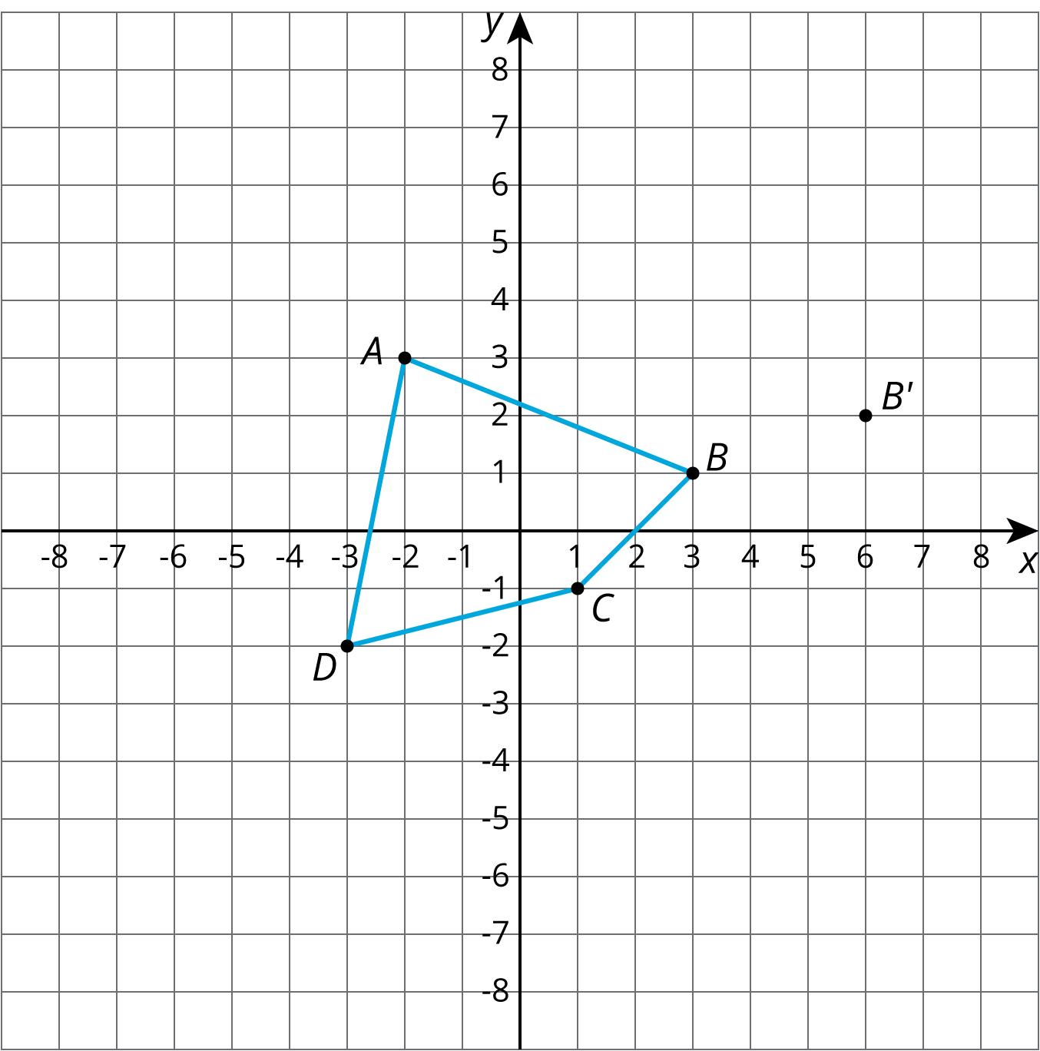
- Triangles $B$ and $C$ have been built by dilating Triangle $A$.
- 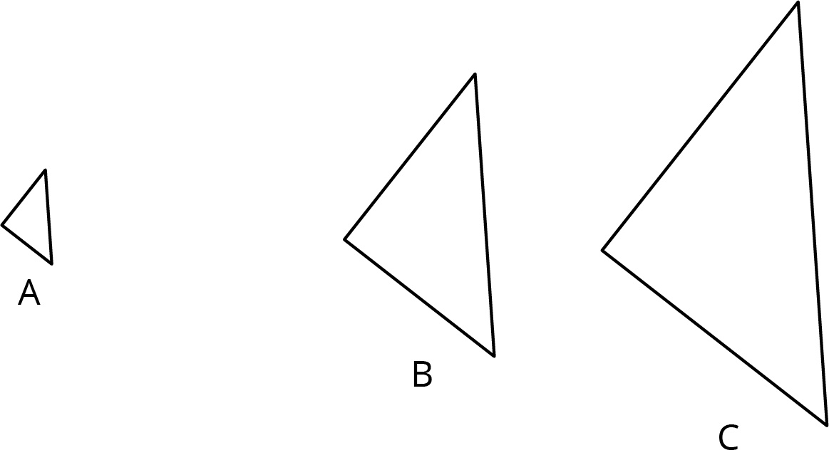
  - Find the center of dilation.
  - Triangle $B$ is a dilation of $A$ with approximately what scale factor?
  - Triangle $A$ is a dilation of $B$ with approximately what scale factor?
  - Triangle $B$ is a dilation of $C$ with approximately what scale factor?
- Here is a triangle.
  - Draw the dilation of triangle $ABC$, with center $\left(0,0\right)$, and scale factor 2. Label this triangle $A^{′}B^{′}C^{′}$.
  - Draw the dilation of triangle $ABC$, with center $\left(0,0\right)$, and scale factor $\frac{1}{2}$. Label this triangle $A^{″}B^{″}C^{″}$.
  - Is $A^{″}B^{″}C^{″}$ a dilation of triangle $A^{′}B^{′}C^{′}$? If yes, what are the center of dilation and the scale factor?
- 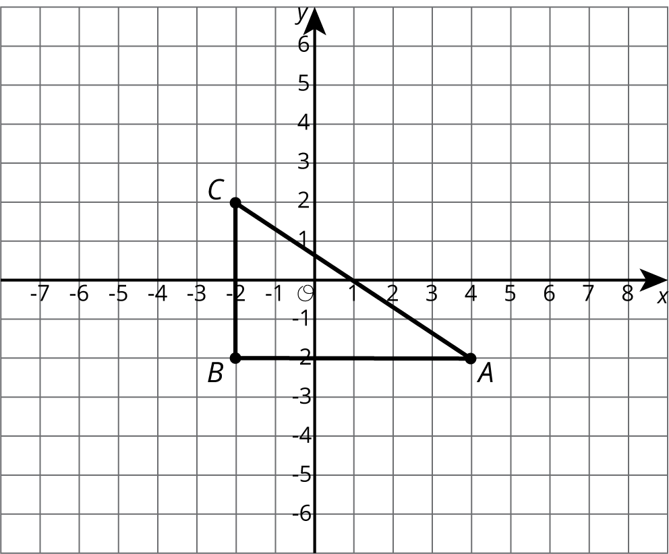

- The diagram shows three lines with some marked angle measures.
- 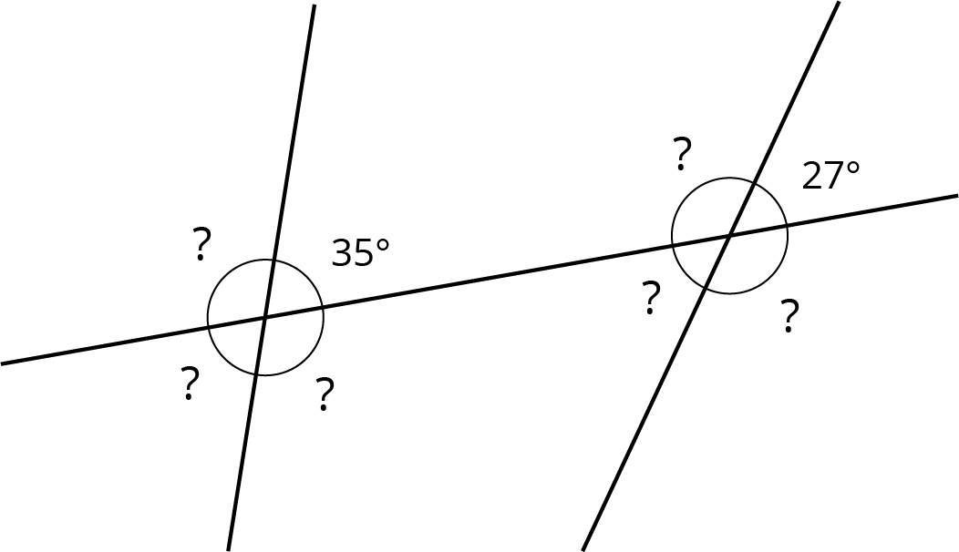
- Find the missing angle measures marked with question marks.
- (From Unit 1, Lesson 12.)
© CC BY Open Up Resources. Adaptations CC BY IM.

