Lesson 7: Areas under a Normal Curve
- Let’s use the normal distribution to estimate the proportion of data values falling within given intervals.

7.1: Find the Areas
The images show a normal curve with mean of 40 and standard deviation of 2.

The area under the curve to the left of 39 is 0.3085.
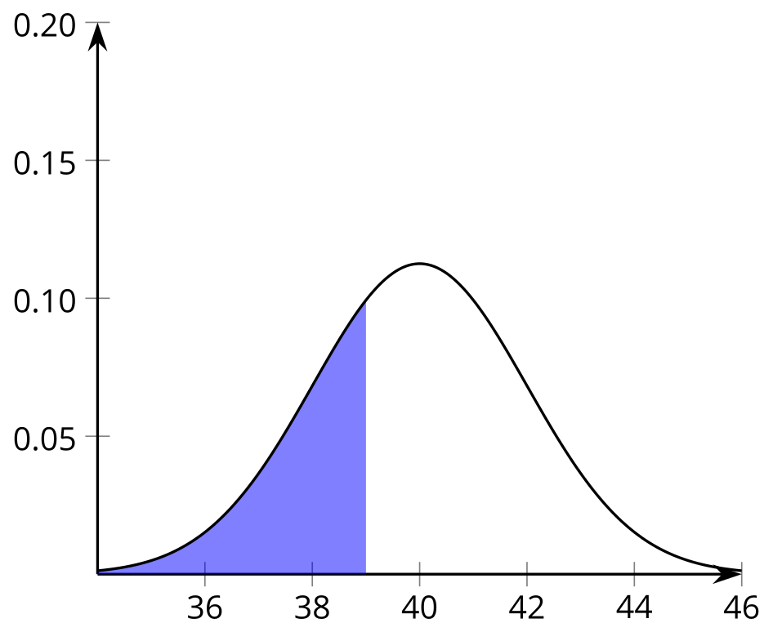

The area under the curve to the left of 43 is 0.9332.
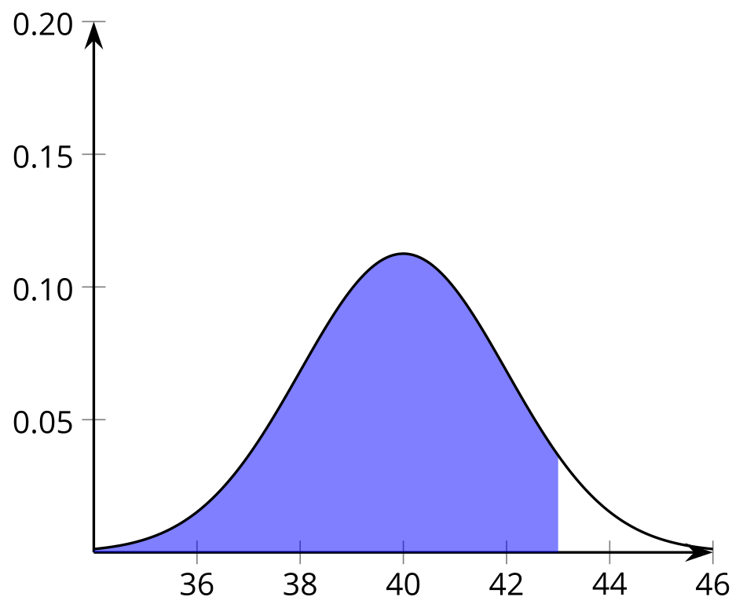
Since it is a normal curve, we know that the total area under the curve is 1. Use the given areas to find the areas in question. Explain your reasoning for each.
- Find the area under the curve to the right of 39.
- Find the area under the curve between 39 and 43.
- Find the area under the curve to the left of 40.
- Find the area under the curve between 39 and 40.

7.2: Life of Lights
The life span of light bulbs is approximately normally distributed. Some statistics about life spans of two different types of light bulbs are listed.
- LED bulbs: mean: 2,300 days, standard deviation: 230 days
- incandescent bulbs: mean: 100 days, standard deviation: 10 days
To estimate the proportion of bulbs that burn out in a certain interval of time, use technology to find the area under the normal curve and above the appropriate interval.
- Estimate the proportion of LED bulbs that are expected to burn out before getting within 1 standard deviation of the mean (before 2,070 days).
- Estimate the proportion of incandescent bulbs that are expected to burn out before getting within 1 standard deviation of the mean (before 90 days).
- Estimate the proportion of LED bulbs that are expected to burn out after getting more than 1 standard deviation greater than the mean (after 2,530 days).
- Estimate the proportion of incandescent bulbs that are expected to burn out after getting more than 1 standard deviation greater than the mean (after 110 days).
- Estimate the proportion of LED bulbs that are expected to burn out in the interval between 1 standard deviation less than the mean and 1 standard deviation greater than the mean (between 2,070 and 2,530 days).
- Estimate the proportion of incandescent bulbs expected to burn out in the interval between 1 standard deviation less than the mean and 1 standard deviation greater than the mean (between 90 and 110 days).
- Estimate the proportion of LED bulbs that are expected to burn out in the interval between 2 standard deviations less than the mean and 2 standard deviations greater than the mean (between 1,840 and 2,760 days).
- Estimate the proportion of LED bulbs that are expected to burn out in the interval between 1,900 days and 2,100 days.
- Estimate the proportion of incandescent bulbs that are expected to burn out in the interval between 107 and 118 days.

7.3: Waiting for a Waiter
The wait times at a popular restaurant are approximately normally distributed. The mean wait time is 24.3 minutes with a standard deviation of 3.2 minutes.
Use technology to estimate the wait times for the described groups of diners.
- Describe the number of minutes diners have to wait if their wait times are in the longest 10% of wait times for diners at this restaurant.
- Describe the number of minutes diners have to wait if their wait times are in the shortest 15% of wait times for diners at this restaurant.
- To find the wait times for the middle 50% of wait times for diners:
  - Draw an example of a normal distribution and shade approximately the middle 50% of the area under the curve.
  - What percentage of the total area is unshaded to the left of the region you shaded? What value marks the line between the unshaded and shaded parts?
  - What percentage of the total area is unshaded to the right of the region you shaded? What value marks the line between the unshaded and shaded parts?
  - The shaded region is between which two values?
- The diners who have wait times in the middle 70% are between which two values?

Are you ready for more?
A normal curve has a mean of 100 and a standard deviation of 10. For each value given, find two different regions that have approximately the given area and shade them in the graphs provided.
- 0.68
- 0.16
- 0.10

Area: 0.68
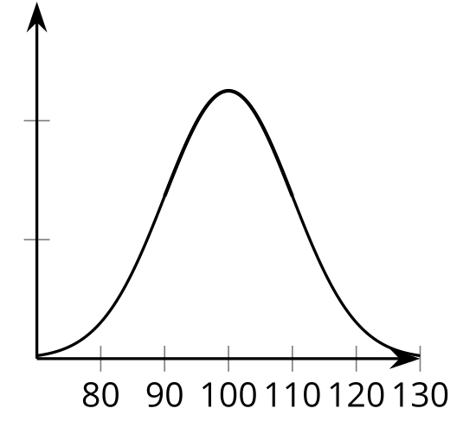

Area: 0.16

Area: 0.10

Area: 0.68

Area: 0.16

Area: 0.10

Lesson 7 Summary
The normal distribution can be used to estimate the proportion of values expected in a certain interval by finding the area under the normal curve and above the interval. Since the total area under a normal curve is 1, the area within any particular interval can be interpreted as the proportion of values that are in that interval.
To find the area, technology or reference tables can be used. When using technology, the system will need to know the mean and standard deviation for the data as well as the boundary values for the region where you want the area.
For example, the weights of large plastic building blocks are approximately normally distributed. The mean weight is 20 grams and the standard deviation is 0.7 grams. Let’s estimate the proportion of all plastic building blocks that weigh between 19.4 and 20.5 grams. This proportion is represented by the shaded area in the figure.
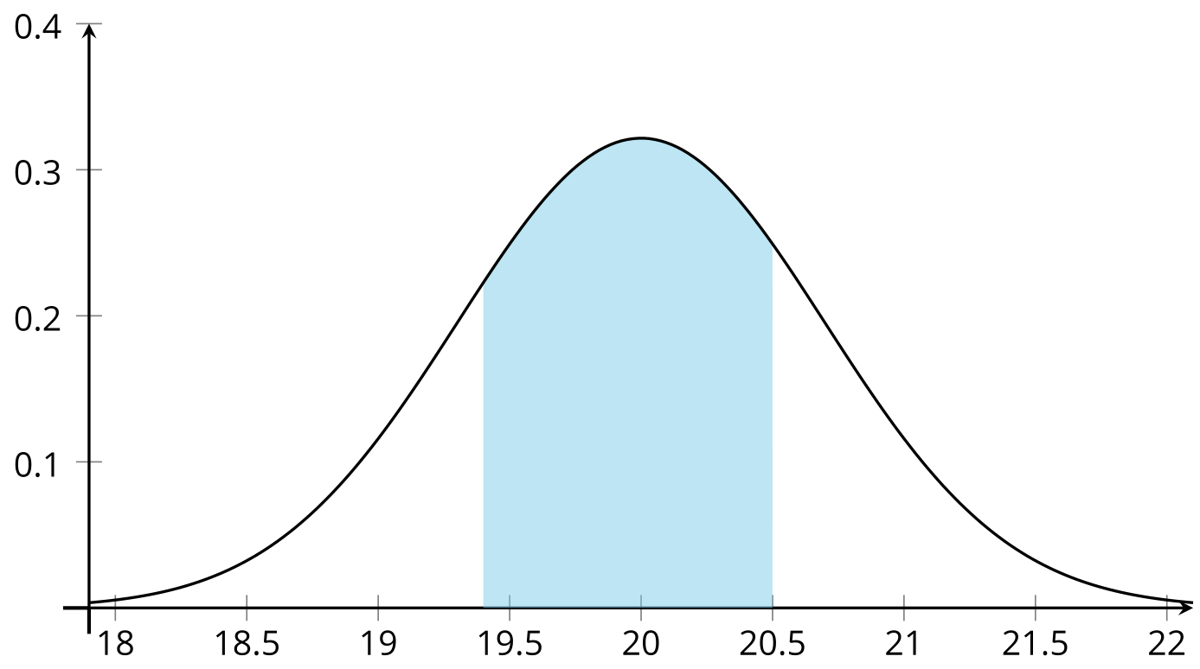
By adding all the information to a technological tool, we find that the proportion of values in this region is 0.5668 or 56.68%. This also means that, when selecting a building block at random, the probability of selecting a block with a weight between 19.4 and 20.5 grams is approximately 0.5668.
© CC BY 2019 by Illustrative Mathematics®

