Unit 4 Lesson 14: Absolute Value Functions (Part 2)

1 Temperature in Toronto (Warm up)

Student Task Statement
Toronto is a city at the border of the United States and Canada, just north of Buffalo, New York. Here are twelve guesses of the average temperature of Toronto, in degrees Celsius, in February 2017.
5 | 2 | -5 | 3 | 0 | -1 | 1.5 | 4
-2.5 | 6 | 4 | -0.5

- The actual average temperature of Toronto in February 2017 is 0 degree Celsius.
- Use this information to sketch a scatter plot representing the guesses, $x$, and the corresponding absolute guessing errors, $y$.
- 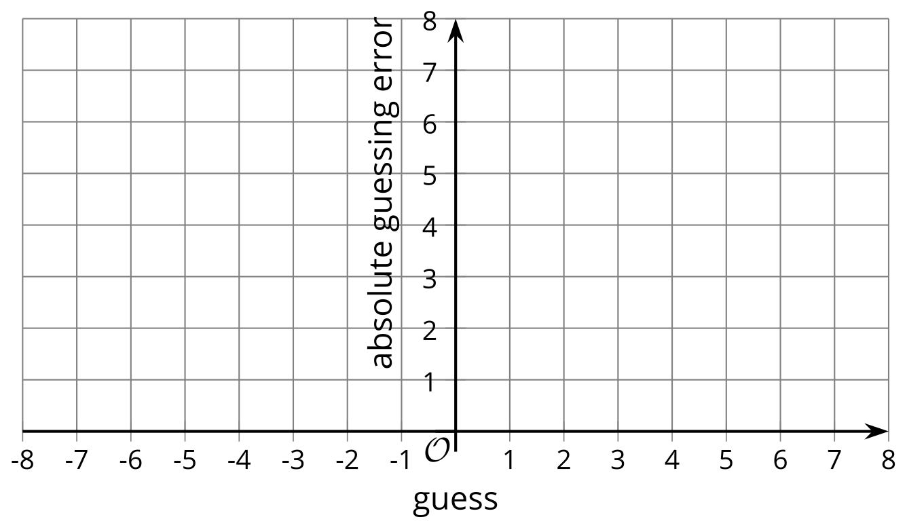
- What rule can you write to find the output given the input?

2 The Distance Function

Student Task Statement
The function $A$ gives the distance of $x$ from 0 on the number line.
- Complete the table and sketch a graph of function $A$.
- $x$ | - $A\left(x\right)$
- 8
 | - 5.6
- $π$
- $\frac{1}{2}$
 | - 1
- 0
- $\text{-}\frac{1}{2}$
- -1
- -5.6
 | - 8
- 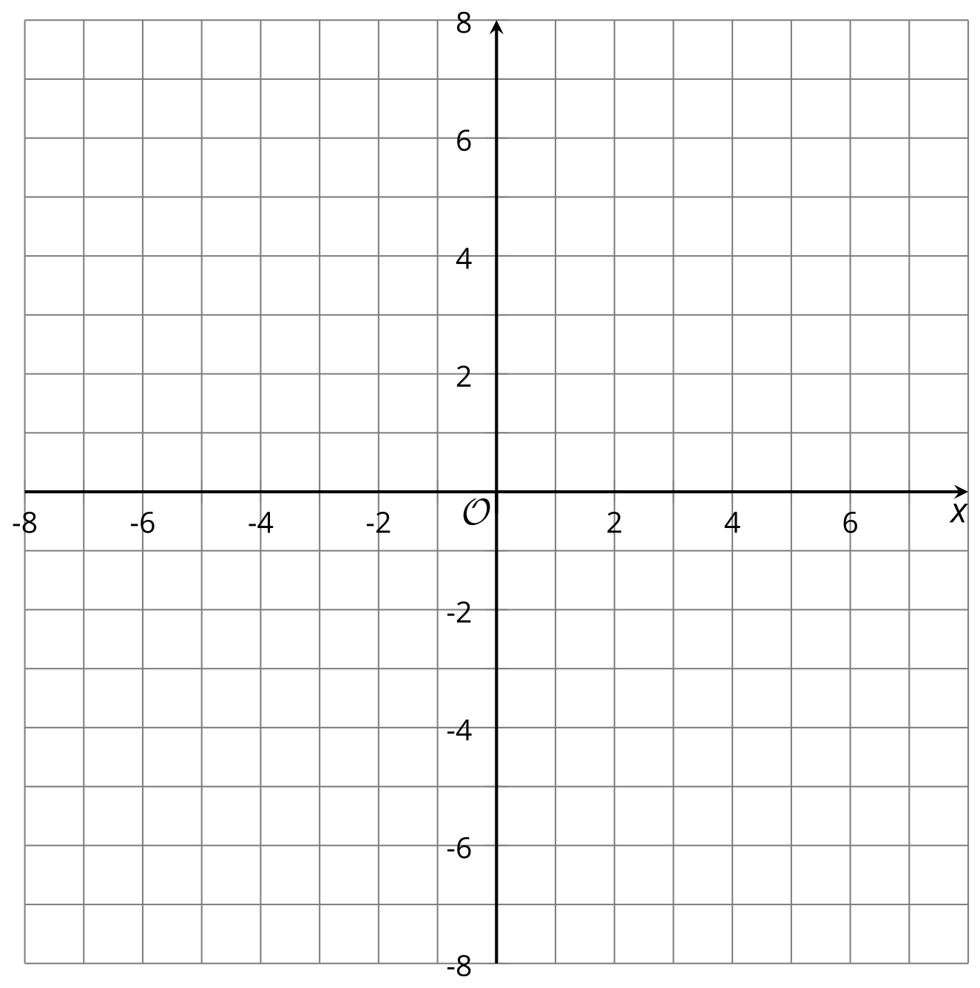
- Andre and Elena are trying to write a rule for this function.
  - Andre writes: $A\left(x\right)=\left\{\begin{matrix}x, & x≥0 \\ \text{-}x, & x<0\end{matrix}\right.$
  - Elena writes: $A\left(x\right)=\left|x\right|$
- Explain why both equations correctly represent the function $A$.

3 Moving Graphs Around

Student Task Statement
Here are equations and graphs that represent five absolute value functions.

$f\left(x\right)=\left|x\right|$
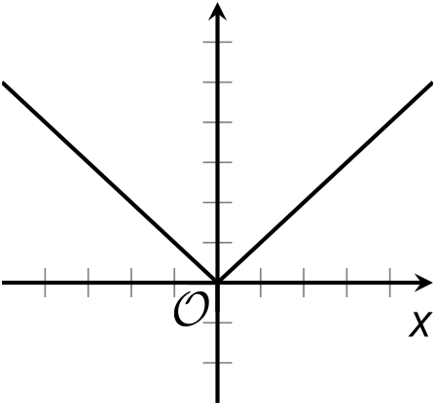

$g\left(x\right)=\left|x−2\right|$
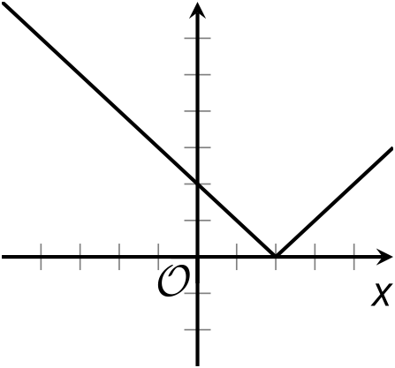

$h\left(x\right)=\left|x+2\right|$
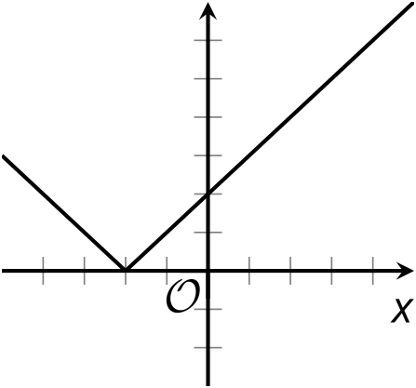

$j\left(x\right)=\left|x\right|−2$
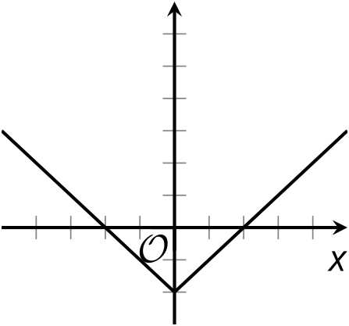

$k\left(x\right)=\left|x\right|+2$
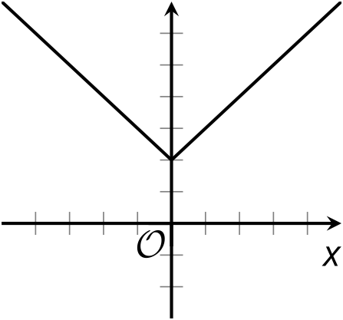
Notice that the number 2 appears in the equations for functions $g,h,j$, and $k$. Describe how the addition or subtraction of 2 affects the graph of each function.
Then, think about a possible explanation for the position of the graph. How can you show that it really belongs where it is on the coordinate plane?

Activity Synthesis
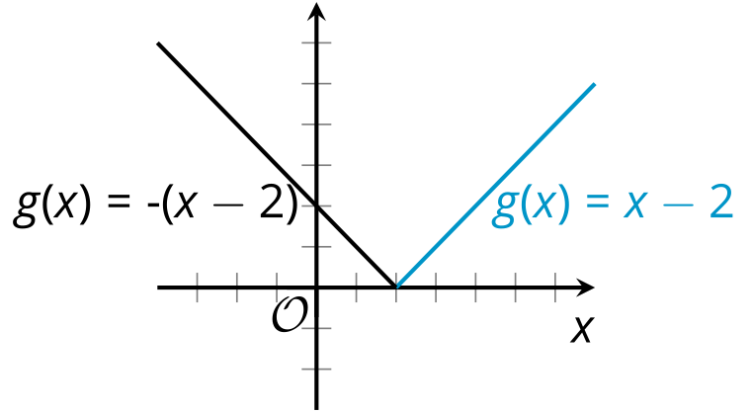

4 More Moving Graphs Around (Optional)

Student Task Statement
Here are five equations and four graphs.
- Equation 1: $y=\left|x−3\right|$
- Equation 2: $y=\left|x−9\right|+3$
- Equation 3: $y=\left|x\right|−6$
- Equation 4: $y=\left|x+3\right|$
- Equation 5: $y=\left|x+3\right|−6$

A
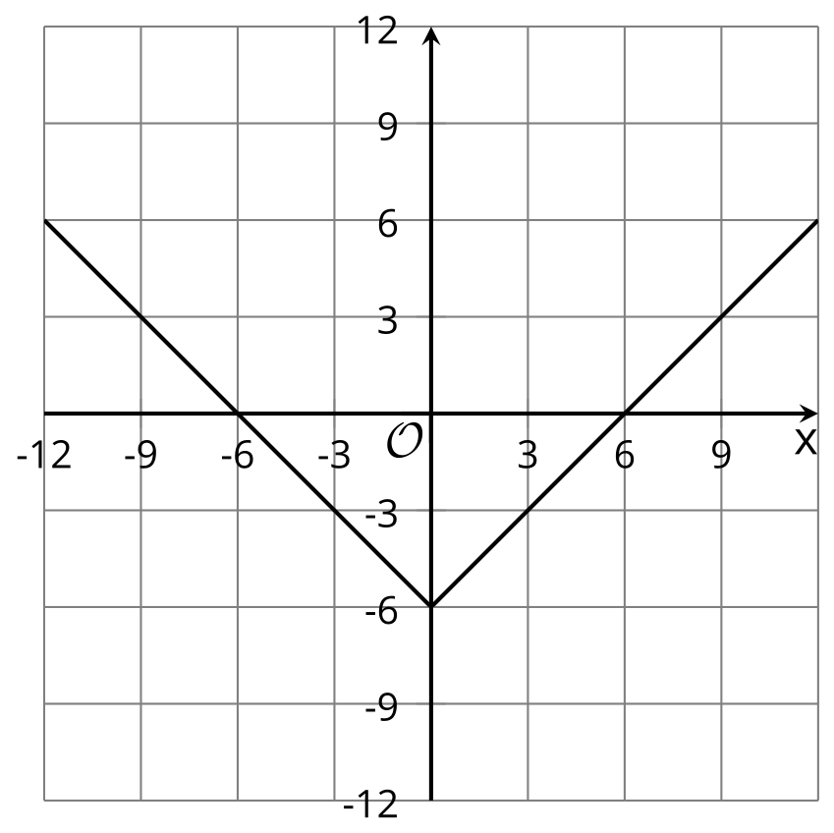

B
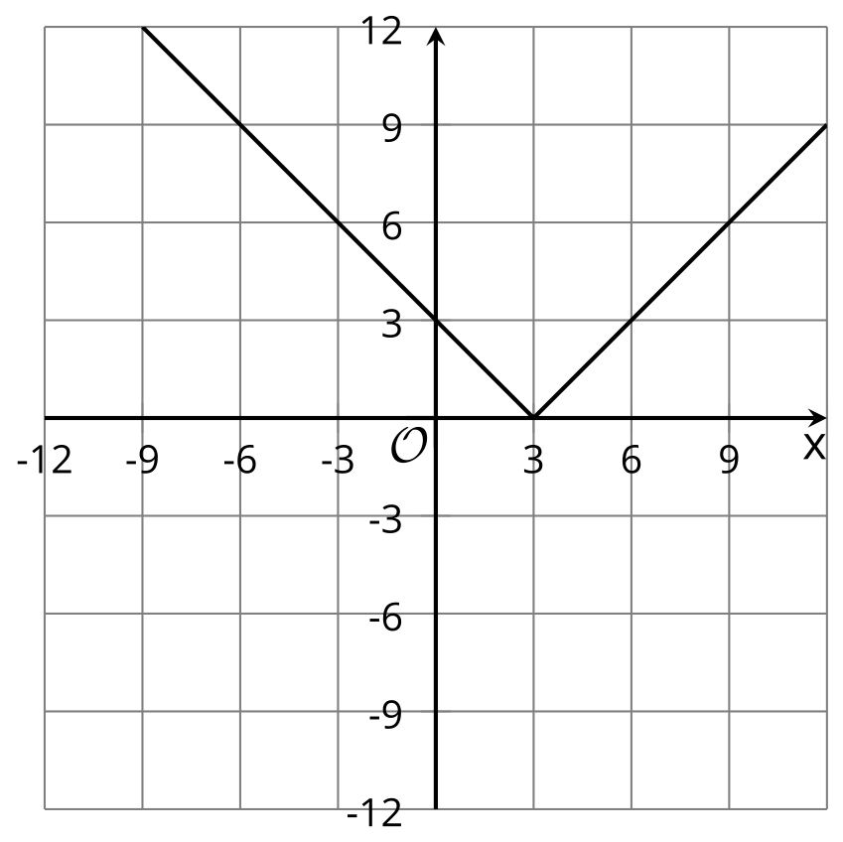

C
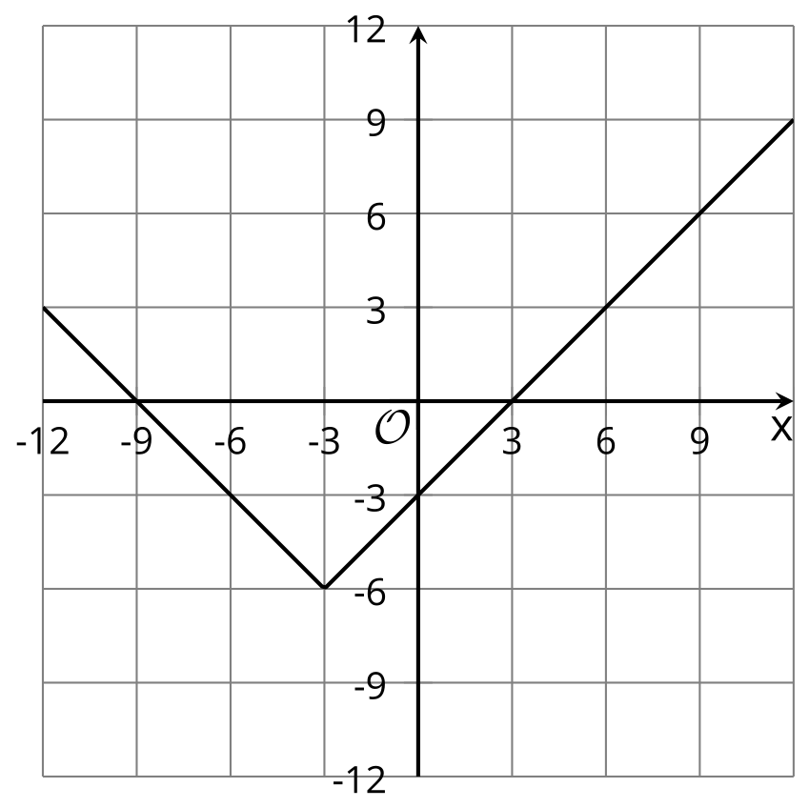

D
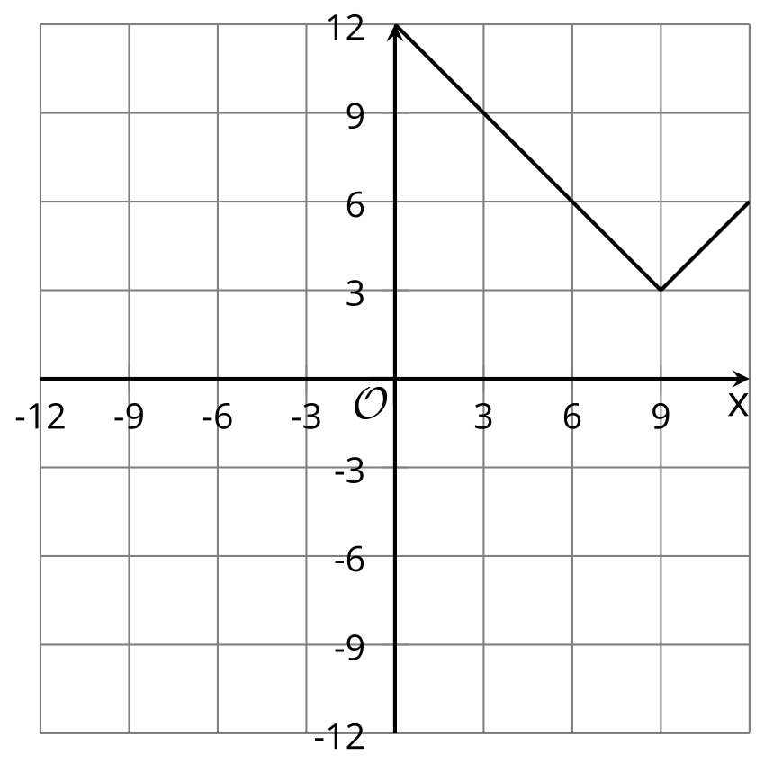

E
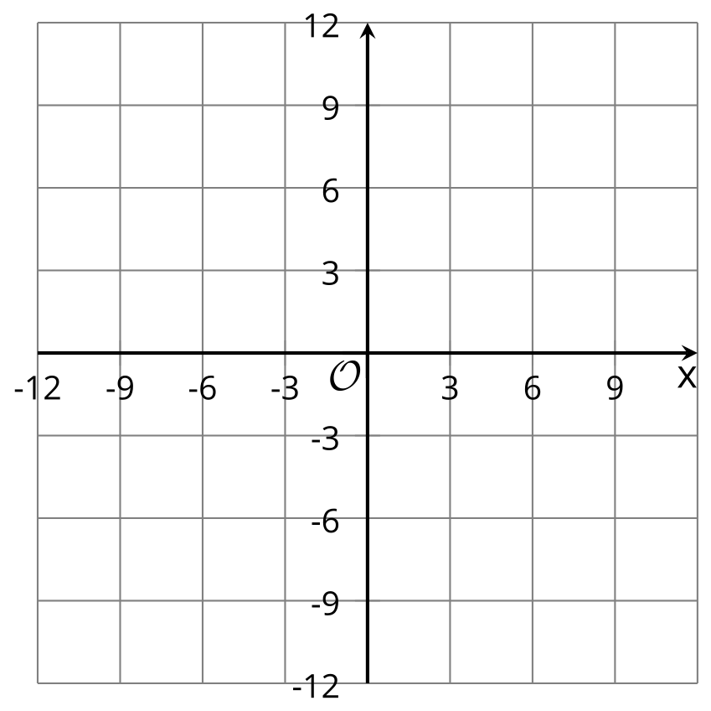
- Match each equation with a graph that represents it. One equation has no match.
- For the equation without a match, sketch a graph on the blank coordinate plane.
- Use graphing technology to check your matches and your graph. Revise your matches and graphs as needed.
© CC BY 2019 by Illustrative Mathematics®

