Unit 1 Lesson 17: Rotate and Tessellate

1 Deducing Angle Measures (Warm up)

Student Task Statement
Your teacher will give you some shapes.
- How many copies of the equilateral triangle can you fit together around a single vertex, so that the triangles’ edges have no gaps or overlaps? What is the measure of each angle in these triangles?
- What are the measures of the angles in the
  - square?
  - hexagon?
  - parallelogram?
  - right triangle?
  - octagon?
  - pentagon?

2 Tessellate This

Images for Launch
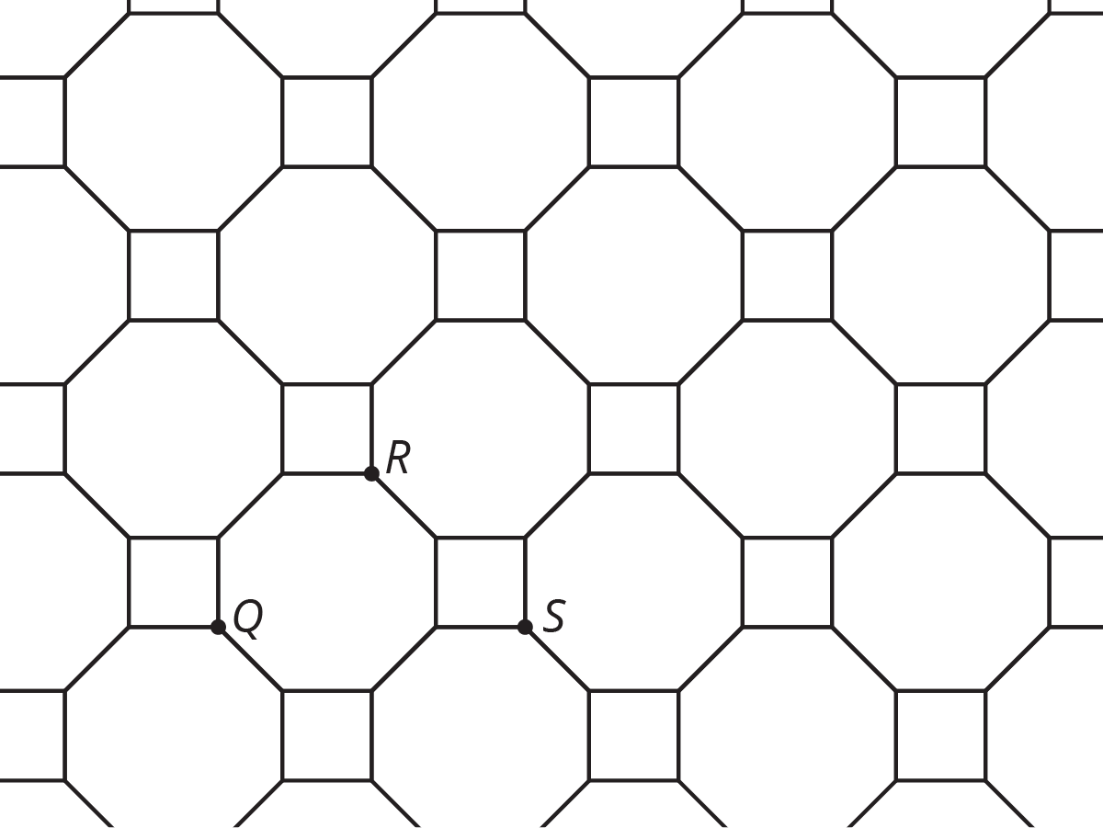

Student Task Statement
- Design your own tessellation. You will need to decide which shapes you want to use and make copies. Remember that a tessellation is a repeating pattern that goes on forever to fill up the entire plane.
- Find a partner and trade pictures. Describe a transformation of your partner’s picture that takes the pattern to itself. How many different transformations can you find that take the pattern to itself? Consider translations, reflections, and rotations.
- If there’s time, color and decorate your tessellation.

3 Rotate That

Images for Launch
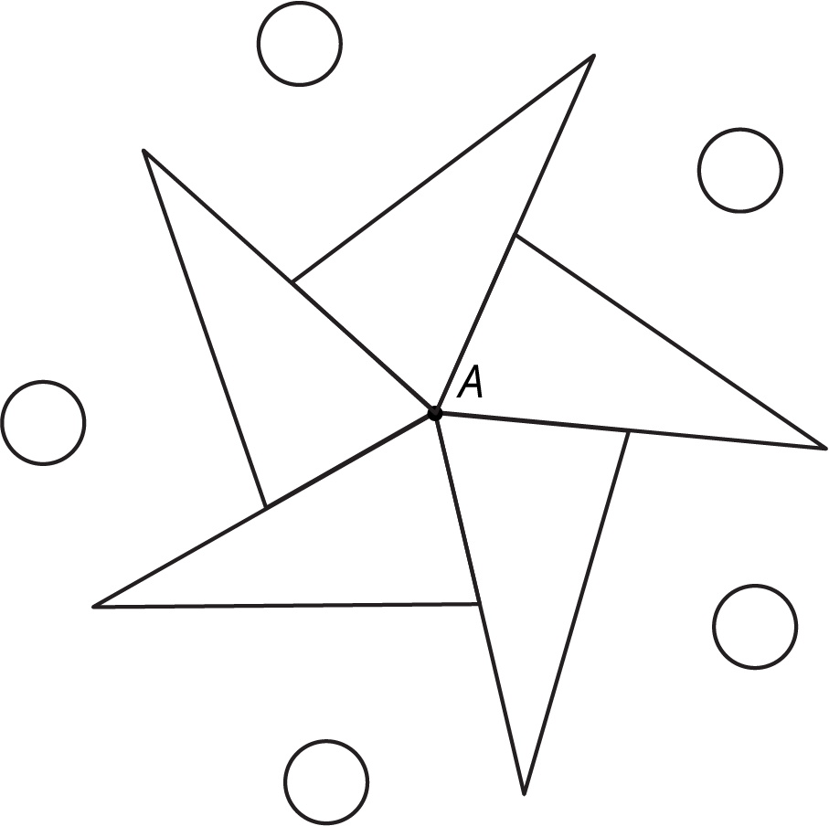

Student Task Statement
- Make a design with rotational symmetry.
- Find a partner who has also made a design. Exchange designs and find a transformation of your partner’s design that takes it to itself. Consider rotations, reflections, and translations.
- If there’s time, color and decorate your design.
© CC BY Open Up Resources. Adaptations CC BY IM.

