Lesson 18: Which One Doesn’t Belong?
- Let’s create a Which One Doesn’t Belong.

Warm-up: Which One Doesn’t Belong? Volume
Which one doesn’t belong?
A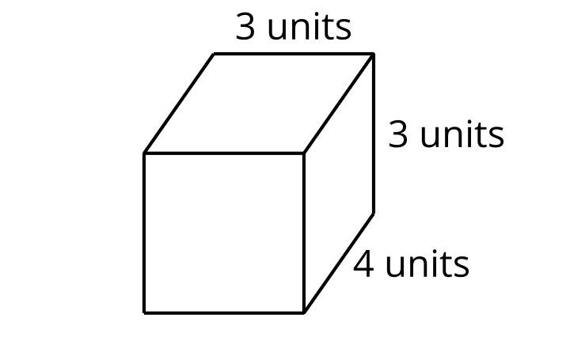
B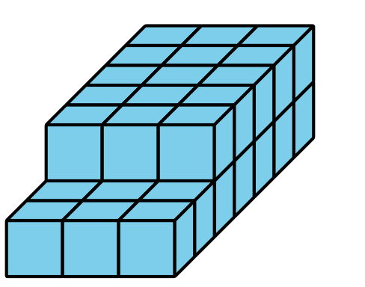
C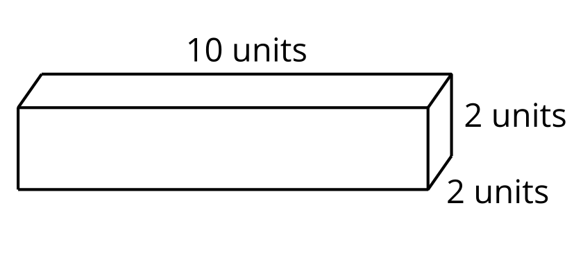
D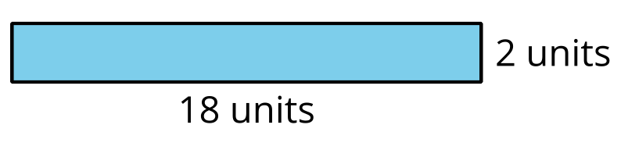

18.1: Which One Doesn't Belong? Design 1
- Choose 3 shapes from the set of cards.
- Draw a fourth shape to complete the Which One Doesn’t Belong.
- For each shape, discuss one reason why it does not belong.
Which one doesn’t belong?
A
B
C
D

18.2: Which One Doesn't Belong? Design 2
- Choose 2 shapes from the set of cards.
- Draw a third and fourth shape to complete the Which One Doesn’t Belong.
- For each shape, discuss one reason why it does not belong.
Which one doesn’t belong?
A
B
C
D

18.3: Which One Doesn't Belong? Design 3
Create your own Which One Doesn’t Belong about any mathematical idea you want others to notice.
Which one doesn't belong?
A
B
C
D
© CC BY 2021 Illustrative Mathematics®

