Lesson 7: Addition and Subtraction on the Number Line

Standards Alignments
Addressing | 2.MD.B.6

Teacher-facing Learning Goals
- Recognize that on a number line, jumps to the right represent addition and jumps to the left represent subtraction.

Student-facing Learning Goals
- Let’s match equations to number line representations.

Lesson Purpose
The purpose of this lesson is for students to attend to the direction of the arrow on the number line to match addition and subtraction expressions.
In previous lessons, students learned that whole numbers can be represented by tick marks and points on the number line. They learned that numbers farther to the right on a number line are greater than those to the left.
In this lesson, students build on that understanding to connect representations that use an arrow to show moving from one number to another on the number line (“jumps”) to the operations of addition and subtraction. Students match equations and number line representations and explain how they know they match (MP2, MP7).

Access for:

Students with Disabilities
- Engagement (Activity 1)

English Learners
- MLR7 (Activity 2)

Instructional Routines
Notice and Wonder (Warm-up)

Materials to Gather
- Glue: Activity 2
- Scissors: Activity 2

Lesson Timeline
Warm-up | 10 min
Activity 1 | 15 min
Activity 2 | 20 min
Lesson Synthesis | 10 min
Cool-down | 5 min

Teacher Reflection Question
How did students work with locating and labeling numbers on the number line prepare them to connect the direction of arrows to addition and subtraction on the number line? What can you do in the next lesson to build on this understanding?

Cool-down
(to be completed at the end of the lesson) 5min
Addition and Subtraction Expressions on a Number Line

Standards Alignments
Addressing | 2.MD.B.6

Student-facing Task Statement

  - Circle the number line that represents 5 + 3.
  - 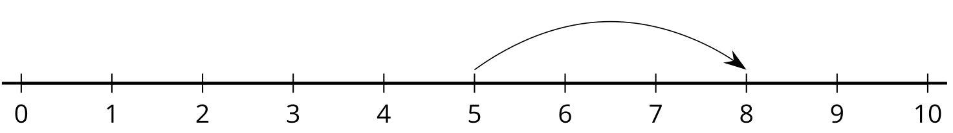
  - 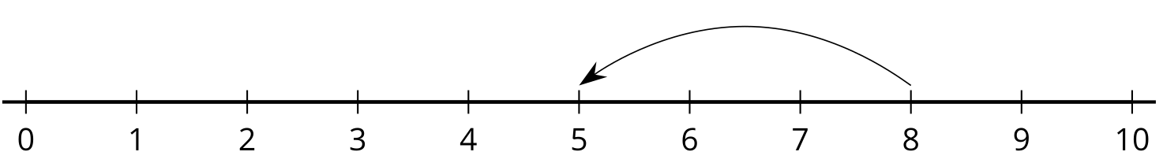
  - Explain why you chose it.

Student Responses

  - The first number line diagram.
  - Sample response: This represents $5+3$ because it starts on 5 and jumps 3 more. I know that $5+3=8$.

