Unit 3 Lesson 28: Around the Room

WU Notice and Wonder: Counting Things in the Classroom (Warm up)

Student Task Statement
What do you notice?
What do you wonder?
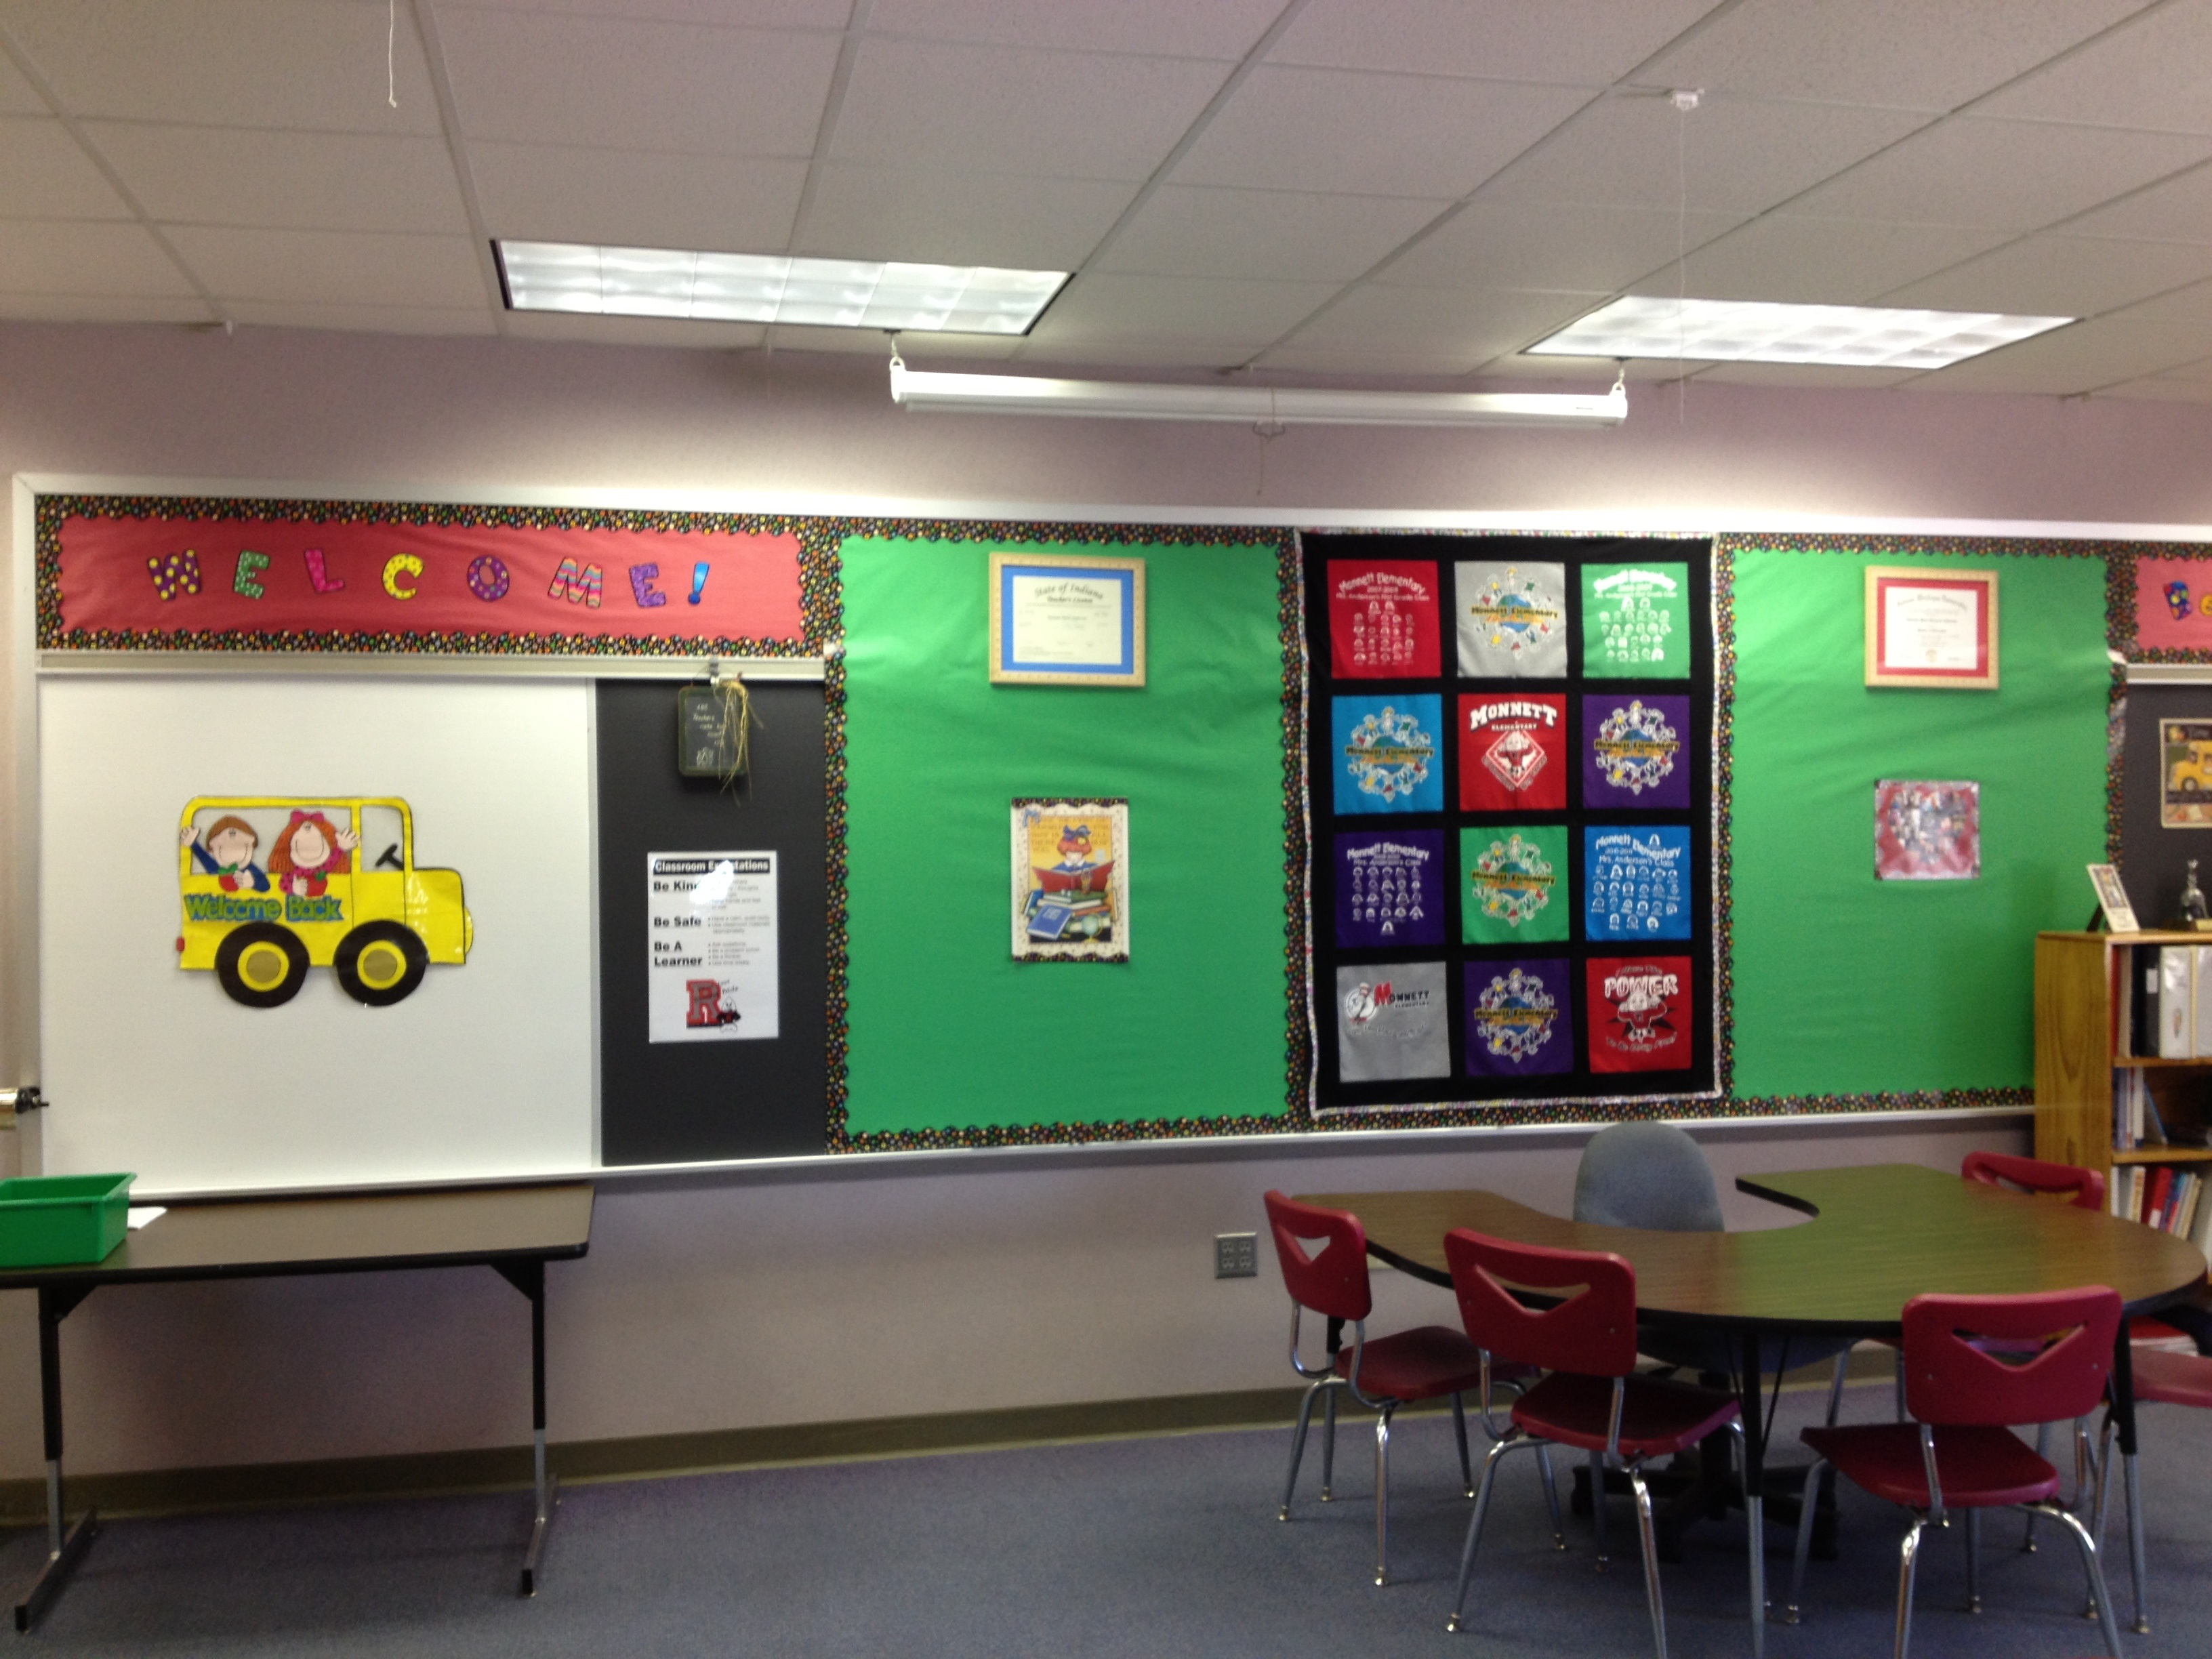

1 Writing Classroom Story Problems

Student Task Statement
Noah had 8 pencils.
Elena had 5 pencils.
Han had 4 pencils.
- Addition story problem:
- Solve the story problem.
Show your thinking using drawings, numbers, or words.
- Equation: ________________________________
- Subtraction story problem:
- Solve the story problem.
Show your thinking using drawings, numbers, or words.
- Equation: ________________________________

2 Story Problem Posters

Student Task Statement

3 Poster Gallery Walk

Student Task Statement
Let’s solve our classmates’ story problems.
- Solve the story problem using drawings, numbers, or words.
- Equation: ________________________________
- Solve the story problem using drawings, numbers, or words.
- Equation: ________________________________
- Solve the story problem using drawings, numbers, or words.
- Equation: ________________________________
- Solve the story problem using drawings, numbers, or words.
- Equation: ________________________________
© CC BY 2021 Illustrative Mathematics®

