Unit 7 Lesson 4: Draw Flat Shapes

WU Notice and Wonder: Dot Paper (Warm up)

Student Task Statement
What do you notice?
What do you wonder?
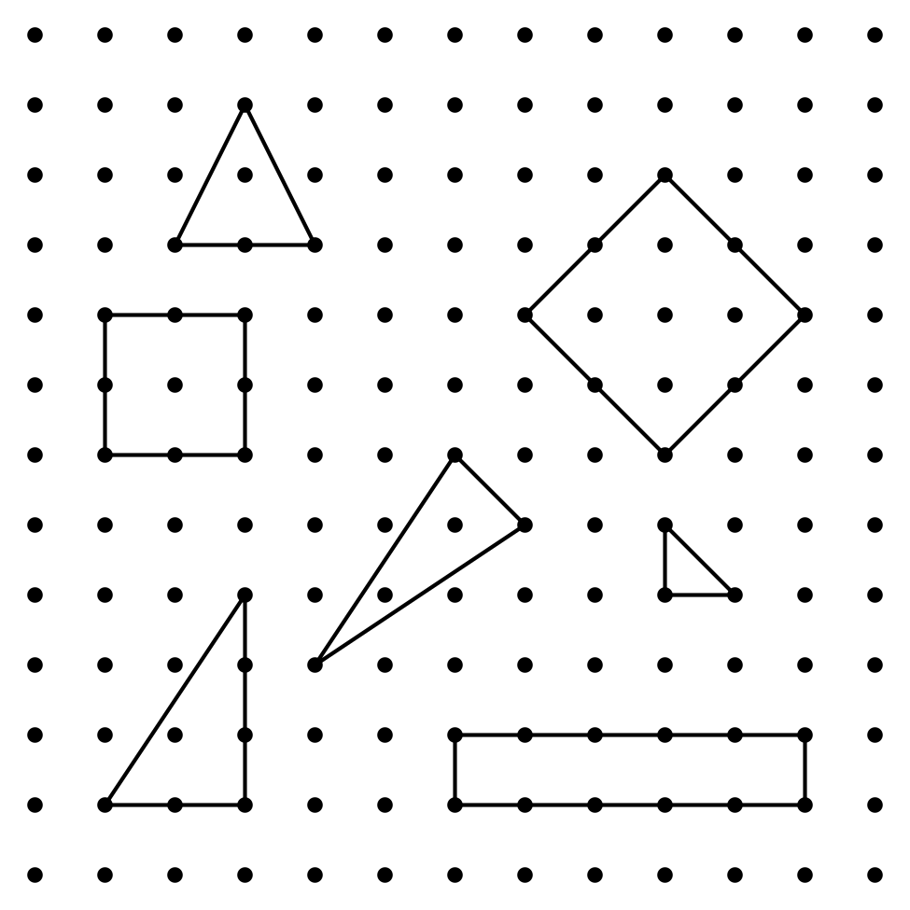

1 Draw Shapes on Dot Paper

Student Task Statement
- Pick a shape card.
- Each partner draws the shape on dot paper.
- Take turns describing the shape you drew.

2 Introduce How Are They the Same, Grade 1 Shapes

Student Task Statement

3 Centers: Choice Time

Student Task Statement
Choose a center.
Capture Squares
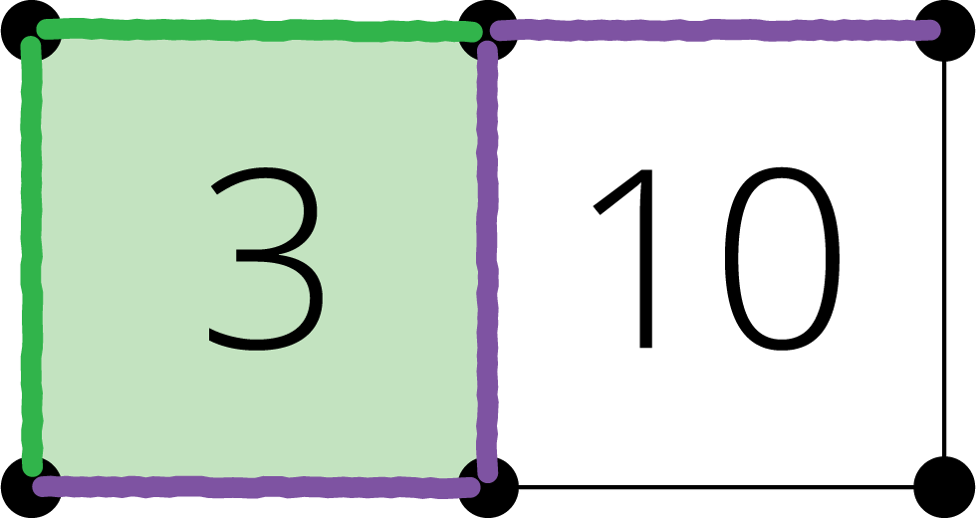
Compare
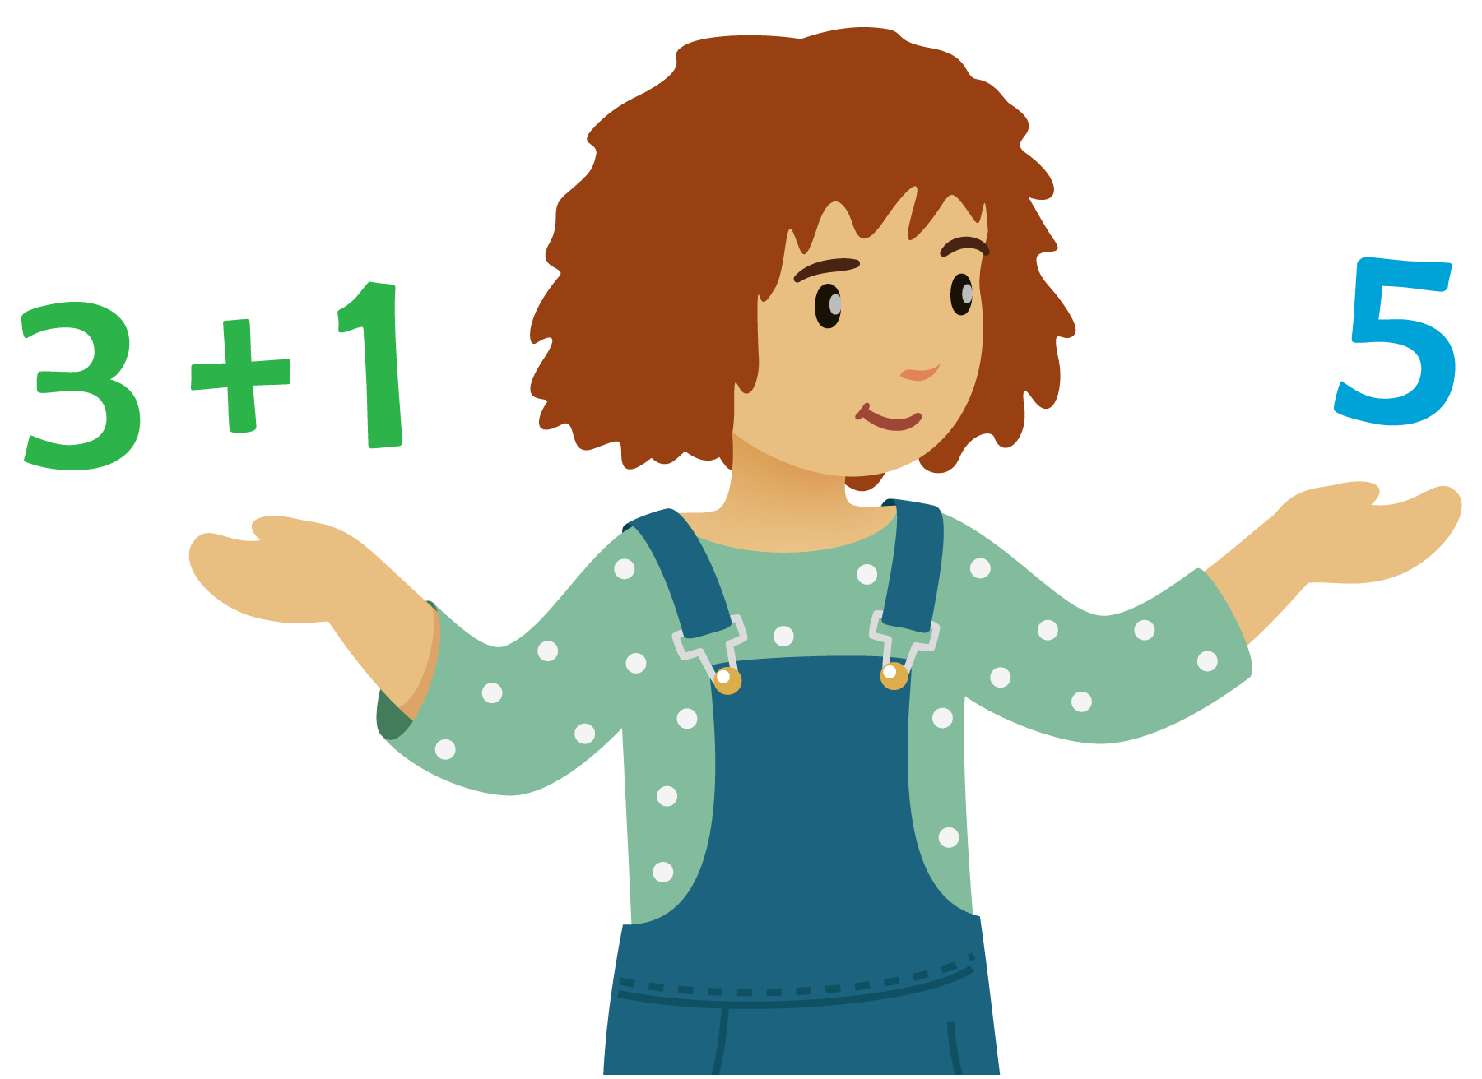
How Close?
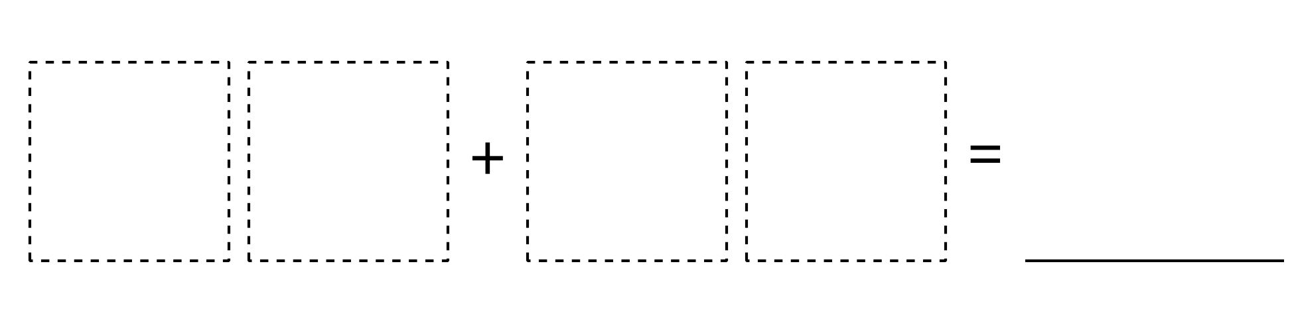
© CC BY 2021 Illustrative Mathematics®

