Lesson 22: School Community Garden

Warm-up: Notice and Wonder: Garden
What do you notice? What do you wonder?
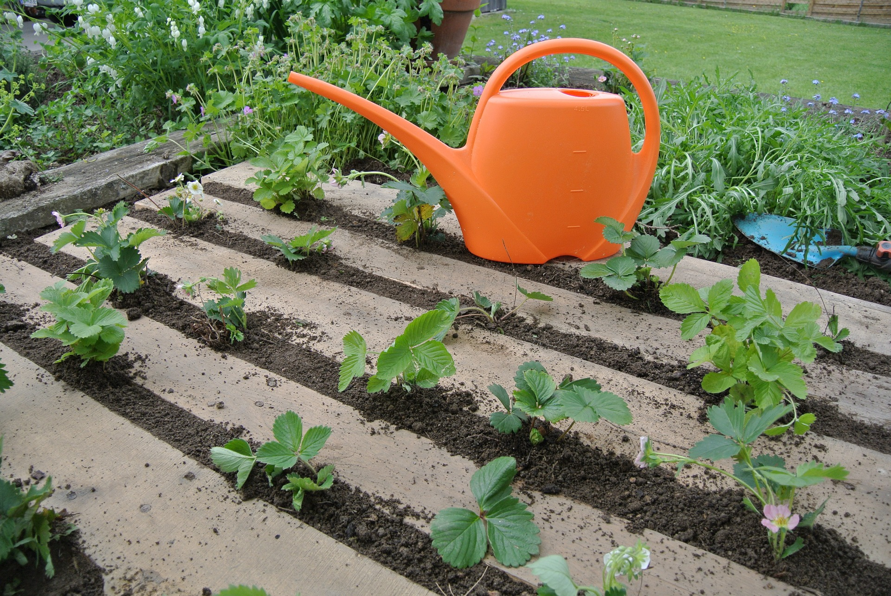

22.1: Produce
For each situation, draw a diagram and write an equation or expression.
- A strawberry patch has 7 rows with 8 strawberry plants in each row.
  - How many strawberry plants are in the patch?
  - 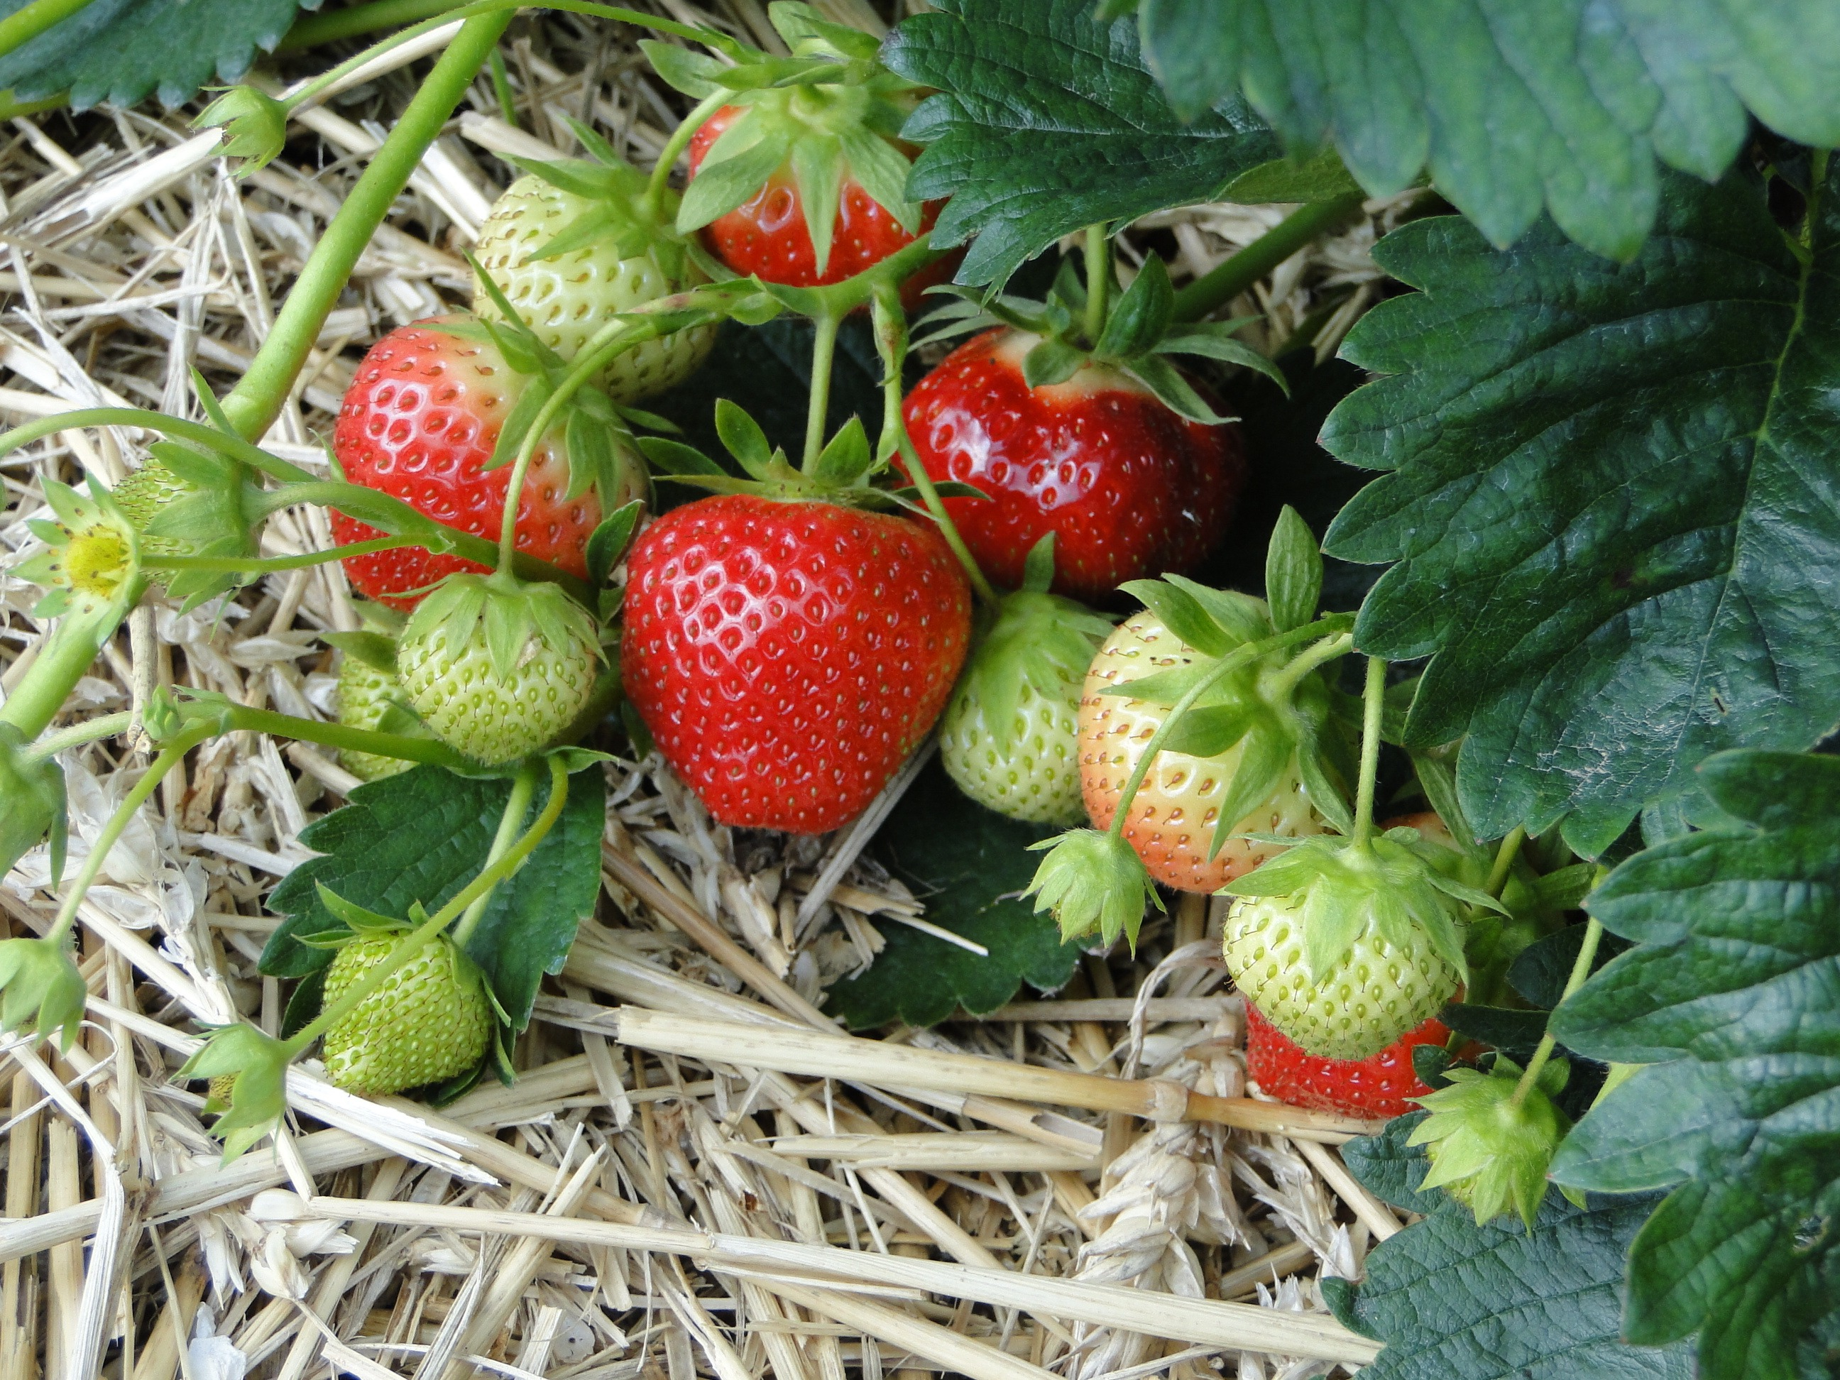
  - To grow strawberries in the best way, the rows should be 4 feet apart. Each plant in the row should be 2 feet apart. How long and wide is the strawberry patch?
  - You can harvest 12 strawberries per plant. How many strawberries will grow in each row?
- With your partner, take turns explaining where you see the numbers in the expression or equation you wrote in your diagram.

22.2: Plan the Garden
- Read the information about some plants you could grow in a garden. Then, circle 2 plants to grow in your part of the school garden.
  - strawberries
  - cantaloupe
  - zucchini
  - tomatoes
  - pinto beans
  - potatoes
- Plan your garden. Both of your plants should harvest between 50–100 fruits or vegetables.
  - How many of each plant will you grow?
  - Predict how many fruits or vegetables you will harvest. Show or explain your reasoning.
- Make a diagram that shows how the plants are arranged and how much space is needed.
Growing Requirements
strawberries
- Grow in patches
- Space rows: 4 feet apart
- Space plants: 2 feet apart
- Each plant produces 12 strawberries.
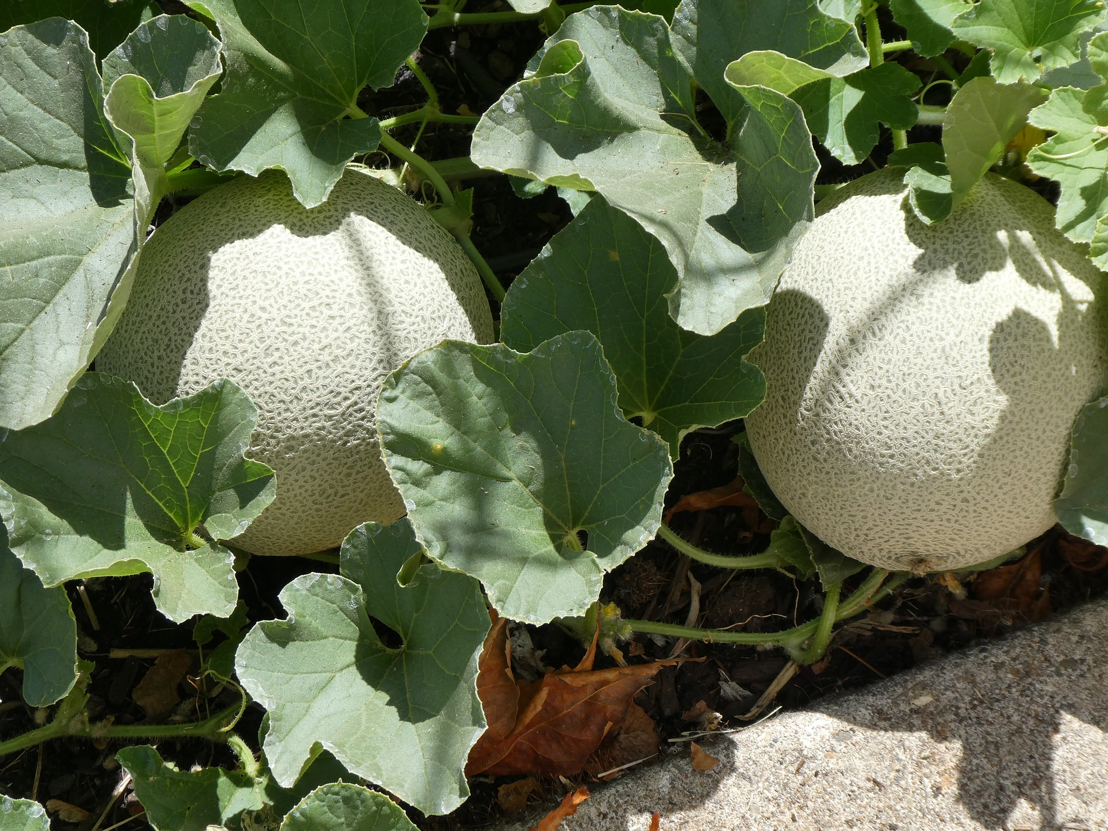
cantaloupes
- Grow on vines
- Space rows: 4 feet apart
- Space plants: 1 foot apart
- Each plant produces about 8 cantaloupes.
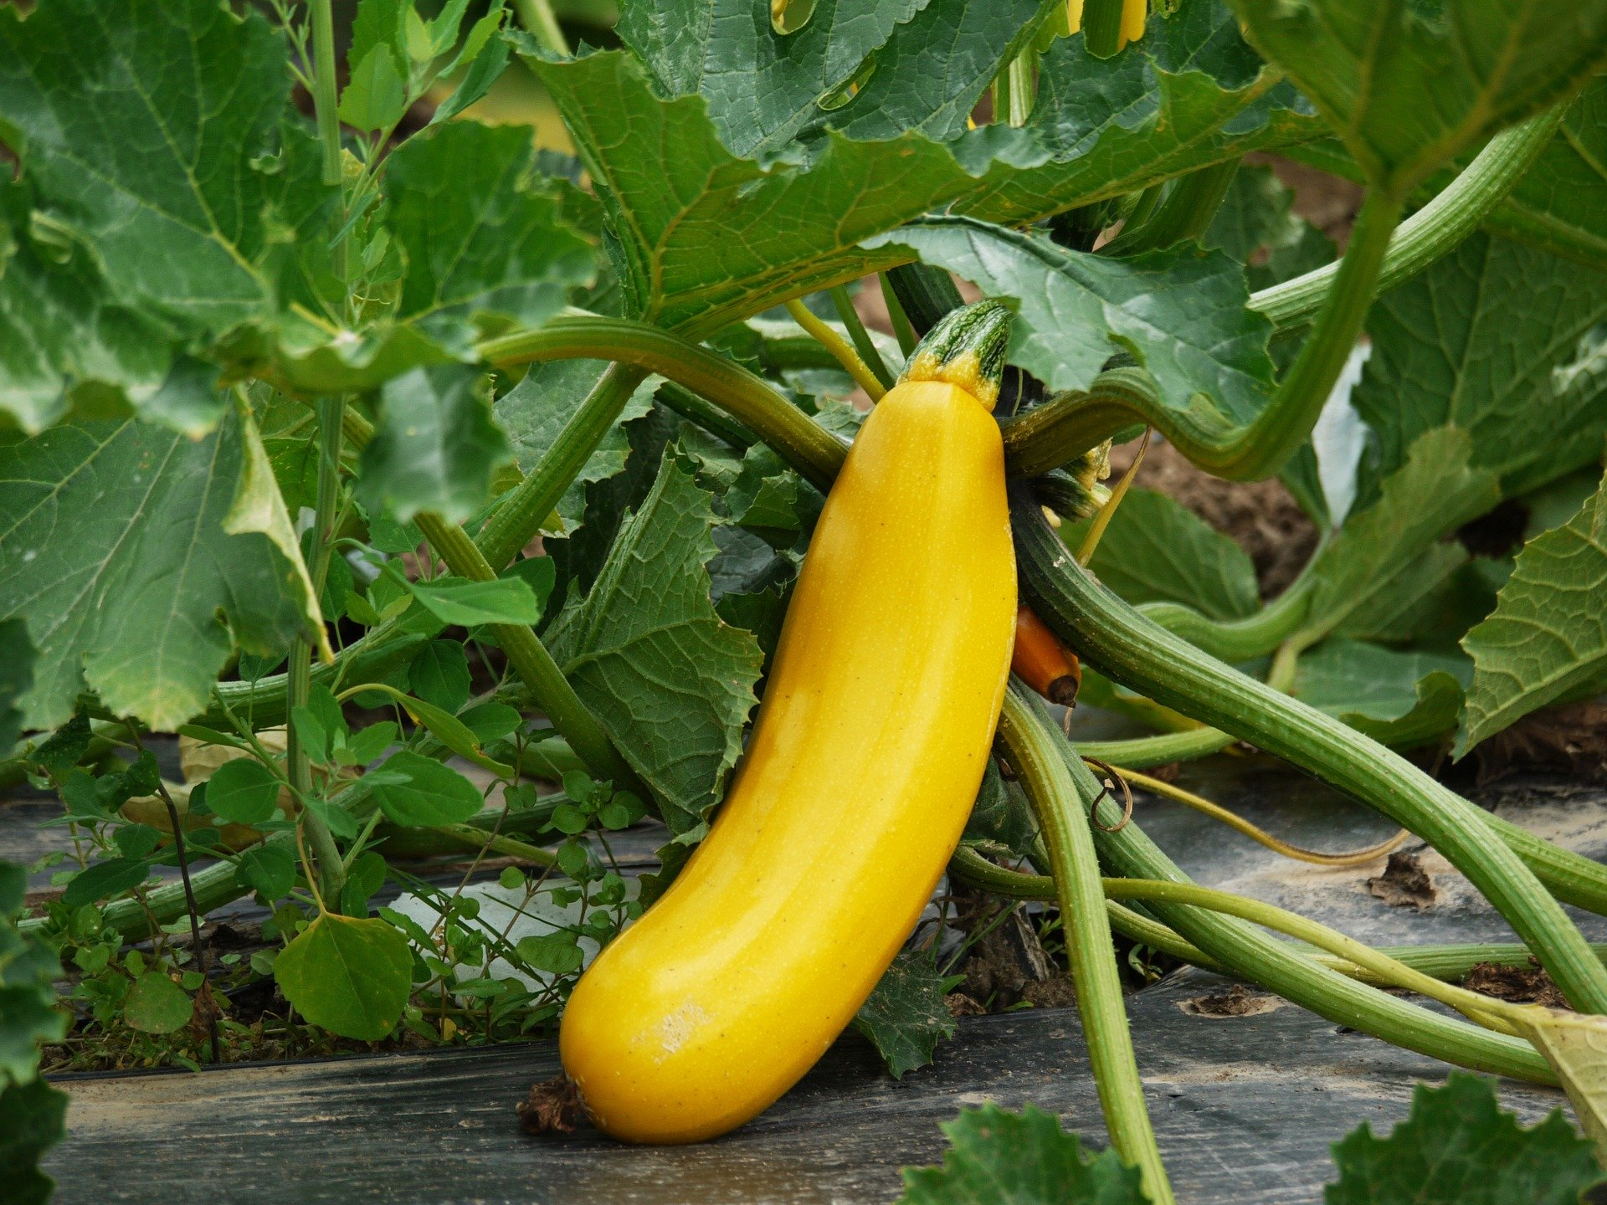
zucchini
- Grow on vines
- Space rows: 5 feet apart
- Space plants: 1 foot apart
- Each plant produces about 8 zucchini.
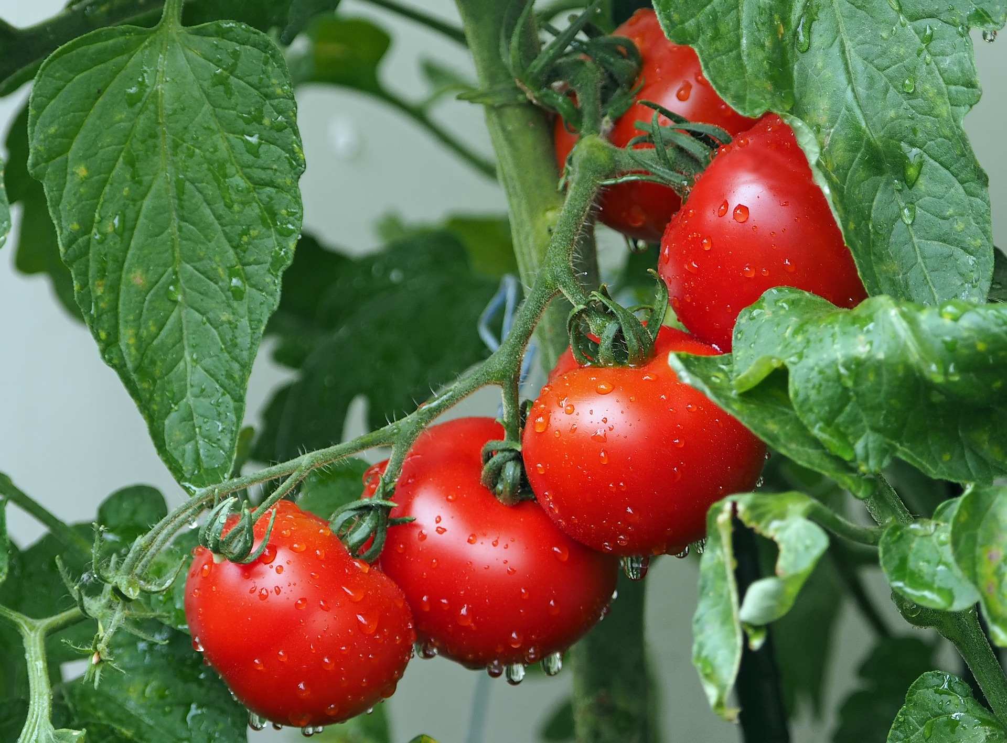
tomatoes
- Grow on vines
- Space rows: 4 feet apart
- Space plants: 2 feet apart
- Each plant produces about 20 tomatoes.
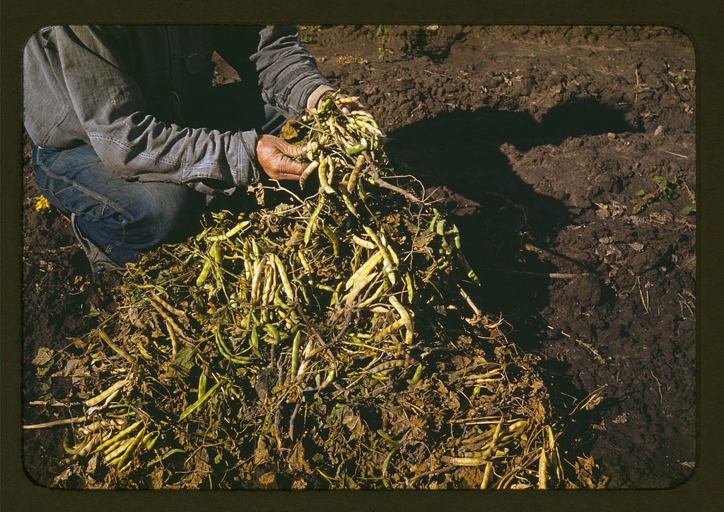
pinto beans
- Grow on bushes in pods
- Space rows: 2 feet apart
- Space plants: 1 foot apart
- Each plant produces 20–25 pods and each pod produces about 5 beans.
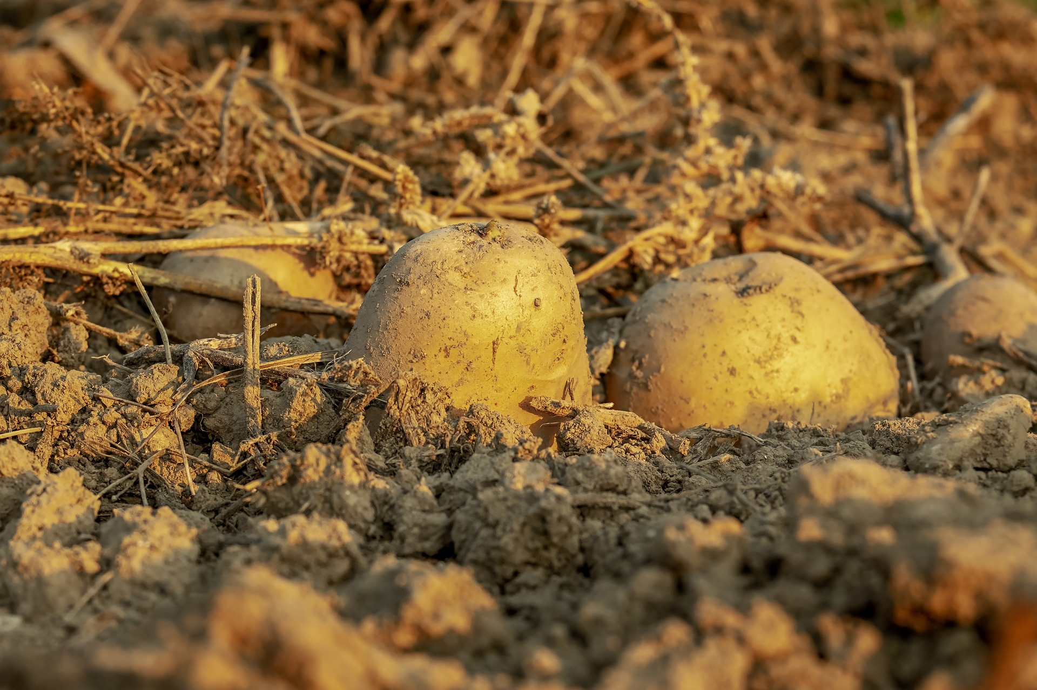
potatoes
- Grow in rows
- Space rows: 2–3 feet apart
- Space plants: 1 foot apart
- Each plant produces 5–10 potatoes.
© CC BY 2021 Illustrative Mathematics®

