Lesson 14: Find the Area of Figures with Missing Sides

Standards Alignments
Addressing | 3.MD.C.7.d

Teacher-facing Learning Goals
- Calculate the area of ungridded figures composed of rectangles, including figures with missing side lengths.

Student-facing Learning Goals
- Let’s find the area of figures with missing side lengths.

Lesson Purpose
The purpose of this lesson is for students to calculate the area of ungridded figures made of rectangles, including figures with missing side lengths.
In previous lessons, students found the area of figures that were fully gridded with squares and moved toward figures without a grid but had all their side lengths labeled. In this lesson, students use the strategies they have learned to decompose the figures into non-overlapping rectangles. They realize that not all measurements need to be given, and that some lengths can be determined given the rectangular structure of these figures.
This lesson has a Student Section Summary.

Access for:

Students with Disabilities
- Engagement (Activity 2)

English Learners
- MLR8 (Activity 2)

Instructional Routines
Notice and Wonder (Warm-up)

Lesson Timeline
Warm-up | 10 min
Activity 1 | 10 min
Activity 2 | 25 min
Lesson Synthesis | 10 min
Cool-down | 5 min

Teacher Reflection Question
Reflect on which students have not shared their strategies in class lately. How can their insight or ways of thinking be highlighted in or tied to upcoming lessons?

Cool-down
(to be completed at the end of the lesson) 5min
Mystery Side Area

Standards Alignments
Addressing | 3.MD.C.7.d

Student-facing Task Statement
Find the area of the figure. Explain or show your reasoning.
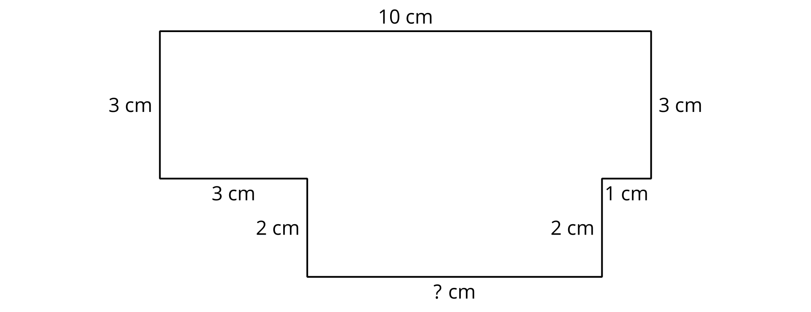

Student Responses
42 sq cm. Sample response: I found the area of the top rectangle to be 30 sq cm because $3×10=30$. Then I found the missing side length to be 6 cm by subtracting 3 cm and 1 cm from 10 cm because opposite side lengths are equal in a rectangle. Then I found the area of the smaller rectangle on the bottom to be $2×6$, which is 12 sq cm. Then I added $30+12$ to get 42 sq cm.

