Unit 5 Lesson 1: Proportional Relationships and Equations

1 Number Talk: Division (Warm up)

Student Task Statement
Find each quotient mentally.
$645÷100$
$645÷50$
$48.6÷30$
$48.6÷x$

2 Feeding a Crowd, Revisited

Student Task Statement
- A recipe says that 2 cups of dry rice will serve 6 people. Complete the table as you answer the questions. Be prepared to explain your reasoning.
  - How many people will 1 cup of rice serve?
  - How many people will 3 cups of rice serve? 12 cups? 43 cups?
  - How many people will $x$ cups of rice serve?
- cups of dry rice | - number of people
- 1
- 2 | - 6
- 3
- 12
- 43
- $x$
- A recipe says that 6 spring rolls will serve 3 people. Complete the table as you answer the questions. Be prepared to explain your reasoning.
  - How many people will 1 spring roll serve?
  - How many people will 10 spring rolls serve? 16 spring rolls? 25 spring rolls?
  - How many people will $n$ spring rolls serve?
- number of spring rolls | - number of people
- 1
- 6 | - 3
- 10
- 16
- 25
- $n$
- How was completing this table different from the previous table? How was it the same?

3 Denver to Chicago

Student Task Statement
A plane flew at a constant speed between Denver and Chicago. It took the plane 1.5 hours to fly 915 miles.
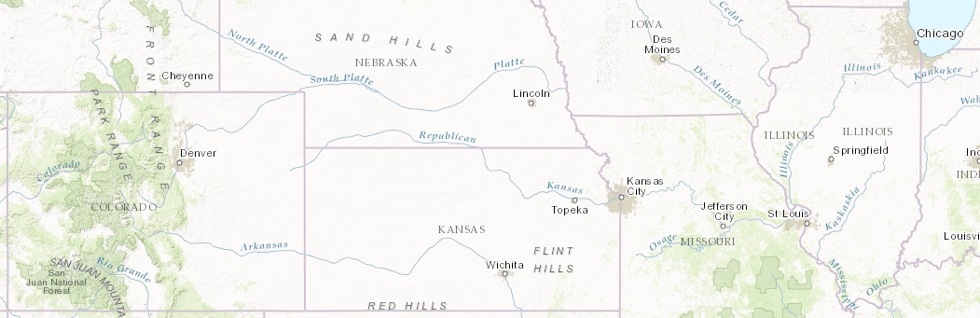
- Complete the table.
- time (hours) | - distance (miles) | - speed (miles per hour)
- 1
- 1.5 | - 915
- 2
- 2.5
- $t$
- How far does the plane fly in one hour?
- How far would the plane fly in $t$ hours at this speed?
- If $d$ represents the distance that the plane flies at this speed for $t$ hours, write an equation that relates $t$ and $d$.
- How far would the plane fly in 3 hours at this speed? in 3.5 hours? Explain or show your reasoning.

4 Revisiting Bread Dough (Optional)

Student Task Statement
A bakery uses 8 tablespoons of honey for every 10 cups of flour to make bread dough. Some days they bake bigger batches and some days they bake smaller batches, but they always use the same ratio of honey to flour.
- Complete the table.
- If $f$ is the cups of flour needed for $h$ tablespoons of honey, write an equation that relates $f$ and $h$.
- How much flour is needed for 15 tablespoons of honey? 17 tablespoons? Explain or show your reasoning.
honey (tbsp) | flour (c)
1
8 | 10
16
20
$h$
© CC BY Open Up Resources. Adaptations CC BY IM.

