Lesson 2: Formas de ver triángulos

Standards Alignments
Addressing | 4.G.A.2, 4.NF.B.3.c, 4.NF.B.4

Teacher-facing Learning Goals
- Classify triangles based on the their side lengths and size of their angles.

Student-facing Learning Goals
- Clasifiquemos y analicemos triángulos.

Lesson Purpose
The purpose of this lesson is for students to classify triangles based on the their side lengths and the size of their angles. Students identify triangles with a right angle as right triangles.
In the previous lesson, students sorted and categorized two-dimensional shapes using any attribute of their choice. In this lesson, students narrow the set of shapes to triangles. They analyze and sort triangles based on their sides and angles.
Along the way, students begin to notice new attributes of triangles and make generalizations about them. They know that all triangles have three sides and three angles. Now they also see, for instance, that some triangles contain right angles, some triangles have equal sides and can be folded into two equal halves, triangles never seem to contain more than one obtuse angle, and so on. Students learn that right triangles are a sub-group of triangles and use what they know about identifying right angles and perpendicular sides to identify the properties of right triangles.
The process of sorting shapes and identifying attributes encourages students to look for structure (MP7), which students will use in later lessons to reason about symmetry and measurements in two-dimensional figures.

Access for:

Students with Disabilities
- Action and Expression (Activity 1)

English Learners
- MLR8 (Activity 1)

Instructional Routines
Number Talk (Warm-up)

Materials to Gather
- Index cards: Activity 2
- Materials from a previous lesson: Activity 1
- Patty paper: Activity 2
- Protractors: Activity 1, Activity 2
- Rulers: Activity 1

Lesson Timeline
Warm-up | 10 min
Activity 1 | 25 min
Activity 2 | 10 min
Lesson Synthesis | 10 min
Cool-down | 5 min

Teacher Reflection Question
What question went unanswered in this lesson? How will you revisit the ideas underlying this question in the lessons that follow?

Cool-down
(to be completed at the end of the lesson) 5min
¿Cuál pertenece al grupo?

Standards Alignments
Addressing | 4.G.A.2

Student-facing Task Statement
Este es un grupo de triángulos que tienen una característica en común y se pueden agrupar.
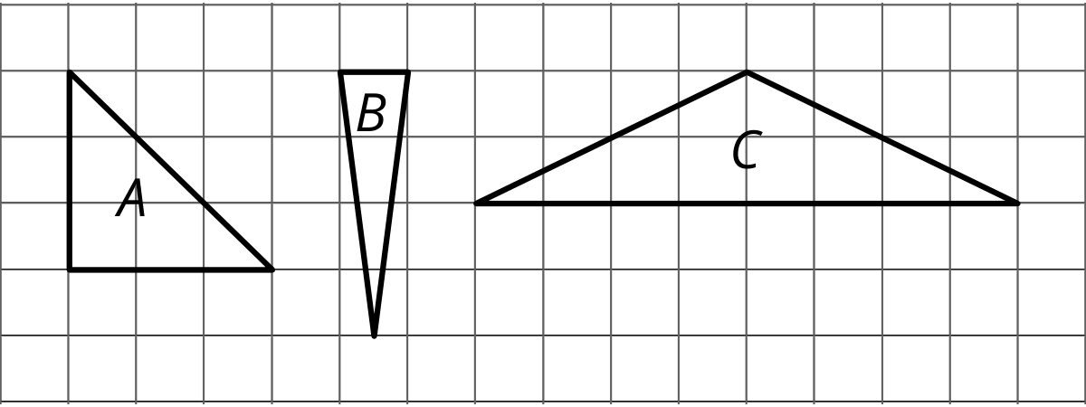
- ¿Cuáles de los siguientes triángulos tienen la misma característica y también pertenecen al grupo? Explica cómo razonaste.
- 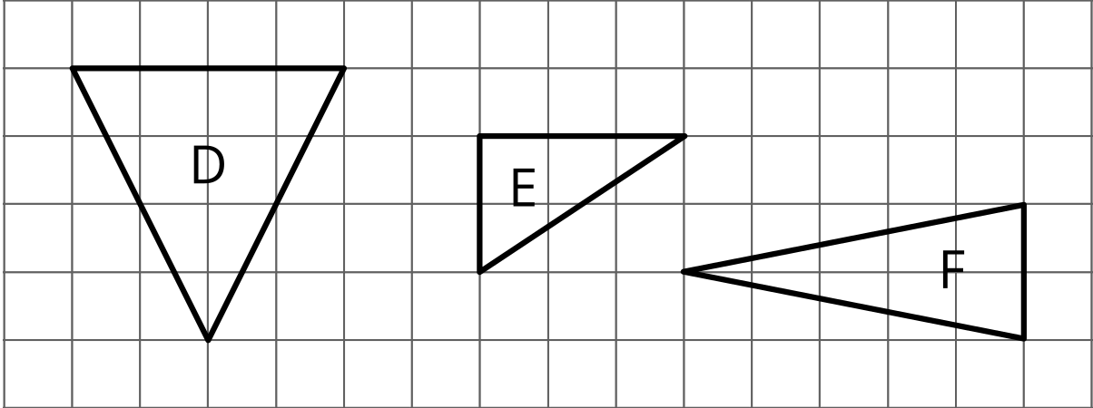
- ¿Cuáles de los seis triángulos son triángulos rectángulos?

Student Responses
- Sample response: Each triangle has two sides that have the same length (or have two angles that are the same size).
  - Triangle D, because the left and right sides are the same length (or because two of the angles are the same size)
  - Triangle F, because the two longer sides are the same length (or because two of the angles are the same size)
- Triangles A and E

