Lesson 7: The Correlation Coefficient
- Let’s see how good a linear model is for some data.

7.1: Which One Doesn’t Belong: Linear Models
Which one doesn’t belong?

A
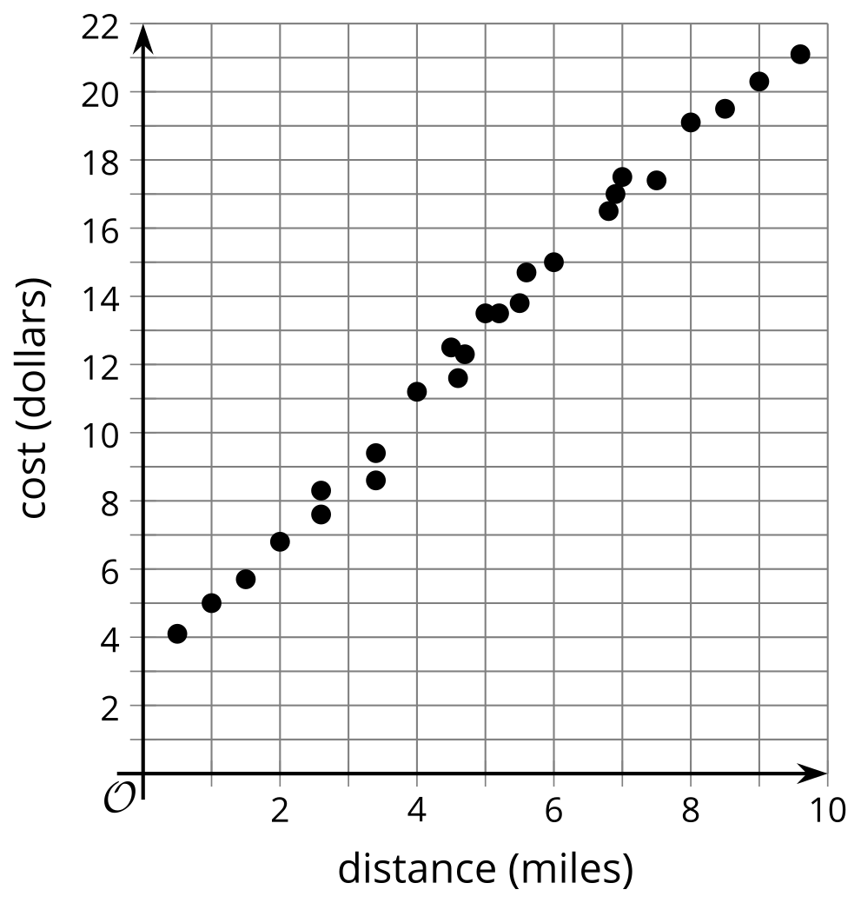

B
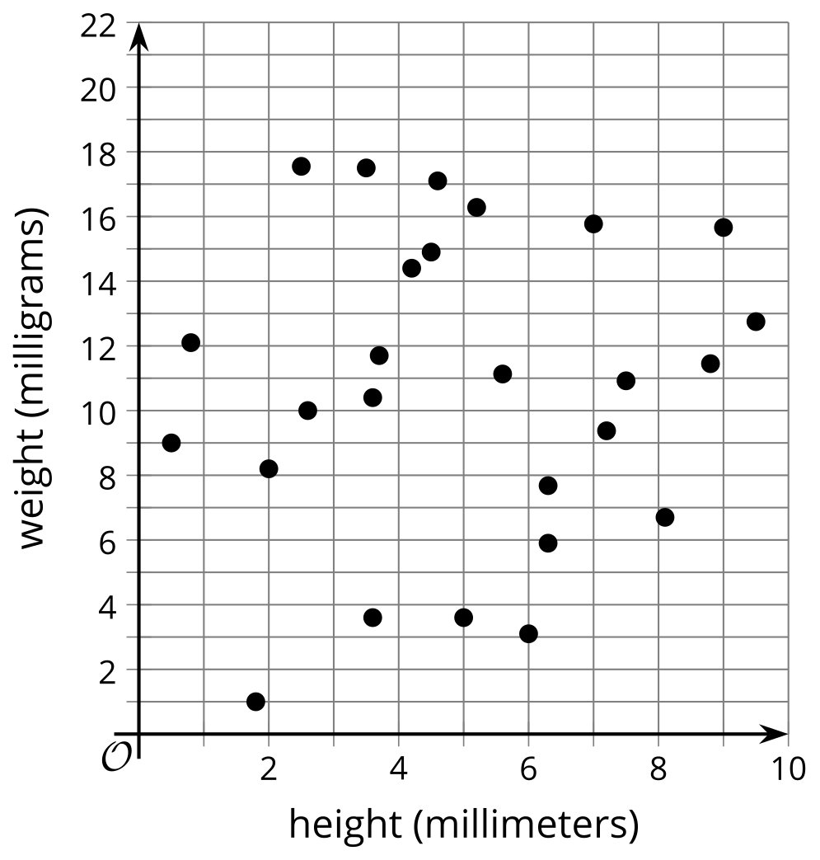

C
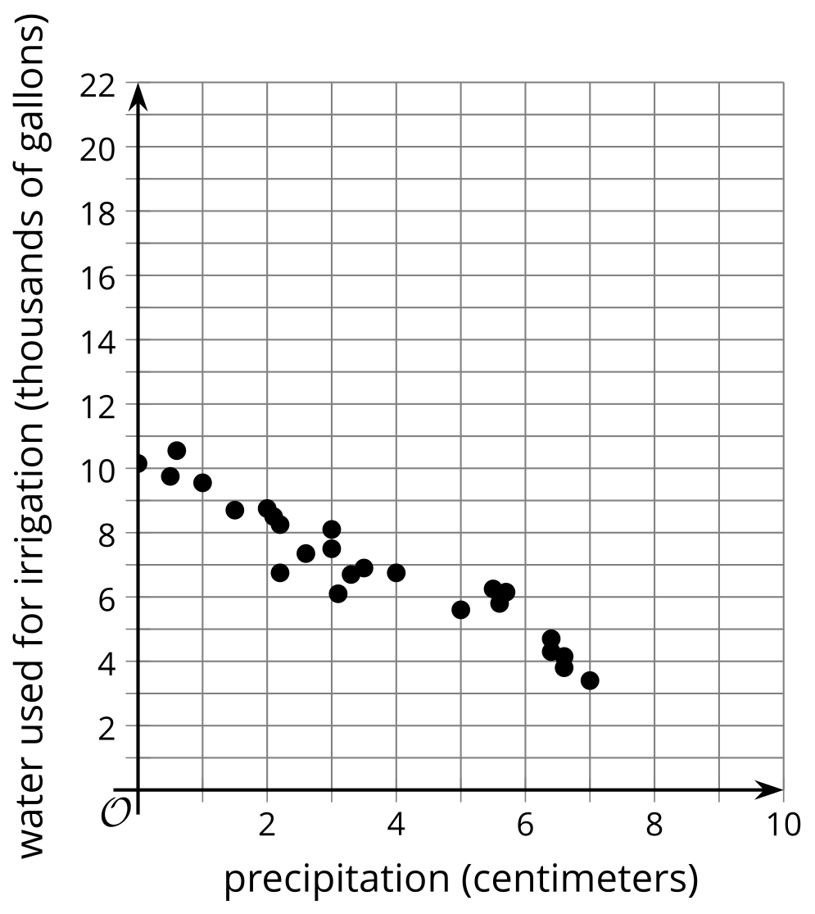

D
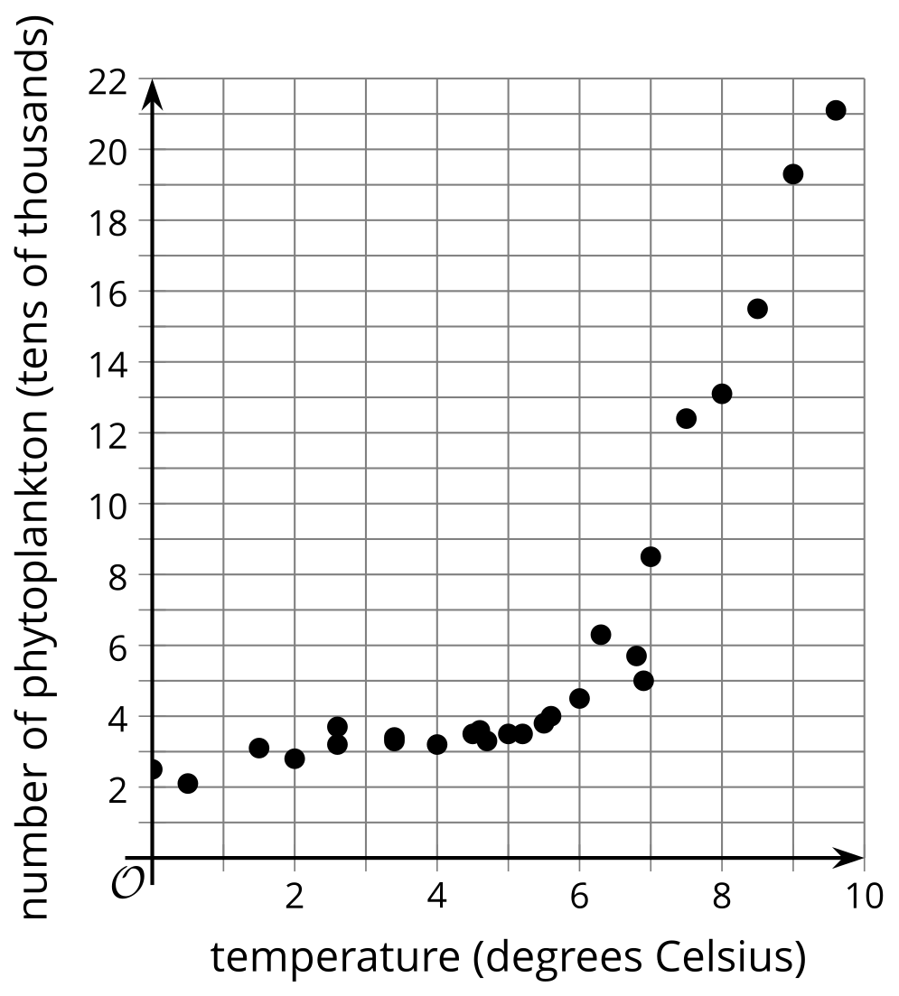

7.2: Card Sort: Scatter Plot Fit
Your teacher will give you a set of cards that show scatter plots of data. Sort the cards into 2 categories of your choosing. Be prepared to explain the meaning of your categories. Then, sort the cards into 2 categories in a different way. Be prepared to explain the meaning of your new categories.

7.3: Matching Correlation Coefficients
- Take turns with your partner to match a scatter plot with a correlation coefficient.
- For each match you find, explain to your partner how you know it’s a match.
- For each match your partner finds, listen carefully to their explanation. If you disagree, discuss your thinking and work to reach an agreement.

A
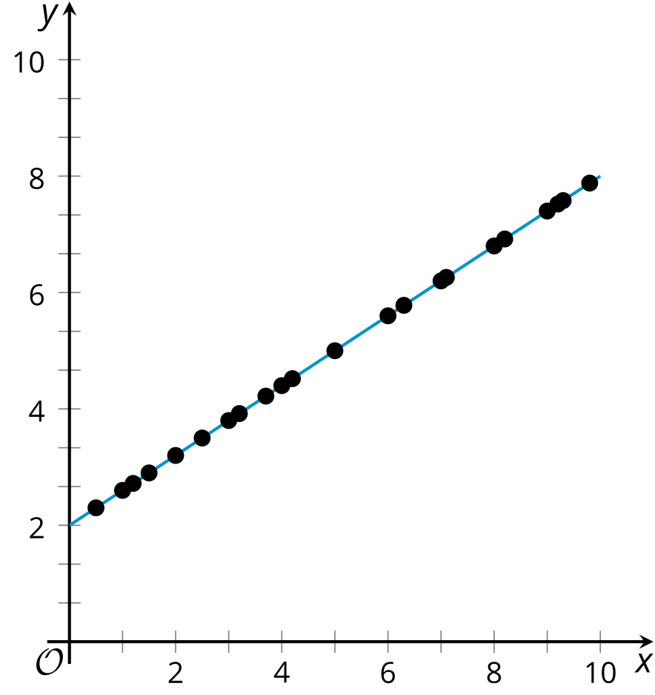
- $r=\text{-}1$
- $r=\text{-}0.95$
- $r=\text{-}0.74$
- $r=\text{-}0.06$
- $r=0.48$
- $r=0.65$
- $r=0.9$
- $r=1$

B
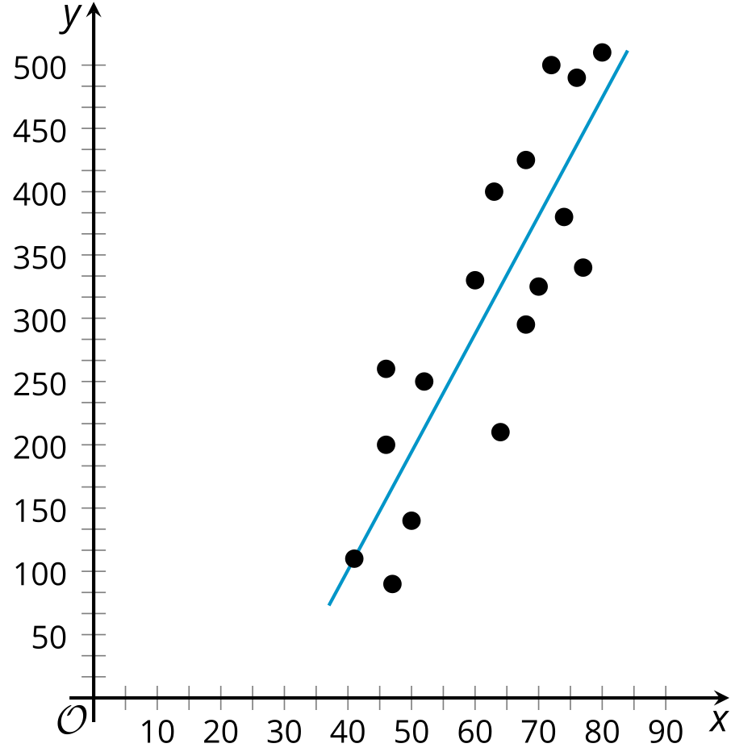

C
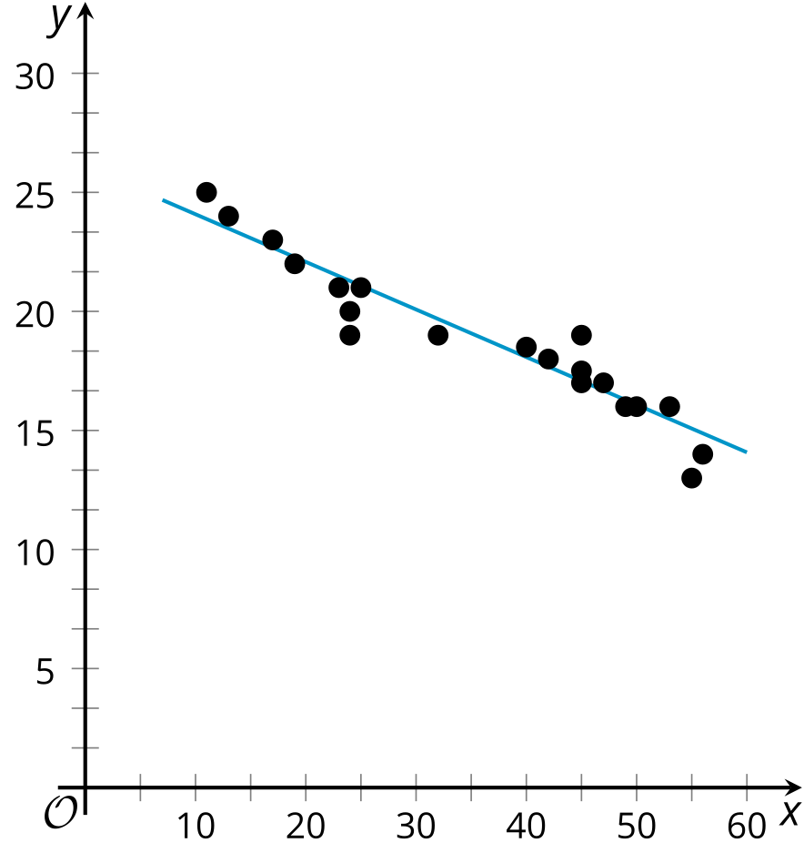

D
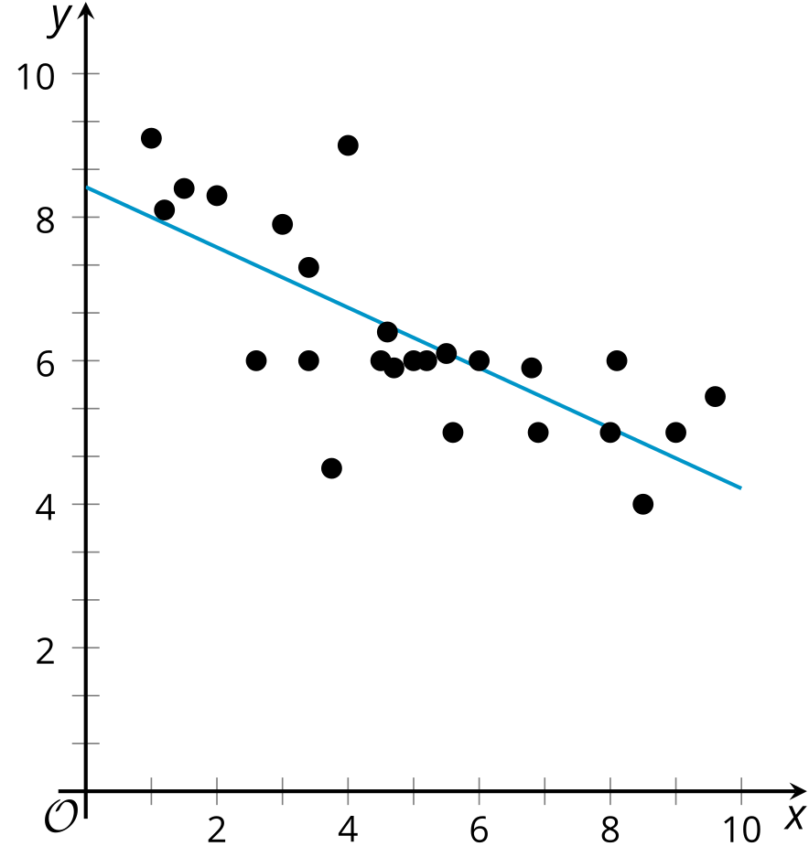

E
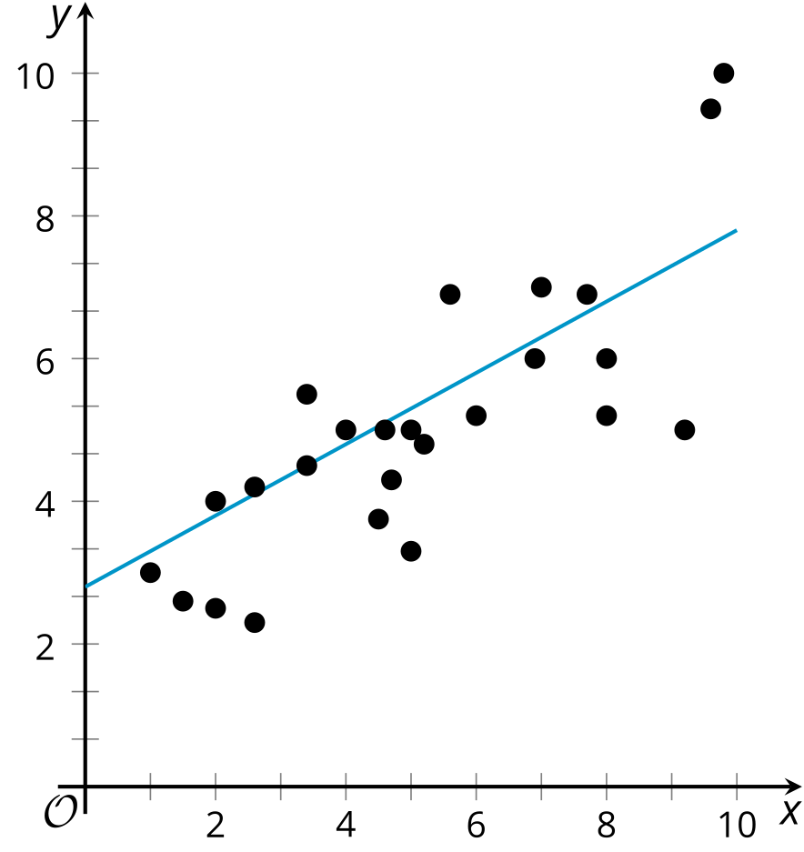

F
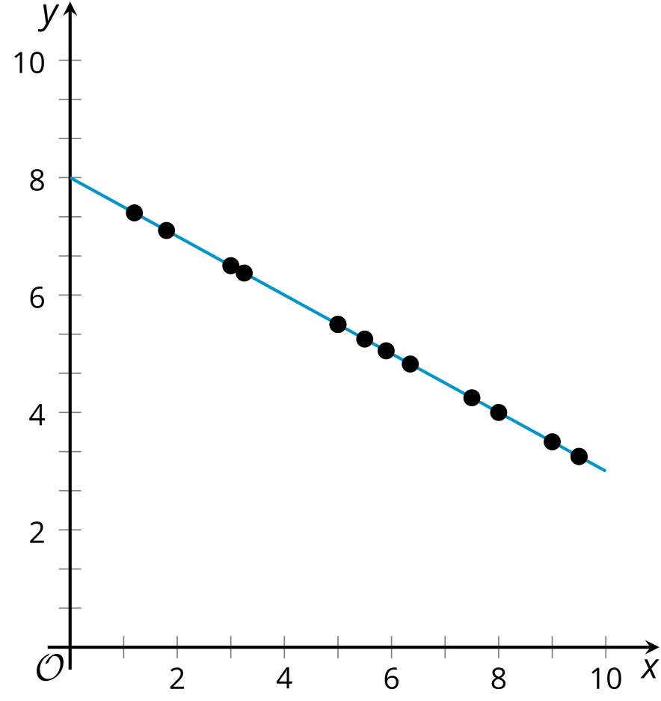

G
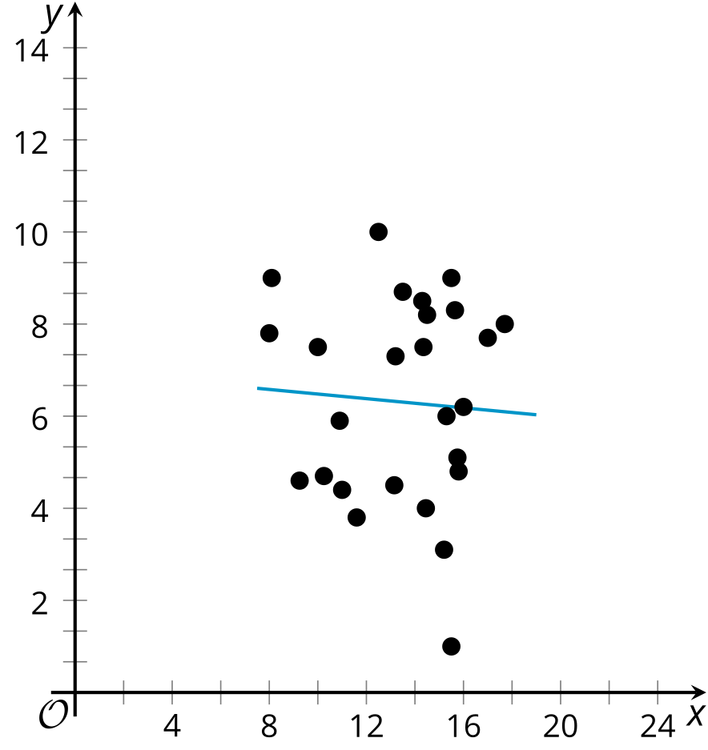

H
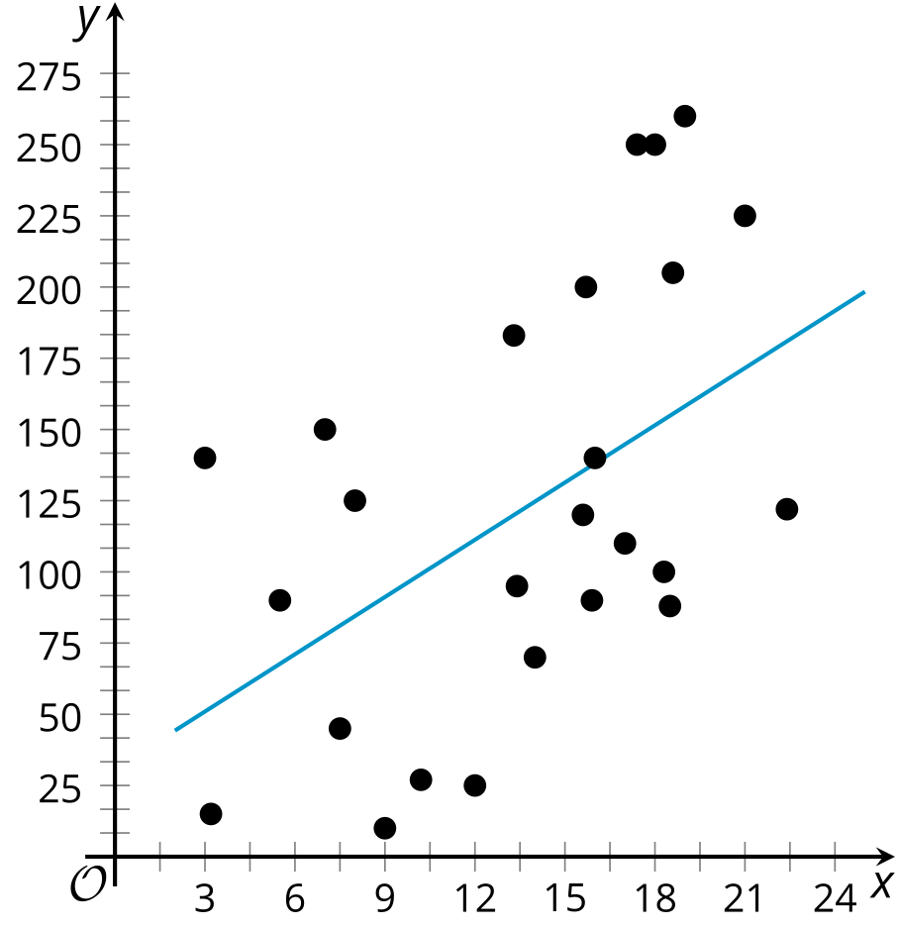

Are you ready for more?
Jada wants to know if the speed that people walk is correlated with their texting speed. To investigate this, she measured the distance, in feet, that 5 of her friends walked in 30 seconds and the number of characters they texted during that time. Each of the 5 friends took 4 walks for a total of 20 walks. Here are the results of the first 20 walks.
distance (feet) | number of characters texted | distance (feet) | number of characters texted
105 | 142 | 95 | 138
125 | 110 | 125 | 110
115 | 120 | 160 | 80
140 | 98 | 175 | 64
145 | 102 | 130 | 106
160 | 89 | 140 | 95
170 | 72 | 150 | 95
140 | 100 | 155 | 90
130 | 107 | 160 | 74
105 | 113 | 135 | 108
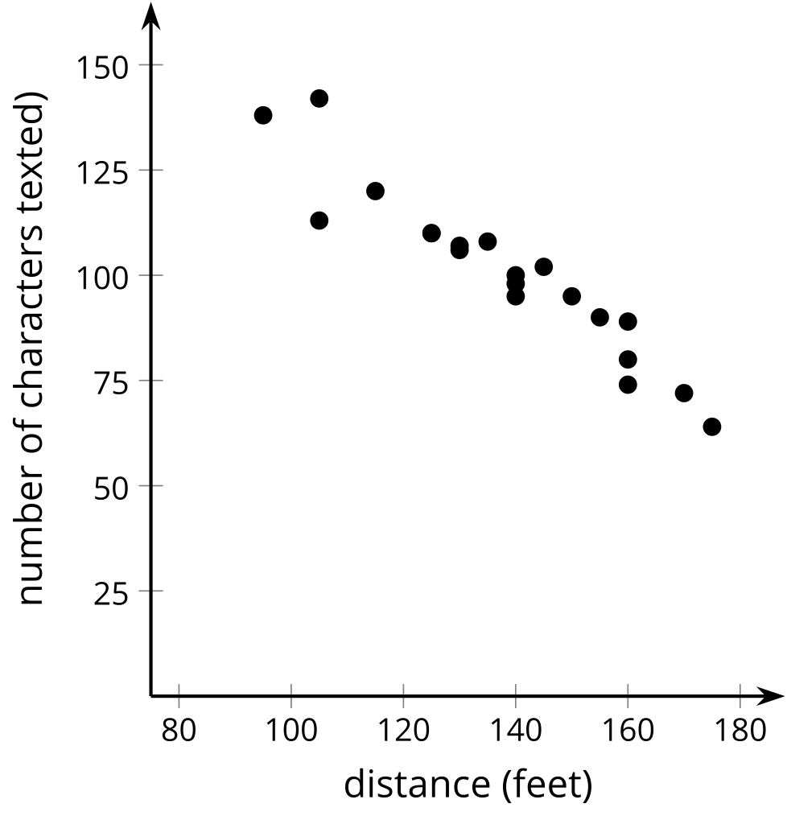
Over the next few days, the same 5 friends practiced walking and texting to see if they could walk faster and text more characters. They did not record any more data while practicing. After practicing, each of the 5 friends took another 4 walks. Here are the results of the final 20 walks.
distance (feet) | number of characters texted | distance (feet) | number of characters texted
140 | 140 | 165 | 151
150 | 155 | 170 | 136
160 | 151 | 190 | 143
155 | 170 | 205 | 132
180 | 125 | 205 | 128
205 | 130 | 210 | 140
225 | 95 | 215 | 109
175 | 161 | 220 | 105
195 | 108 | 230 | 126
155 | 142 | 225 | 138
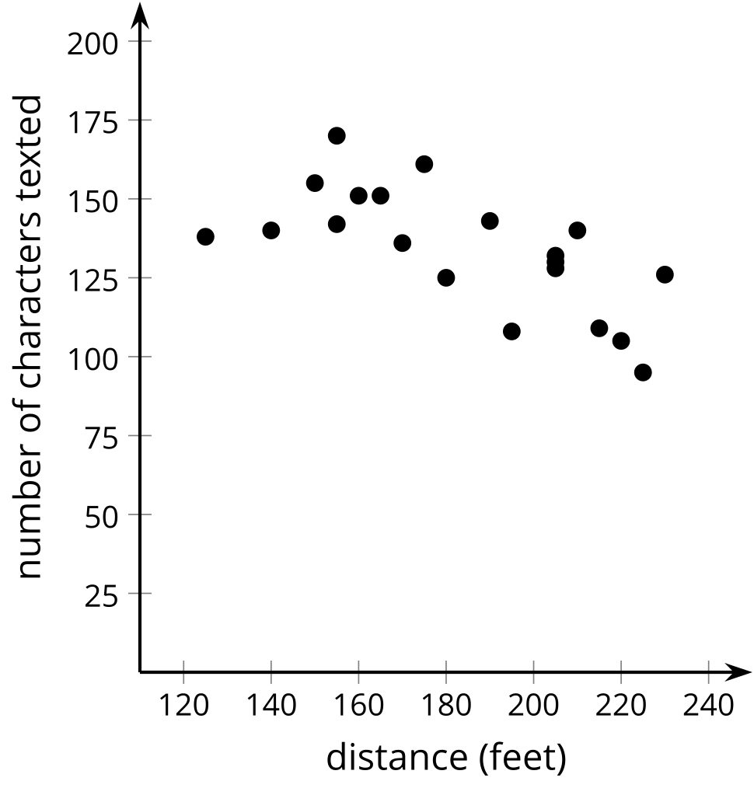
- What do you notice about the 2 scatter plots?
- Jada noticed that her friends walked further and texted faster during the last 20 walks than they did during the first 20 walks. Since both were faster, she predicts that the correlation coefficient of the line of best fit for the last 20 walks will be closer to -1 than the correlation coefficient of the line of best fit for the first 20 walks. Do you agree with Jada? Explain your reasoning.
- Use technology to find an equation of the line of best fit and the correlation coefficient for each data set. Was your answer to the previous question correct?
- Why do you think the correlation coefficients for the 2 data sets are so different? Explain your reasoning.

Lesson 7 Summary
While residuals can help pick the best line to fit the data among all lines, we still need a way to determine the strength of a linear relationship. Scatter plots of data that are close to the best fit line are better modeled by the line than scatter plots of data that are farther from the line.
The correlation coefficient is a convenient number that can be used to describe the strength and direction of a linear relationship. Usually represented by the letter $r$, the correlation coefficient can take values from -1 to 1. The sign of the correlation coefficient is the same as the sign of the slope for the best fit line. The closer the correlation coefficient is to 0, the weaker the linear relationship. When the correlation coefficient is closer to 1 or -1, the linear model fits the data better.
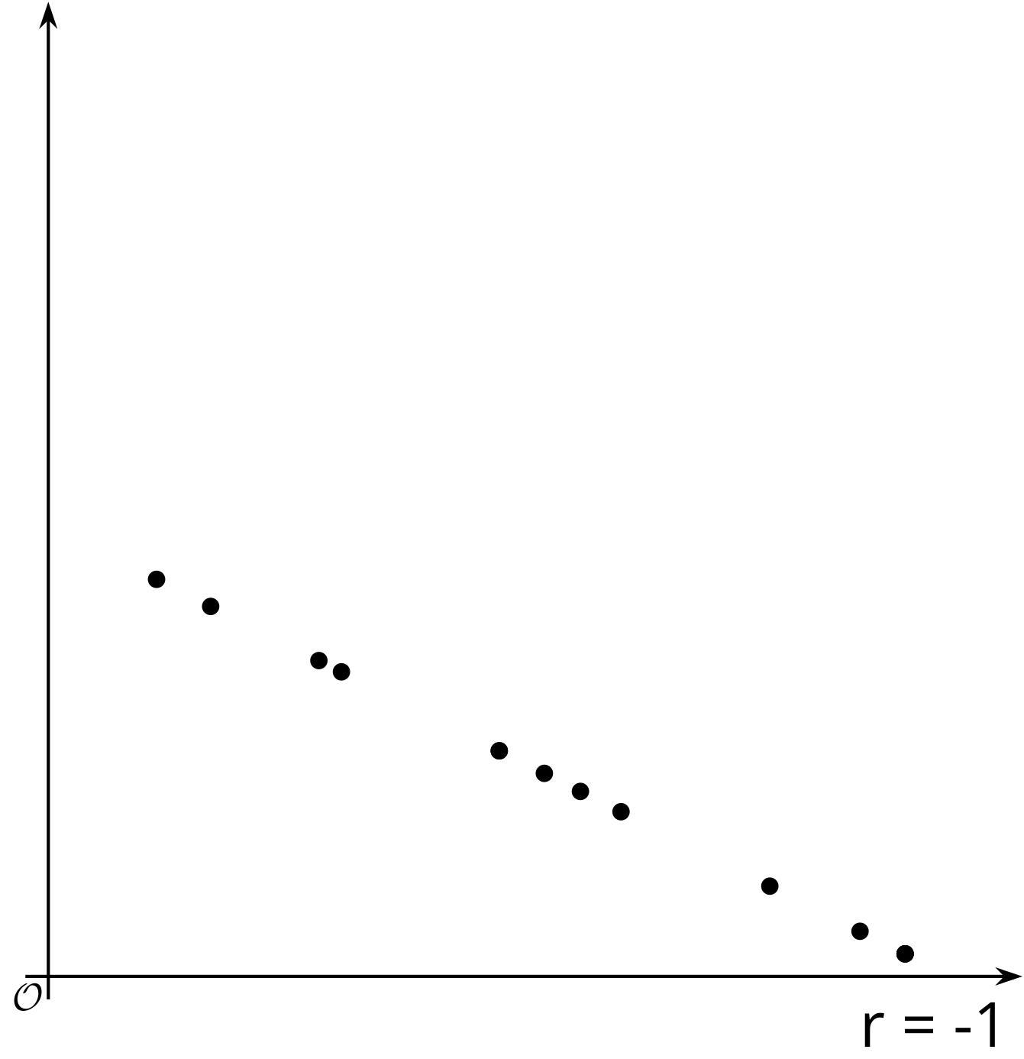
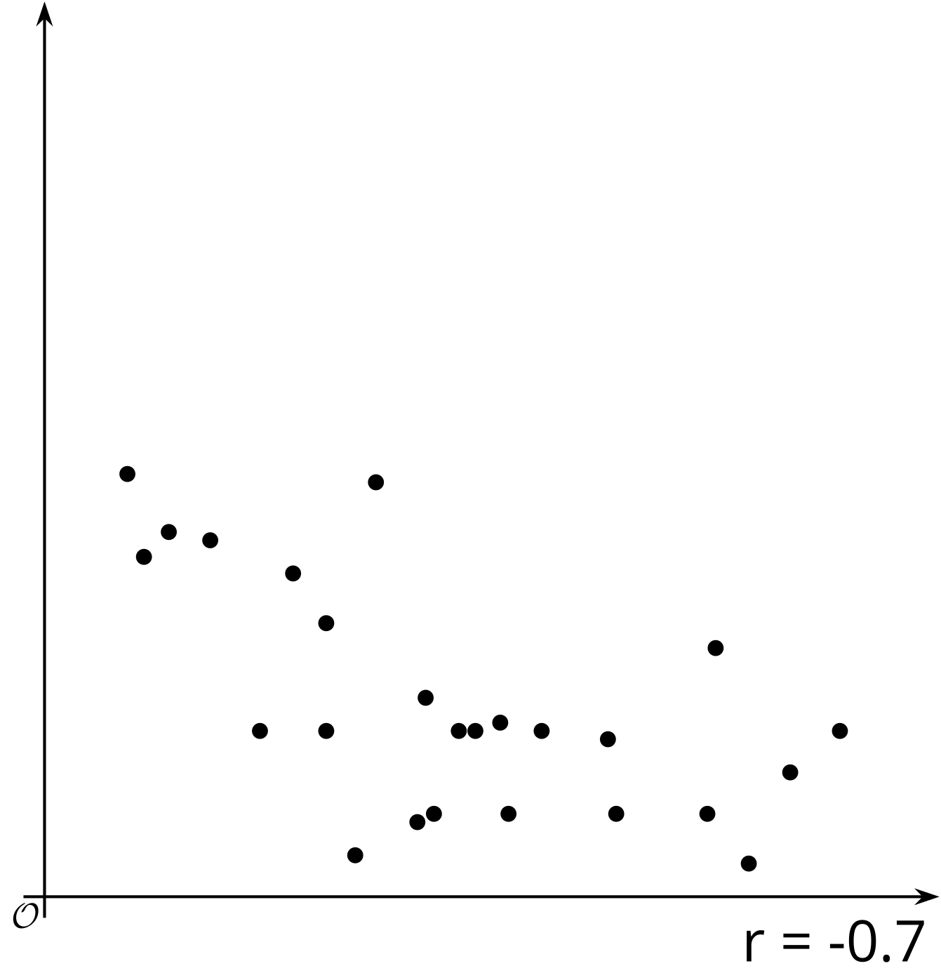
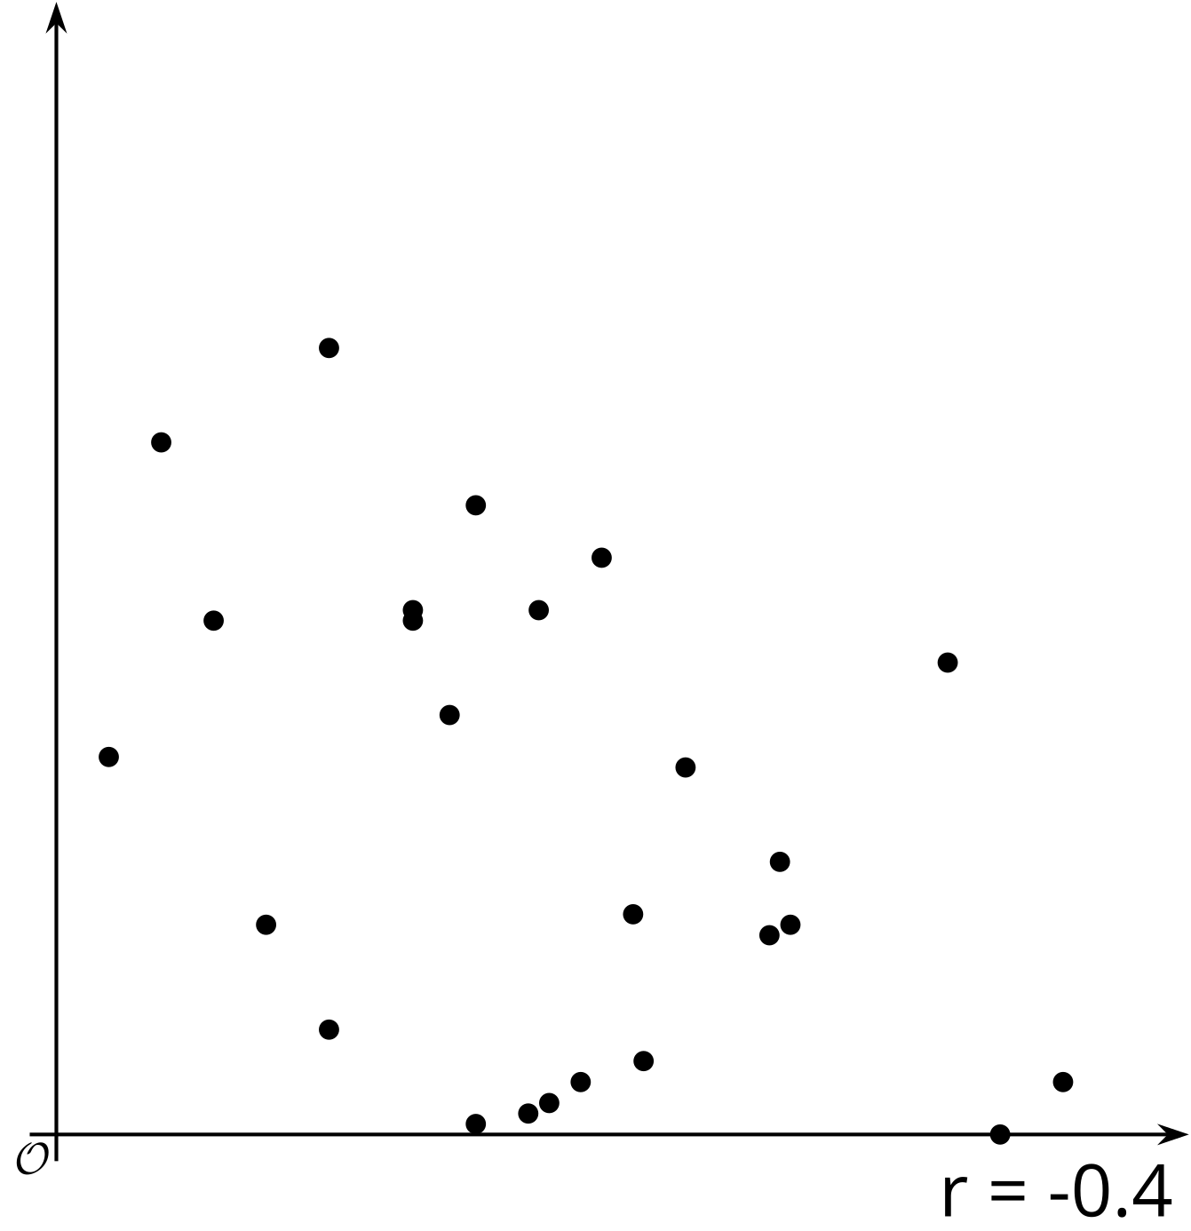
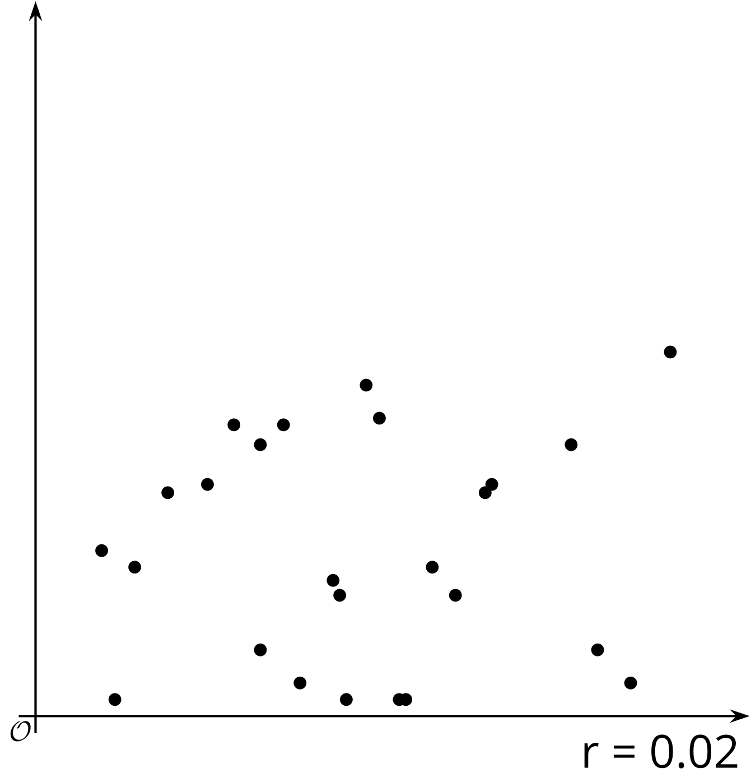
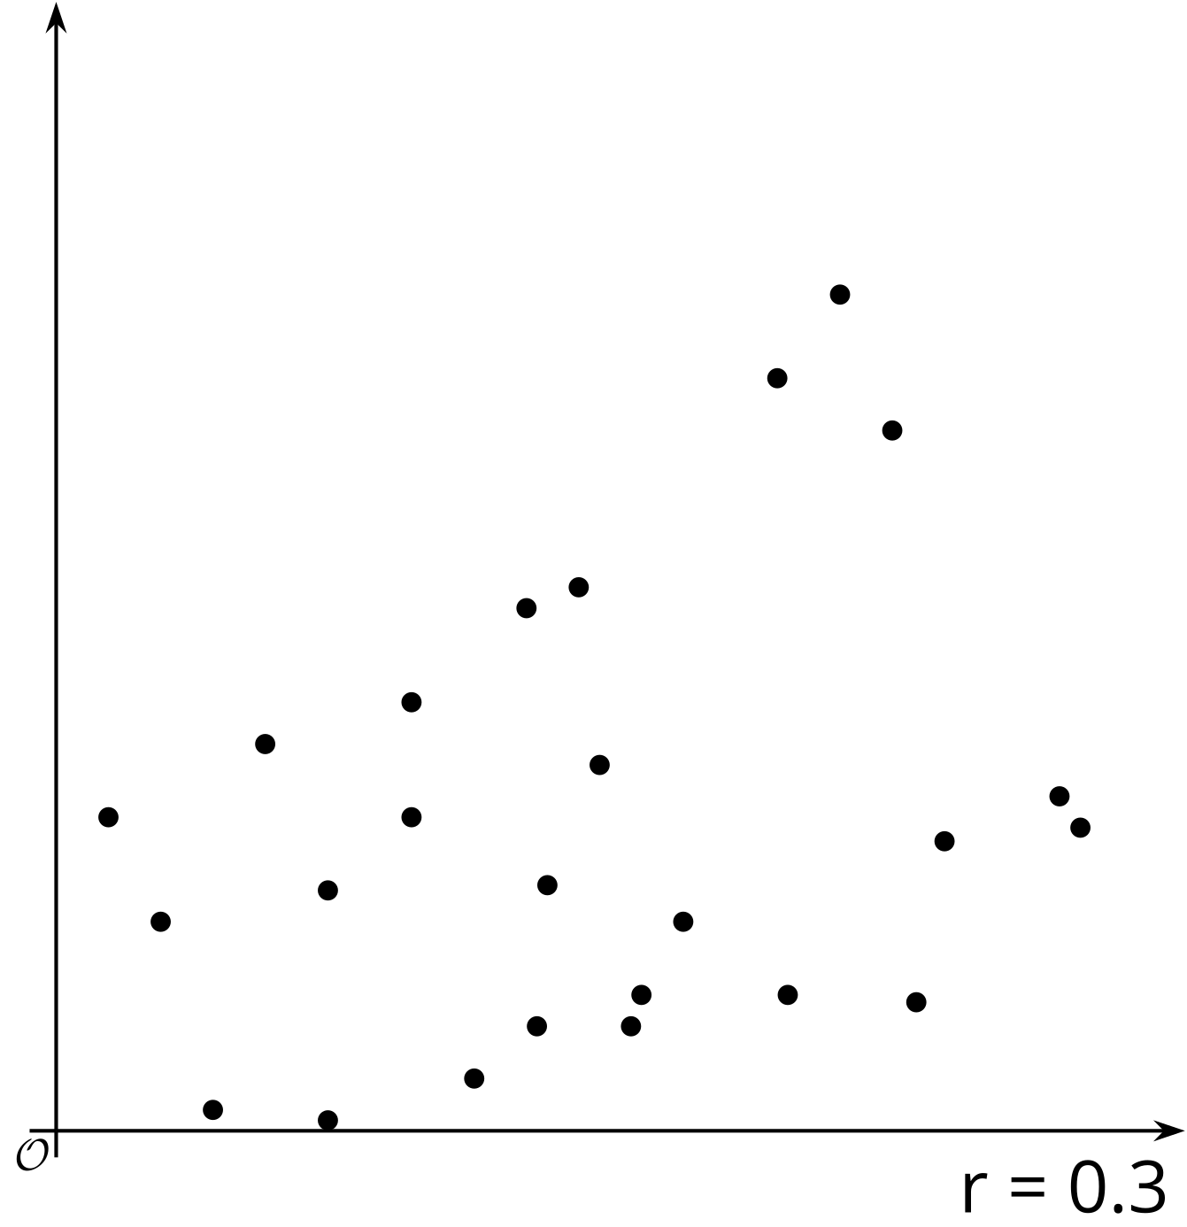
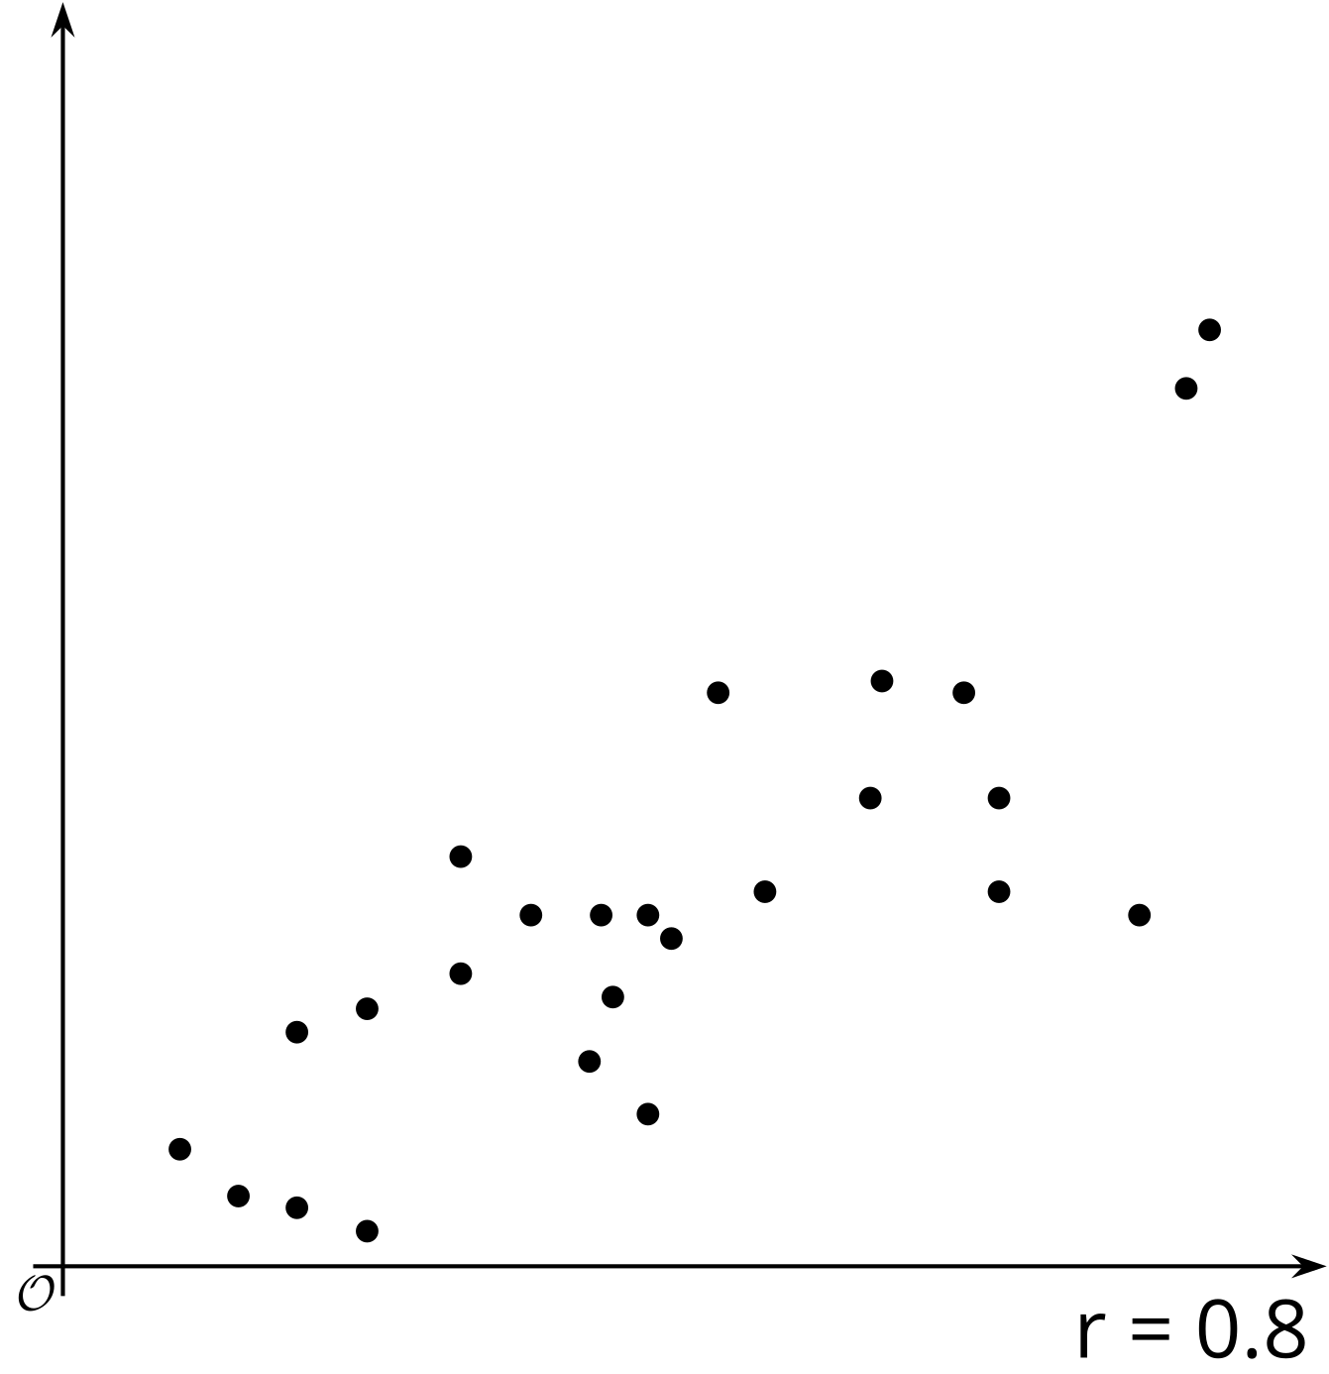
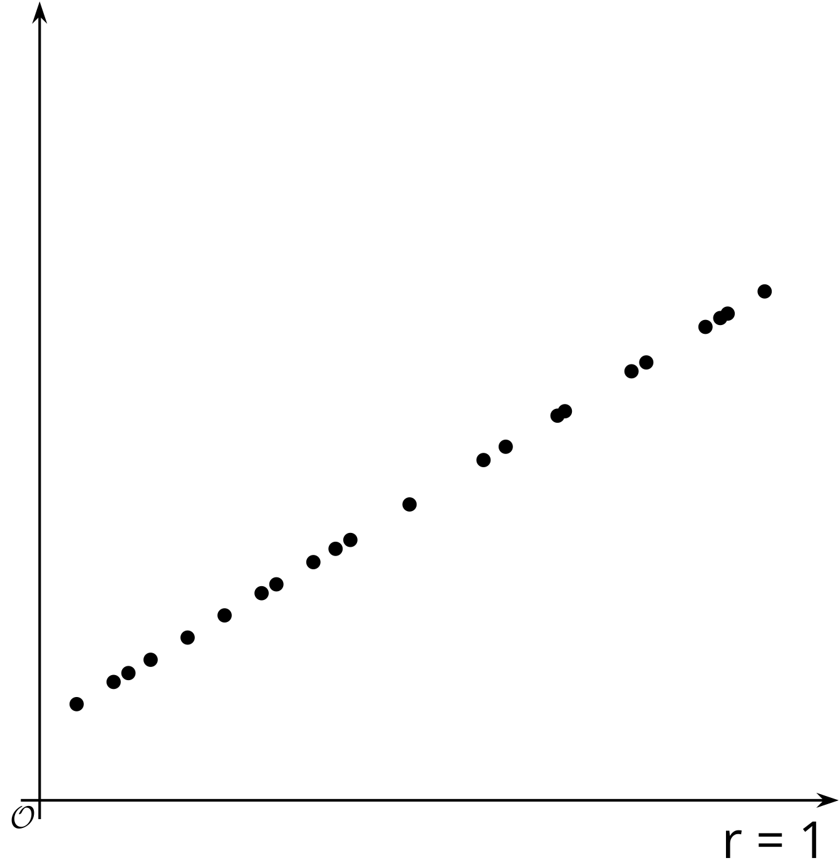
While it is possible to try to fit a linear model to any data, you should always look at the scatter plot to see if there is a possible linear trend. The correlation coefficient and residuals can also help determine whether the linear model makes sense to use to estimate the situation. In some cases, another type of function might be a better fit for the data, or the two variables you are examining may be uncorrelated, and you should look for other connections using other variables.
© CC BY 2019 by Illustrative Mathematics®

