Unit 5 Lesson 12: Prisms and Pyramids

1 The Faces of Geometry (Warm up)

Student Task Statement
Three solids are shown.

A
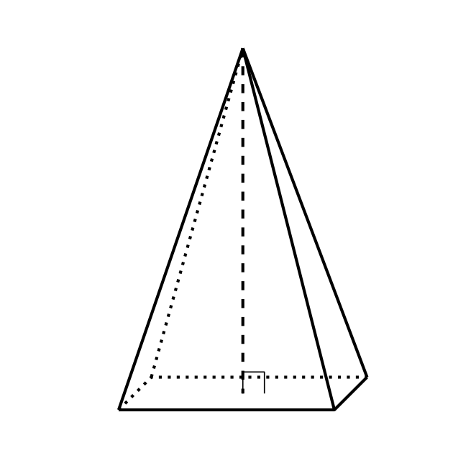

B
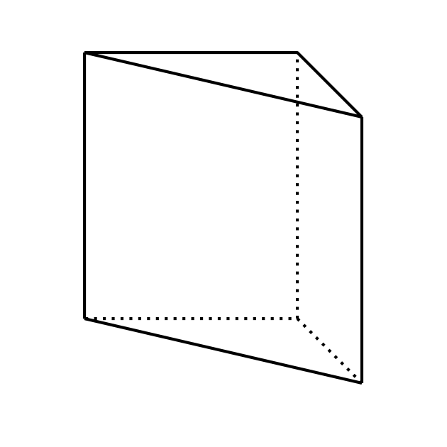

C
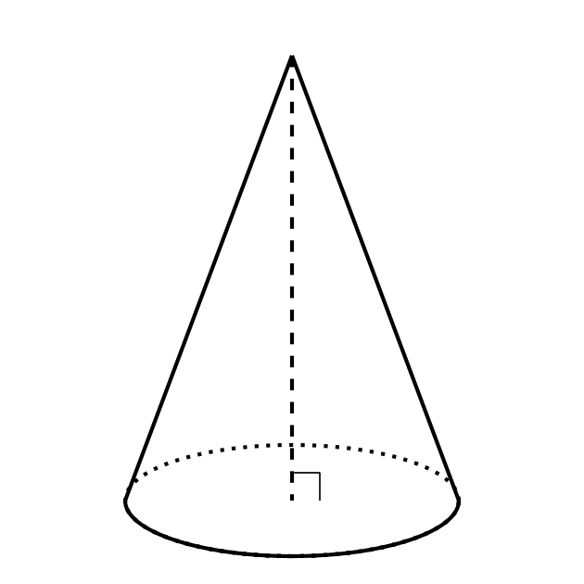
Draw all the surfaces of each solid.

2 Card Sort: Sorting Shapes

Student Task Statement
Your teacher will give you a set of cards that show geometric solids. Sort the cards into 2 categories of your choosing. Be prepared to explain the meaning of your categories. Then, sort the cards into 2 categories in a different way. Be prepared to explain the meaning of your new categories.

3 Building a Prism from Pyramids

Student Task Statement
Your teacher will give your group 3 nets. Each student should select 1 of the 3 nets.
- Cut out your net and assemble a pyramid. The printed side of the net should face outward.
- Assemble your group’s 3 pyramids into a triangular prism. Each pair of triangles with a matching pattern will come together to form one of the rectangular faces of the prism. You will need to disassemble the prism in a later activity, so use only a small amount of tape (or no tape at all if possible).
- Make a conjecture about the relationship between the volume of the pyramid marked P1 and the volume of the prism.
- What information would you need to verify that your conjecture is true?
Don’t throw away your pyramids! You’ll use them again.

Images for Activity Synthesis
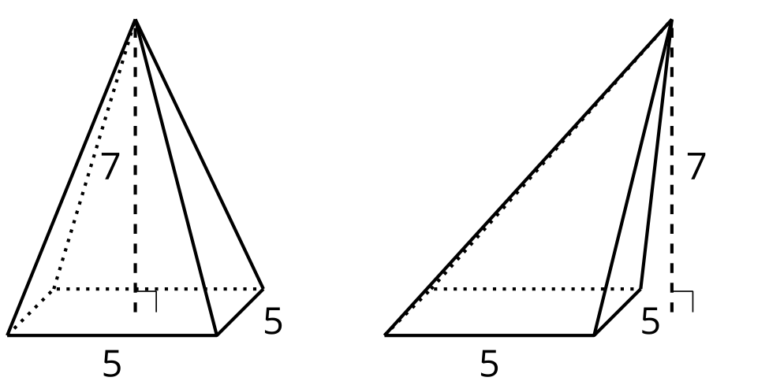
© CC BY 2019 by Illustrative Mathematics®

