Lesson 8: Equations on a Number Line

Standards Alignments
Addressing | 2.MD.B.6, 2.NBT.A.2

Teacher-facing Learning Goals
- Use number line diagrams to represent and write addition and subtraction equations.

Student-facing Learning Goals
- Let’s write equations and represent them on a number line.

Lesson Purpose
The purpose of this lesson is for students to write equations based on number lines and represent equations on the number line.
In the previous lesson, students interpreted representations of addition and subtraction equations on the number line. They used the direction of the arrow to determine what operation was represented and matched equations to number lines.
In this lesson, students write equations based on number line representations and represent given equations on number lines.

Access for:

Students with Disabilities
- Representation (Activity 2)

English Learners
- MLR8 (Activity 1)

Instructional Routines
Choral Count (Warm-up)

Lesson Timeline
Warm-up | 10 min
Activity 1 | 15 min
Activity 2 | 20 min
Lesson Synthesis | 10 min
Cool-down | 5 min

Teacher Reflection Question
What evidence have students given that they understand the connection between the number line and written equations? What questions did you ask to make the connection more visible?

Cool-down
(to be completed at the end of the lesson) 5min
Represent Addition and Subtraction on the Number Line

Standards Alignments
Addressing | 2.MD.B.6

Student-facing Task Statement
- Represent $22−5=17$ on the number line.
- Write an equation to show what’s represented on the number line.
- 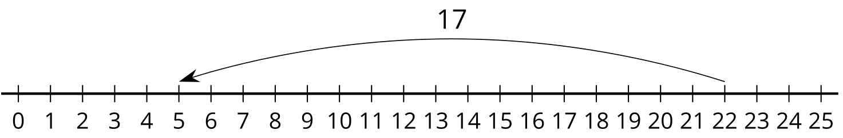

Student Responses
- 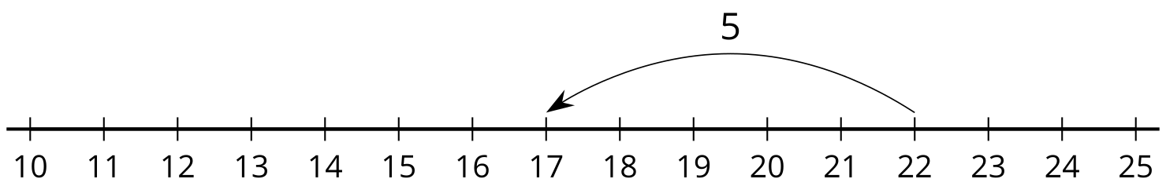
- $22−17=5$

