Unit 7 Lesson 5: Some Triangles, All Triangles

WU Which One Doesn’t Belong: Shapes (Warm up)

Student Task Statement
Which one doesn’t belong?
A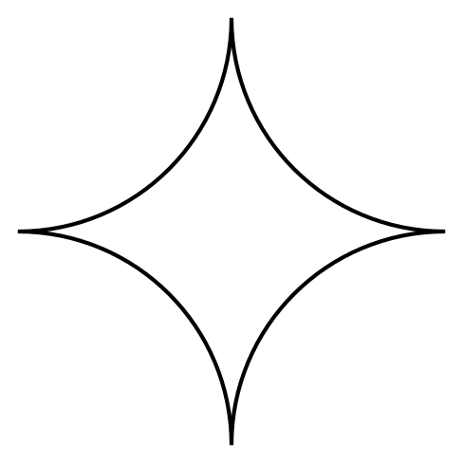
B
C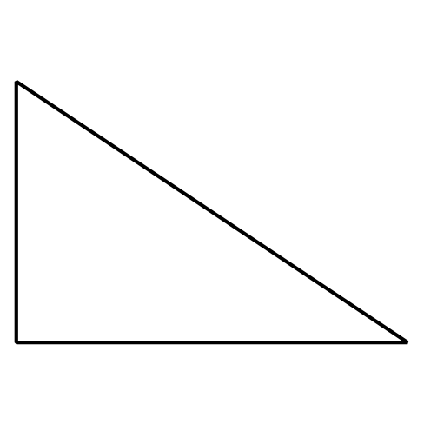
D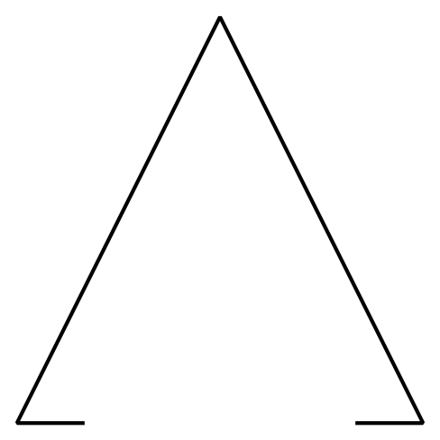

1 Triangles and “Not Triangles”

Student Task Statement
- These are triangles.
- 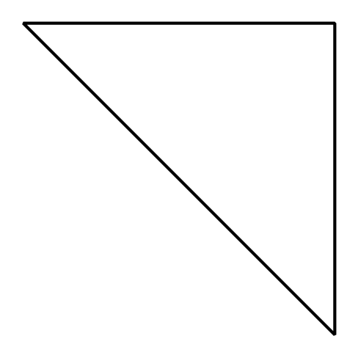
- 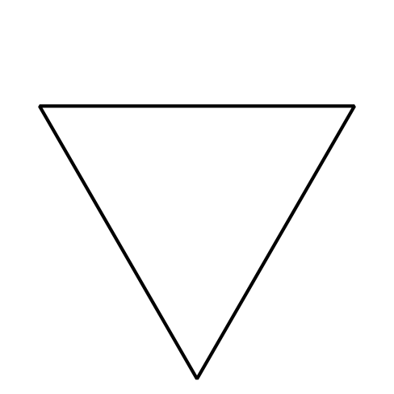
- What is the same about all these triangles?
- These are not triangles.
- 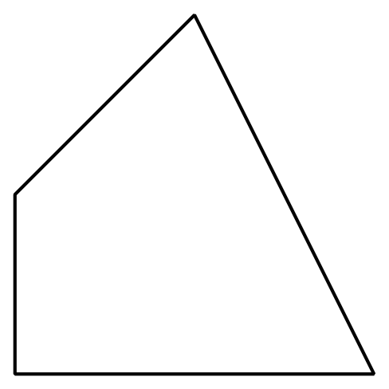
- 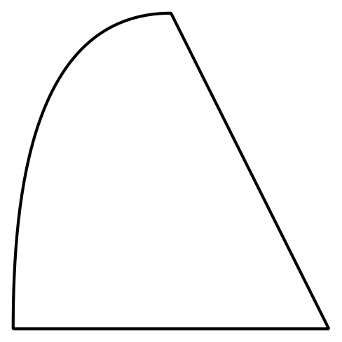
- What makes these shapes different from the triangles?

2 Draw Triangles

Student Task Statement
- Draw 3 different triangles.
- Draw 3 different shapes that are not triangles.

3 Centers: Choice Time

Student Task Statement
Choose a center.
Geoblocks
How Are They the Same?
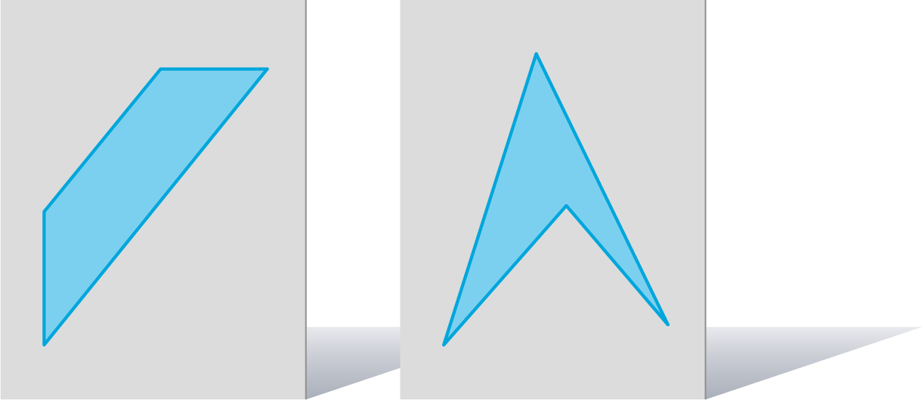
Compare
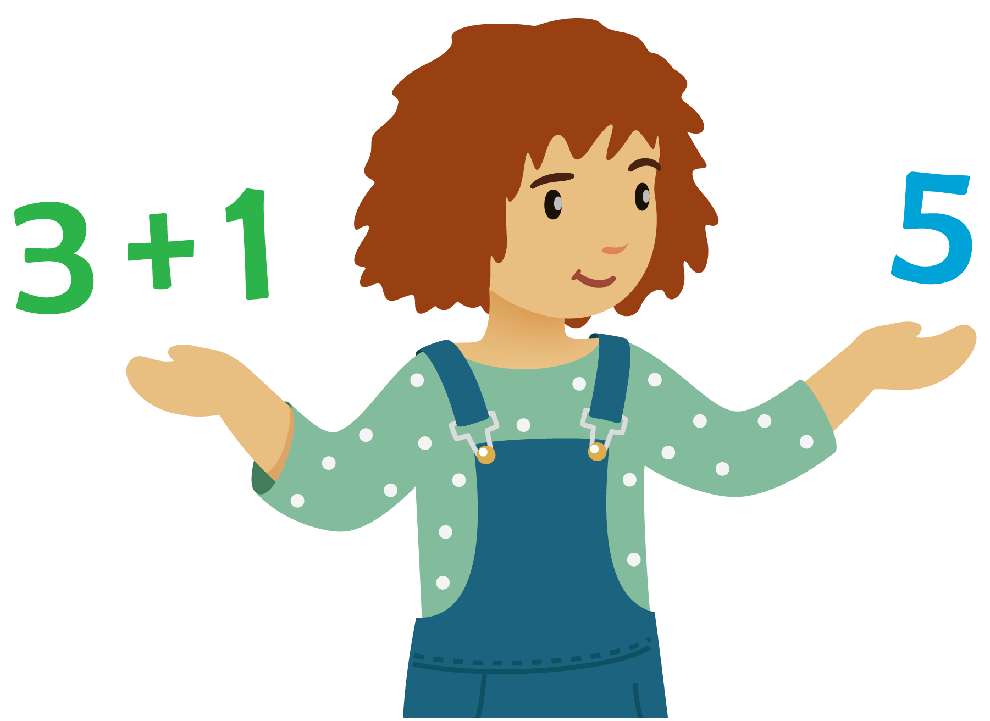
How Close?
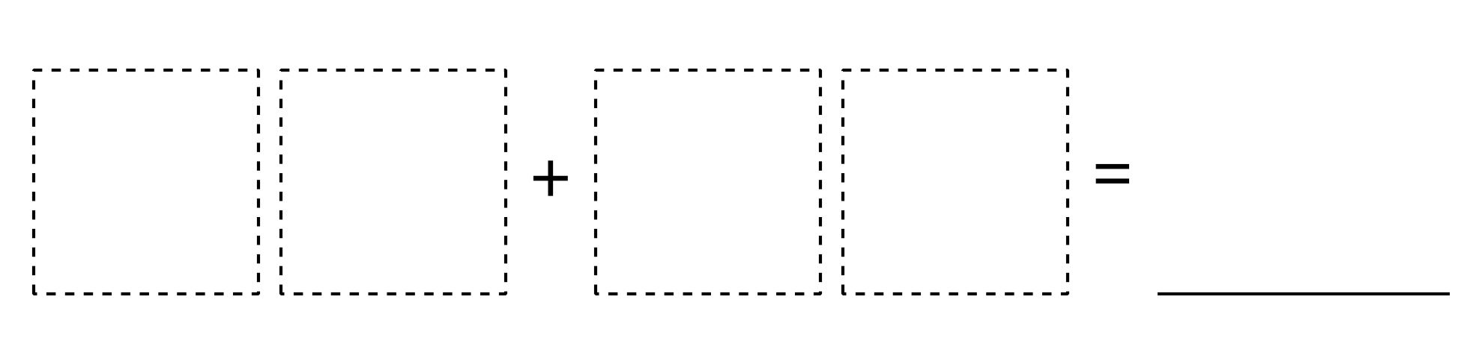
© CC BY 2021 Illustrative Mathematics®

