Unit 2 Lesson 12: Decompose Area

WU Number Talk: Partial Products (Warm up)

Student Task Statement
Find the value of each expression mentally.
- $3×20$
- $3×24$
- $5×2$
- $5×2\frac{1}{2}$

1 Which Garden Is Larger?

Student Task Statement
- Noah’s garden is 5 yards by $6\frac{1}{4}$ yards. Draw a diagram of Noah’s garden on the grid.
- 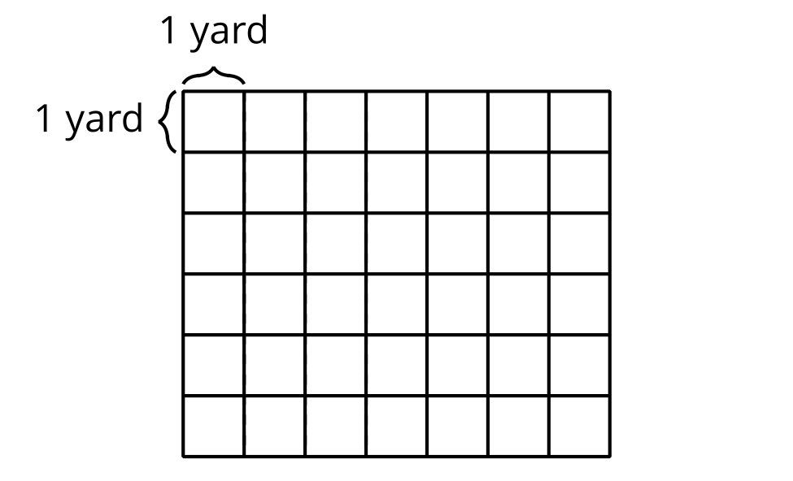
- Priya’s garden is 6 yards by $5\frac{1}{4}$ yards. Draw a diagram of Priya’s garden on the grid.
- Whose garden covers a larger area? Be prepared to explain your reasoning.

2 Different Ways to Find the Area

Student Task Statement
Partner A
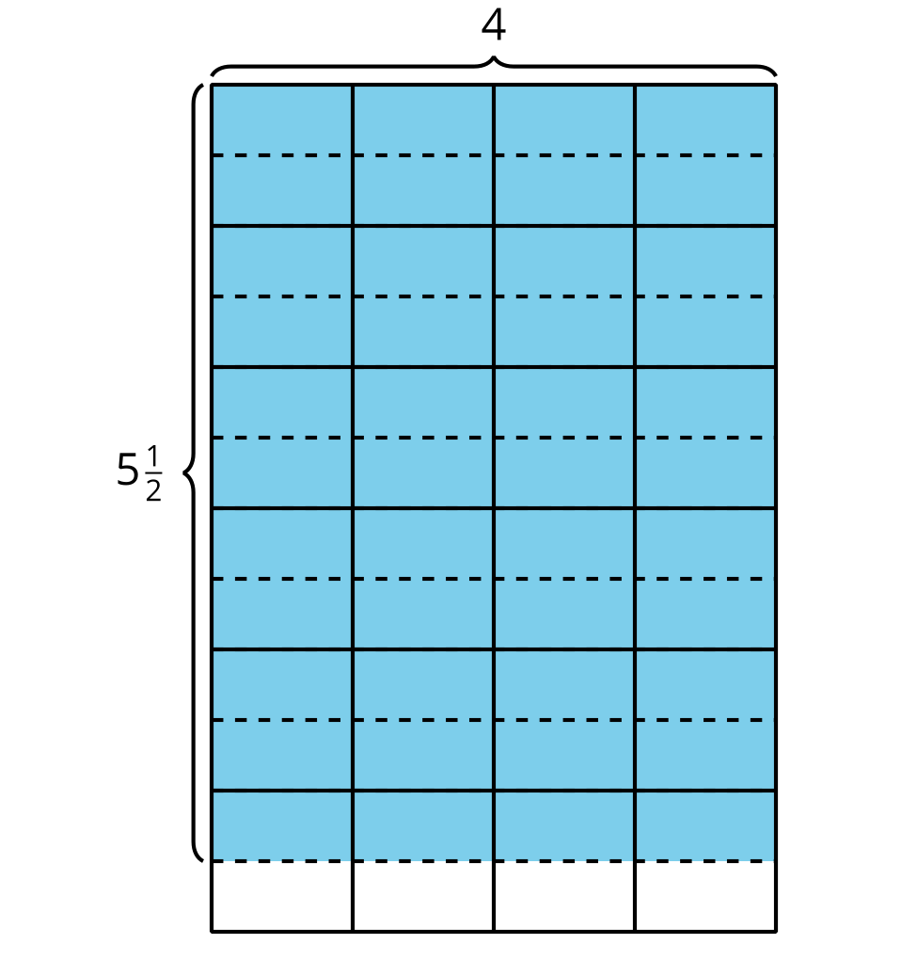
Jada: $4×5$
Priya: $4×\frac{1}{2}$
Tyler: $6×4$
Partner B
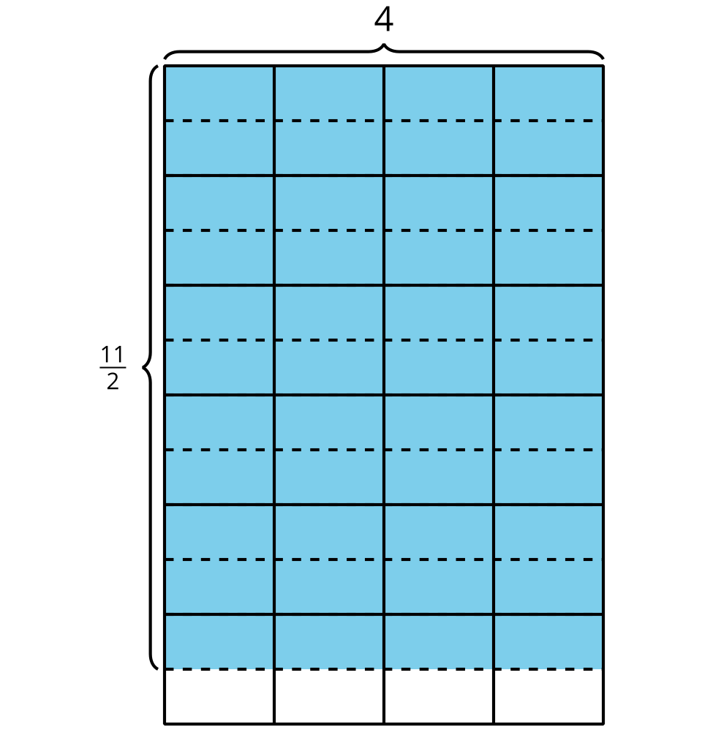
Clare: $\frac{10}{2}×4$
Diego: $4×6$
Elena: $4×11$
- Each problem shows the first step a student used to find the area of the shaded region. Explain how each student could finish their work to find the area and show your thinking on the diagram.
- Share your response with your partner. What is the same? What is different?
© CC BY 2021 Illustrative Mathematics®

