Unit 7 Lesson 6: Rectangles and Squares

WU Number Talk: Some Sums (Warm up)

Student Task Statement
Find the value of each expression mentally.
- $57+10$
- $57+11$
- $57+21$
- $57+42$

1 Rectangles and Squares

Student Task Statement
- These are rectangles.
- 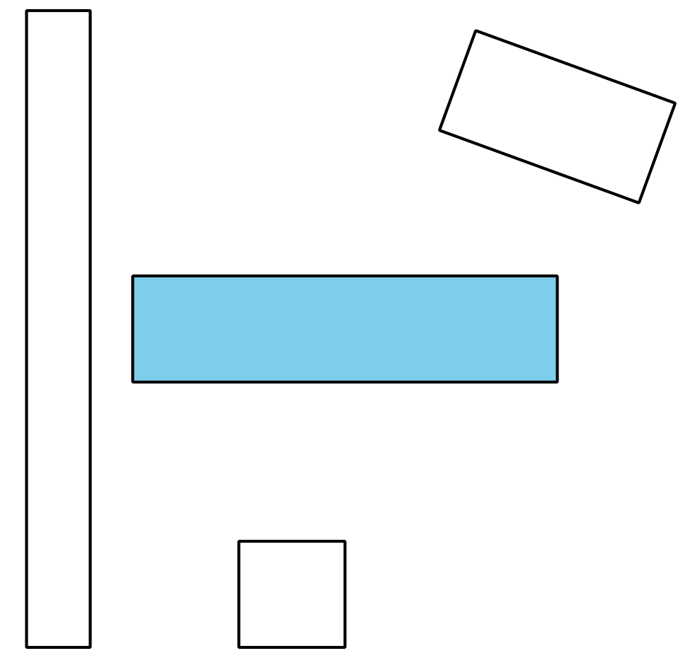
- What is the same about all these rectangles?
- These are not rectangles.
- 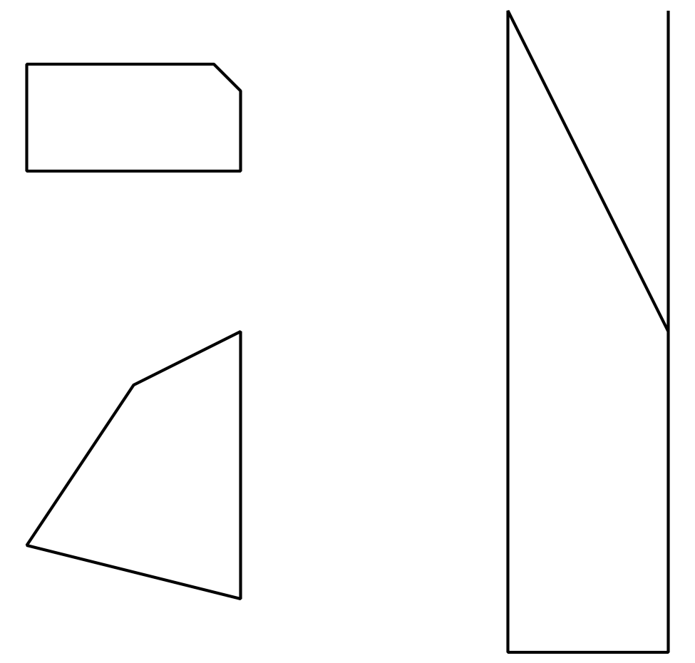
- What makes these shapes different from the rectangles?
- These are squares.
- 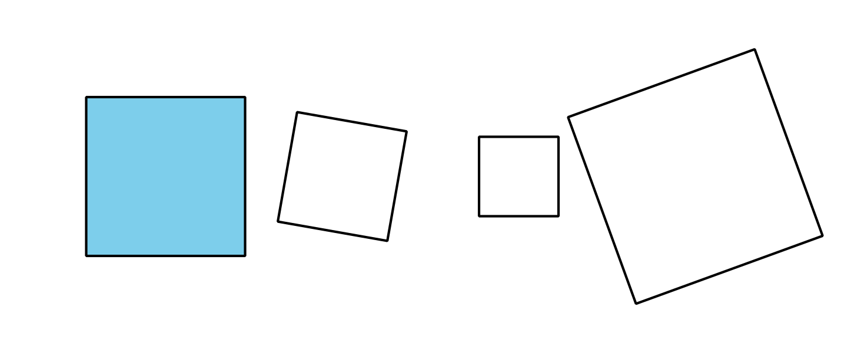
- What is the same about all these squares?
- These are not squares.
- 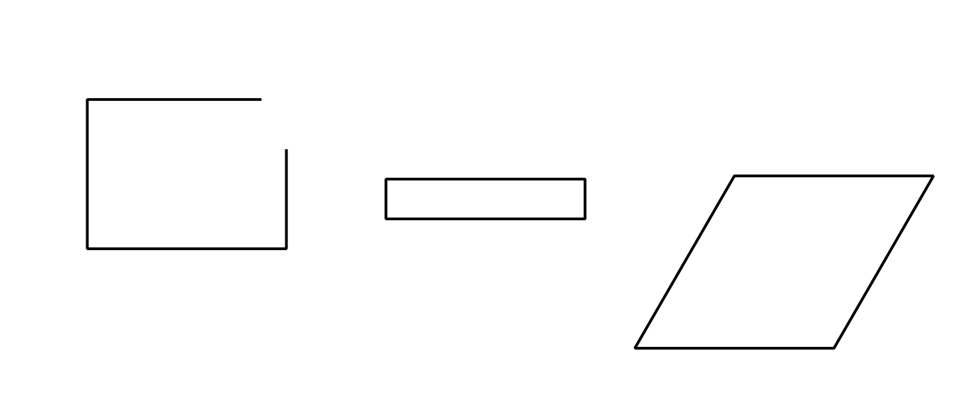
- What makes these shapes different from the squares?

2 Draw Rectangles and Squares

Student Task Statement
- Draw 5 rectangles.
- How do you know these are rectangles?
- Draw 3 shapes that are not rectangles.
- How do you know these are not rectangles?
- Draw 5 squares.
- How do you know these are squares?
- Draw 3 shapes that are not squares.
- How do you know these are not squares?
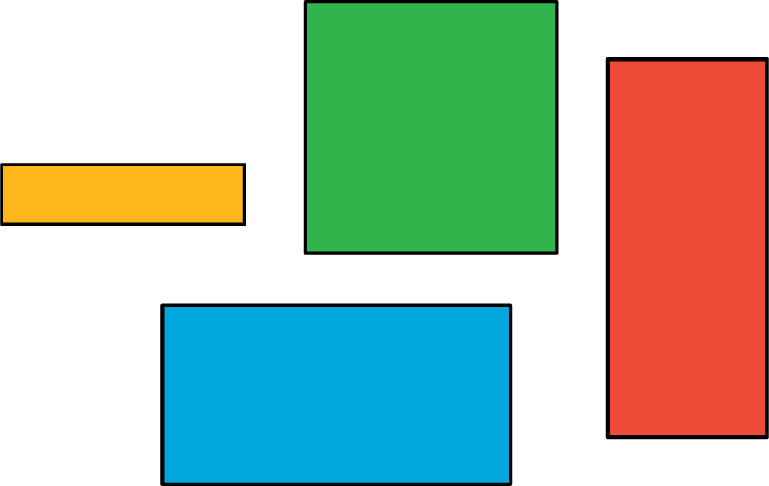
© CC BY 2021 Illustrative Mathematics®

