Lesson 6 Practice Problems
- Match histograms A through E to dot plots 1 through 5 so that each match represents the same data set.
- 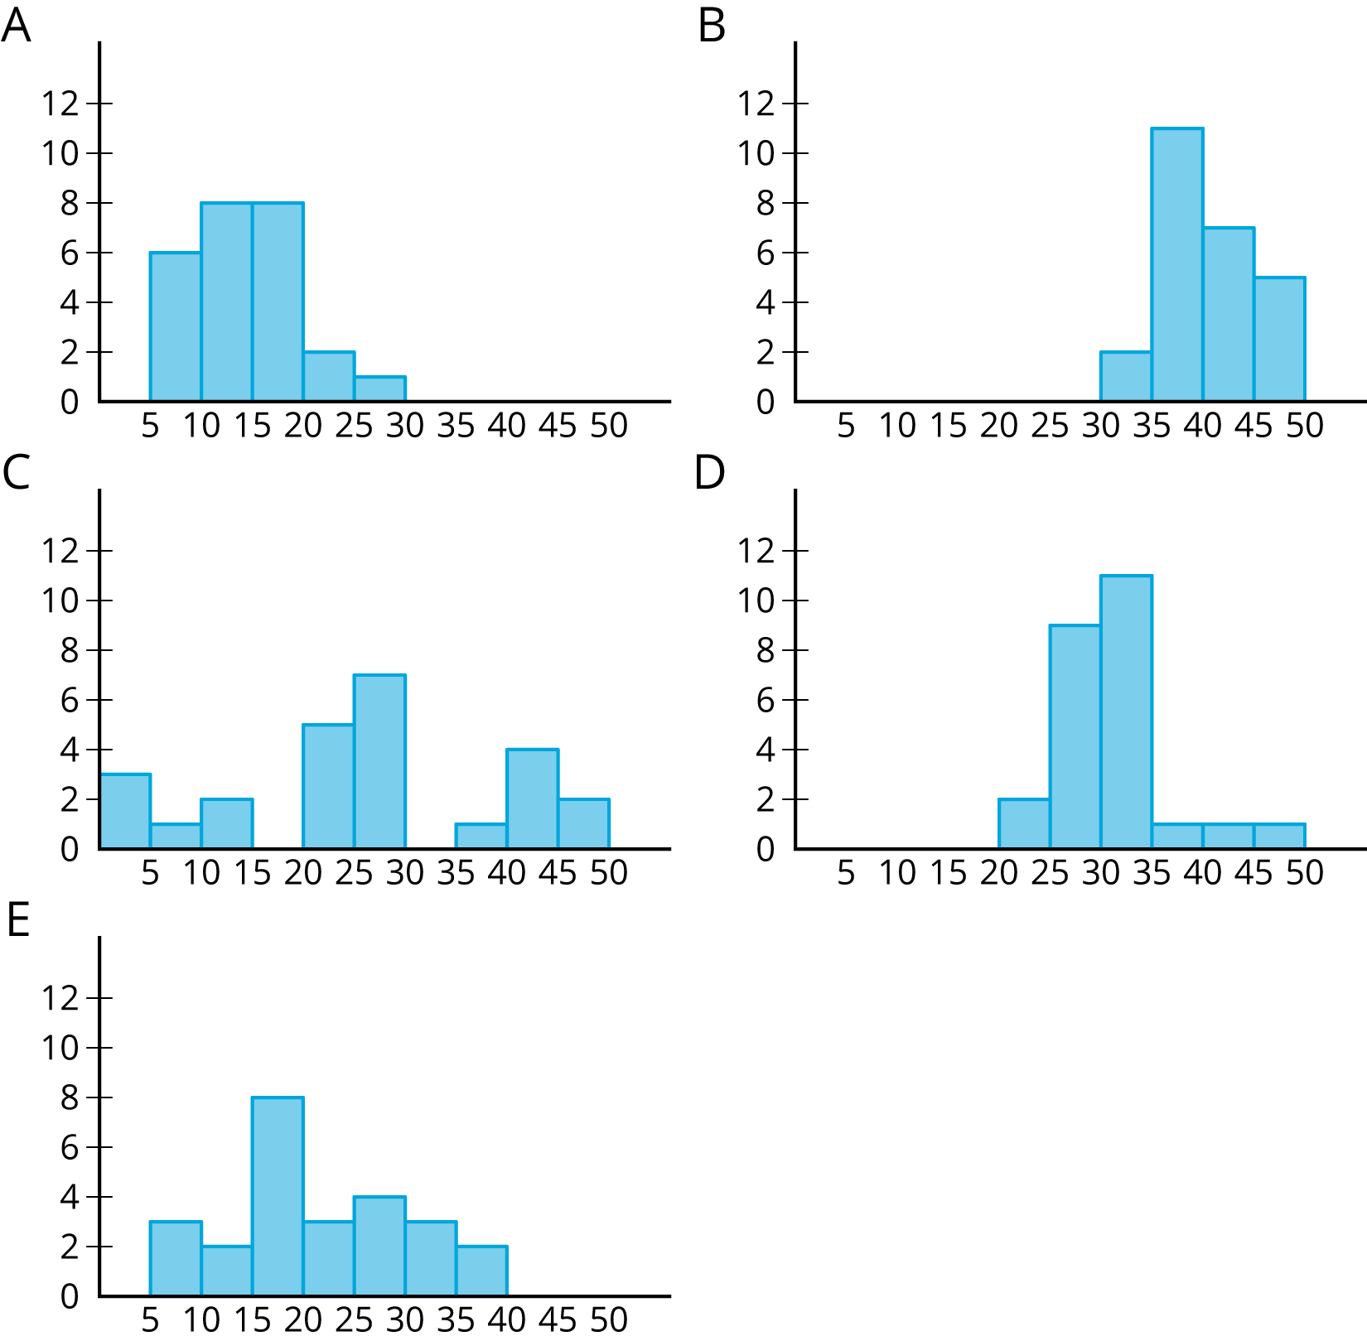

- 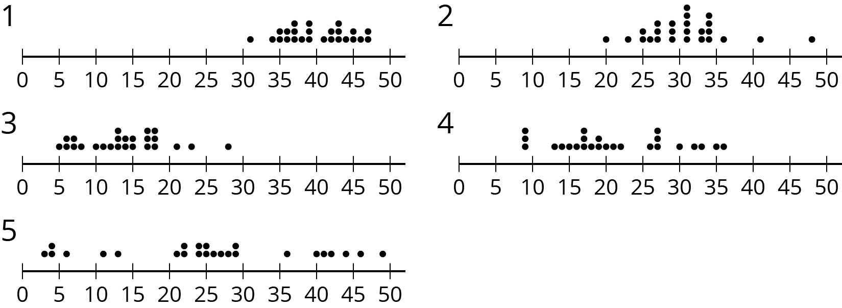
- $\left(\text{-}2,3\right)$ is one vertex of a square on a coordinate plane. Name three points that could be the other vertices.
- (From Unit 7, Lesson 12.)
- Here is a histogram that summarizes the lengths, in feet, of a group of adult female sharks. Select all the statements that are true, according to the histogram.
- 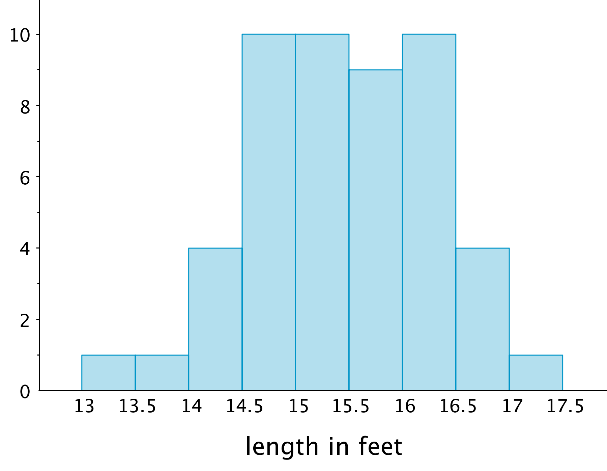
  - A total of 9 sharks were measured.
  - A total of 50 sharks were measured.
  - The longest shark that was measured was 10 feet long.
  - Most of the sharks that were measured were over 16 feet long.
  - Two of the sharks that were measured were less than 14 feet long.
- This table shows the times, in minutes, it took 40 sixth-grade students to run 1 mile.
- time (minutes) | - frequency
- 4 to less than 6 | - 1
- 6 to less than 8 | - 5
- 8 to less than 10 | - 13
- 10 to less than 12 | - 12
- 12 to less than 14 | - 7
- 14 to less than 16 | - 2
- Draw a histogram for the information in the table.
© CC BY Open Up Resources. Adaptations CC BY IM.

