## Unit 5 Lesson 2: Two Equations for Each Relationship

### 1 Missing Figures (Warm up)

#### Student Task Statement

Here are the second and fourth figures in a pattern.

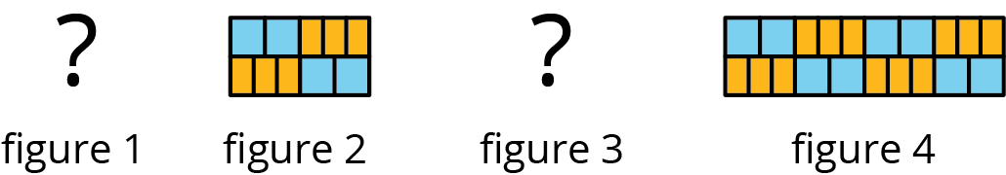

1. What do you think the first and third figures in the pattern look like?
2. Describe the 10th figure in the pattern.

### 2 Meters and Centimeters

#### Student Task Statement

There are 100 centimeters (cm) in every meter (m).

|  |  |
| --- | --- |
| length (m) | length (cm) |
| 1 | 100 |
| 0.94 |  |
| 1.67 |  |
| 57.24 |  |
|  |  |

|  |  |
| --- | --- |
| length (cm) | length (m) |
| 100 | 1 |
| 250 |  |
| 78.2 |  |
| 123.9 |  |
|  |  |

1. Complete each of the tables.
2. For each table, find the constant of proportionality.
3. What is the relationship between these constants of proportionality?
4. For each table, write an equation for the proportional relationship. Let represent a length measured in meters and represent the same length measured in centimeters.

### 3 Filling a Water Cooler

#### Student Task Statement

It took Priya 5 minutes to fill a cooler with 8 gallons of water from a faucet that was flowing at a steady rate. Let be the number of gallons of water in the cooler after minutes.

1. Which of the following equations represent the relationship between and ? Select **all** that apply.
2. What does 1.6 tell you about the situation?
3. What does 0.625 tell you about the situation?
4. Priya changed the rate at which water flowed through the faucet. Write an equation that represents the relationship of and when it takes 3 minutes to fill the cooler with 1 gallon of water.
5. Was the cooler filling faster before or after Priya changed the rate of water flow? Explain how you know.

### 4 Feeding Shrimp (Optional)

#### Student Task Statement

At an aquarium, a shrimp is fed gram of food each feeding and is fed 3 times each day.

1. How much food does a shrimp get fed in one day?
2. Complete the table to show how many grams of food the shrimp is fed over different numbers of days.

|  |  |
| --- | --- |
| * number of days | * food in grams |
| * 1 |  |
| * 7 |  |
| * 30 |  |

* 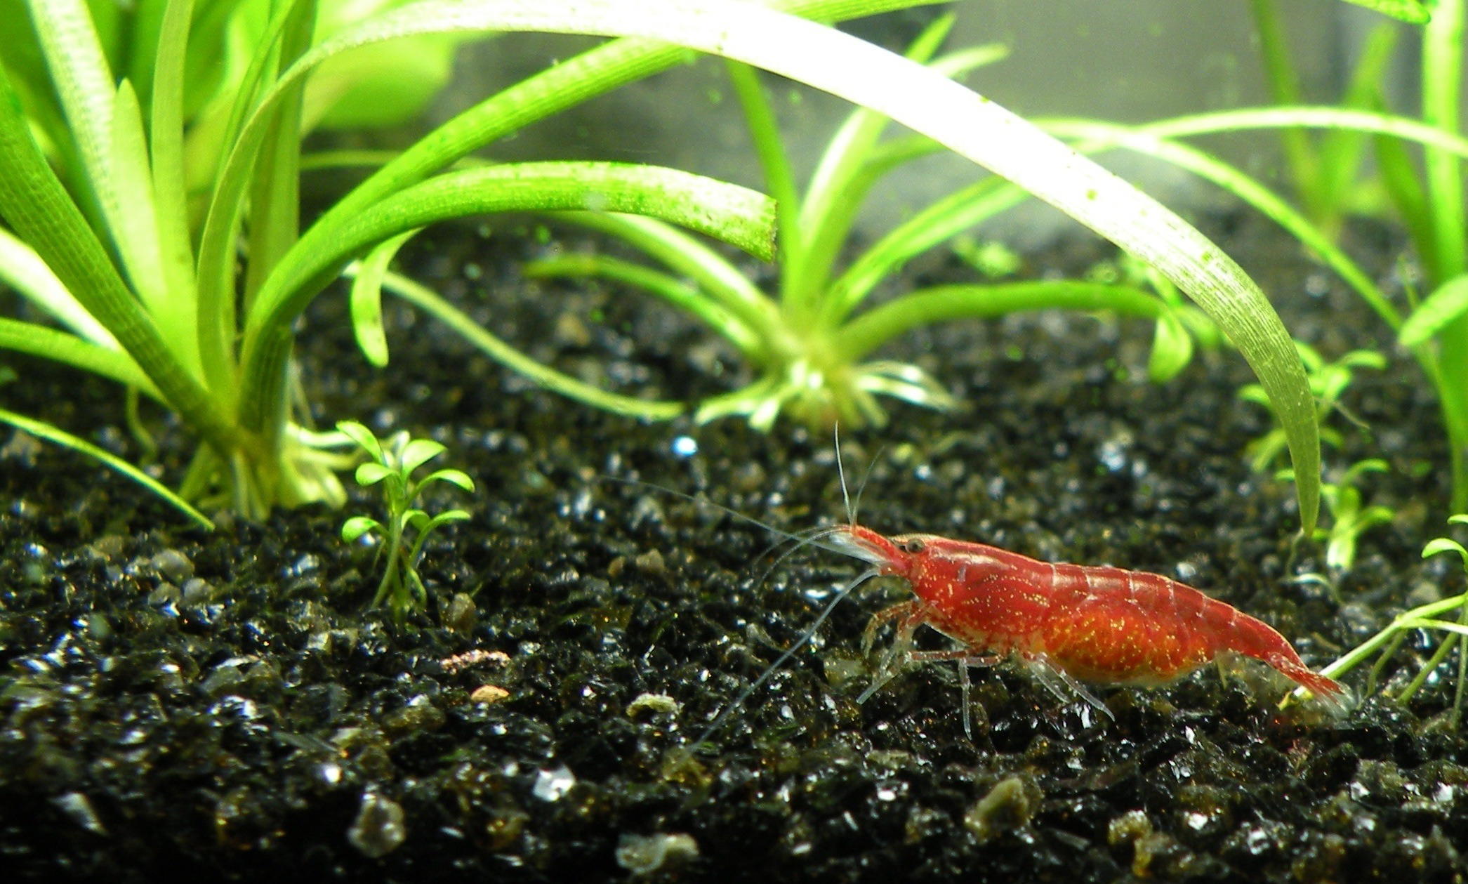

1. What is the constant of proportionality? What does it tell us about the situation?
2. If we switched the columns in the table, what would be the constant of proportionality? Explain your reasoning.
3. Use for number of days and for amount of food in grams that a shrimp eats to write *two* equations that represent the relationship between  and .
4. If a tank has 10 shrimp in it, how much food is added to the tank each day?
5. If the aquarium manager has 300 grams of shrimp food for this tank of 10 shrimp, how many days will it last? Explain or show your reasoning.



© CC BY Open Up Resources. Adaptations CC BY IM.