Lesson 6: Building Quadratic Functions to Describe Situations (Part 2)
- Let’s look at the objects being launched in the air.

6.1: Sky Bound
A cannon is 10 feet off the ground. It launches a cannonball straight up with a velocity of 406 feet per second.
Imagine that there is no gravity and that the cannonball continues to travel upward with the same velocity.
- Complete the table with the heights of the cannonball at different times.
- seconds | - 0 | - 1 | - 2 | - 3 | - 4 | - 5 | - $t$
- distance above ground (feet) | - 10
- Write an equation to model the distance in feet, $d$, of the ball $t$ seconds after it was fired from the cannon if there was no gravity.

6.2: Tracking a Cannonball
Earlier, you completed a table that represents the height of a cannonball, in feet, as a function of time, in seconds, if there was no gravity.
- This table shows the actual heights of the ball at different times.
- seconds | - 0 | - 1 | - 2 | - 3 | - 4 | - 5
- distance above ground (feet) | - 10 | - 400 | - 758 | - 1,084 | - 1,378 | - 1,640
- Compare the values in this table with those in the table you completed earlier. Make at least 2 observations.

  - Plot the two sets of data you have on the same coordinate plane.
  - 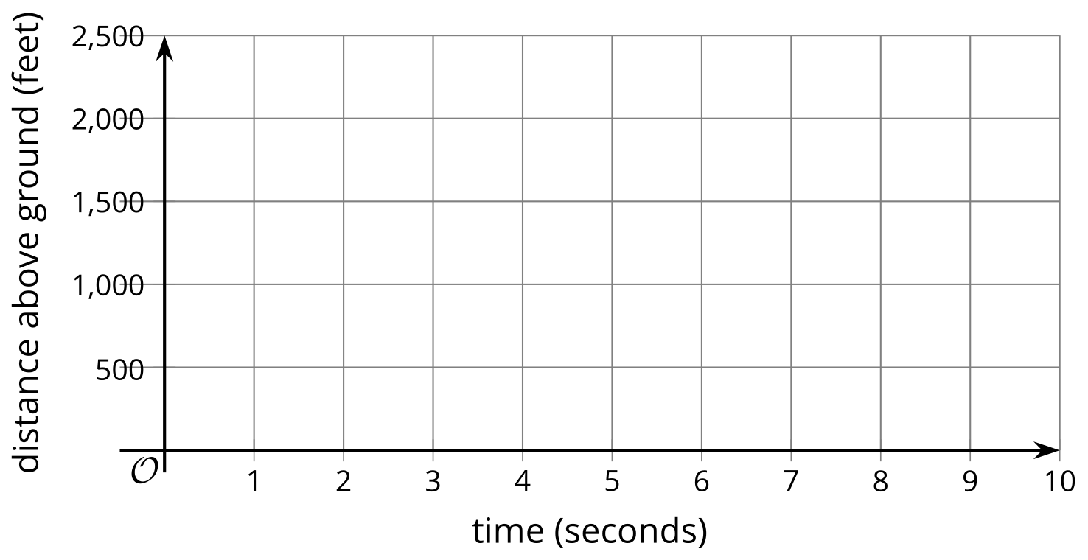
  - How are the two graphs alike? How are they different?
- Write an equation to model the actual distance $d$, in feet, of the ball $t$ seconds after it was fired from the cannon. If you get stuck, consider the differences in distances and the effects of gravity from a previous lesson.

6.3: Graphing Another Cannonball
The function defined by $d=50+312t−16t^{2}$ gives the height in feet of a cannonball $t$ seconds after the ball leaves the cannon.
- What do the terms 50, $312t$, and $\text{-}16t^{2}$ tell us about the cannonball?
- Use graphing technology to graph the function. Adjust the graphing window to the following boundaries: $0<x<25$ and $0<y<2,​000$.
- Observe the graph and:
  - Describe the shape of the graph. What does it tell us about the movement of the cannonball?
  - Estimate the maximum height the ball reaches. When does this happen?
  - Estimate when the ball hits the ground.
- What domain is appropriate for this function? Explain your reasoning.

Are you ready for more?
If the cannonball were fired at 800 feet per second, would it reach a mile in height? Explain your reasoning.

Lesson 6 Summary
In this lesson, we looked at the height of objects that are launched upward and then come back down because of gravity.
An object is thrown upward from a height of 5 feet with a velocity of 60 feet per second. Its height $h\left(t\right)$ in feet after $t$ seconds is modeled by the function $h\left(t\right)=5+60t−16t^{2}$.
- The linear expression $5+60t$ represents the height the object would have at time $t$ if there were no gravity. The object would keep going up at the same speed at which it was thrown. The graph would be a line with a slope of 60 which relates to the constant speed of 60 feet per second.
- The expression $\text{-}16t^{2}$ represents the effect of gravity, which eventually causes the object to slow down, stop, and start falling back again.
Notice the graph intersects the vertical axis at 5, which means the object was thrown into the air from 5 feet off the ground. The graph indicates that the object reaches its peak height of about 60 feet after a little less than 2 seconds. That peak is the point on the graph where the function reaches a maximum value. At that point, the curve changes direction, and the output of the function changes from increasing to decreasing. We call that point the vertex of the graph.
Here is the graph of $h$.
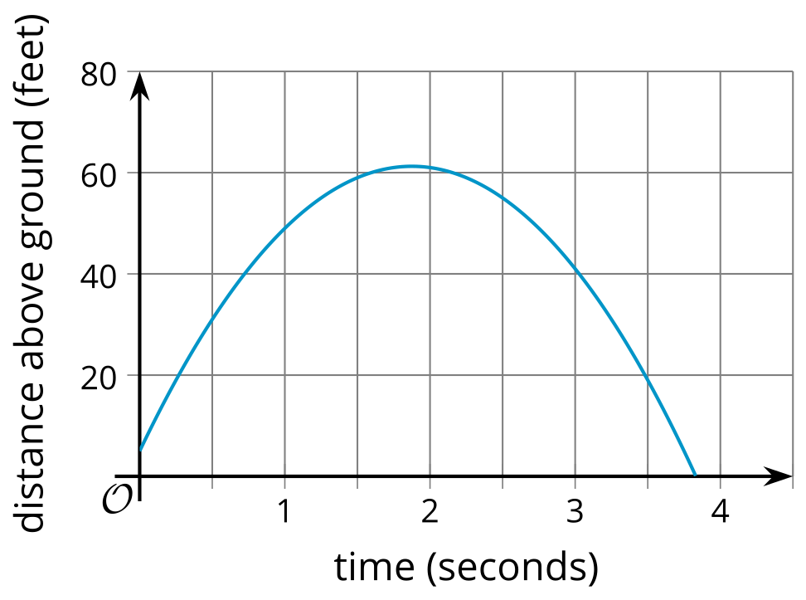
The graph representing any quadratic function is a special kind of “U” shape called a parabola. You will learn more about the geometry of parabolas in a future course. Every parabola has a vertex, because there is a point where it changes direction—from increasing to decreasing, or the other way around.
The object hits the ground a little before 4 seconds. That time corresponds to the horizontal intercept of the graph. An input value that produces an output of 0 is called a zero of the function. A zero of the function $h$ is approximately 3.8, because $h\left(3.8\right)≈0$.
In this situation, input values less than 0 seconds or more than about 3.8 seconds would not be meaningful, so an appropriate domain for this function would include all values of $t$ between 0 and about 3.8.
© CC BY 2019 by Illustrative Mathematics®

